**Name: Thammisetti Lingaiah**

Map Reduce Example using Python Code

1. Review the following to create the python code

Section 1: wordcount_mapper.py

Section 2: wordcount_reducer.py

The reducer code has some basic parts, see the comments in the code.

>gedit wordcount_mapper.py

>gedit wordcount_reducer.py

Enter the following to see that the indentations line up as above

>more wordcount_mapper.py

>more wordcount_reducer.py

Enter the following to make it executable

>chmod +x wordcount_mapper.py

>chmod +x wordcount_reducer.py

Enter the following to see what directory you are in

>pwd

It should be /user/cloudera , or something like that.

2. Create some data:

>echo "A long time ago in a galaxy far far away" > /home/cloudera/testfile1

> echo "Another episode of Star Wars" > /home/cloudera/testfile2

3. Create a directory on the HDFS file system (if already exists that’s OK):

hdfsdfs -mkdir /user/cloudera/input

4. Copy the files from local filesystem to the HDFS filesystem:

hdfsdfs -put /home/cloudera/testfile1 /user/cloudera/input

hdfsdfs -put /home/cloudera/testfile2 /user/cloudera/input

5. You can see your files on HDFS

hdfsdfs -ls /user/cloudera/input

6. Run the Hadoop WordCount example with the input and output specified.

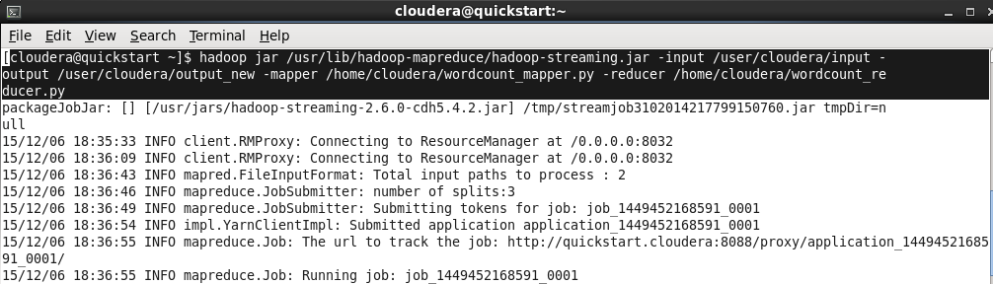

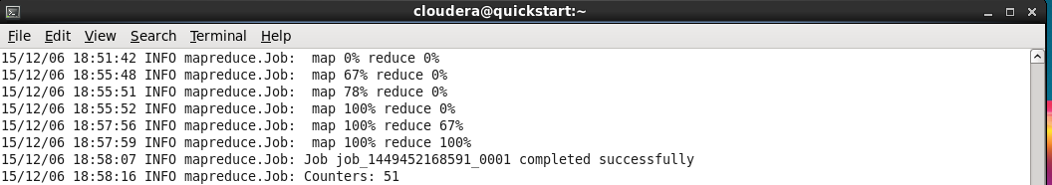

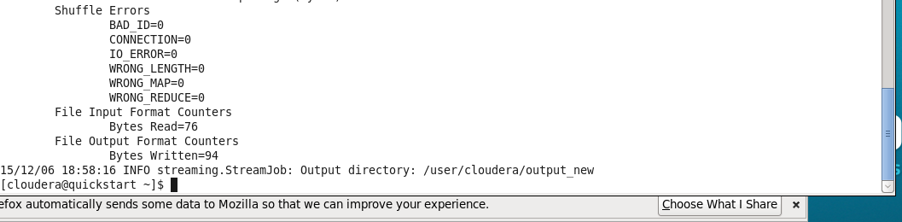

7. Check the output file to see the results:

hdfsdfs -cat /user/cloudera/output_new/part-r-00000

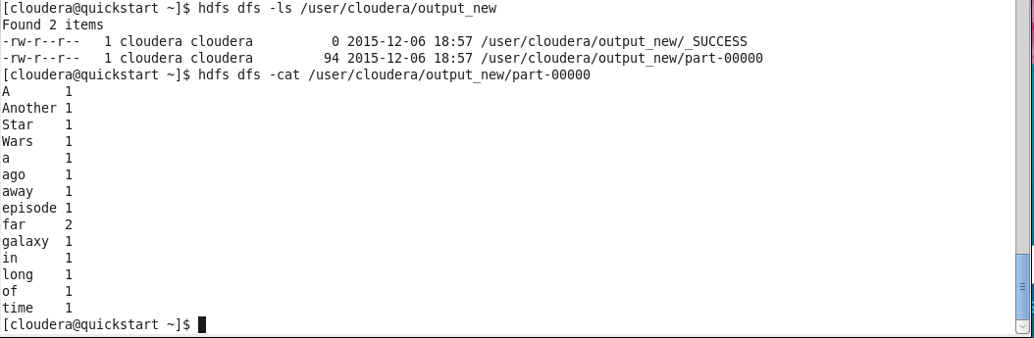

8. View the output directory:

hdfsdfs -ls /user/cloudera/output_new

Look at the files there and check out the contents, e.g.:

hdfsdfs -cat /user/cloudera/output_new/part-r-00000

results in Hue( HDFS) interface:

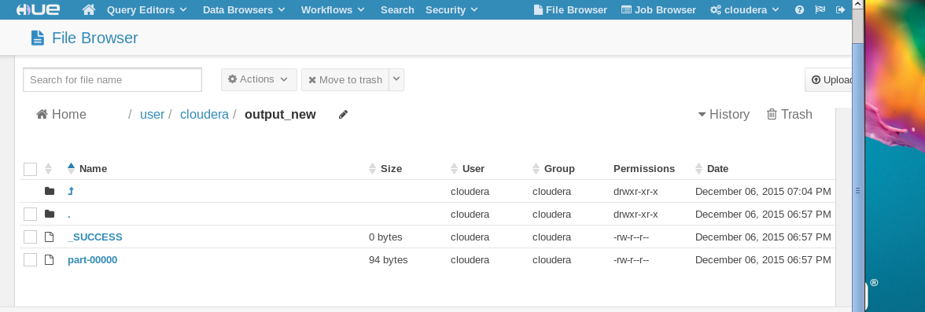

9. Streaming options:

Try: hadoop jar /usr/lib/hadoop-mapreduce/hadoop-streaming.jar --help

or see hadoop.apache.org/docs/r1.2.1/

Let’s change the number of reduce tasks to see its effects. Setting it to 0 will execute no reducer and only produce the map output. (Note the output directory is changed in the snippet below because Hadoop doesn’t like to overwrite output)

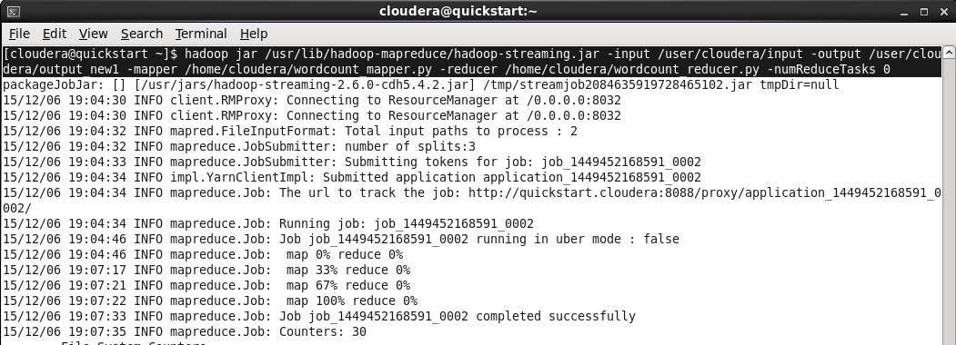

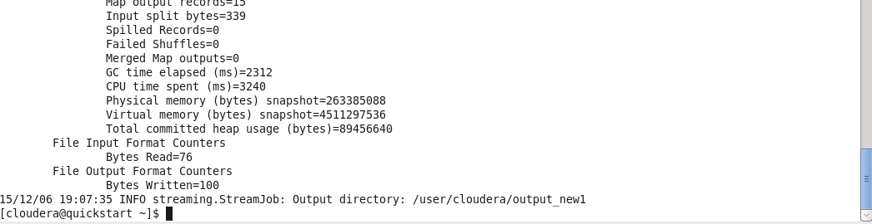the results:

hdfsdfs -cat /user/cloudera/output_new1/part-r-00000

hdfsdfs -cat /user/cloudera/output_new1/part-r-00001

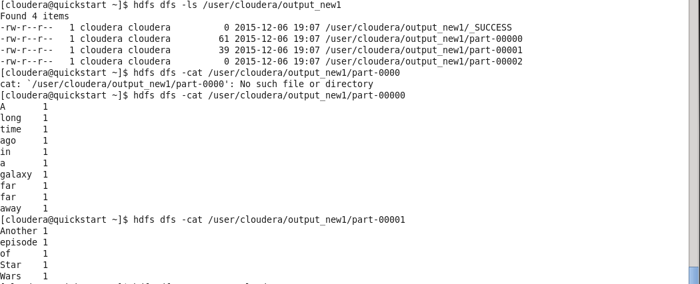

results in Hue( HDFS) interface:

