HARDWARE PRODUCT DEVELOPMENT REPORT
GridGuard Edge
A Modular Smart Energy & Electrical Safety Monitor for Hostels, Shops and Small Workshops
Product concept • Market research • Requirements • Architecture • Roadmap
Prepared as an electronics and hardware product-development concept
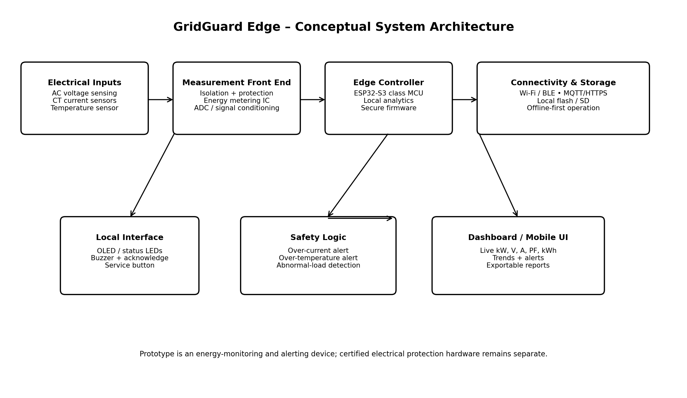
Prototype concept — not a certified electrical protection product

Executive Summary
GridGuard Edge is a proposed modular smart energy and electrical-condition monitoring device for hostels, small shops, laboratories, workshops, offices and other low-voltage facilities. The concept combines electrical measurement, temperature sensing, local alerts and connected analytics in one compact device. The product is intended to answer a practical question that a normal electricity bill cannot answer: which circuit is consuming power, when abnormal consumption occurs, and whether the electrical environment is showing an early warning sign.
The opportunity is supported by the continuing expansion of smart metering in India. A Ministry of Power update reported 5.28 crore smart meters installed across the country under various schemes as of 31 December 2025, with 5.44 crore reported by 15 January 2026. RDSS also includes large-scale smart-metering and distribution-modernisation activity. This creates a broader ecosystem in which consumers and facility managers increasingly have access to digital electricity data.
Competitor research shows distinct approaches. Sense focuses on high-resolution whole-home monitoring and machine-learning-based appliance detection; Shelly offers compact connected meters with voltage, current, power-factor and energy measurements; Schneider Electric provides professional digital meters and power-monitoring platforms for buildings and industrial environments.
GridGuard Edge is therefore positioned as a proposed middle-ground architecture: more diagnostic and locally useful than a basic meter, but simpler and more modular than a large industrial energy-management platform. The core product would provide live V/A/kW/PF/kWh data, configurable current channels, thermal monitoring, abnormal-load alerts, local display/status feedback, Wi-Fi/BLE connectivity and offline data logging. The first prototype would use an ESP32-class controller and an isolated measurement front end.

1. Market Need and Opportunity
Problem statement: Many users receive total energy-consumption information but have limited visibility into circuit-level behaviour, abnormal loads, thermal conditions and actionable alerts. This concept targets the gap between simple energy meters and feature-rich building/industrial monitoring systems.
- Facility managers need faster identification of unexpectedly high loads without manually checking every appliance.
- Hostels, laboratories and workshops often contain mixed loads such as fans, pumps, motors, heaters, computers and power tools.
- Users benefit from historical trends and alerts rather than only a monthly kWh figure.
- Local/offline operation is useful when internet connectivity is unreliable; the device should keep measuring and store data locally.
- A modular architecture can support single-phase deployment first and a three-phase version later.
Market evidence: Government smart-meter programmes demonstrate a large and expanding digital-metering ecosystem. The Ministry of Power states that RDSS has sanctioned smart metering for consumers, distribution transformers and feeders, while smart meters provide near-real-time visibility and mobile-app access to usage information.
Opportunity hypothesis: Existing products demonstrate strong capabilities, but the proposed opportunity is to combine circuit-level sensing, local-first operation, thermal anomaly monitoring and a low-complexity user interface in a product designed around small facilities. This is a product hypothesis to be validated through customer interviews and prototype trials, not a claim that competitors cannot perform these functions.

2. Market and Competitor Research
The following comparison is based on publicly available product information reviewed in September 2026.
Product / platform | Documented capabilities | Observed positioning | Design implication for GridGuard
Sense Home Energy Monitor | Real-time monitoring; high-resolution electrical sampling; machine-learning appliance detection; app-based insights. | Consumer/home energy analytics. | Use a simpler, more transparent local dashboard and add facility-oriented circuit/thermal alerts.
Shelly 3EM-63W Gen3 | Single/three-phase support; voltage, current, power factor, active/apparent power and energy; Wi-Fi; local data logging. | Compact connected energy meter. | Differentiate through modular sensing, local UI, anomaly logic and a facility-focused workflow.
Schneider Electric digital/power meters | Energy monitoring; real-time data; power-quality and connected monitoring options across building/industrial applications. | Professional commercial/industrial metering. | Target a smaller, easier-to-prototype product with lower system complexity while leaving certified industrial protection to appropriate equipment.

Sources: Sense documents real-time energy monitoring and appliance detection using electrical signatures. Shelly documents voltage/current/power-factor/energy monitoring and Wi-Fi operation. Schneider Electric documents digital energy meters and connected power-monitoring solutions for buildings and industrial facilities.
Competitive design conclusion: The concept should not attempt to compete solely on the number of dashboard features. Its engineering value should come from measurement integrity, safe hardware architecture, configurable sensing, fast local alerts, useful diagnostics and an upgradeable firmware/software platform.

3. Product Concept

3.1 Product purpose
GridGuard Edge is a DIN-rail/wall-mount electronics module that measures electrical parameters, monitors enclosure/cable temperature, identifies configurable abnormal conditions and presents information locally and remotely.

3.2 Target users
- Hostel and small-building facility managers
- Small workshops and laboratories
- Retail shops and offices
- College project/lab environments
- Technicians who need a portable diagnostic prototype before permanent installation

3.3 Core features
- Voltage, current, active power, apparent power, power factor and accumulated energy measurement
- 1–3 configurable current channels depending on hardware variant
- Temperature sensing at the enclosure and/or selected cable/terminal locations
- Configurable over-current, over-temperature and abnormal-load alerts
- Wi-Fi and BLE for setup and data access
- Local OLED/status LEDs/buzzer for immediate feedback
- Offline logging with later synchronization
- MQTT/HTTPS integration for dashboards
- Exportable CSV-style energy history
- Firmware update capability with rollback protection planned for production

4. User Requirements
ID | User need | Requirement | Priority
UR-01 | See current consumption | Show live voltage, current, power and PF. | High
UR-02 | Track energy | Store cumulative kWh and historical intervals. | High
UR-03 | Know about abnormal loads | Generate configurable alerts for threshold violations. | High
UR-04 | Work during internet outages | Continue measurement and local logging without cloud access. | High
UR-05 | Easy commissioning | Provide BLE/Wi-Fi setup and a simple configuration workflow. | Medium
UR-06 | Quick local feedback | Provide status LEDs/OLED and audible alert acknowledgement. | Medium
UR-07 | Expandable product | Allow additional CT channels and sensors in later revisions. | Medium
UR-08 | Safe service | Use isolated sensing and protected low-voltage electronics. | High

5. Product Requirement Specification
The values below are proposed engineering targets for the first prototype. They are not certification claims and must be verified by calibration, electrical-safety testing and environmental testing.
Parameter | Prototype target | Verification method
Supply | Protected low-voltage DC input; isolated AC measurement front end | Schematic review + electrical test
Voltage measurement | 80–300 V AC line-neutral target | Calibrated AC source / reference meter
Current measurement | 0–63 A per CT channel target | Programmable load + reference clamp/meter
Energy accuracy | Target ±1% after calibration in defined operating range | Reference power analyzer
Update rate | 1 s dashboard update; faster internal sampling | Firmware timing test
Local storage | At least 30 days of interval data | Data-retention test
Alert latency | <5 s target for threshold events | Event injection test
Connectivity | 2.4 GHz Wi-Fi + BLE for setup | Range and reconnect tests
Operating environment | 0–50 °C prototype target | Thermal chamber / controlled test
Protection | Input fuse/protection, isolation, creepage/clearance by design | Electrical design review + lab testing
Enclosure | Non-conductive or appropriately rated enclosure | Mechanical inspection
Firmware recovery | Safe update/recovery mechanism for production design | Fault-injection test

6. System Architecture
The architecture separates high-voltage measurement from the low-voltage controller. Current transformers provide non-invasive current measurement. The voltage path must use an appropriately isolated and protected measurement design. The prototype controller processes the measurements, applies threshold logic, stores data and communicates with the dashboard.

6.1 Proposed hardware blocks
- ESP32-S3-class microcontroller for processing, Wi-Fi and BLE.
- Dedicated energy-metering IC or precision ADC/signal-conditioning chain for voltage/current measurement.
- Split-core CT sensors for current measurement; final CT rating selected from target load class.
- Temperature sensor such as a digital sensor or thermistor placed near high-risk terminals/enclosure hotspots.
- OLED/status LEDs and buzzer for local interaction.
- Non-volatile memory or microSD for local history in prototype builds.
- Protected, isolated low-voltage power supply.
- Optional relay/contactor interface in a future version; any mains switching stage requires independent safety review and appropriate certification.

7. Hardware and Firmware Design

7.1 Firmware structure
- Boot and self-test: verify sensors, storage and configuration.
- Measurement task: sample voltage/current and calculate electrical parameters.
- Filtering/calibration task: remove noise and apply calibration constants.
- Safety/alert task: compare values against configured thresholds and debounce events.
- Storage task: write interval summaries locally.
- Communication task: publish MQTT/HTTPS data when connected.
- User-interface task: update OLED/LED/buzzer state.
- Diagnostics task: record sensor faults, communication faults and watchdog resets.

7.2 Data model
A basic record can contain timestamp, channel ID, voltage RMS, current RMS, active power, apparent power, power factor, accumulated energy, temperature and alarm flags. Production firmware should add device ID, firmware version, calibration revision and error codes.

7.3 Cybersecurity and privacy
- Use unique device credentials rather than one shared password.
- Encrypt remote communication using TLS where supported.
- Store only the minimum user/site information required.
- Provide a local factory-reset process that clears credentials.
- Sign production firmware and protect the update process against unauthorized images.

8. User Interaction and Software
The local interface should remain useful even when Wi-Fi is unavailable. A simple screen can rotate through: total power, voltage/current, energy today, temperature, and alarm status. The mobile/web dashboard can provide live graphs, daily/weekly trends, threshold configuration and downloadable history.
Screen / view | Information | User action
Home | Current kW, voltage, alarm state | Acknowledge alarm
Channels | V/A/kW/PF per channel | Select channel
Energy | Today/week/month kWh | Choose period
Temperature | Current and maximum temperature | View trend
Alerts | Time, type, measured value, threshold | Acknowledge / configure
Settings | Wi-Fi, channel names, thresholds, calibration status | Configure

9. Development Roadmap
Phase | Duration | Main activities | Exit criteria
1. Discovery & requirements | Weeks 1–2 | User interviews, use cases, load profiles, competitor benchmarking, risk analysis. | Approved PRD and measurable requirements.
2. Proof of concept | Weeks 3–5 | Bench measurement circuit, CT interface, ESP32 firmware, basic logging. | Stable measurement on resistive and inductive test loads.
3. EVT prototype | Weeks 6–9 | Custom PCB, enclosure concept, local UI, Wi-Fi/BLE, calibration workflow. | Prototype passes electrical and functional bench tests.
4. DVT | Weeks 10–13 | Thermal, EMC pre-checks, long-duration logging, communication recovery, mechanical refinement. | Design meets defined prototype verification plan.
5. Pilot | Weeks 14–18 | Deploy limited units in controlled sites, collect feedback, improve firmware/UI. | Pilot reliability and usability targets achieved.
6. Production preparation | Weeks 19–24 | BOM optimization, test fixture, manufacturing procedure, compliance planning, service documentation. | Production-ready design package and validation plan.

10. Prototype, Testing and Validation Plan
Testing must be staged from low-voltage electronics to controlled mains testing. Mains work should be performed by qualified personnel using appropriate isolation, PPE, fusing, test equipment and laboratory procedures.
Test area | Example test | Pass criterion
Measurement accuracy | Compare V/A/kW/kWh with calibrated reference. | Within defined prototype accuracy target.
Load variation | Test low, medium and high loads; resistive and motor loads. | Stable readings and no firmware crashes.
Thermal | Run continuous load and monitor enclosure/sensor temperature. | No unsafe temperature rise; alert occurs at configured threshold.
Connectivity | Disconnect Wi-Fi, restore network, restart router. | Data continues locally and synchronizes after recovery.
Storage | Fill/rotate log data and simulate power loss. | No unacceptable corruption; records recover predictably.
Alarm | Inject threshold events and clear them. | Alert generated within target latency and correctly cleared.
EMC pre-check | Observe behaviour near switching loads and noise sources. | No unacceptable measurement instability or resets.
Mechanical | Vibration/handling and enclosure fit checks. | No loose terminals or mechanical failure.

11. Production and Commercialization Considerations
- Design-for-test: provide test pads and a programming/calibration fixture.
- Calibration: each measurement channel should have traceable calibration procedures and stored calibration constants.
- BOM: prefer components with multiple qualified suppliers where possible.
- Assembly: use a PCB layout that clearly separates high-voltage and SELV/low-voltage domains.
- Enclosure: provide strain relief, tamper-evident options and clear terminal markings.
- Service: modular CT connectors and replaceable low-voltage modules can reduce service time.
- Compliance: before commercial sale, determine and complete the electrical-safety, EMC, radio, environmental and metering requirements applicable to the exact market and product claims.
- Business model: hardware sale plus optional monitoring software/service; alternatively, an offline-only model can avoid recurring cloud costs for basic users.

12. Risks and Mitigation
Risk | Impact | Mitigation
Unsafe mains design | Very high | Use isolation, protective components, creepage/clearance rules, qualified review and laboratory testing.
Measurement error | High | Use precision sensing, calibration, reference instruments and defined accuracy limits.
False alarms | Medium | Use configurable thresholds, hysteresis, debounce and event history.
Wi-Fi unreliability | Medium | Offline-first logging and automatic reconnect.
Sensor drift | Medium | Calibration checks and diagnostic limits.
Component availability | Medium | Approved alternate parts and early BOM risk review.
Over-scoped first version | High | Freeze an MVP before adding AI, switching or advanced power-quality features.
Regulatory delay | High | Start compliance planning during architecture, not after prototype completion.

13. Conclusion
GridGuard Edge is a feasible hardware-product concept that combines electrical measurement, embedded processing, connectivity and user-oriented diagnostics. Its technical foundation is achievable with established sensing and microcontroller technologies, while the main engineering challenge is safe and accurate mains measurement rather than simply building a connected dashboard. The concept is intentionally modular so that the first prototype can validate measurement and user value before adding advanced analytics or control.
The recommended next step in a real product-development programme is not immediate mass production. It is a controlled proof-of-concept followed by calibrated measurement testing, user interviews, prototype deployment and a formal safety/compliance assessment. If those stages validate the requirements, the design can progress to EVT, DVT and pilot production.

References
- Ministry of Power, Government of India / Press Information Bureau, “Progress on Smart Meter Installation under RDSS,” 2 February 2026. https://www.pib.gov.in/PressReleasePage.aspx?PRID=2222217
- Ministry of Power, Government of India / Press Information Bureau, “Smart Metering Adoption: 4.76 Crore Smart Meters Installed,” 8 December 2025. https://www.pib.gov.in/PressReleasePage.aspx?PRID=2200456
- Ministry of Power, Government of India / Press Information Bureau, “Nationwide Push for Smart Prepaid Meters,” 11 December 2025. https://www.pib.gov.in/PressReleasePage.aspx?PRID=2202459
- Sense, “How the Sense Home Energy Monitor Works.” https://sense.com/consumer-blog/how-the-sense-home-energy-monitor-works/
- Sense Help Center, “Devices: How Sense Detects Devices In Your Home.” https://help.sense.com/hc/en-us/articles/115009732808-Devices-How-Sense-Detects-Devices
- Shelly, “Shelly 3EM-63W Gen3.” https://www.shelly.com/products/shelly-3em-63w-gen3
- Schneider Electric India, “Smart Metering.” https://www.se.com/in/en/product-subcategory/4180-smart-metering/
- Schneider Electric India, “Digital Energy Meters.” https://www.se.com/in/en/product-subcategory/82264-digital-energy-meters/

