# **Hackathon Project**

## **Project Title:**

ProVisionAI: Unleashing the Power of Gemini Vision for Image Annotation

## **Team Name:**

The PowerHouse

## **Team Members:**

* D. Jahnavi
* L .Shilpa
* D. Anjali
* N. Mamatha

## **Phase-1: Brainstorming & Ideation**

### **Objective:**

ProVisionAI: Unleashing the Power of Gemini Vision for Image Annotation

### **Key Points:**

1. **Problem Statement:**
   * ProVision AI is an innovative project aimed at revolutionizing image annotation through advanced AI capabilities, specifically leveraging Google's powerful Gemini Vision Pro model. This project provides users with a sophisticated platform for annotating images with rich descriptive captions and insightful information.

**2.Proposed Solution:**

ProVisionAI tackles these challenges by offering an intelligent, AI-powered image annotation platform. Our solution encompasses the following key components:

**• Automated Captioning:** Gemini Vision's powerful image understanding allows ProVisionAI to automatically generate descriptive captions for images, providing rich contextual information. This eliminates the need for manual captioning, saving significant time and effort.

**• Intelligent Object Detection and Segmentation:** ProVisionAI utilizes Gemini Vision to identify and segment objects within images, providing precise bounding boxes and pixel-level masks. This enables accurate object localization and detailed scene understanding, crucial for training robust computer vision models.

**• Metadata Extraction:** Beyond captions and bounding boxes, ProVisionAI can extract valuable metadata from images, such as attributes, tags, and contextual information. This enriches the annotation data and provides deeper insights into the image content.

**• Customizable Workflows:** ProVisionAI offers flexible and customizable workflows to adapt to different annotation tasks and project requirements. Users can define their own annotation guidelines, create custom labels, and manage the annotation process efficiently.

**• User-Friendly Interface:** Our platform provides an intuitive and easy-to-use interface for uploading images, viewing annotations, and managing projects. This simplifies the annotation process for both technical and non-technical users.

**• API Access:** ProVisionAI offers API access for seamless integration with existing workflows and applications. This allows developers to incorporate our annotation capabilities into their own systems.

**• Scalable Infrastructure:** Built on a robust and scalable infrastructure, ProVisionAI can handle massive datasets and high volumes of annotation requests, ensuring efficient processing even for large-scale projects.

**3.Target Users:**

ProVisionAI is designed for a wide range of users, including:

**•** Computer vision researchers

**•** Data scientists

**•** Machine learning engineers

**•** Developers

**•** Content creators

**•** Any individual or organization that needs to annotate images efficiently and accurately.

1. **Expected Outcome:**
   * **ProVisionAI's** automation capabilities should drastically decrease the time required to annotate image datasets compared to manual methods. This will lead to **faster project completion** and reduced labor costs.

## **Phase-2: Requirement Analysis**

### **Objective:**

Define the technical and functional requirements for the provision AI

### **Key Points:**

**I. Functional Requirements:**

These describe what the system should *do*.

* **Image Upload:**
  + Users should be able to upload images in common formats (JPEG, PNG, GIF, TIFF, etc.).
  + The system should support single image uploads and batch uploads.
  + There should be client-side validation (file type, size limits).
  + Upload progress should be displayed to the user.
  + Image previews should be generated and displayed.
* **Gemini Vision Integration:**
  + The system should securely authenticate with the Gemini Vision API.
  + The system should send uploaded images to the Gemini Vision API for processing.
  + The system should receive and parse the JSON response from the API.
  + Error handling for API communication should be implemented.
* **Automated Captioning:**
  + The system should display the caption generated by Gemini Vision clearly.
  + Users should be able to copy the generated caption.
* **Object Detection and Segmentation:**
  + The system should display bounding boxes around detected objects on the image.
  + Object labels should be displayed alongside the bounding boxes.
  + (Optional) Different colors can be used for different object categories.
  + (Future) Support for more detailed segmentation masks.
* **User Interface:**
  + The interface should be clean, intuitive, and easy to navigate.
  + The interface should be responsive and work well on different screen sizes.
  + Clear instructions and feedback messages should be provided to the user.
* **Data Export:**
  + Users should be able to download the annotations (captions, bounding boxes, labels) in a structured format (e.g., JSON, CSV).
* **User Authentication (Optional, but recommended for future versions):**
  + Users should be able to create accounts and log in.
  + User accounts should be secure.
  + User data should be protected.
* **Project Management (Optional, for future versions):**
  + Users should be able to create and manage annotation projects.
  + Project settings (e.g., annotation guidelines, custom labels) should be configurable.
  + Team collaboration features (roles, permissions) could be added.

**II. Non-Functional Requirements:**

These describe *how* the system should perform.

* **Performance:**
  + Image upload and processing should be reasonably fast.
  + The system should be responsive to user interactions.
  + API calls to Gemini Vision should be optimized.
* **Scalability:**
  + The system should be able to handle a large number of users and images.
  + The system should be scalable to accommodate future growth.
* **Security:**
  + API keys and user credentials should be securely stored and managed.
  + The system should be protected against common web vulnerabilities.
* **Usability:**
  + The interface should be user-friendly and intuitive.
  + The system should be easy to learn and use.
* **Reliability:**
  + The system should be reliable and available.
  + Error handling should be robust.
* **Maintainability:**
  + The codebase should be well-structured and easy to maintain.
  + The system should be easy to update and extend.
* **Portability:**
  + The system should be portable and deployable on different platforms (cloud, on-premise).

**III. Prioritization (MoSCoW Method):**

* **Must have:** Image upload, Gemini Vision integration, automated captioning, object detection, basic UI, data export.
* **Should have:** User authentication, improved UI/UX, more robust error handling.
* **Could have:** Project management, team collaboration, support for more data types (video, etc.), advanced segmentation.
* **Won't have (for MVP):** Highly specialized features, integrations with other platforms, complex analytics.

**IV. Open Issues and Risks:**

* **Gemini Vision API availability and cost:** Dependence on an external API.
* **Scalability challenges:** Ensuring the system can handle large datasets and high traffic.
* **Security considerations:** Protecting API keys and user data.
* **User adoption:** Ensuring the interface is user-friendly and meets user needs.

## **Phase-3: Project Design**

### **Objective:**

Develop the architecture and user flow of the application.

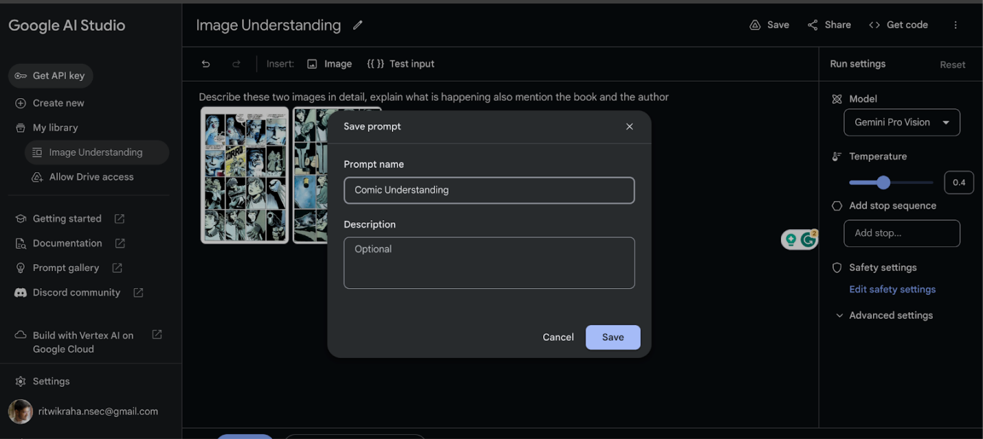

### **Key Points:**

**. System Architecture:**

ProVisionAI will employ a three-tier architecture:

1. **Presentation Tier (Frontend):** Handles user interaction and displays results.
   * Technologies: React (for dynamic UI), HTML, CSS, JavaScript.
   * Key Components:
     + Image Upload Component: Drag-and-drop, file selection, image preview.
     + Annotation Display Component: Displays the image, caption, and object bounding boxes/labels.
     + User Interaction Components: Buttons (e.g., "Annotate," "Download"), forms, etc.
2. **Application Tier (Backend):** Manages business logic, API communication, and data processing.
   * Technologies: Python (Flask or Django REST Framework), Gemini Vision API client.
   * Key Components:
     + API Endpoints: /annotate (for image processing), other endpoints as needed.
     + Gemini Vision Integration Module: Handles API authentication, requests, and responses.
     + Annotation Processing Module: Formats and processes the annotations from Gemini Vision.
     + (Optional) Data Storage Module: Interacts with the database (if used).
3. **Data Tier (Database - Optional for MVP):** Stores user data, annotations, etc.
   * Technologies: PostgreSQL (recommended for scalability), or a simpler database for MVP.
   * Key Components: Database server, data models.

**II. User Flow:**

1. **Image Upload:**
   * User visits the ProVisionAI web application.
   * User interacts with the Image Upload component.
   * User drags and drops an image or selects a file from their computer.
   * The frontend validates the image (file type, size) client-side.
   * The image is uploaded to the backend via the /annotate API endpoint.
2. **Backend Processing:**
   * The backend receives the image.
   * The Gemini Vision Integration Module authenticates with the Gemini Vision API.
   * The backend sends the image to the Gemini Vision API for processing.
   * Gemini Vision performs image captioning and object detection.
   * Gemini Vision returns the annotations (captions, bounding boxes, labels) in JSON format.
   * The Annotation Processing Module (if needed) processes the JSON data.
   * (Optional) The backend stores the image metadata and annotations in the database.
3. **Displaying Annotations:**
   * The backend sends the processed annotations back to the frontend.
   * The Annotation Display Component receives the data.
   * The component displays the image, the generated caption below it, and overlays bounding boxes with labels on the image.
4. **User Interaction:**
   * User can review the generated caption and object detections.
   * User can (optionally) edit or correct the annotations (future feature).
   * User can click the "Download" button to download the annotations in JSON format.

**III. API Endpoints (Example):**

* /annotate (POST): Receives the image and returns annotations (caption, object detections).
* /annotations/<image_id> (GET): Retrieves annotations for a specific image (if database is used).
* /users (POST): Creates a new user account (if user accounts are implemented).

**IV. Data Models (Example - if database is used):**

* Image: image_id (PK), filename, upload_date, user_id (FK).
* Annotation: annotation_id (PK), image_id (FK), caption, objects (JSON field).
* User: user_id (PK), username, email, password.

**V. Technology Stack (Refined):**

* **Frontend:** React, HTML, CSS, JavaScript, a UI library (e.g., Material UI, Ant Design).
* **Backend:** Python (Flask or Django REST Framework), Gemini Vision API client library.
* **Database:** PostgreSQL (for production), SQLite (for MVP development).
* **Task Queue (Optional but Recommended):** Celery, Redis Queue (for asynchronous image processing).
* **Cloud Hosting:** Google Cloud Platform, AWS, or similar.

**VI. Development Considerations:**

* **API Key Management:** Use environment variables or a secrets management service. *Never* hardcode API keys.
* **Error Handling:** Implement robust error handling at all levels.
* **Asynchronous Processing:** Use a task queue for image processing to prevent blocking.
* **Security:** Implement authentication and authorization to protect user data.
* **Scalability:** Design the backend and database to handle increasing traffic.
* **User Experience:** Prioritize a clean, intuitive, and responsive user interface.
  + .

## 

## **Phase - 4: Project Planning (Agile Methodologies)**

### **Objective:**

Break down development tasks for efficient completion.

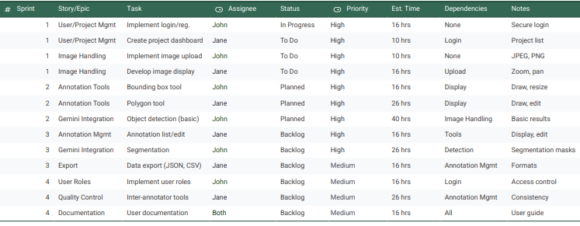

Let's create a comprehensive project plan for ProVisionAI, focusing on key aspects and deliverables.

**1. Project Goals & Objectives:**

* **Primary Goal:** Develop a robust and user-friendly image annotation tool, ProVisionAI, leveraging the power of Gemini Vision API to streamline the annotation process.
* **Objectives:**
  + Integrate Gemini Vision API for assisted annotation (object detection, image classification, potentially segmentation).
  + Provide a comprehensive set of manual annotation tools (bounding boxes, polygons, keypoints, lines).
  + Design an intuitive and efficient user interface.
  + Implement robust data management (import/export, project management, version control).
  + Ensure performance and scalability for handling large datasets.
  + (Optional) Implement collaborative features (user roles, real-time collaboration).

**2. Target Audience:**

* Researchers
* Data scientists
* Machine learning engineers
* Computer vision professionals
* Anyone needing to annotate images for AI/ML tasks

**3. Scope & Deliverables:**

* **In Scope:**
  + Core annotation functionality (bounding boxes, polygons, keypoints, lines).
  + Gemini Vision API integration for assisted annotation.
  + User-friendly interface with intuitive controls.
  + Data management (import/export, project management).
  + Thorough testing and documentation.
* **Out of Scope (for initial release):**
  + Advanced collaboration features (real-time collaboration, complex workflows).
  + Support for niche annotation types (e.g., 3D bounding boxes).
  + Highly specialized image formats.

**4. Technology Stack (Example):**

* **Frontend:** React, Angular, or Vue.js
* **Backend:** Python (Flask or Django), Node.js (Express)
* **Database:** PostgreSQL, MongoDB
* **Cloud Platform (Optional):** AWS, Google Cloud, Azure
* **Gemini Vision API:** Access via client libraries.

**5. Project Team & Roles:**

* Project Manager
* Frontend Developers
* Backend Developers
* QA/Testing Engineers
* UI/UX Designer (if dedicated resource available)

**6. Risk Management:**

* **Risk:** Gemini Vision API performance/limitations. **Mitigation:** Thoroughly test API integration early, have fallback mechanisms.
* **Risk:** UI/UX challenges. **Mitigation:** Invest in UI/UX design and user testing.
* **Risk:** Data management issues. **Mitigation:** Choose a robust database, implement data validation and backups.
* **Risk:** Project delays. **Mitigation:** Agile methodology, regular progress checks, proactive issue resolution.

**7. Communication Plan:**

* Regular team meetings (daily stand-ups, sprint reviews).
* Communication tools (Slack, email).
* Progress reports and updates to stakeholders.

**8. Budget (High-Level Estimate):**

*(This is a placeholder – detailed budgeting requires more information.)*

* Development costs (salaries, cloud resources).
* Gemini Vision API usage costs.
* Testing and QA costs.
* Project management overhead.

**9. Success Metrics:**

* Number of active users.
* User satisfaction (feedback, surveys).
* Performance and stability of the application.
* Adoption of ProVisionAI in target user groups.

## **Phase-5: Project Development**

### **Objective:**

Implement core features of the Provision AI

### **Key Points:**

Let's outline a project development plan for "ProVisionAI: Unleashing the Power of Gemini Vision for Image Annotation." This plan will cover key stages, considerations, and potential features.

**Project Goal:** To develop a robust and efficient image annotation tool leveraging Gemini Vision's capabilities.

**Target Audience:** Researchers, data scientists, machine learning engineers, and anyone needing to annotate images for computer vision tasks.

**Key Features:**

* **Gemini Vision Integration:** Core functionality will revolve around using Gemini's vision API for image analysis and annotation assistance. This could include:
  + **Object Detection:** Pre-labeling objects in images to speed up annotation.
  + **Image Classification:** Suggesting image categories.
  + **Semantic Segmentation:** Potentially providing initial segmentation masks.
  + **Feature Extraction:** Using Gemini's understanding of image content to suggest relevant tags or attributes.
* **Annotation Tools:** A comprehensive set of tools for manual annotation, including:
  + **Bounding Boxes:** Drawing rectangles around objects.
  + **Polygons:** Creating precise shapes for irregular objects.
  + **Keypoints/Landmarks:** Marking specific points on an object.
  + **Lines and Splines:** Annotating boundaries or paths.
  + **Segmentation Masks:** Refining or creating segmentation masks.
* **User Interface (UI):** A user-friendly and intuitive interface is crucial. Consider:
  + **Clear Visualizations:** Easy to see images and annotations.
  + **Keyboard Shortcuts:** For efficient annotation.
  + **Zoom and Pan:** Precise image navigation.
  + **Layer Management:** Organizing annotations.
* **Data Management:**
  + **Import/Export:** Support for common image formats (JPEG, PNG, TIFF, etc.) and annotation formats (PASCAL VOC, COCO JSON, YOLO, etc.).
  + **Project Management:** Organize images and annotations into projects.
  + **Version Control:** Track changes to annotations.
  + **Database Integration:** Consider a database (e.g., PostgreSQL, MongoDB) for storing image metadata and annotations.
* **Collaboration Features (Optional):**
  + **User Roles and Permissions:** Control access to projects and annotations.
  + **Real-time Collaboration:** Multiple users can annotate the same images simultaneously.
  + **Review and Approval Workflow:** Facilitate quality control.
* **Performance and Scalability:**
  + **Efficient Image Loading:** Handle large images and datasets.
  + **Optimized Annotation Tools:** Minimize latency.
  + **Scalable Architecture:** Support a growing number of users and projects.

**Development Stages:**

1. **Requirements Gathering:** Detailed analysis of user needs and features.
2. **Architecture Design:** Planning the system architecture, including frontend, backend, and database.
3. **API Integration:** Integrating with the Gemini Vision API.
4. **UI Development:** Building the user interface.
5. **Backend Development:** Implementing the server-side logic and database interactions.
6. **Testing:** Thorough testing to ensure functionality and performance.
7. **Deployment:** Deploying the application to a server or cloud platform.
8. **Maintenance and Updates:** Ongoing maintenance and adding new features.

**Technology Stack (Example):**

* **Frontend:** React, Angular, or Vue.js
* **Backend:** Python (Flask or Django), Node.js (Express), or other suitable framework.
* **Database:** PostgreSQL, MongoDB, or other appropriate database.
* **Cloud Platform (Optional):** AWS, Google Cloud, Azure.
* **Gemini Vision API:** Access through the appropriate client libraries.

**Challenges and Considerations:**

* **Gemini Vision API Limitations:** Understanding the capabilities and limitations of the API.
* **Cost of Gemini Vision API Usage:** Consider the pricing model.
* **Accuracy of Gemini Vision Predictions:** Handle cases where the API's suggestions are incorrect.
* **User Experience:** Designing an intuitive and efficient user interface.
* **Performance Optimization:** Ensuring the application is responsive and scalable.

**Project Timeline (Example - Adapt to your specific needs):**

* **Phase 1 (4 weeks):** Requirements gathering, architecture design, API integration.
* **Phase 2 (8 weeks):** UI and backend development.
* **Phase 3 (4 weeks):** Testing and deployment.

This detailed plan provides a solid foundation for developing ProVisionAI. Remember to iterate and adapt the plan as the project progresses and you gain more insights. Good luck!

## **Phase-6: Functional & Performance Testing**

### **Objective:**

Ensure that the Provision AI works as expected.

