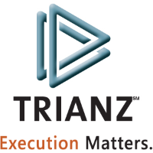

TALENTO FAQs

Statement of Confidentiality

The information in this document is confidential to Trianz. It shall not be disclosed, duplicated, or used for any purpose other than that stated here, in whole or in part, without the written consent of Trianz.

Document Classification

Public | Internal Use only | Confidential

- Do not forward or copy data in part or full without explicit permission of ISWG. Data access is limited to ___________ (URL of list)

Use Strong authentication/Lock in a Drawer. Log access in a register

X Retention period is __1__ Year(s)

Document Reference

<Reference info>.

Document History
Version | Date | Details

Table of Contents

Glossary……………………………………………………4

Introduction………………………………………………4

PM Role…………………………………………………4-7

OM Role…………………………………………………8-12

DH Role…………………………………………………..13

RL Role…………………………………………………….14

Admin……………………………………………………..15-17

Employee…………………………………………………17

Glossary

Word/Abbreviation | Description
PM | Project Manager
OM | Operations Manager
DH | Delivery Head
RL | Recruitment Lead

Introduction
● Talento application is used to allocate resources into projects by raising a talentrequisition. Resources can be fulfilled by internal or external resources.
Project Manager:
When PM logins into the application:

1) What are the operations can he/she do in the application?
A) Create tr, update his\her skills.

2) What are the pages he/she can view in the application?
A) TR Home, My Profile, My Approvals.

3) What can he/she do in TR Home?
A) He/she can Create tr, search the tr by tr# using search button, view the trs created, filter the trs based on my request dropdown, export the data to excel using export to excel button.

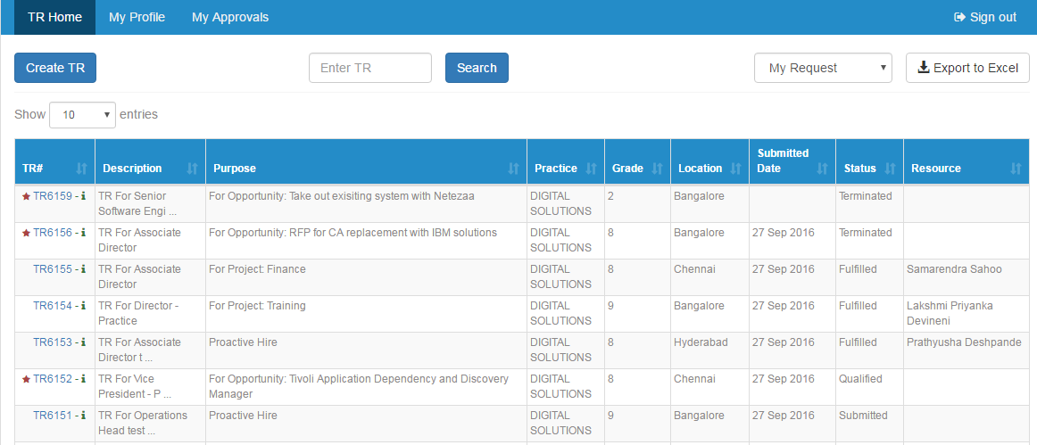

4) How can he/she create TR?
A) Following are the steps to create TR:
1. Click on the create tr button and the talent requisition page will be displayed.
2. Project info, timeline info, skillset and job description are the sections to be filled.
3. After filling all the mandatory fields, then you can either save the tr for future use or submit the tr or clear the information that is filled.

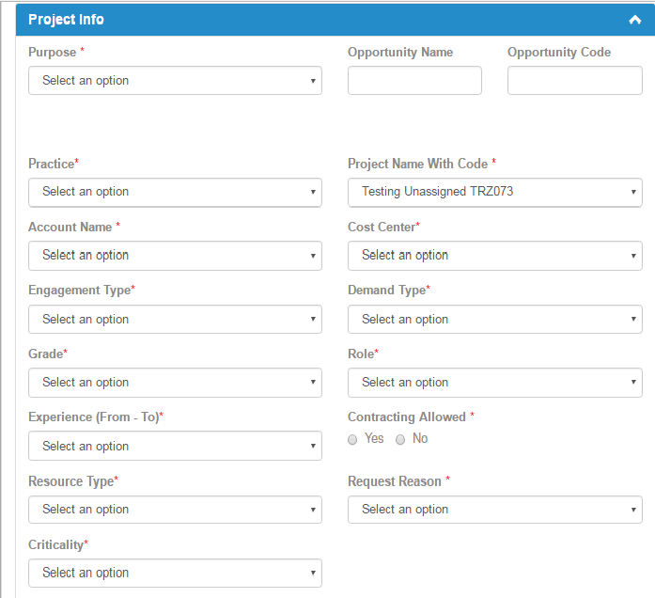

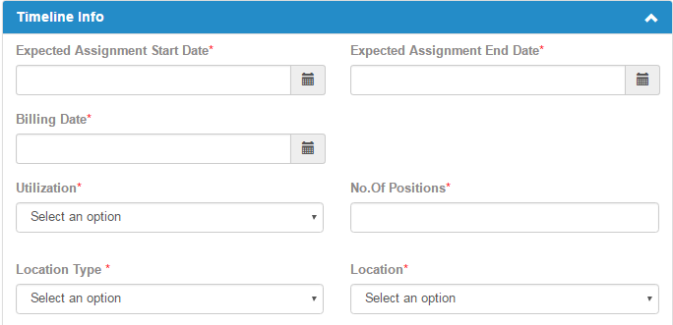
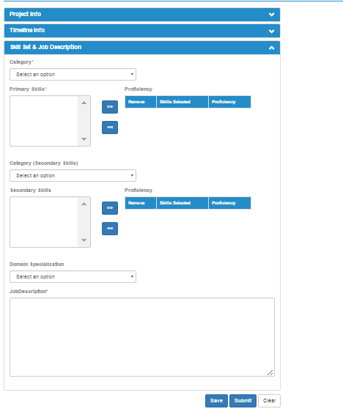

5) What can he/she do in My Profile page?
A) He/she can upload the resume, download the profile template, view the Assignments and skills, and update the skills.
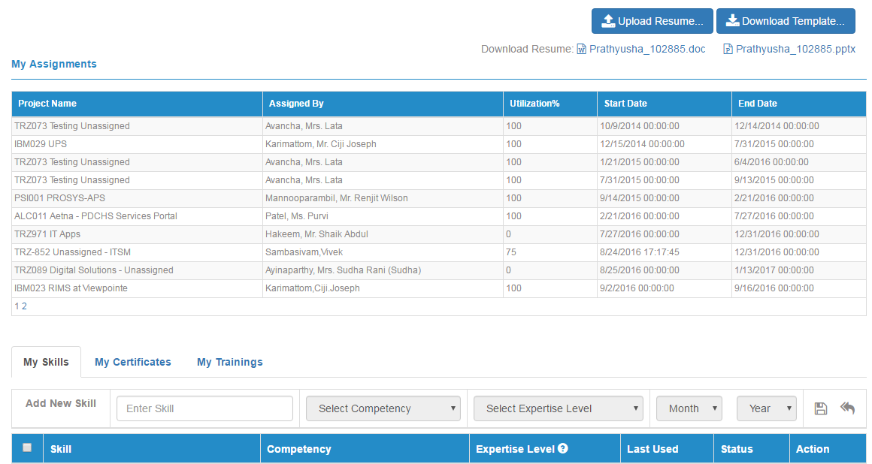

6) How can he/she update the self-skills in My Skills tab?
A) Click on My Profile tab>>Navigate to the bottom of the screen >>My Skills>>select the skill>>change the expertise level from the dropdown>>click on save>>submit the skill.

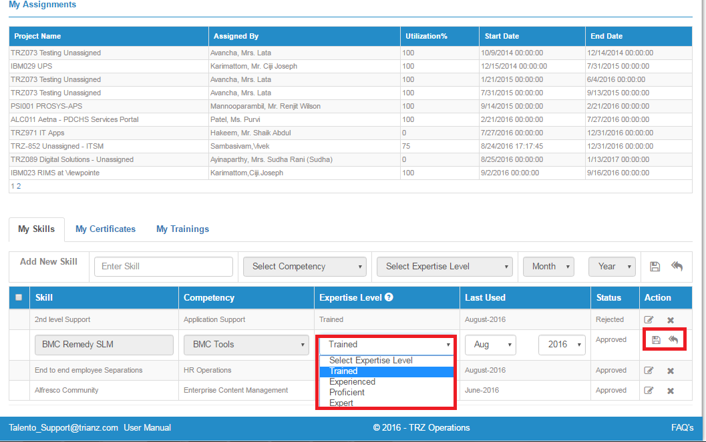
Operation Manager:

When OM Logins into the application:
- What are the operations he/she can do?
- He/she can create tr, qualify the tr, propose the resources to the tr, convert the tr to external, assign project to the resources who are on bench.

- What are the pages he/she can view in the application?
- TR Home, My Profile, My Approvals, Reports, Assignment and External Fulfillment.

- What can he/she do in TR Home?
- He/she can create tr, search the tr by tr# using search button, view the trs created, filter the trs based on practice and my request dropdown, export the data to excel using export to excel button.

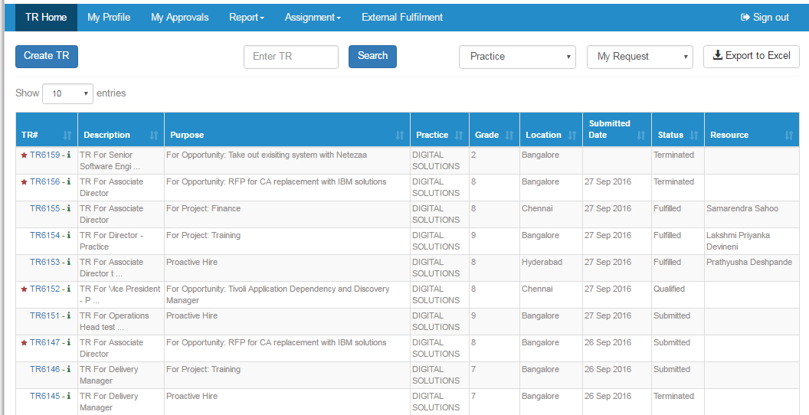

4) How can he/she Create TR?
A) 1. Click on the create tr button and the talent requisition page will be displayed.
2. Project info, timeline info, skillset and job description are the sections to be filled.
3. After filling all the mandatory fields, then you can either save the TR for future use or submit the tr or clear the information that is filled.

5) What can he/she do in My Profile page?
A) He/she can upload the resume, download the profile template, view the assignments and Skills, and update the skills.

6) How can he/she update the self-skills in My Skills tab?
A) Click on My Profile tab>>navigate to the bottom of the screen >>My Skills>>select the skill>>change the expertise level from the dropdown>>click on save>>submit the skill.

7) What is the use of Report tab?
A) In Report tab there are several reports like Employee Master Report, Bench Resources Report, Employee Skills Report, ITS Resource Dashboard.

8) What can he/she view in Employee Master Report?
A) All the employee details are displayed. Filter can be done based on the Status (Billed, Bench, and Shadow), Employee ID, Name, Practice, Grade and he/she can export the data to excel page.
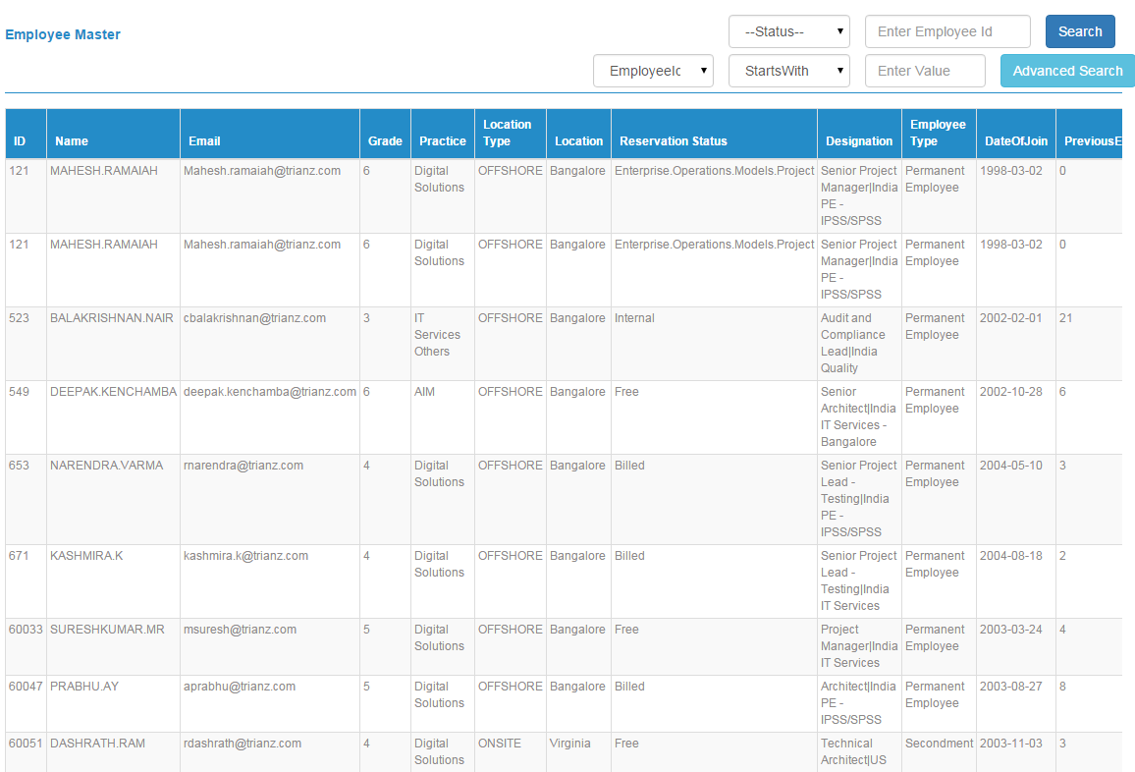

9) What does Bench resource report contain?
A) All the bench employee details are displayed and based on the location type ( Offshore, Onsite) and employee id we can filter the employee details.

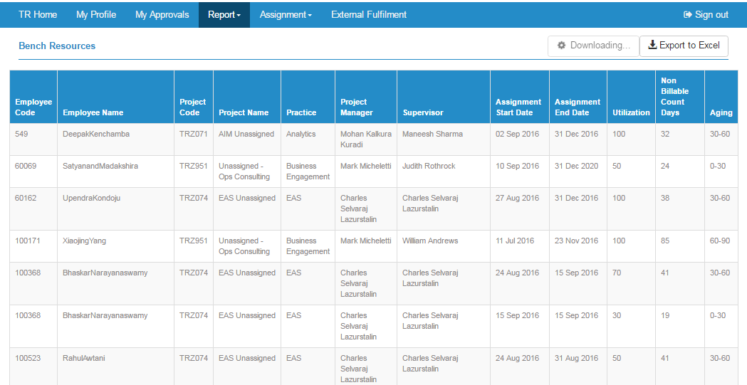

10) What does Employee Skills Report contain?
A) All the skills of the employee are displayed by clicking on + symbol in emp id column. We can filter the employee by search field.
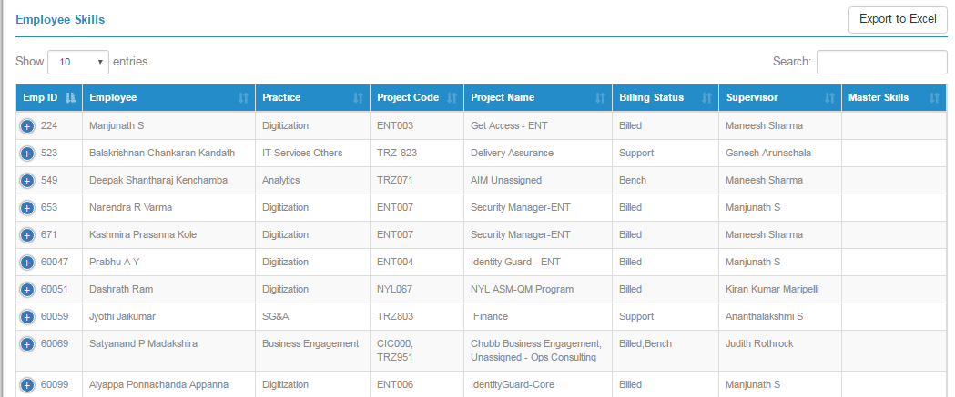

11) What does TR report contain?
A) All the details of the employee are displayed. The export to excel button is displayed.
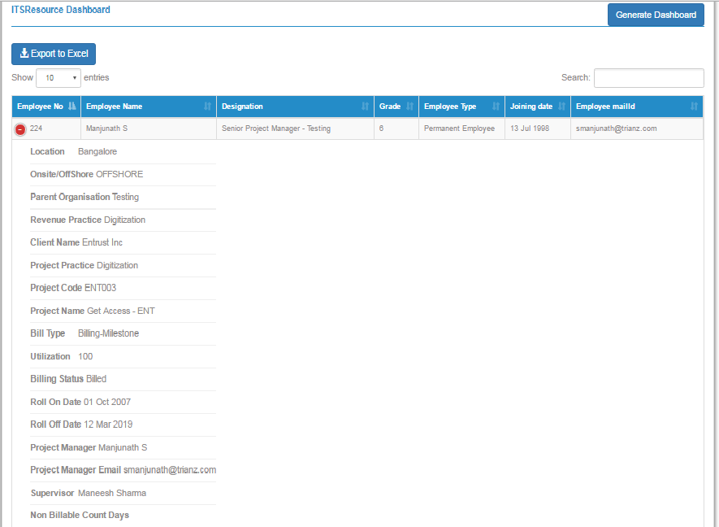

12) What does the Assignment tab contain?
A) Based on the project we can get the details of the employees who are assigned to that project, the employees who are on bench. The various designations of the employee.

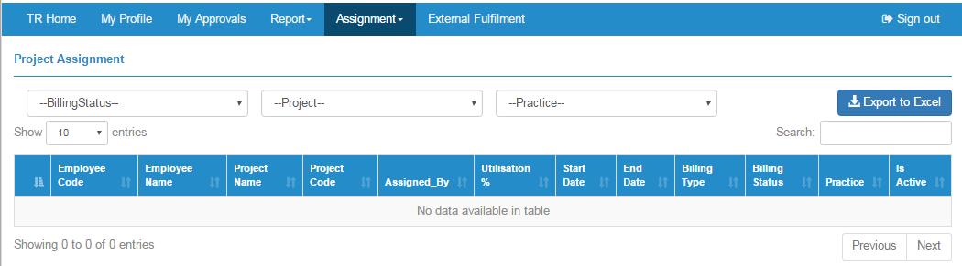

13) What is External Fulfillment?
A) All the external trs and proposed candidates for those trs are displayed.
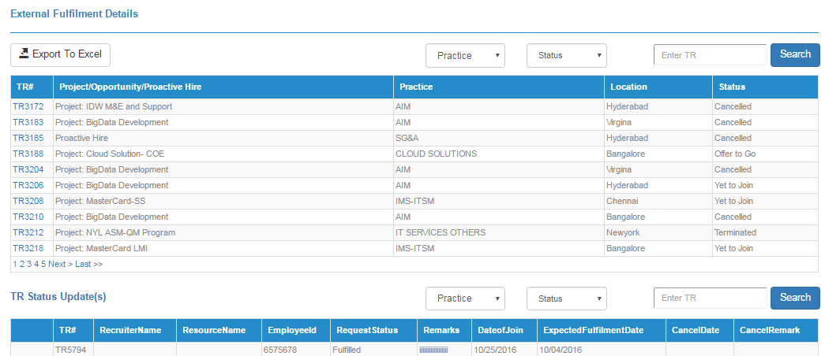

14) What happens when we click on the TR# hyperlink?
A) When we click on the tr# the details of the tr are displayed i.e. account, assignment, request details and the status of the tr, history are displayed. Additionally convert to internal and update tr status buttons will be displayed.

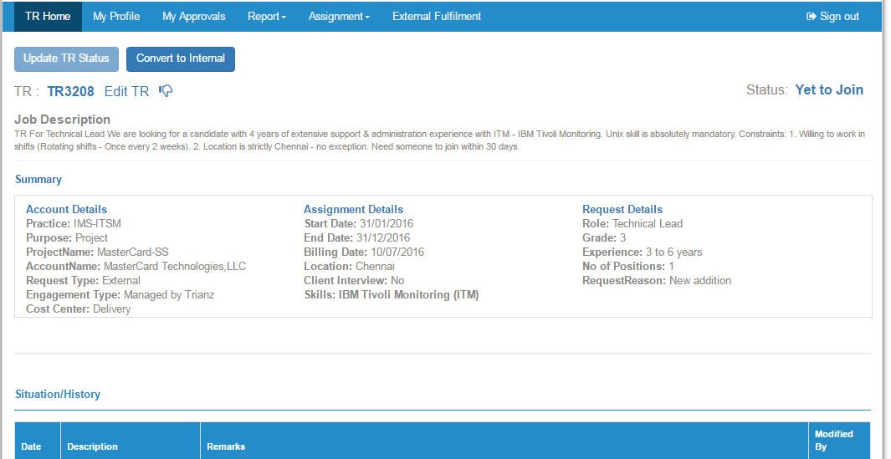

Delivery Head:
When DH logins into the application:
1) What can he/she do?
A) He/she can create tr and view all the trs created, can approve/reject/review the internal/external trs or skills of the employees, view the reports and dashboard.
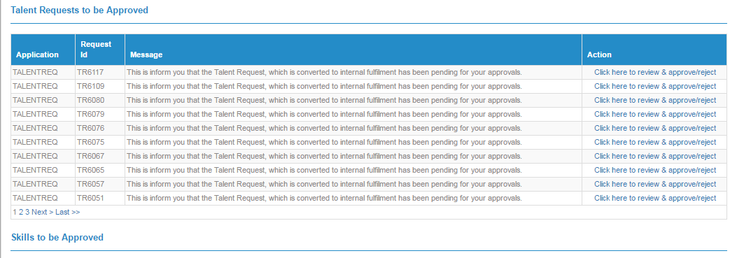

2) What can he/she view in the application?
A) TR Home, My Profile, My Approvals, Report, Dashboard.

3) What can he/she do in TR Home?
A) He/she can create tr, search the tr by tr# using search button, view the trs created, filter the trs based on my request dropdown, export the data to excel using export to excel button.

4) What does Dashboard tab contain?
A) The graphical representation of the resources (Resource Dashboard) and Demand Dashboard.
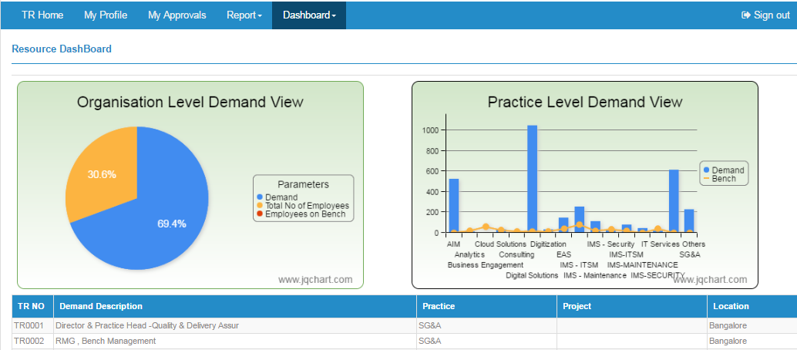

Recruitment Lead:
When RL logins into the application
1) What can he/she view in the application?
A) TR Home, My Approvals, External Fulfillment. 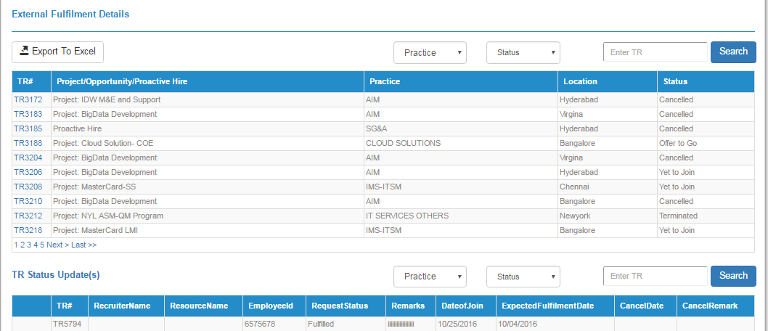

2) What happens when we click on the tr# hyperlink?
A) When we click on the tr# the details of the tr are displayed i.e. account, assignment, request details and the status of the tr, history are displayed.

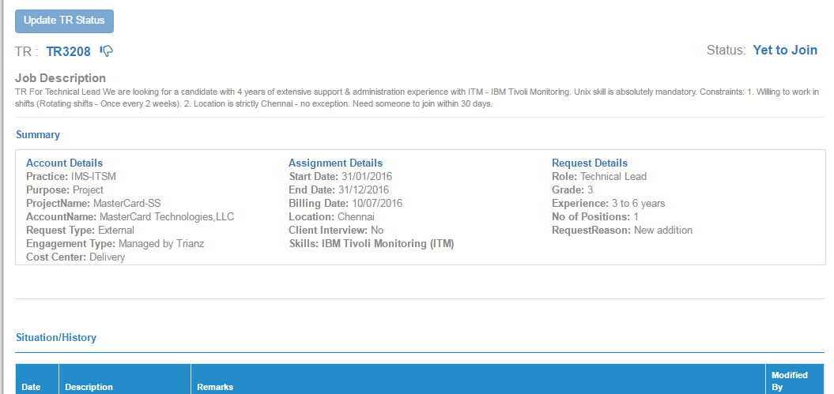

Admin:
When admin logins into the application:

1) What are the operations can he/she do in the application?
A) Create tr and role.

2) What are the pages can he/she view in the application?
A) TR Home, My Profile, My approvals, Report, Admin, Dashboard.

3) What can he/she do in tr home?
A) He/she can create tr and view the entire details of the trs.

4) What does admin tab contain?
A) Role configuration, master lookup configuration, designation master and manager configuration.

5) What is the functionality of Role Configuration?
A) Only admin has access to create, edit, and delete the role of employee.

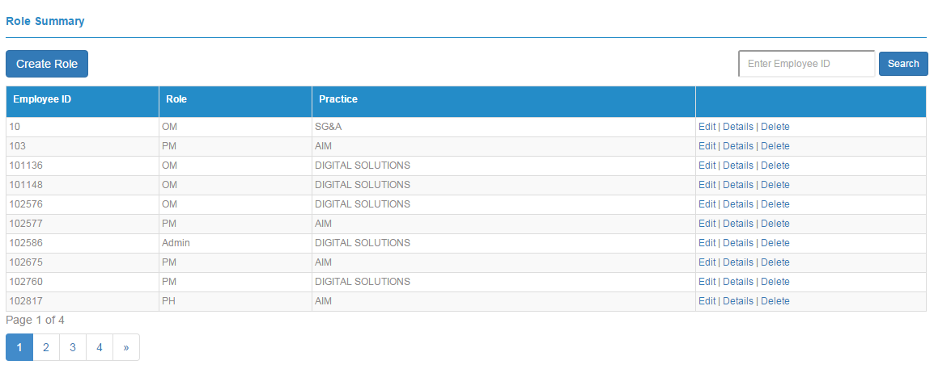

6) What is the functionality of Master Lookup Configuration?
A) We can create new master lookup and search the master lookup details based on the lookup type.
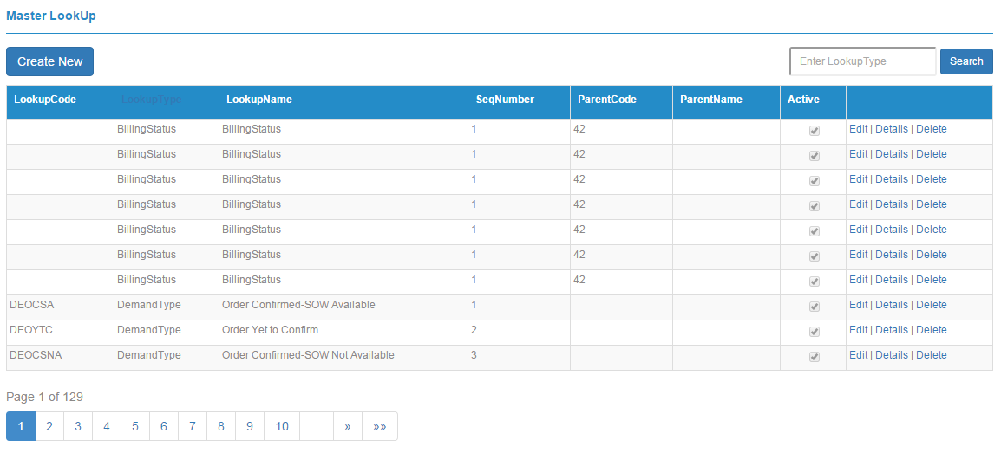

7) What is the functionality of Designation Master?
A) We can create designation and can search the designation details based on grade and designation name.

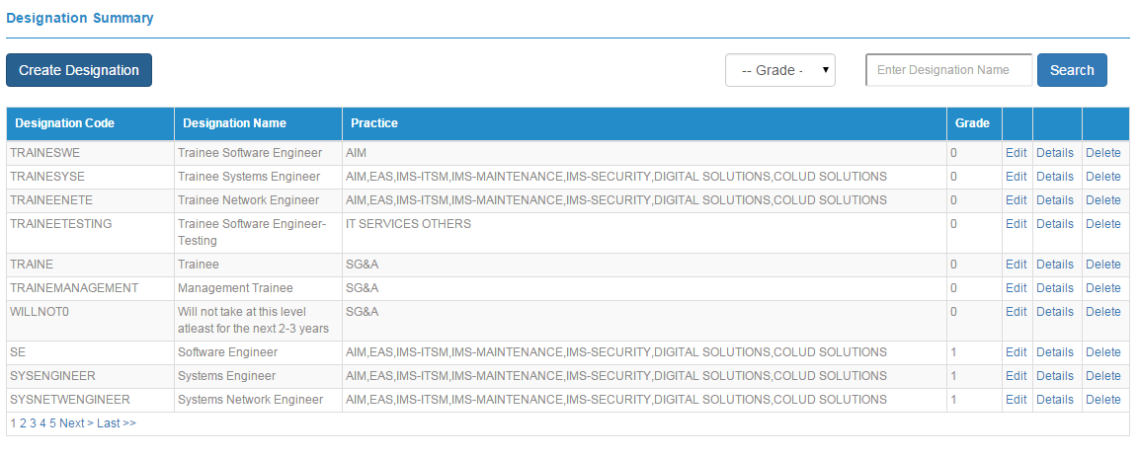

8) What is the functionality of Manager Configuration?
A) We can edit and view the project manager details.
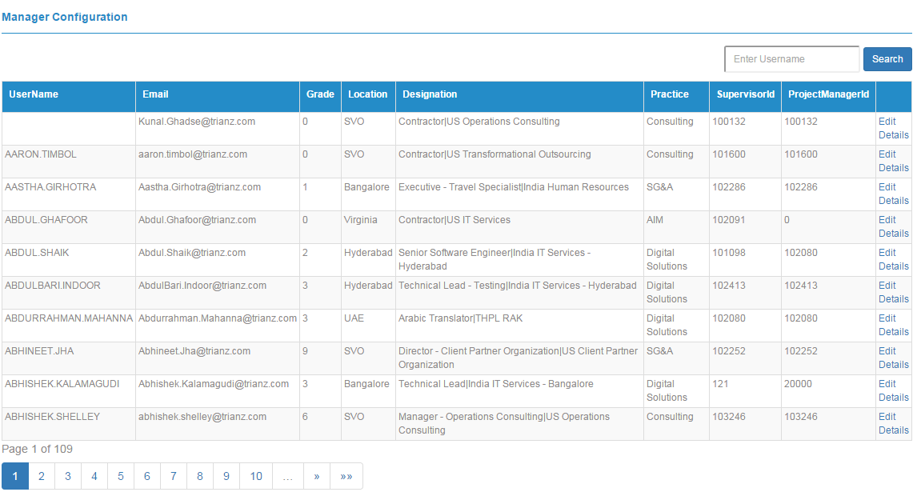

Employee:

When an Employee Logins to the Application

1) What can he/she do in the application?
A) He/she can View profile, upload resume and update skills.

