DSI236 Practical Assignment Report
MSUAS Student Services Information Portal
Responsive and interactive multimedia web application prototype | October 2026
Group of five — insert all members' names, student numbers and assigned contributions before submission.

1. Case Study Analysis
Students may consult different channels to find academic, health, finance, accommodation, career and campus-life information. This portal consolidates selected public service summaries in one responsive interface and points to official pages for verification.

2. Problem Identification
Students need a simple, mobile-friendly way to discover services and understand next steps without navigating many disconnected sources. Target users include current and prospective students, new students, student representatives and visitors.

3. Purpose and Objectives
Provide a single portal that summarises key services, supports search and category filters, reveals details, prepares email enquiries and demonstrates HTML5, CSS3, JavaScript, multimedia, p5.js and accessibility.

4. Planning and Features
Responsive navigation, hero banner, quick-access cards, seven service summaries, search, category filtering, expandable details, p5.js network, directory search, official contact information and validated enquiry form. Sitemap, user flow and wireframe are included.

5. Technologies
HTML5 semantic landmarks and forms; CSS3 custom properties, Grid, Flexbox and media queries; JavaScript event handling, filtering, DOM manipulation and validation; p5.js interactive network; generated campus banner; Markdown and SVG documentation assets.

6. Interface Design
Deep teal/navy, muted teal, gold and off-white create a professional student-focused palette. Consistent cards, spacing, tags and headings establish hierarchy. Desktop uses two columns; tablet/mobile layouts stack and use a collapsible menu.

7. HTML5 Development
The page uses header, nav, main, section, article, aside, form and footer landmarks. Inputs have explicit labels; heading hierarchy is structured; a skip link supports keyboard users.

8. CSS3 and Responsive Design
CSS Grid and Flexbox organise content. Breakpoints at 1100px, 850px and 560px adapt layouts. Focus-visible styles and reduced-motion support are included.

9. JavaScript Interactivity
The app supports search, category filtering, result counts, no-results feedback, detail toggles, directory navigation, sidebar filtering, mobile menu and form validation. A valid form creates a mailto draft; it does not send or store messages.

10. Multimedia and p5.js
A custom campus banner and interactive p5.js network add multimedia. Nodes cover Library, e-Learning, Health, Student Life, Admissions and Fees. The network is illustrative, not a geographic map. p5.js is loaded from a CDN.

11. Official Information Sources
Health: https://msuas.ac.zw/health-services/ ; official site: https://web.msuas.ac.zw/ ; Admissions: https://web.msuas.ac.zw/admissions/ ; Bursar: https://web.msuas.ac.zw/bursars-department/ ; Fees: https://web.msuas.ac.zw/fees/ ; student-affairs documents: https://web.msuas.ac.zw/downloads/ ; e-Learning: https://elearning.msuas.ac.zw/ ; Library: https://library.msuas.ac.zw/our-services/ ; borrowing: https://library.msuas.ac.zw/services/borrow-reserve-renew/ ; library spaces: https://library.msuas.ac.zw/spaces-rooms/.

12. Accuracy and Scope
Independent academic prototype, not an official MSUAS system. Information may change; verify hours, contacts, fees and policies on official pages. Separate residence-allocation rules and counselling-office contacts were not verified. No login, payments, student records or backend email sending.

13. Usability, Accessibility and Testing
A skip link, semantic landmarks, form labels, visible focus, status announcements, keyboard-operable controls and reduced-motion styling are included. Run the manual checklist in the Markdown report and record observed results. Test at 375px, 768px and 1366px in at least two browsers.

14. Demonstration Script
Explain the problem; show desktop design; search and filter; expand details; open official sources; use directory; select p5.js nodes; test form validation; resize to mobile; discuss limitations and test outcomes.

15. Development Process
Case Study Analysis → Problem Identification → Planning → Interface Design → HTML5 Development → CSS3/Responsive Design → JavaScript Interactivity → Multimedia/p5.js Integration → Testing → Documentation → Final Demonstration.

16. Suggested Group-of-Five Allocation
Member 1: analysis/report; Member 2: HTML; Member 3: CSS/responsive UI; Member 4: JavaScript; Member 5: p5.js/multimedia/QA. All members should understand the full application.

Manual Test Checklist
Test | Steps | Expected result | Actual result
Initial load | Open index.html / local server | Styles, cards and assets appear | Pending group verification
Search/filter | Search library/clinic; select Academic | Matching cards display | Pending group verification
Expand details | Activate detail buttons | Details and aria-expanded update | Pending group verification
Form validation | Submit empty, invalid and valid data | Invalid blocked; valid opens email draft | Pending group verification
Responsive | Test 375px, 768px and 1366px | No overflow; layout adapts | Pending group verification
Keyboard | Tab through controls | Focus visible and skip link works | Pending group verification
p5.js | Select each node | Status description changes | Pending group verification

Appendix: Design Previews
Static design previews are included for planning and report use. Capture fresh browser screenshots after running and testing the working application.
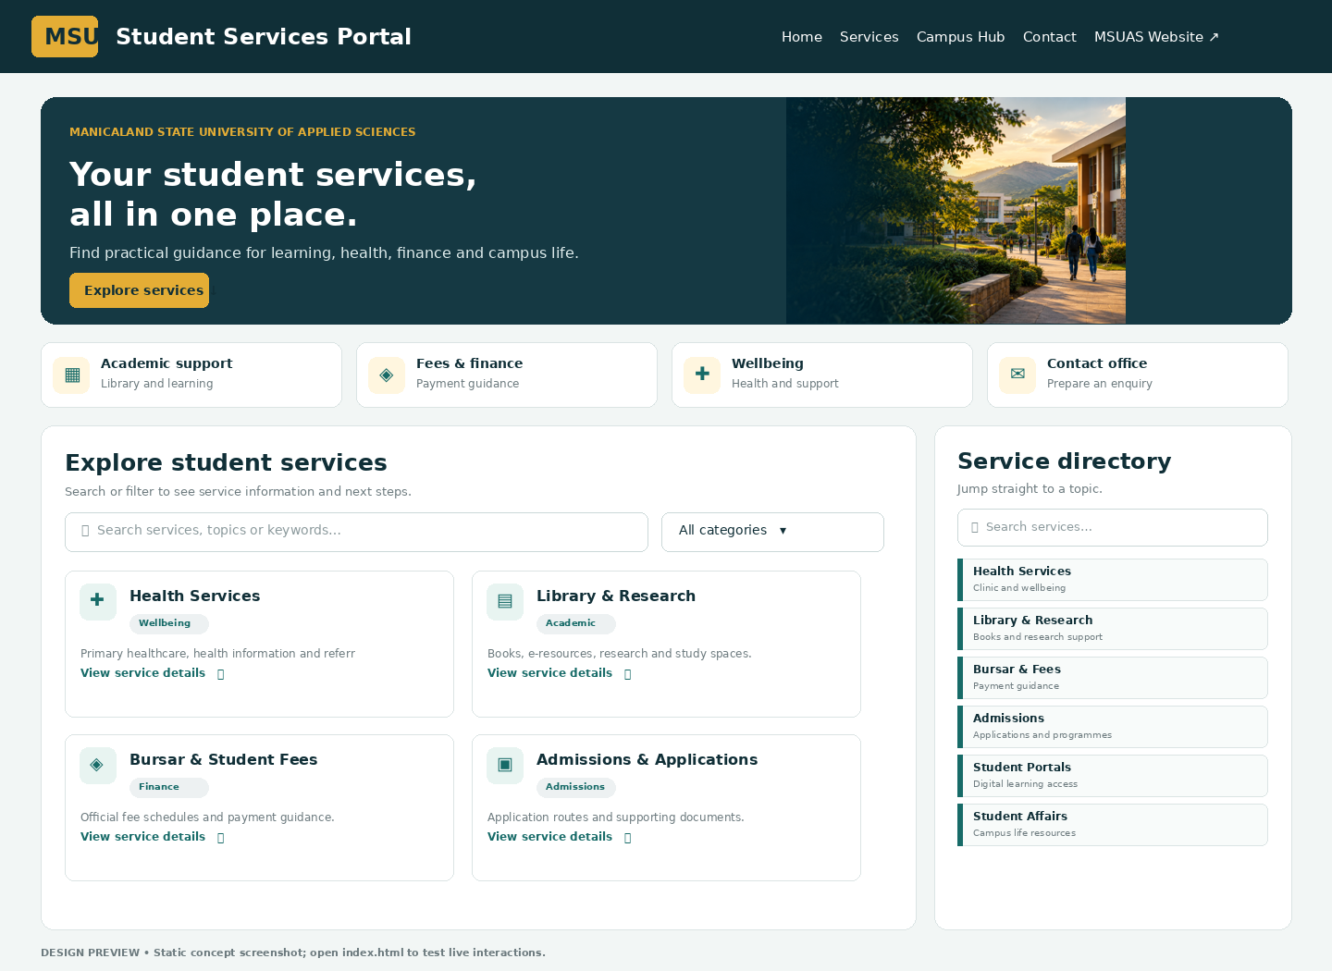
Figure 1. Homepage design preview (static concept, not a live browser capture).
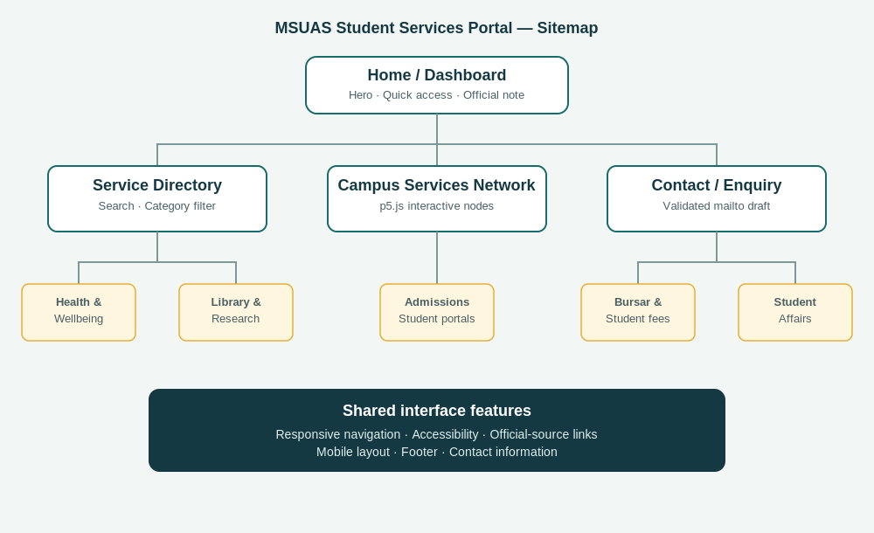
Figure 2. Application sitemap.

