
College of Business,
Technology and
Engineering

Sheffield Hallam University
College of Business, Technology and Engineering (BTE)
MSc Computing Research Project Report
Developing and Evaluating a Machine Learning-Based Ensemble System for Predicting Employee Attrition
Student Name | Linga Swamy Muntha
Student ID | 35050628
Supervisor | Popoola Jumoke
Course | MSC Data analytics with Banking and Finance .
Module | Computing Research Project
Date | 14/08/2026
Word count, main body | 2,748

STATEMENT 2: This dissertation IS CONFIDENTIAL and circulation should be restricted to those involved in its assessment only.
Acknowledgements
I would like to express my gratitude to my supervisor and teaching team for their guidance and supervision throughout the project. I also thank the open-source software communities and the Kaggle contributor for making the IBM Attrition Dataset available for analysis.

Abstract
In this project, using a public IBM Attrition Dataset, it was determined whether the use of ensemble machine learning also enhances the prediction of employee attrition. There were 1,470 employee records and 13 variables provided in the file ibm.csv.The file ibm.csv provided 1,470 employee records and 13 variables; there were no missing values or duplicate records. The number of employees who left the job (attrition) was 237 (16.12%) which caused a class imbalance. Logistic Regression, Decision Tree, Random Forest, Support Vector Machine, XGBoost, Soft Voting and Stacking were modeled in a quantitative comparative pipeline. All numerical variables were z-scored, categorical variables were one-hot encoded and only SMOTE was used within the training phase to minimise leakage risk. Accuracy, precision, recall, F1-score, ROC-AUC and confusion matrices were used to evaluate the models. Random Forest and XGBoost performed best in terms of accuracy (83.33%), while Logistic Regression had the best attrition recall (55.32%), F1-score (0.3444) and hold-out ROC-AUC (0.6751). Compared to Soft Voting, the ROC-AUC was similar (0.6736) and recall was significantly lower. Age, monthly income, number of companies worked, job satisfaction, environmental satisfaction, marital status and years at company were identified as influential model features by SHAP analysis. The results demonstrated that increasing the complexity of the model did not necessarily result in improved minority class detection. The final product will be a reproducible analytical pipeline that will be useful in supporting, not automating, HR decision making.

Contents
Introduction 5
1.1 Background and Context 5
1.2 Problem Definition 5
1.3 Research Question 5
1.4 Research Aim 5
1.5 Research Objectives 5
1.6 Benefits, Deliverable and Rationale 6
Literature Review 7
2.1 Review Strategy and Selection 7
2.2 Feature Selection and Data Preparation 7
2.3 Comparative Machine Learning 7
2.4 Ensemble Learning 8
2.5 Imbalance, Evaluation and Leakage 8
2.6 Explainable AI 8
2.7 Critical Synthesis, Contrasts and Research Gap 9
2.8 How Literature Informed Implementation 10
Project Design 10
3.1 Requirements Engineering 10
3.2 System Architecture 10
3.3 Technology Selection 11
3.4 Selection and Rationale of Data 12
3.5 Ethics, Data Governance and Risk 12
3.6 Testing and Version Control 12
3.7 Research Design and Modelling Procedure 13
4 Results 13
4.1 Implementation Outputs 13
4.2 Descriptive Results 14
4.3 Performance Results 15
4.4 Cross-Validation and Testing Results 17
4.5 Results Against Objectives and Research Question 18
4.6 Explainability and Traceability 18
4.7 Interpretation of Findings 19
5 Project Planning Review 20
6 Conclusion 20
6.1 Achievement of Objectives and Research Question 20
6.2 Contribution and Lessons Learned 20
6.3 Limitations, Recommendations and Future Research 21
7 AI Transparency Statement 21
References 22
Appendices 25
Appendix A: AI Use Declaration 25
Appendix B: Institutional Research Ethics Form 25
Appendix C: Publication Procedure Form 25
Appendix D: Data Gathering Instruments 26
Appendix E: Secondary Data and Software Code 26
E.1 Core Reproduction Code 27
Appendix F: Original Research Project Plan 27
Appendix G: Gantt Chart - Planned vs Actual 28
Appendix H: Literature Review Evidence 29
Appendix I: Risk Artefacts 30
Appendix J: System Test Cases and Testing Evidence 32
Appendix K: Architecture Artefacts 32
Appendix L: GitHub Repository Evidence 33
Appendix M: Additional Supporting Figures 33
Appendix N: Additional Supporting Tables 36

Introduction

1.1 Background and Context
When staff leaves, it can lead to recruitment and training costs, disruption and knowledge loss. Machine learning provides an opportunity to analyze multiple employee traits at once and see if any patterns emerge that relate to turnover. Recent works have been expanded to area of ensemble learning and explainable AI (Al-Ali et al., 2026), and Raza et al. (2022) provided a success demonstration of area machine-learning models to predict attrition and identify influential employee variables.

1.2 Problem Definition
The problem is not just to predict whether the data will contain attrition, but to find a model that is useful for detecting the minority attrition class. The headline accuracy from published studies is not comparable due to the various datasets, pre-processing techniques, and metrics utilized. It is possible for a high accuracy model to be off the mark for most of the employees who have departed. We therefore evaluate several classifiers in the same leakage controlled pipeline to compare the recall, F1-score and ROC AUC with the accuracy.

1.3 Research Question
How can employee attrition in Human Resources be predicted using a machine learning-based ensemble system ?

1.4 Research Aim

To develop a machine learning-based ensemble system for predicting employee attrition and to evaluate its performance against individual base classification algorithms.

1.5 Research Objectives
1. To identify recent trends in the influential features affecting employee attrition in Human Resources, through a review of current literature and data-driven feature analysis.
2. To determine the optimal ensemble strategy (voting or stacking) for combining base classifiers to improve the prediction of employee attrition.
3. To examine the design and implementation of a machine learning-based ensemble system for predicting employee attrition.
4. To assess the predictive performance of the developed ensemble system against individual base classifiers using appropriate evaluation metrics.
5. Assess the performance of all models with accuracy, precision, recall, F1 score, ROC-AUC and confusion matrices.
6. Conduct explainability analysis for responsible HR interpretation.

1.6 Benefits, Deliverable and Rationale
The primary users will be HR analysts and practitioners who require information to support retention. The deliverable is a repeatable pipeline of Python code for data validation, data preprocessing, seven predictive models, evaluation and explainability evidence. It is NOT an automated employment decision maker; it's a decision support tool. The research is warranted since it seeks to answer this question with a consistent design and test if ensemble models are really superior to simpler classifiers for the set of data provided.

Literature Review

2.1 Review Strategy and Selection
The review is structured by theme, which includes feature preparation, comparative machine learning, ensemble learning, imbalance and evaluation, and explainable AI. Employee attrition or turnover was used in combination with other search terms used with machine learning, IBM HR Analytics, feature selection, voting, stacking and SHAP. Only peer-reviewed studies that were clearly related to the research question were included; the webpages, the domains of predictions that were not related to the research question, and the sources that did not provide any detailed methodological information were excluded. Aims, methods, limitations and links between studies are recorded in the supporting literature matrix.

2.2 Feature Selection and Data Preparation
In IBM attrition prediction, Najafi-Zangeneh et al. (2021) demonstrated that feature selection can enhance the F1 performance and model stability. This means that the selection of classifiers is just one component of model quality. The current project thus validates the data prior to the modelling, separates numerical from categorical predictors, and avoids the influence of the hold-out set on fitted transformations. Another consideration is the scope of the dataset: Veglio et al. (2025) leveraged over 205 variables from a multinational organization, while the current public file has a much more limited form of employee profile. The smaller scope enhances the ease of replicability and reduces the generalisability.

2.3 Comparative Machine Learning
Raza et al. (2022) reported excellent employee-attrition performance values for an optimised Extra Trees (ET) classifier and they found some characteristics important like income and age. Govindarajan et al. (2025) applied various classifiers such as Random Forest, SVM, Decision Tree, Gradient Boosting and a hybrid model to the IBM HR dataset and found the highest accuracy with the hybrid model. After conducting a review of 58 turnover studies, Talebi et al. (2025) noted that there were significant differences across algorithms, datasets, and evaluation methods. The results indicate that it would not be wise to simply take one algorithm for granted.

2.4 Ensemble Learning
Alsheref et al. (2022) showed that the use of classifiers in combination helps enhance the automated prediction of attrition. Soft voting of LR, RF and XGBoost with SHAP interpretation was presented by Alyousef et al. (2026) and LightGBM and XGBoost was combined to gain by Qin et al. (2026). But one should not assume that an ensemble will be superior as different metrics will favour different models. For instance, Alyousef et al. (2026) found that a model that had the highest accuracy was not necessarily the strongest in terms of F1-score. The present study is then a test of both Soft Voting and Stacking against five individual baselines.

2.5 Imbalance, Evaluation and Leakage
There are only 1,470 records supplied and 237 of those are attrition, which can mask poor detection of minorities. Precision denotes the accuracy of the attrition alerts, while recall denotes the number of actual attrition cases that are detected, and F1-score is a balance between them. Ranking ability across thresholds (ROC-AUC). All of these measures are therefore reported in the project. To prevent leakage, the leakage is controlled by splitting before fitted preprocessing and StandardScaler, one-hot encoding and SMOTE are placed inside the training pipeline. The hold out test partition is not used, except for final evaluation.

2.6 Explainable AI
Al-Ali et al. (2026) proposed the use of predictive modelling along with SHAP for transparency and fairness in HR analytics. Similarly, Saurabh et al. (2026) employed explainable machine learning to explain the organizational and psychological factors that lead to attrition. Explainability can be useful to check which features contribute to the predictions but does not imply causation. The present project is thus reporting contributions as model associations and calls for human judgment in the creation of employment related action.

2.7 Critical Synthesis, Contrasts and Research Gap
There is a strong body of literature that shows the use of machine learning techniques in the context of attrition, but less in terms of direct comparability. Various feature sets, sampling procedures and validation approaches are employed across various studies. One interesting problem is the choice of classifier, with some papers highlighting the importance of maximum accuracy, and others demonstrating that F1-score or recall may be more important for a different choice. Thus, there is a need for research to have a consistent comparison of individual models and ensemble models with one dataset, one leakage controlled workflow and several metrics, and interpretable output.
Table 1. Research gaps and the response adopted in this project.
Gap | What is missing | Response
G1 | Directly comparable model evaluation | Seven models use one split and pipeline.
G2 | Minority-class assessment beyond accuracy | Recall, F1, ROC-AUC and confusion matrices.
G3 | Evidence that ensembles beat simpler models | Voting and Stacking tested against five baselines.
G4 | Leakage-safe imbalance handling | SMOTE and preprocessing remain inside training.
G5 | Interpretable HR output | SHAP and coefficient interpretation with non-causal caveats.

2.8 How Literature Informed Implementation
The review resulted in four design decisions: keep multiple baseline algorithms; use imbalance handling only during training; use multiple metrics to evaluate; and introduce an explainability phase. These decisions directly relate the literature review to the implementation and evaluation.

Project Design

3.1 Requirements Engineering
The requirements for the project include loading and validating IBM.csv, preparing numerical and categorical features, keeping a stratified holdout set, dealing with class imbalance, fitting five baseline classifiers and two ensembles, exporting evaluation metrics of the previous steps, and creating an interpretable output. Reproducibility, Leakage Control, Auditability and the use of Open-source tools were considered non-functional requirements. The functional and non-functional requirements are detailed in Appendix N.

3.2 System Architecture
The high-level design transitions from dataset validation to pre-processing, stratified splitting, individual models and ensembles, common evaluation and HR decision support. At low level, StandardScaler and one-hot encoding are fitted within a ColumnTransformer, then the SMOTE is used with the training data only and the classifier is trained. Test data is only used after fitting the model.
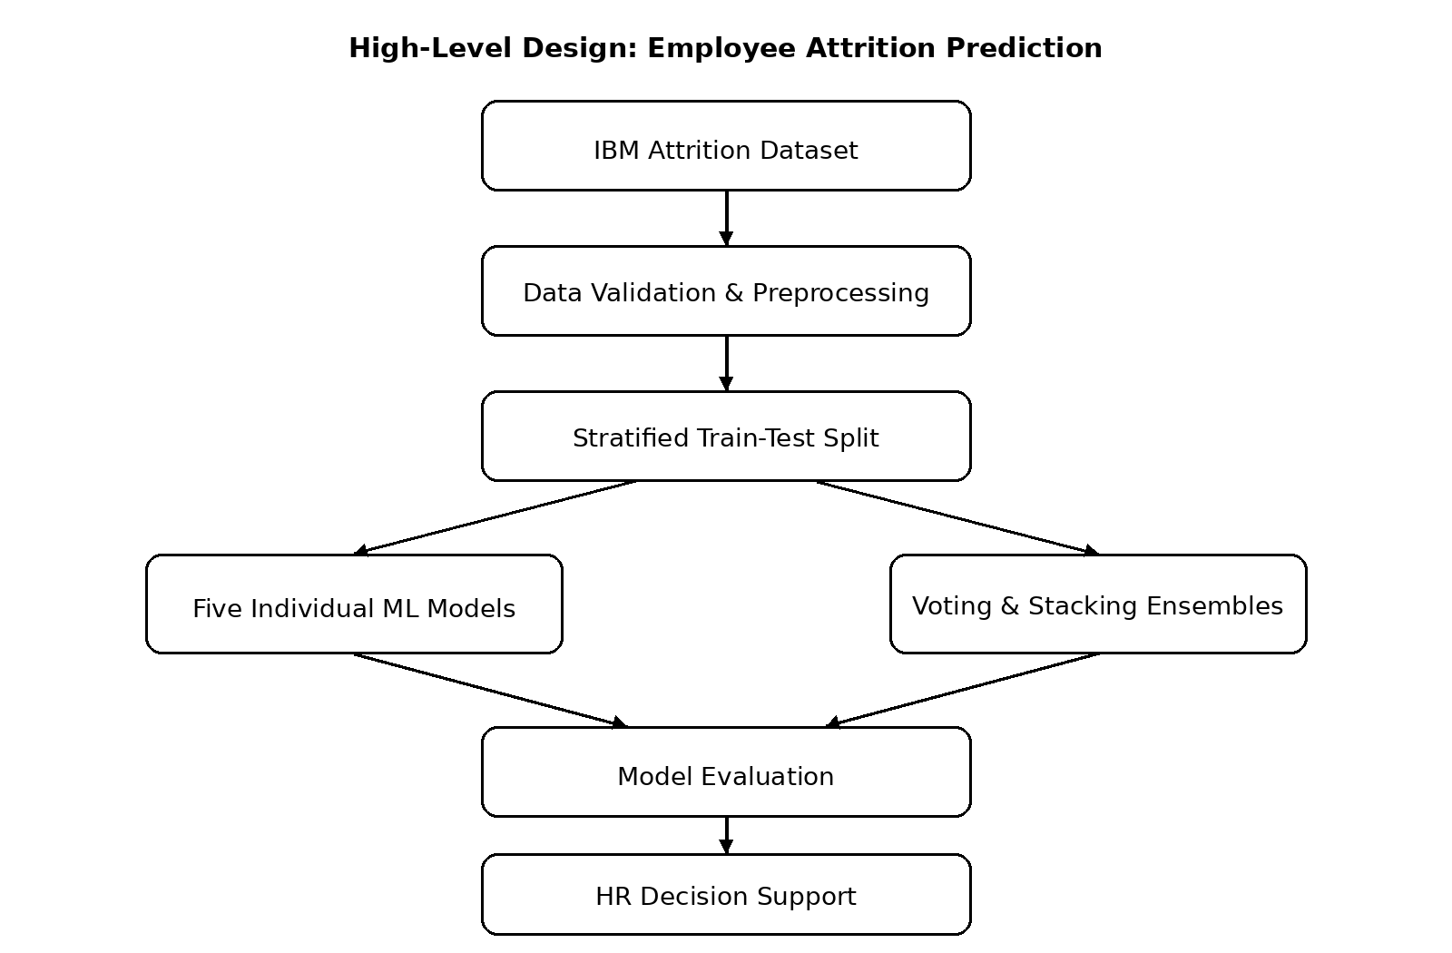
Figure 1. High-level architecture of the employee attrition prediction pipeline.
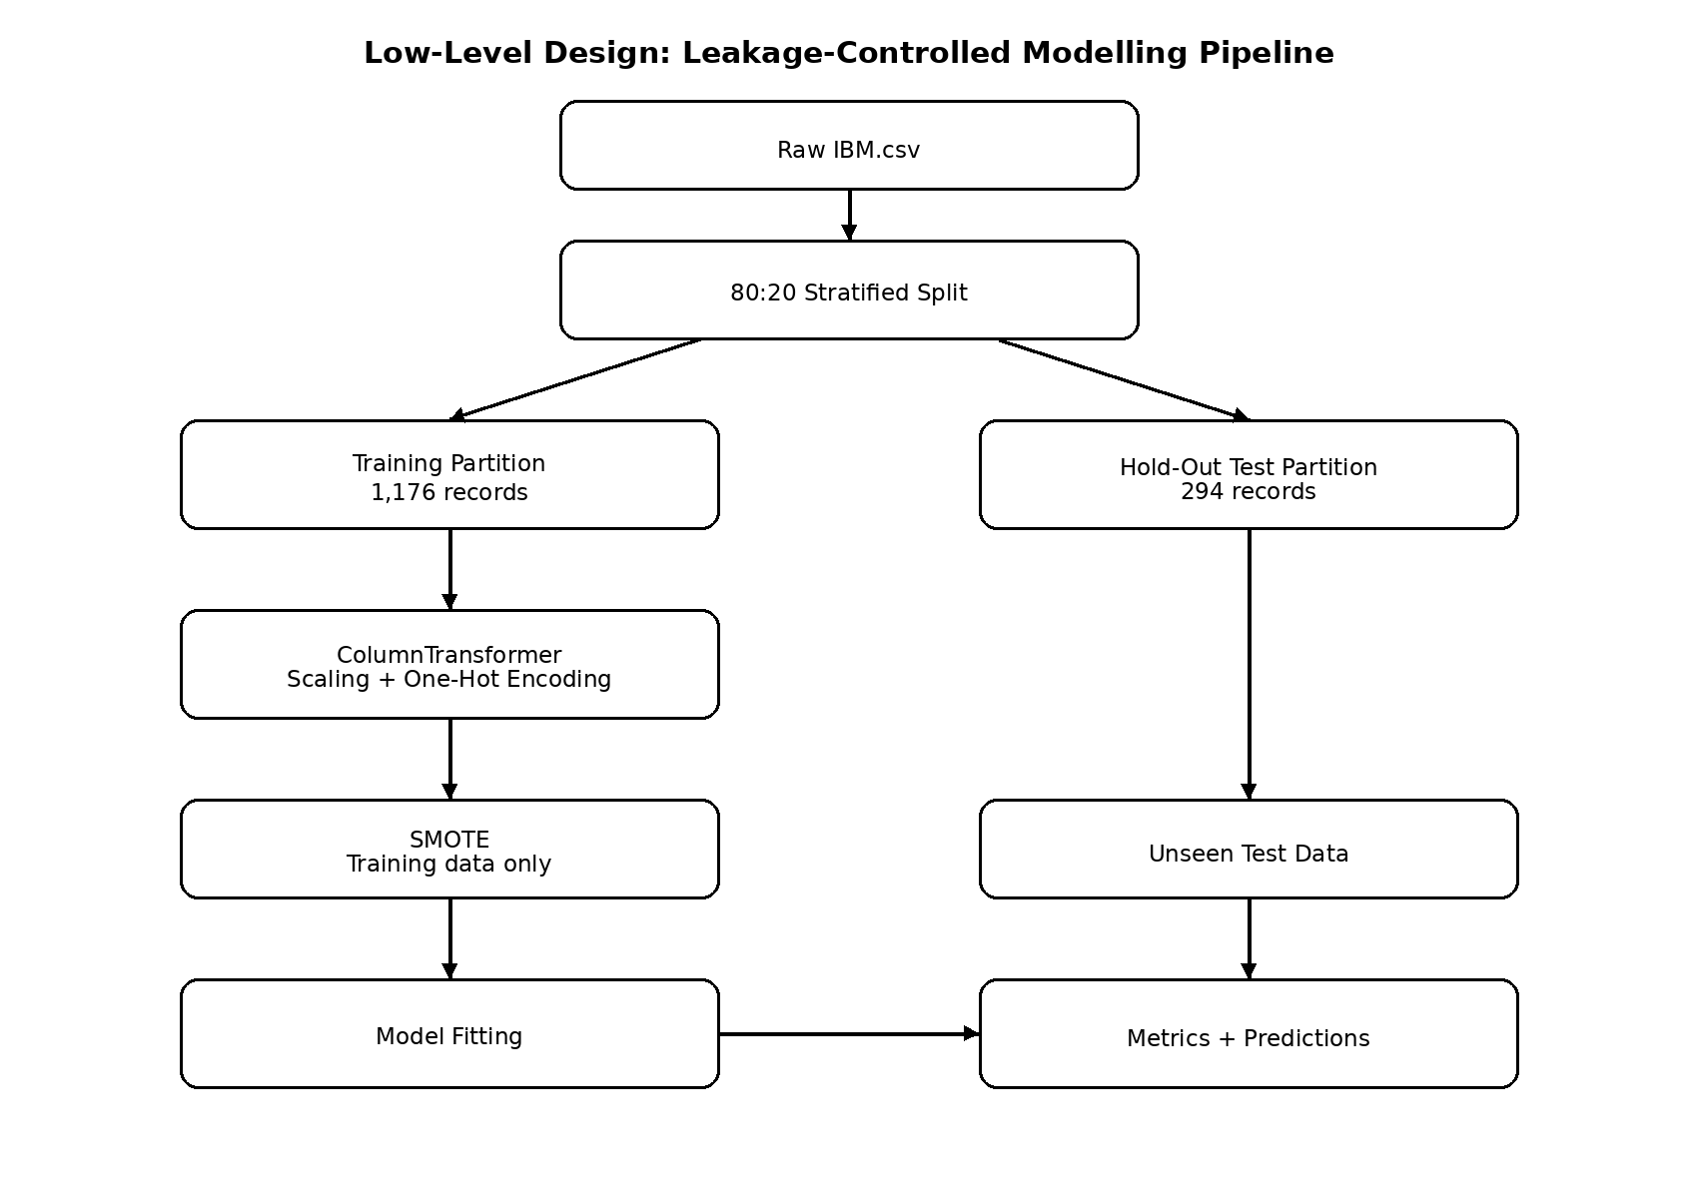
Figure 2. Low-level leakage-controlled modelling design.

3.3 Technology Selection
Data was handled in Python, using pandas and NumPy, preprocessed in Python using scikit-learn, SMOTE was performed using imbalanced-learn, boosted classification is performed using XGBoost, figures are drawn using Matplotlib, and explanation is done using SHAP. All of them can be used in a reproducible applied machine-learning workflow.

3.4 Selection and Rationale of Data
The Kaggle IBM Attrition Dataset was chosen because it directly addresses a binary problem of employee-turnover in the industry. There are 1470 rows and 13 columns in the supplied file, none of which are missing values, and none of which are duplicate values. Attrition occurs in 237 records (16.12%). From the records, 1176 were used for training and 294 were used for testing in an 80:20 split. The details of the datasets and the sources are included in Appendix E.

3.5 Ethics, Data Governance and Risk
The modelling data is secondary and has no direct names, emails, telephone numbers or postal addresses. There are however ethical issues, such as bias, privacy, and over-interpretation and misuse of projected attrition probabilities. The system, therefore, is one of support for the decision making process. Leakage, overfitting, lack of predictive performance and class imbalance were the most critical technical challenges. The signed institutional ethics form should be placed in Appendix B and risk artefacts are attached in Appendix I.

3.6 Testing and Version Control
Tests were performed for shape, missingness, duplicate rows, target encoding, split integrity, prediction count and valid probability output. 10 of the 10 checks were passed. There wasn't any formal user acceptance testing because the deliverable is not an implemented HR application, but an analytical pipeline. The code is provided as a repeatable Python script; the final public URL on GitHub and evidence of commit history should be added in Appendix L.

3.7 Research Design and Modelling Procedure
The study design is positivist, deductive and quantitative experimental. The variables, algorithms and evaluation measures were chosen based on existing research on employee attrition and the empirical stage involved testing these on the provided data. The stratified split was followed by an independent preprocessing of the models. Numerical predictors were standardised and categorical predictors were one-hot encoded to allow models like Logistic Regression and SVM to work on a uniform numerical feature space. Only training data was then used for SMOTE. Fifteen individual classifiers were fitted first to serve as baseline. For the soft voting, the probability estimates from Logistic Regression, Random Forest and XGBoost were combined, and for the stacking, the base classifiers were Logistic Regression, Random Forest and XGBoost and a Logistic Regression meta-classifier was used. The training partition was used five-fold cross validation to test the stability and the untouched hold-out set was used only once for the final comparison. The final interpretation did not simply choose the most accurate model, but also took into account the recall and F1-score, the ROC-AUC and the confusion-matrix behaviour since this is a key element of the research problem to identify the minority attrition class.

4 Results

4.1 Implementation Outputs
The pipeline successfully loaded 1,470 records, created two partitions for training and testing classifiers, namely training stratified partition of 1176 and hold-out partition of 294, and it fitted five individual classifiers and two ensemble classifiers. It produced hold-out metrics, five-fold cross validation results, confusion matrices, ROC curves, comparison figures and explanations using SHAP explanations.

4.2 Descriptive Results
The attrition class accounts for 16.12% of the data. Employees labeled Attrition also were younger in average age (33.61 vs 37.56 years) considered their monthly income (4,787.09 vs 6,832.74), job satisfaction (2.47 vs 2.78) and environmental satisfaction (2.46 vs 2.77) were less satisfied, and their tenure at the company was shorter (5.13 vs 7.37 years). These are descriptive differences, and are not to be understood as causal effects.
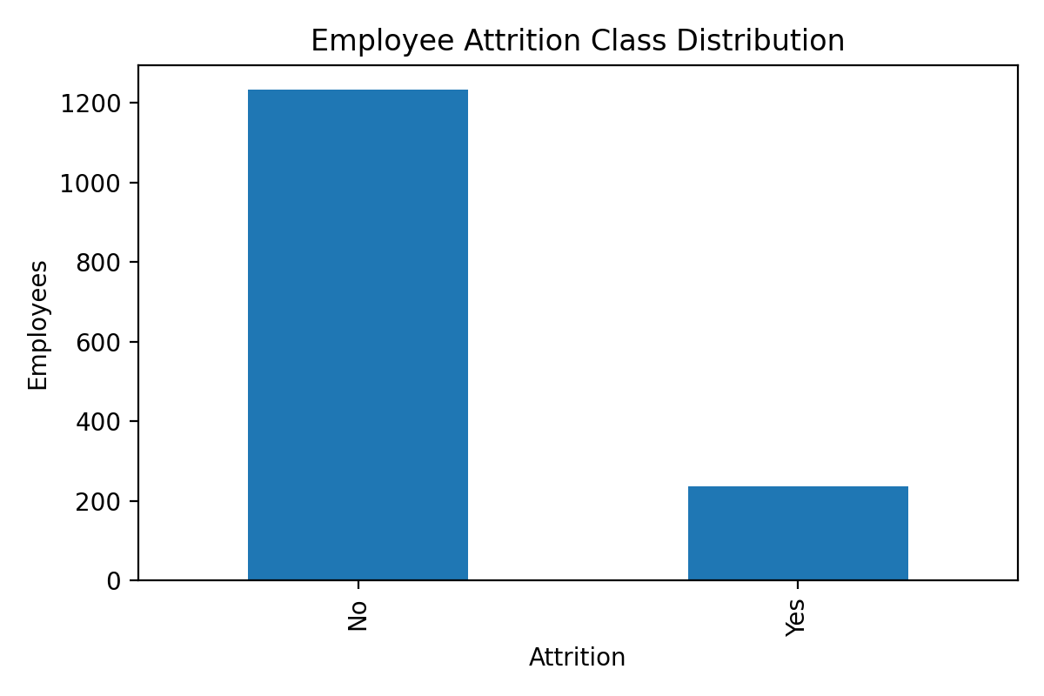
Figure 3. Employee attrition class distribution.

4.3 Performance Results
Random Forest and XGBoost showed the highest accuracy of 0.8333 on the hold-out dataset but had fairly low number of true cases of attrition. Logistic Regression achieved lower accuracy (0.6633) but the highest recall (0.5532), F1-score (0.3444) and ROC-AUC (0.6751). It found 26 out of 47 actual attrition cases. Soft Voting achieved ROC-AUC 0.6736 and F1 0.3056; Stacking achieved ROC-AUC 0.6558 and F1 0.2388. Thus, neither ensemble outperformed Logistic Regression on the set of combined minority-class criteria for final interpretation.
Table 2. Hold-out performance on 294 unseen employee records.
Model | Acc. | Prec. | Recall | F1 | ROC-AUC
Logistic Regression | 0.6633 | 0.2500 | 0.5532 | 0.3444 | 0.6751
Decision Tree | 0.7415 | 0.1778 | 0.1702 | 0.1739 | 0.4798
Random Forest | 0.8333 | 0.4444 | 0.1702 | 0.2462 | 0.6669
SVM | 0.7245 | 0.2344 | 0.3191 | 0.2703 | 0.5999
XGBoost | 0.8333 | 0.4545 | 0.2128 | 0.2899 | 0.6417
Voting Ensemble | 0.8299 | 0.4400 | 0.2340 | 0.3056 | 0.6736
Stacking Ensemble | 0.8265 | 0.4000 | 0.1702 | 0.2388 | 0.6558

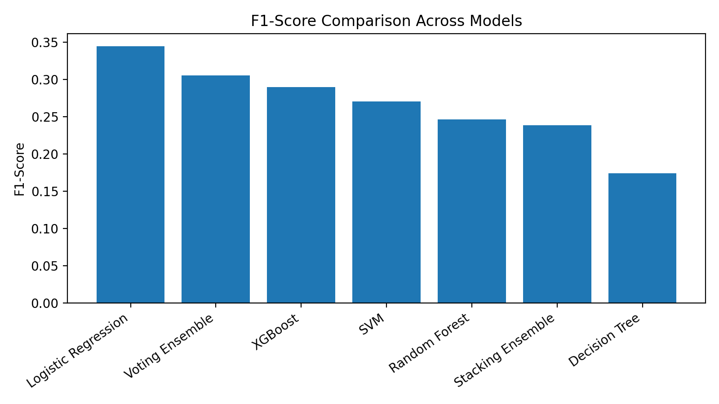
Figure 4. F1-score comparison across models.
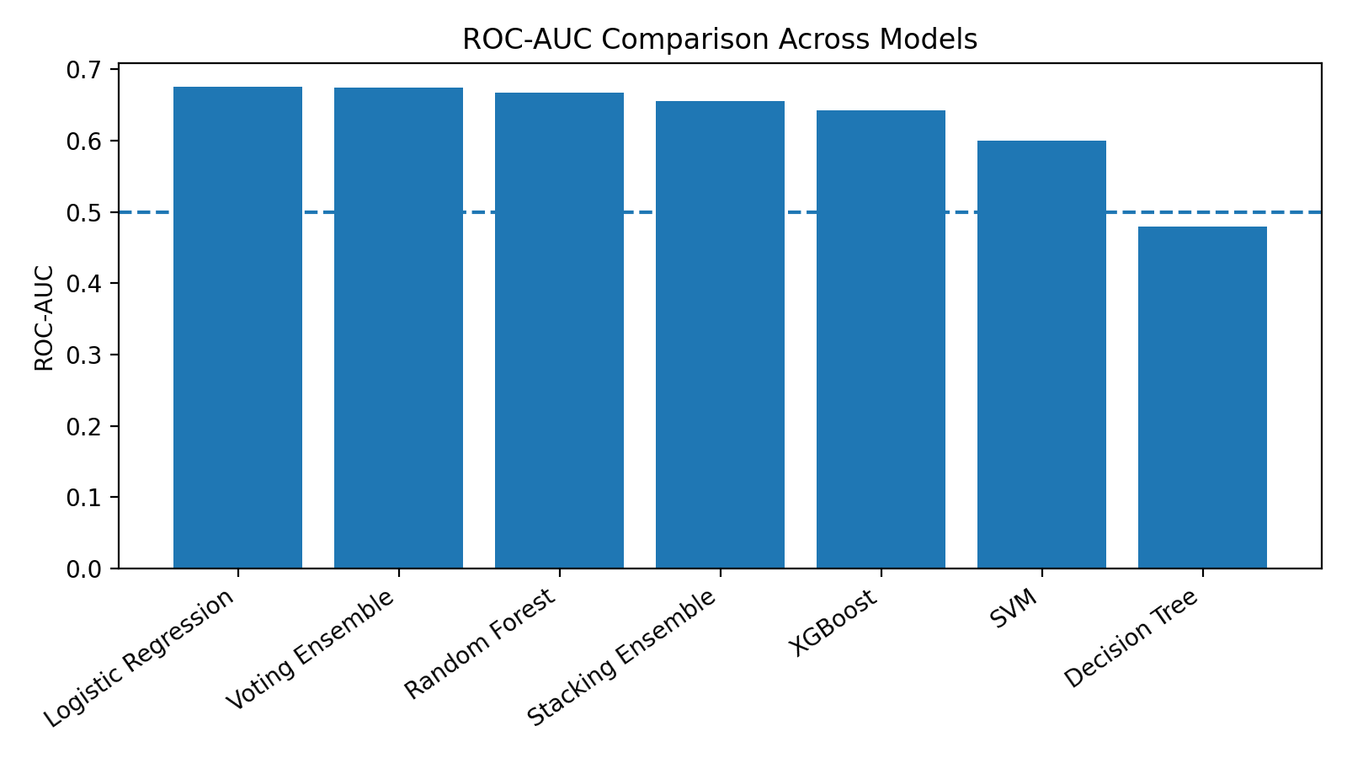
Figure 5. ROC-AUC comparison across models.
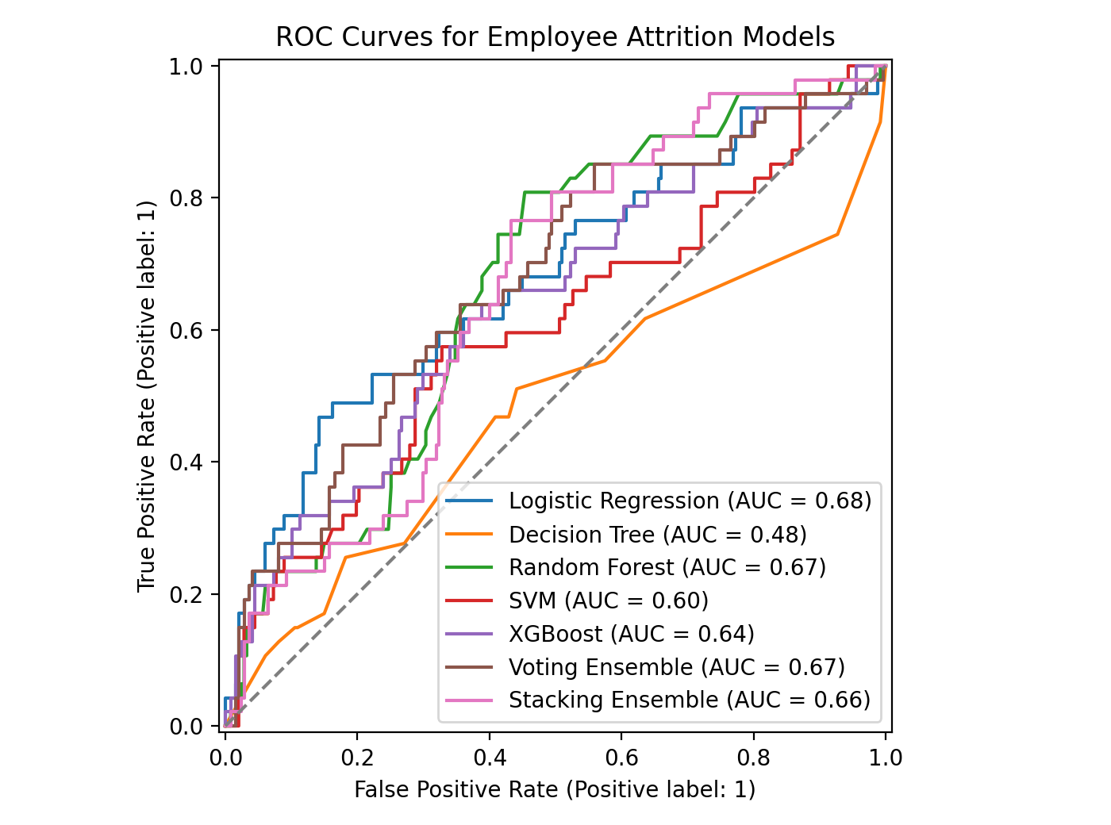
Figure 6. ROC curves for all seven models.
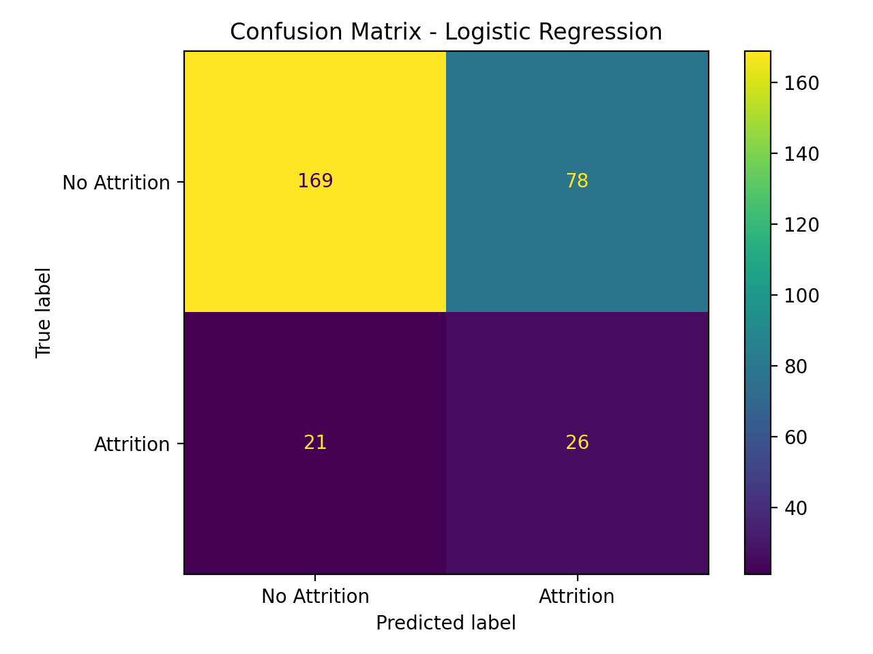
Figure 7. Confusion matrix for Logistic Regression.

4.4 Cross-Validation and Testing Results
The results are summarized below.The results of 4 Cross-Validation and Testing are summarized below. Soft Voting achieved the highest mean ROC-AUC value (0.7477) on the training data with Random Forest (0.7387) and Logistic Regression (0.7352) coming in next. However, Logistic Regression gave the best mean recall score (0.6474). The data split and prediction workflow were deemed good to go as all ten system checks passed. Appendices J and N give full crossvalidation and test tables.

4.5 Results Against Objectives and Research Question
All five objectives were met: literature and dataset exploration, five baseline classifiers, two ensembles, multi-metric evaluation and explainability. It can thus be directly concluded that the research question was answered: ensemble methods were possible and competitive, but did not yield the best balanced classification of attrition on this data set. Logistic Regression was the preferred model due to its highest F1 scores, recall and hold-out ROC-AUC scores despite its lower overall accuracy.

4.6 Explainability and Traceability
Age, monthly income, number of companies worked, job satisfaction, environmental satisfaction, single marital status, years at company, and work-life balance and distance from home emerged as the top model inputs for SHAP analysis. These features are associations in the fitted model, not reasons for the employees to quit. The requirements are followed up with their implementation evidence in Appendix N, and the full confusion-matrix and feature tables are included in this appendix.
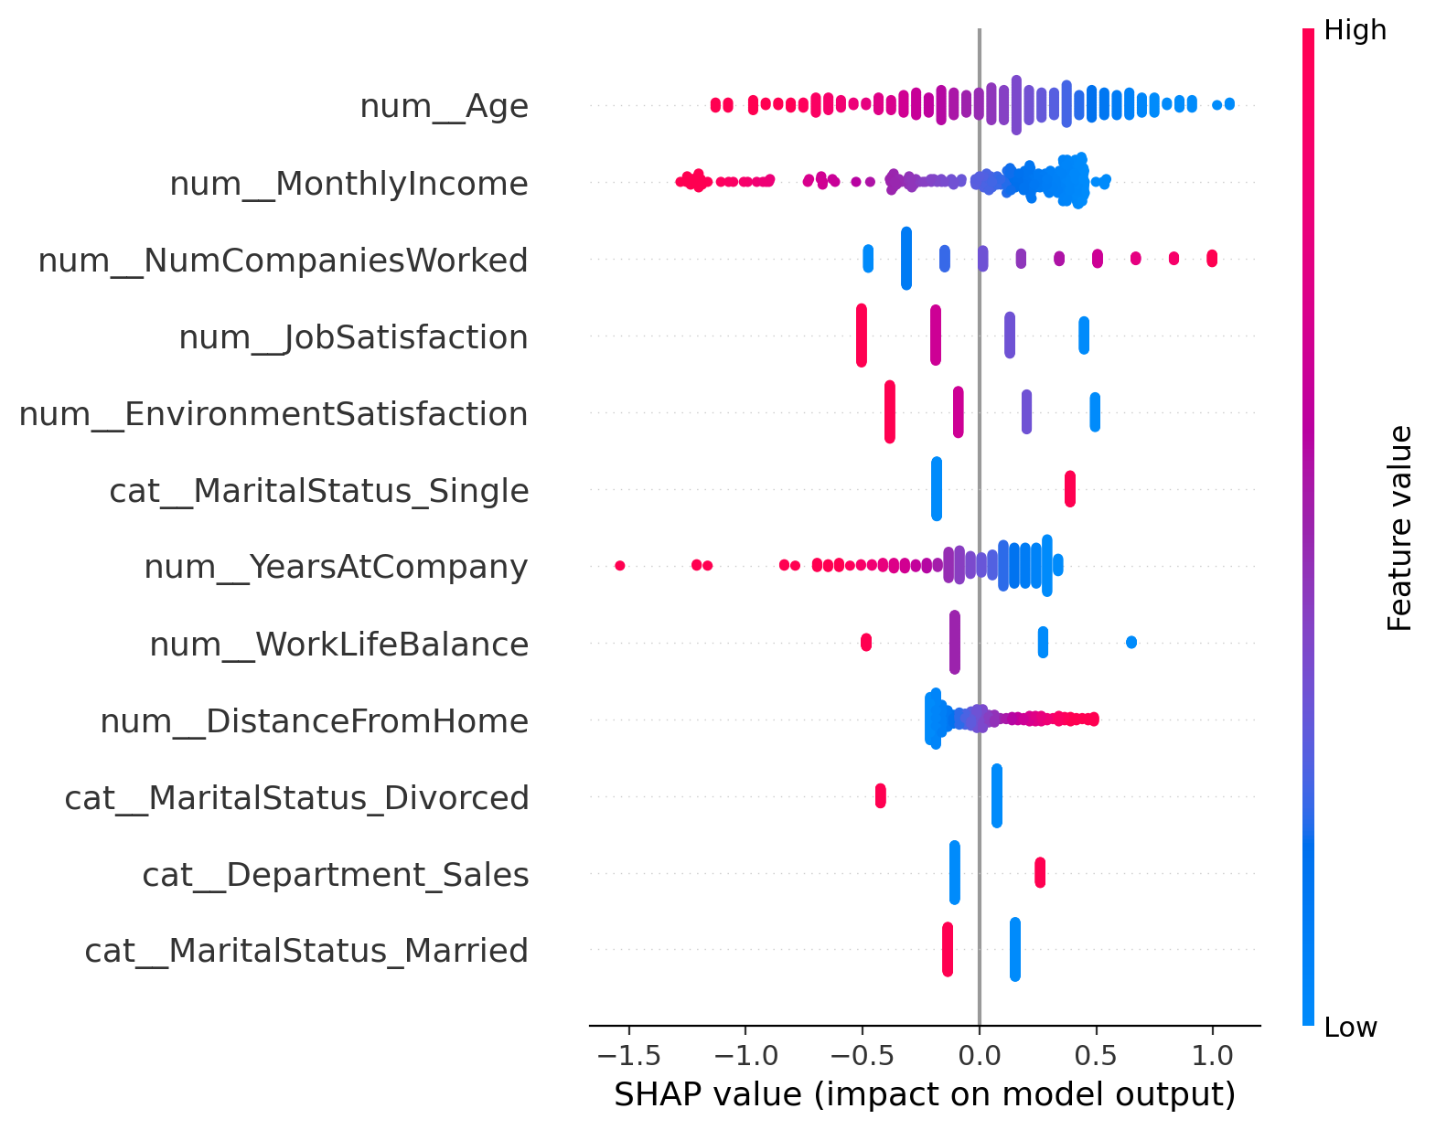
Figure 8. SHAP summary for the selected Logistic Regression model.

4.7 Interpretation of Findings
The results prove that the employee-attrition modelling is not a leader board exercise but a decision problem. The overall accuracy of the random forest model and the XGBoost model were attractive but their confusion matrices indicated that these two models failed to capture a large proportion of minority class while capturing most of the non-attrition class. In contrast to Logistic Regression, the CPC had a higher number of actual attrition cases, but more false positives. This is a trade off that may be preferable in an HR screening situation where a false positive may be followed up with human review and a false negative may result in an unidentified potentially at-risk employee. The result also offers a convenient comparison with some studies that claim superior hybrid/ensemble accuracy for other factors such as the target metric, threshold and feature space. The project is not claiming Logistic Regression is always better; it is just saying that under the particular pipeline and given set of data the Logistic Regression classifier performed best considering it was a balanced classifier.

5 Project Planning Review
The initial plan spanned 12 June – 10 September 2026, and included literature review and data preparation, baseline modelling, ensemble development, evaluation, explainability, testing, and report preparation. This is how the completed implementation was done. The results were used to emphasize recall and F1 score during evaluation as the highest accuracy models were found to be inaccurate for the majority of the cases of attrition. In the project records provided, actual dates for each phase were not included, and Appendix G presents the original project plan without making up any proposed schedule variances. If necessary the student should include their own actual dates from their own project log book.

6 Conclusion

6.1 Achievement of Objectives and Research Question
The project was successful in meeting its technical goals and provided a complete and repeatable workflow to predict attrition. The preprocessing and test conditions were the same for seven models. All three classifiers, Random Forest, XGBoost, and Logistic Regression, achieved the same accuracy (83.33%) but Logistic Regression showed the highest F1-score (0.3444), recall (0.5532) and hold-out ROC-AUC (0.6751). The tested ensembles were thus not consistently the best individual model. This provides the answer to the research question and demonstrates the successful implementation of ensemble learning, yet higher complexity does not necessarily represent better use for the detection of minority classes.

6.2 Contribution and Lessons Learned
The deliverable consists of a leakage controlled pipeline that exposes the accuracy/attrition trade-off. The key takeaway is that it is important to select a model for the intended HR use, not for a single metric. The second lesson is that training only preprocessing and resampling are necessary for credible evaluation. Explanability also contributes to transparency, but can't be considered as causal evidence.

6.3 Limitations, Recommendations and Future Research
As this is a publicly available dataset with only 1,470 employees and limited number of predictors, the results are not necessarily extrapolatable directly to a real organisation. There were no external HR users assessed the pipeline. There is a need for future work to validate the approach on larger and longitudinal organisational datasets, test cost sensitive and balanced ensemble methods, optimize the decision thresholds, assess fairness amongst employee groups, and user evaluation with HR professionals. All deployments must have privacy controls, monitoring and mandatory human review.

7 AI Transparency Statement
Report Outlining, Python code drafting and refinement, debugging, interpretation of generated outputs and language editing were performed with the help of AI. Some numerical results presented in this report were obtained by executing a fixed random seed version of the Python executable provided by IBM, and have been reproduced. The student is required to choose the suitable level of the Institutional AI Transparency Scale for the module and submit a proper declaration that is based on the actual use of AI and not copied from someone else.

References
Al-Ali, M., Alwateer, M., Alsaedi, S. A., Balaha, H. M., Badawy, M., & Elhosseini, M. A. (2026). Integrating machine learning and explainable AI for employee attrition prediction in HR analytics. Scientific Reports, 16, 6344. https://doi.org/10.1038/s41598-026-36424-2
Alsheref, F. K., Fattoh, I. E., & Ead, W. M. (2022). Automated prediction of employee attrition using ensemble model based on machine learning algorithms. Computational Intelligence and Neuroscience, 2022, 7728668. https://doi.org/10.1155/2022/7728668
Alyousef, M. I., Khan, H. W., & Sattar, M. U. (2026). A hybrid predictive model for employee turnover: Integrating ensemble learning and feature-driven insights from IBM HR Analytics. Information, 17(2), 208. https://doi.org/10.3390/info17020208
Govindarajan, R., Kumar, N. K., & Reddy, S. (2025). Predicting employee attrition: A comparative analysis of machine learning models using the IBM Human Resource Analytics Dataset. Procedia Computer Science, 258, 4084-4093. https://doi.org/10.1016/j.procs.2025.04.659
M. Yasser H. (n.d.). IBM Attrition Dataset [Data set]. Kaggle. https://www.kaggle.com/datasets/yasserh/ibm-attrition-dataset
Najafi-Zangeneh, S., Shams-Gharneh, N., Arjomandi-Nezhad, A., & Hashemkhani Zolfani, S. (2021). An improved machine learning-based employees attrition prediction framework with emphasis on feature selection. Mathematics, 9(11), 1226. https://doi.org/10.3390/math9111226
Qin, R., Qi, X., Yuan, Y., & Alatas, B. (2026). Employee turnover prediction research of human resource management on machine learning algorithms and big data analysis. Journal of Organizational and End User Computing, 38(1), 1-27. https://doi.org/10.4018/JOEUC.399146
Raza, A., Munir, K., Almutairi, M., Younas, F., & Fareed, M. M. S. (2022). Predicting employee attrition using machine learning approaches. Applied Sciences, 12(13), 6424. https://doi.org/10.3390/app12136424
Saurabh, S., Mukherjee, R., Ghosh, V., Chakraborty, S., & Srivastava, N. K. (2026). “I quit because…”: A psychological interpretation of push-pull dynamics of employee attrition informed by explainable machine learning. Acta Psychologica, 266, 106869. https://doi.org/10.1016/j.actpsy.2026.106869
Talebi, H., Khatibi Bardsiri, A., & Bardsiri, V. K. (2025). Machine learning approaches for predicting employee turnover: A systematic review. Engineering Reports, 7(8), e70298. https://doi.org/10.1002/eng2.70298
Veglio, V., Romanello, R., & Pedersen, T. (2025). Employee turnover in multinational corporations: A supervised machine learning approach. Review of Managerial Science, 19(3), 687-728. https://doi.org/10.1007/s11846-024-00769-7

Appendices

Appendix A: AI Use Declaration
Table A1. AI use declaration.
Item | Declaration
Tool | General-purpose large language model assistant.
Used for | Outlining; code drafting/refinement; debugging support; output interpretation; language editing.
Verification | Results reproduced from IBM.csv using executable Python and saved metric files.
AITS level | Level 2 – AI for Shaping
Responsibility | Student remains responsible for code, interpretation, citations and final submission.

Appendix B: Institutional Research Ethics Form.
College of Business,
Technology and
Engineering

UREC2 RESEARCH ETHICS PROFORMA FOR STUDENTS UNDERTAKING LOW RISK PROJECTS WITH HUMAN PARTICIPANTS

This form is designed to help students and their supervisors to complete an ethical scrutiny of proposed research. The University Research Ethics Policy (www.shu.ac.uk/research/excellence/ethics-and-integrity/policies) should be consulted before completing this form. The initial questions are there to check that completion of the UREC 2 is appropriate for this study. The final responsibility for ensuring that ethical research practices are followed rests with the supervisor for student research.

Note that students and staff are responsible for making suitable arrangements to ensure compliance with the General Data Protection Act (GDPR). This involves informing participants about the legal basis for the research, including a link to the University research data privacy statement and providing details of who to complain to if participants have issues about how their data was handled or how they were treated (full details in module handbooks). In addition, the act requires data to be kept securely and the identity of participants to be anonymised. They are also responsible for following SHU guidelines about data encryption and research data management. Guidance can be found on the SHU Ethics Website www.shu.ac.uk/research/excellence/ethics-and-integrity

Please note that it is mandatory for all students to only store data on their allotted networked F drive space and not on individual hard drives or memory sticks etc.

The present form also enables the University and College to keep a record confirming that research conducted has been subjected to ethical scrutiny.

The form must be completed by the student and the supervisor and independently reviewed by a second reviewer or module leader (additional guidance can be obtained from your College Research Ethics Chair). In all cases, it should be counter-signed and kept as a record showing that ethical scrutiny has occurred. Some courses may require additional scrutiny. Students should retain a copy for inclusion in their research projects, and a copy should be uploaded to the relevant module Blackboard site.

Please note that it may be necessary to conduct a health and safety risk assessment for the proposed research. Further information can be obtained from the University’s Health and Safety Website https://sheffieldhallam.sharepoint.com/sites/3069/SitePages/Risk-Assessment.aspx

SECTION A

- Checklist questions to ensure that this is the correct form:

Health Related Research within the NHS, or His Majesty’s Prison and Probation Service (HMPPS), or with participants unable to provide informed consent check list.

Question | Yes/No
Does the research involve? | No
- Patients recruited because of their past or present use of the NHS
- Relatives/carers of patients recruited because of their past or present use of the NHS | No
- Access to NHS staff, premises, or resources | No
- Access to data, organs, or other bodily material of past or present NHS patients | No
- Foetal material and IVF involving NHS patients | No
- The recently dead in NHS premises | No
- Prisoners or others within the criminal justice system recruited for health-related research | No
- Police, court officials, prisoners, or others within the criminal justice system | No
- Participants who are unable to provide informed consent due to their incapacity even if the project is not health related | No
- Is this an NHS research project, service evaluation or audit?  For NHS definitions please see the following website http://www.hra.nhs.uk/documents/2013/09/defining-research.pdf | No
Question | Yes/No
- Will any of the participants be vulnerable?  Note: Vulnerable people include children and young people, people with learning disabilities, people who may be limited by age or sickness, pregnancy, people researched because of a condition they have, etc. See full definition on ethics website in the document Code of Practice for Researchers Working with Vulnerable Populations (under the Supplementary University Polices and Good Research Practice Guidance) | No
- Are drugs, placebos, or other substances (e.g., food substances, vitamins) to be administered to the study participants or will the study involve invasive, intrusive, or potentially harmful procedures of any kind? | No
- Will tissue samples (including blood) be obtained from participants? | No
- Is pain or more than mild discomfort likely to result from the study? | No
- Will the study involve prolonged or repetitive testing? | No
- Is there any reasonable and foreseeable risk of physical or emotional harm to any of the participants?  Note: Harm may be caused by distressing or intrusive interview questions, uncomfortable procedures involving the participant, invasion of privacy, topics relating to highly personal information, topics relating to illegal activity, or topics that are anxiety provoking, etc. | No
- Will anyone be taking part without giving their informed consent? | No
- Is the research covert?  Note: ‘Covert research’ refers to research that is conducted without the knowledge of participants. | No
- Will the research output allow identification of any individual who has not given their express consent to be identified? | No

If you have answered YES to any of the above questions, then you MUST consult with your supervisor to obtain research ethics from the appropriate institution outside the university. This could be from the NHS or Her Majesty’s Prison and Probation Service (HMPPS) under their independent Research Governance schemes. Further information is provided below. https://www.myresearchproject.org.uk/

- Checks for Research with Human Participants

If you have answered YES to any of these questions you are REQUIRED to complete and submit a UREC3 or UREC4 form. Your supervisor will advise. If you have answered NO to all these questions, then proceed with this form (UREC2).

- General Project Details

Details
Name of student |  | LINGA SWAMY MUNTHA
SHU email address |  | LingaSwamy.S.Muntha@student.shu.ac.uk
Department/College |  | Sheffield Hallam University
Name of supervisor |  | Jumoke Popoola
Supervisor’s email address |  | J.Popoola@shu.ac.uk
Title of proposed research |  | Building a Machine Learning-Based Ensemble System for Predicting Employee Attrition.
Proposed start date |  | 12 June 2026
Proposed end date |  | 10 September 2026
Background to the study and the rationale (reasons) for undertaking the research (500 words) |  | Employee attrition is one of the major challenges faced by modern organisations because replacing experienced employees is expensive and negatively impacts productivity, organisational knowledge, and business performance. Human Resource departments increasingly rely on data-driven decision making to predict employee turnover before resignation occurs. Traditional statistical approaches often fail to identify complex relationships among employee characteristics such as job satisfaction, overtime, monthly income, work-life balance, years at the company, and performance ratings.  Recent advances in machine learning have demonstrated significant potential for improving prediction accuracy by discovering hidden patterns within structured HR datasets. Several algorithms have been proposed in previous research, including Logistic Regression, Decision Trees, Random Forest, Support Vector Machines, and XGBoost. However, previous studies report inconsistent findings regarding which algorithm provides the best prediction performance for employee attrition. This research addresses this gap by developing a machine learning-based ensemble system, combining multiple base classifiers, and evaluating its performance against individual models using the IBM HR Analytics Employee Attrition dataset obtained from Kaggle.  The project involves preprocessing the dataset, exploratory data analysis, feature engineering, model development, performance evaluation using multiple metrics, and interpretation of influential factors contributing to employee turnover. Since the study uses a publicly available anonymised dataset, no personal or sensitive information will be collected from human participants. If user evaluation of the developed prediction dashboard is undertaken, participation will be voluntary, anonymous, and conducted after informed consent. The outcomes of the study are expected to provide practical recommendations that assist HR professionals in proactive employee retention strategies while contributing to the growing body of research on machine learning applications in human resource analytics.
Aims & research question(s) | To develop a machine learning-based ensemble system for predicting employee attrition and to evaluate its performance against individual base classification algorithms.  Research Question  How can employee attrition in Human Resources be predicted using a machine learning-based ensemble system?  Objectives  1. To identify recent trends in the influential features affecting employee attrition in Human Resources, through a review of current literature and data-driven feature analysis.  2. To determine the optimal ensemble strategy (voting or stacking) for combining base classifiers to improve the prediction of employee attrition.  3. To examine the design and implementation of a machine learning-based ensemble system for predicting employee attrition.  4. To assess the predictive performance of the developed ensemble system against individual base classifiers using appropriate evaluation metrics.
Methods to be used for:  - Recruitment of participants  - Data collection  - Data analysis | Approximately 5–10 computing students will be invited voluntarily to evaluate the usability and usefulness of the developed machine learning prediction system. Participation will be voluntary, anonymous, and based on informed consent. No vulnerable participants will be recruited.  https://www.kaggle.com/datasets/mahmoudemadabdallah/hr-analytics-employee-attrition-and-performance  The primary dataset will be the publicly available IBM HR Analytics Employee Attrition dataset obtained from Kaggle. Participants involved in evaluating the developed system will complete a short anonymous feedback questionnaire after interacting with the prototype. No personally identifiable information will be collected.  The IBM HR dataset will undergo preprocessing, feature encoding, normalisation, and exploratory data analysis. Multiple machine learning classification algorithms, including Logistic Regression, Decision Tree, Random Forest, Support Vector Machine, and XGBoost, will be trained as base classifiers and combined into an ensemble system (e.g., voting or stacking), then evaluated using Accuracy, Precision, Recall, F1-score, ROC-AUC, and Confusion Matrix. Participant feedback will be summarised using descriptive statistics and qualitative comments.
Outline the nature of the data held, details of anonymisation, storage and disposal procedures as required. | All collected data will be stored securely on the Sheffield Hallam University OneDrive/F-drive in password-protected folders. No participant names or identifiable information will be collected. Questionnaire responses will be anonymised before analysis. Data will only be used for academic purposes and will be permanently deleted after completion of the dissertation in accordance with GDPR and University policy.

4. Research in External Organisations

Question | Yes/No
  Question | Yes/No
  1. Will the research involve working with copyrighted documents, films, broadcasts, photographs, artworks, designs, products, programs, databases, networks, processes, existing datasets, or secure data? | YES  (using the IBM HR Analytics Dataset from Kaggle)
  2. If you answered YES to question 1, are the materials you intend to use in the public domain?  Notes: ‘In the public domain’ does not mean the same thing as ‘publicly accessible’.  - Information which is 'in the public domain' is no longer protected by copyright (i.e., copyright has either expired or been waived) and can be used without permission.  - Information which is 'publicly accessible' (e.g., TV broadcasts, websites, artworks, newspapers) is available for anyone to consult/view. It is still protected by copyright even if there is no copyright notice. In UK law, copyright protection is automatic and does not require a copyright statement, although it is always good practice to provide one. It is necessary to check the terms and conditions of use to find out exactly how the material may be reused etc.  If you answered YES to question 1, be aware that you may need to consider other ethics codes. For example, when conducting Internet research, consult the code of the Association of Internet Researchers; for educational research, consult the Code of Ethics of the British Educational Research Association. | Yes (publicly available research dataset)
  3. If you answered NO to question 2, do you have explicit permission to use these materials as data?  If YES, please show evidence to your supervisor. | YES  (I have shown evidence to supervisor has approved The data is pubicity accessible and Permission.
  4. If you answered NO to question 3, is it because:  A. you have not yet asked permission  B. you have asked and not yet received and answer  C. you have asked and been refused access.  Note: You will only be able to start the research when you have been granted permission to use the specified material. | A/B/C
- Will the research involve working with/within an external organisation (e.g., school, business, charity, museum, government department, international agency, etc.)? | No
- If you answered YES to question 1, do you have granted access to conduct the research from the external organisation?  If YES, students please show evidence to your supervisor. You should retain this evidence safely. | N/A
- If you do not have permission for access is this because:  - you have not yet asked  - you have asked and not yet received an answer  - you have asked and been refused access  Note: You will only be able to start the research when you have been granted access. | N/A

- Research with Products and Artefacts

SECTION B

HEALTH AND SAFETY RISK ASSESSMENT FOR THE RESEARCHER
- Does this research project require a health and safety risk assessment for the procedures to be used? (Discuss this with your supervisor)

☐ Yes
☐ No

If YES the completed Health and Safety Risk Assessment form should be attached. A standard risk assessment form can be generated through the Awaken system (https://shu.awaken-be.com). Alternatively if you require more specific risk assessment, e.g. a COSHH, attach that instead.

- Will the data be collected fully online (no face-to-face contact with participants)?

☐ Yes (See the safety guidance for online research and go to question 7b)
☐ No (Go to question 3)

- Will the proposed data collection take place on campus?

☐ Yes (Please answer questions 5 to 8)
☐ No (Please complete all questions and consult with your supervisor))

- Where will the data collection take place?
(Tick as many as apply if data collection will take place in multiple venues)

 | Location | Please specify
☐ | Researcher's Residence
☐ | Participant's Residence
☐ | Education Establishment
☐ | Other e.g., business/voluntary organisation, public venue
☐ | Outside UK

- How will you travel to and from the data collection venue?

☐ On foot ☐ By car ☐ Public Transport
☐ Other (Please specify)
Please outline how you will ensure your personal safety when travelling to and from the data collection venue.
Data collection will be conducted entirely online; therefore, no travel is required.

- How will you ensure your own personal safety whilst at the research venue?

Not applicable because no travel is required.

- Are there any potential risks to your health and wellbeing associated with either (a) the venue where the research will take place and/or (b) the research topic itself?

☐ None that I am aware of
☐ Yes (Please outline below including steps taken to minimise risk)’
This research uses a publicly available anonymised dataset from Kaggle and an online questionnaire to collect usability feedback. There are no physical, psychological, or emotional risks to the researcher or participants. Participation is voluntary, anonymous, and participants may withdraw at any time without consequence.

- If you are carrying out research off-campus, you must ensure that each time you go out to collect data you ensure that someone you trust knows where you are going (without breaching the confidentiality of your participants), how you are getting there (preferably including your travel route), when you expect to get back, and what to do should you not return at the specified time.

Please outline here the procedure you propose using to do this.

N/A

Insurance Check

The University’s standard insurance cover will not automatically cover research involving any of the following:

i) Participants under 5 years old
ii) Pregnant women
iii) 5000 or more participants
iv) Research being conducted in an overseas country
v) Research involving aircraft and offshore oil rigs
vi) Nuclear research
vii) Any trials/medical research into Covid 19

If your proposals do involve any of the above, please contact the Insurance Manager directly (fin-insurancequeries-mb@exchange.shu.ac.uk) to discuss this element of your project.

Adherence to SHU Policy and Procedures

Ethics sign-off
Personal statement
I can confirm that:
- I have read the Sheffield Hallam University Research Ethics Policy and Procedures
- I agree to abide by its principles.
Student
Name: LINGA SWAMY MUNTHA | Date: 23/07/2026
Signature:
Supervisor ethical sign-off
I can confirm that completion of this form has not identified the need for ethical approval by the TPREC/CREC or an NHS, Social Care, or other external REC. The research will not commence until any approvals required under Sections 4 & 5 have been received and any necessary health and safety measures are in place.
Name: Dr Jumoke Popoola | Date: 23/07/2026
Signature: 
Independent Reviewer ethical sign off

Name: | Date:
Signature:

Please ensure that you have attached all relevant documents. Your supervisor must approve them before you start data collection:

Documents | Yes | No | N/A
Research proposal if prepared previously | ☐ | ☐ | ☐
Any recruitment materials (e.g., posters, letters, emails, etc.) | ☐ | ☐ | ☐
Participant information sheet | ☐ | ☐ | ☐
Participant consent form | ☐ | ☐ | ☐
Details of measures to be used (e.g., questionnaires, etc.) | ☐ | ☐ | ☐
Outline interview schedule / focus group schedule | ☐ | ☐ | ☐
Debriefing materials | ☐ | ☐ | ☐
Health and Safety Risk Assessment Form | ☐ | ☐ | ☐

Appendix C: Publication Procedure Form
College of Business,
Technology and
Engineering

Computing Research Project
55-710244-BF-20256

PUBLICATION PROCEDURE FORM
I LINGA SWAMY MUNTHA confirm that I understand will comply with the Publication Procedure outlined in the Module Handbook and the Blackboard Site.

Student: | Signature | Date 10-09-2026
Supervisor: | Signature: Dr Jumoke Popoola  | Date 10/09/2026

In this module, while you create your own research question or topic area, your supervisor makes a significant intellectual contribution to this work as the research progresses. Your supervisor will make the decision on whether your work merits publication based on the quality of the work you have produced. Your supervisor will co-author the paper for publication with you and your supervisor will both be listed as authors. You are required to sign the declaration below to confirm that you understand and will follow this procedure.
Declaration:

Appendix D: Data Gathering Instruments
The modelling dataset was not applicable as only secondary data was analysed. No Interviews, questionnaires or observational instrument was used and no formal user acceptance testing was performed.

Appendix E: Secondary Data and Software Code
Table E1. Secondary dataset source.
Item | Detail
Dataset | IBM Attrition Dataset
Source | Kaggle
URL | https://www.kaggle.com/datasets/yasserh/ibm-attrition-dataset
File | IBM.csv
Shape | 1,470 rows x 13 columns
Target | Attrition
Attrition cases | 237 (16.12%)

Table E2. Software/code inventory.
File | Purpose
employee_attrition_project.py | End-to-end analysis, modelling, testing and figure generation.
holdout_model_results.csv | Hold-out metrics for seven models.
cross_validation_results.csv | Five-fold training-partition results.
system_tests.csv | Automated system checks.
feature_importance.csv | Explainability summary.
PNG figures | Architecture, performance, confusion matrix and SHAP evidence.

E.1 Core Reproduction Code
X_train, X_test, y_train, y_test = train_test_split(
X, y, test_size=0.20, random_state=42, stratify=y)

preprocessor = ColumnTransformer([
("num", StandardScaler(), numerical_features),
("cat", OneHotEncoder(handle_unknown="ignore", sparse_output=False), categorical_features)])
pipeline = Pipeline([
("preprocessing", preprocessor),
("smote", SMOTE(random_state=42)),
("classifier", LogisticRegression(max_iter=2000, random_state=42))])
pipeline.fit(X_train, y_train)
y_pred = pipeline.predict(X_test)

Appendix F: Original Research Project Plan
Table F1. Baseline project plan.
Phase | Activity | Planned Period
P1 | Topic, question, aim and objectives | 12 Jun - 25 Jun
P2 | Literature review and source selection | 19 Jun - 16 Jul
P3 | EDA and preprocessing | 26 Jun - 9 Jul
P4 | Individual model development | 10 Jul - 23 Jul
P5 | Ensemble development | 24 Jul - 6 Aug
P6 | Evaluation and explainability | 31 Jul - 13 Aug
P7 | Prototype/testing | 7 Aug - 20 Aug
P8 | Report and presentation | 14 Aug - 3 Sep
P9 | Final review/submission | 4 Sep - 10 Sep

Appendix G: Gantt Chart - Planned vs Actual
The original planned chart is reproduced below. Actual dates for the various phases were not available in the project records provided; if needed, add verified actual dates to the project log.
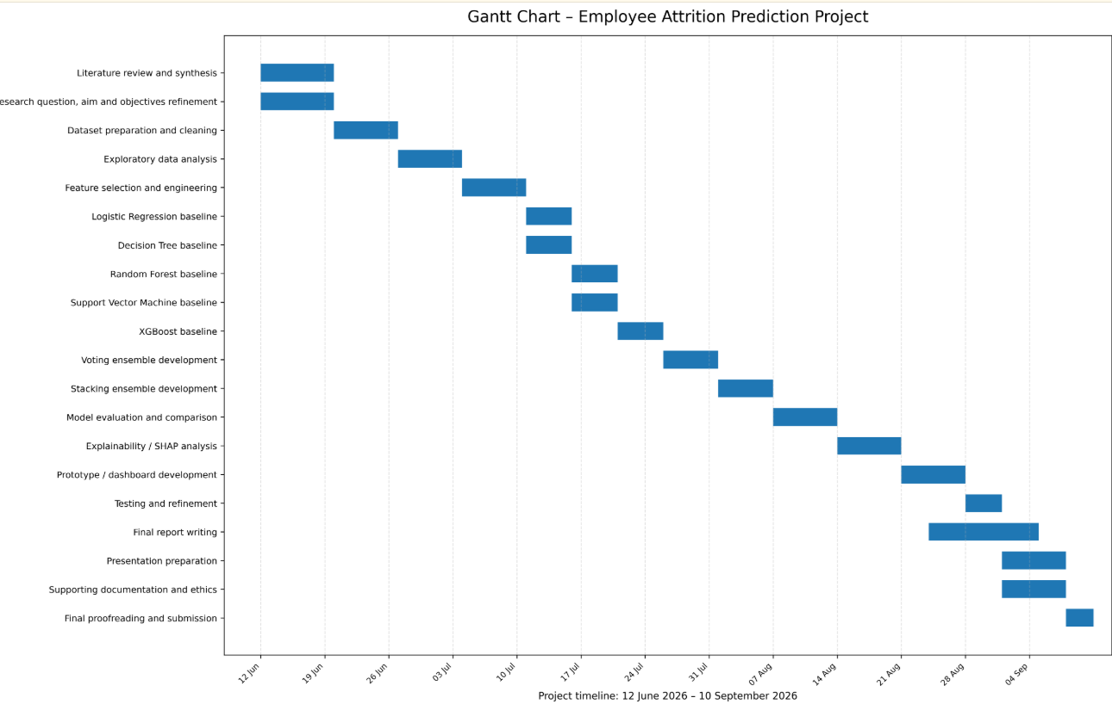
Figure 10. Planned project schedule from the original project documentation.

Appendix H: Literature Review Evidence
Table H1. Representative search strings.
# | Search String | Purpose
S1 | "employee attrition" AND "machine learning" | Core prediction
S2 | "IBM HR Analytics" AND attrition AND classification | IBM-aligned studies
S3 | "employee attrition" AND ensemble AND voting | Voting
S4 | "employee attrition" AND stacking | Stacking
S5 | "employee attrition" AND SHAP | Explainability
S6 | employee turnover AND systematic review AND machine learning | Research synthesis

Table H2. Core literature by theme.
Theme | Representative Sources
Feature selection | Najafi-Zangeneh et al. (2021)
Comparative ML | Raza et al. (2022); Govindarajan et al. (2025); Veglio et al. (2025)
Ensembles | Alsheref et al. (2022); Alyousef et al. (2026); Qin et al. (2026)
Systematic review | Talebi et al. (2025)
Explainability | Al-Ali et al. (2026); Saurabh et al. (2026)

Appendix I: Risk Artefacts
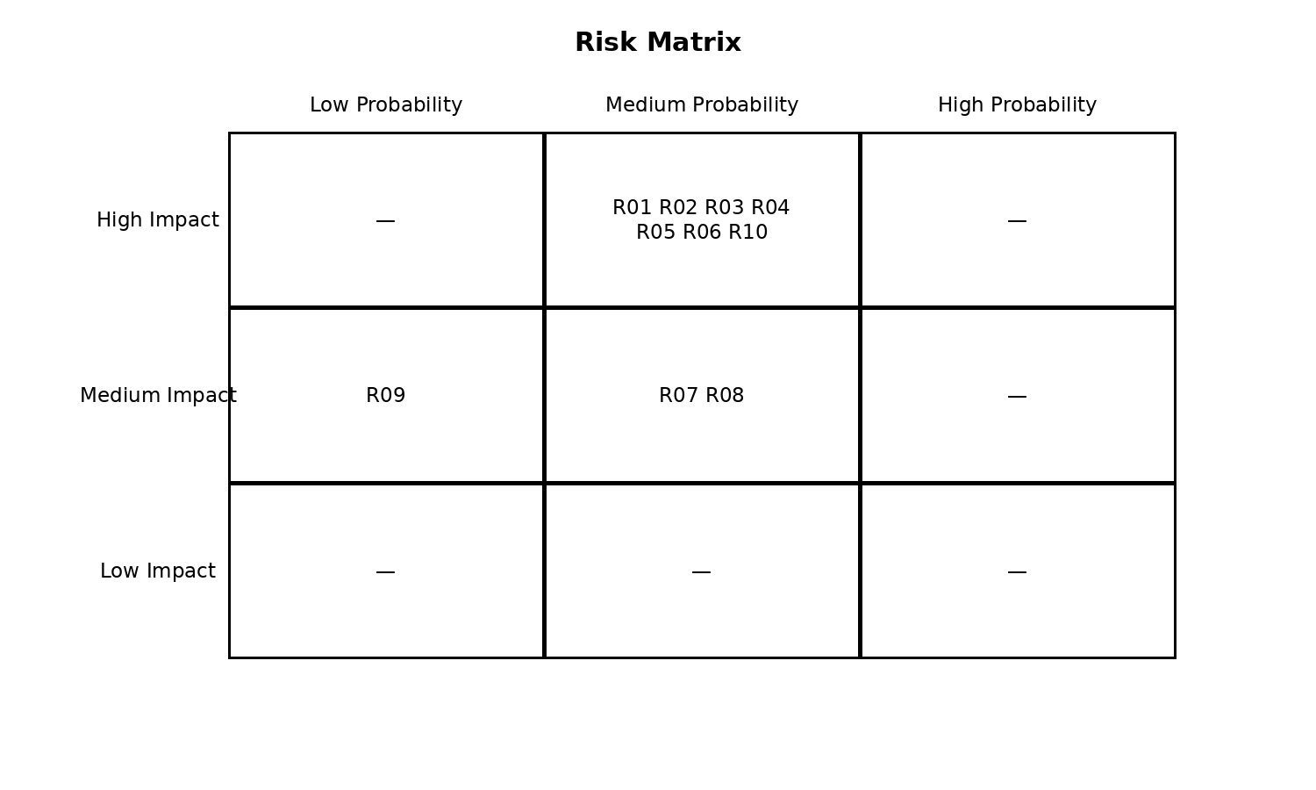
Figure 9. Project risk matrix.
Table I1. Risk register.
ID | Risk | L | I | Mitigation | Status
R01 | Class imbalance | M | H | Stratified split; training-only SMOTE | Controlled
R02 | Data leakage | M | H | Pipeline-enclosed preprocessing | Controlled
R03 | Overfitting | M | H | Cross-validation and hold-out testing | Controlled
R04 | Weak predictive performance | M | H | Compare seven models and multiple metrics | Observed/evaluated
R05 | Time constraints | M | H | Prioritise objectives | Controlled
R06 | Bias/fairness | M | H | Explainability and human review | Controlled
R07 | Limited generalisability | M | M | Restrict claims; future external validation | Limitation
R08 | Explainability limitations | M | M | No causal interpretation | Controlled
R09 | Software problems | L | M | Stable environment and backups | Controlled
R10 | Misuse of predictions | M | H | Decision support only | Controlled

Appendix J: System Test Cases and Testing Evidence
Table J1. System test evidence.
ID | Check | Expected | Result
TC1 | Dataset shape | 1,470 x 13 | Pass
TC2 | Missing values | 0 | Pass
TC3 | Duplicates | 0 | Pass
TC4 | Target encoding | 0/1 | Pass
TC5 | Training rows | 1,176 | Pass
TC6 | Test rows | 294 | Pass
TC7 | Split overlap | None | Pass
TC8 | Predictions | 294 | Pass
TC9 | Classes | 0/1 | Pass
TC10 | Probabilities | 0-1 | Pass

Appendix K: Architecture Artefacts
Figure K1. High-level architecture.
Figure K2. Low-level modelling design.

Appendix L: GitHub Repository Evidence
Repository URL: [Insert public GitHub repository URL before submission.]
Include a screenshot of the repository structure and commit history. Do not use another student’s repository or invent a URL.

Appendix M: Additional Supporting Figures
Figure M1. Attrition distribution.
Figure M2. F1 comparison.
Figure M3. ROC-AUC comparison.
Figure M4. ROC curves.
Figure M5. Logistic Regression confusion matrix.
Figure M6. SHAP summary.

Appendix N: Additional Supporting Tables
Table N1. Functional requirements.
ID | Requirement
FR1 | Load and validate IBM.csv
FR2 | Check missing values, duplicates and target distribution
FR3 | Encode categorical and standardise numerical features
FR4 | Create stratified train/test split
FR5 | Handle imbalance without test contamination
FR6 | Train Logistic Regression
FR7 | Train DT, RF, SVM and XGBoost
FR8 | Develop Voting and Stacking
FR9 | Calculate classification metrics
FR10 | Generate evaluation figures
FR11 | Produce explainability evidence

Table N2. Non-functional requirements.
ID | Requirement
NFR1 | Fixed seed and reproducibility
NFR2 | Leakage-safe by construction
NFR3 | Auditable outputs
NFR4 | Open-source implementation
NFR5 | Runs without GPU
NFR6 | Interpretable output

Table N3. Full hold-out results.
Model | Acc | Prec | Rec | F1 | AUC | TN | FP | FN | TP
Logistic Regression | 0.6633 | 0.2500 | 0.5532 | 0.3444 | 0.6751 | 169 | 78 | 21 | 26
Decision Tree | 0.7415 | 0.1778 | 0.1702 | 0.1739 | 0.4798 | 210 | 37 | 39 | 8
Random Forest | 0.8333 | 0.4444 | 0.1702 | 0.2462 | 0.6669 | 237 | 10 | 39 | 8
SVM | 0.7245 | 0.2344 | 0.3191 | 0.2703 | 0.5999 | 198 | 49 | 32 | 15
XGBoost | 0.8333 | 0.4545 | 0.2128 | 0.2899 | 0.6417 | 235 | 12 | 37 | 10
Voting Ensemble | 0.8299 | 0.4400 | 0.2340 | 0.3056 | 0.6736 | 233 | 14 | 36 | 11
Stacking Ensemble | 0.8265 | 0.4000 | 0.1702 | 0.2388 | 0.6558 | 235 | 12 | 39 | 8

Table N4. Five-fold cross-validation results.
Model | Mean AUC | SD | Mean F1 | Mean Recall
Logistic Regression | 0.7352 | 0.0389 | 0.4017 | 0.6474
Decision Tree | 0.6274 | 0.0208 | 0.3444 | 0.4368
Random Forest | 0.7387 | 0.0249 | 0.3700 | 0.2789
SVM | 0.7024 | 0.0335 | 0.3718 | 0.4474
XGBoost | 0.7291 | 0.0291 | 0.3673 | 0.2842
Voting Ensemble | 0.7477 | 0.0287 | 0.4214 | 0.3789
Stacking Ensemble | 0.7335 | 0.0296 | 0.3713 | 0.2895

Table N5. Top SHAP features.
Feature | Mean |SHAP|
Age | 0.3970
MonthlyIncome | 0.3726
NumCompaniesWorked | 0.3450
JobSatisfaction | 0.3187
EnvironmentSatisfaction | 0.2883
MaritalStatus_Single | 0.2505
YearsAtCompany | 0.2201
WorkLifeBalance | 0.2024
DistanceFromHome | 0.1621
MaritalStatus_Divorced | 0.1507
Department_Sales | 0.1492
MaritalStatus_Married | 0.1452

College of Social Sciences and Arts - Dr. Antonia Ypsilanti (a.ypsilanti@shu.ac.uk ) College of Business, Technology and Engineering - Dr. Tony Lynn (t.lynn@shu.ac.uk ) College of Health, Wellbeing and Life Sciences - Dr. Nikki Jordan-Mahy (n.jordan-mahy@shu.ac.uk )
Safety guidance for online research includes information on how to set up online surveys and/or conduct online interviews/focus groups. These guidelines can be found in BB. Please check with your supervisor/module leader.
It is mandatory to attach the Participant Information Sheet (PIS)
It is mandatory to attach a Participant Consent Form, unless it is embedded in an online survey, in which case your supervisor must approve it before you start data collection

