**Appendices (intended for online publication)**

**Appendix A**

**A1 Experimental Instructions for the Main Experiment**

**General Information**

Welcome! You are about to participate in an experiment on decision making. You will receive £2 for showing up to and £5 for completing this experiment. Additionally, you can earn money during the experiment.

The experiment will consist of several parts. At the end of the experiment, one of the parts will be randomly selected by the computer. Your final earnings will be determined according to your performance in the selected part. The instructions on how your performance is determined for each part will be shown on your screens. Please read the instructions carefully and take notes if necessary as you will not be able to go back to read them again when the experiment starts.

You may leave at any point during the experiment, if you do not wish to complete the experiment. If you leave the experiment before it is completed, you will only be paid the show up fee of £2.

Throughout the experiment you must not communicate with other participants. The use of any electronic devices is strictly prohibited. If you break these rules, you will be excluded from the experiment without receiving any fee. Please make sure that all such devices are turned off and put away out of sight.

Your decisions are anonymous and under no circumstances will be linked to your identity.

If you have any questions at any point during the experiment, please raise your hand and someone will come to your desk to answer it. If you agree by these rules, you can sign and date the CONSENT FORM on your desks that you are willing to participate in this experiment and consenting the use of your data in the final report of the project.

**[On screen instructions]**

**Part 1**

In this part, you will complete the Circle Task. In the Circle Task, you will be asked to pick a circle with more dots in a series of circle pairs. One of the circles will contain 50 dots and the other one 55 dots. The figure below shows an example of a circle pair. Each circle pair will appear on your screens for 1 second only. After the circle pair disappears from your screen, you will be asked to judge whether the right or the left circle contained more dots. You have to indicate your judgement by clicking on the "Left" or "Right" button. When you click the button of your choice, you will move to the next pair of circles. The task consists of 60 circle pairs. Your performance score in this task will be the total number of correctly judged circles. **If Part 1 is selected for the payment, you will earn £0.20 per each correct answer.**

During the experiment you will be matched with three other participants to form a group consisting of 4 participants. You will be in the same group throughout the whole course of the experiment. All of your group members will also complete the Circle task and receive a performance score based on the number of correctly judged circles.

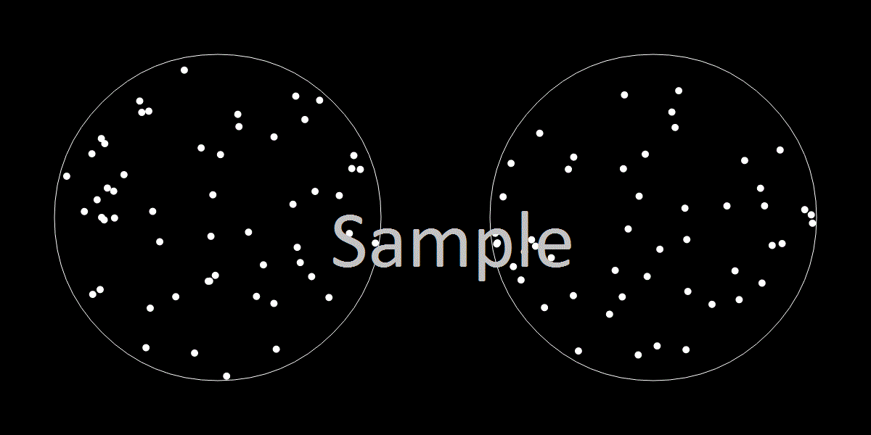

**Press to Continue**

Before starting the Circle task, please indicate the probability that your performance score will be one of the top two scores of your group. The accuracy of your stated probability that your performance will be in the top two scores of your group will influence your payment. The experiment is designed such that you have the highest chance to earn money if you state the true probability with which you believe that your score is in the top two scores in your group.

Your stated probability will determine your choice between two options:

Option A: you receive an additional £1 if your performance score in the Circle task is in the top two scores in your group of 4 participants

Option B: you receive an additional £1 with probability X

X is a number between 0% and 100% and will be randomly picked by the computer. Each number between 0% and 100% is equally likely to be picked. Your reported probability of being in the top two determines the choice between option A and option B in the following way. If X is higher than your reported probability, option B is chosen and you receive £1 with probability X. If X is lower than your reported probability, option A is chosen and you receive £1 if your performance score is in the top two scores of your group.

This means that you always maximize the chances of winning the £1 if you state the true probability with which you believe that your score will be in top two. We can illustrate this with an example.

For example, let's assume that after reading the instructions for the Circle task you believe that it is 62% likely that your score will be in top two scores of your group.

Suppose you report your belief accurately. Then, if X is below 62% you will get option A, which gives you a higher probability of winning (namely 62%) than you would get with option B (namely X). If X is above 62% you will get option B, which gives you a higher chance of winning (namely X) than you would get with option A (namely 62%). So, whatever the value of X, you will always get the option that gives you the highest chance of winning.

Suppose you report an inaccurate belief, let's say 10%. Then, if X is below 10% you will get option A, which gives you a higher probability of winning (namely 62%) than you would get with option B (namely X). If X is above 10%, you will get option B, but this option may give you a lower chance of winning than option A. If X is between 10% and 62%, you get option B, even though you are better off with option A which gives you a probability of 62%. Reporting a wrong belief will therefore reduce your chances of winning the £1.

The logic in this example holds for all probabilities beliefs. **The mechanism may look very complicated but whatever your belief is that your score will be in the top two scores of your group of 4 participants,** **you maximize your chance of winning £1 if you report your true belief. We will add £1 to your total earnings in Part 1 if you win.**

[Feedback treatment] At the end of the task, you will be informed whether your score was in the top two or bottom two of your group.

[NoFeedback treatment] At the end of the experiment, you will be informed whether your score was in the top two or bottom two of your group.

Before you start the Circle task, on a scale from 0 to 100, please indicate the probability that your score will be in the TOP two of your group. You are most likely to win £1 if you are as accurate as possible. (Please assign 0% if you are completely certain you will score in the BOTTOM two and 100% if you are completely certain you will score in the TOP two of your group. Assign intermediary values if you are uncertain whether you will score in the TOP or BOTTOM two of your group).

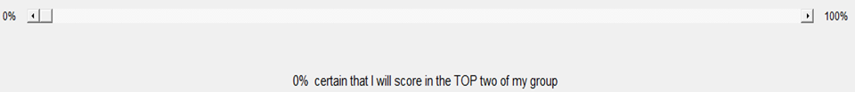

**Press to Continue**

**Feedback After Part 1:**

[Feedback treatment] This is the end of Part 1. Your performance score for the Circle task was one of the [Top or Bottom] two scores of your group.

[NoFeedback treatment] This is the end of Part 1.

**Press to Continue**

**Part 2**

In this part, you will complete the Number Adding Task. In the Number Adding task, you will be asked to add five two digit numbers in a series of tables. The figure below shows the work screen you will use for this task. You will enter the answer into the box below the table. After you have entered the answer, you can click the NEXT button. No matter whether the answer is correct or not, a new table will be generated. Your performance score in this task will be the number of correct answers at the end of the 300 seconds. **If Part 2 is selected for the payment, you will earn £0.50 per each correctly solved number addition.** If you enter a wrong answer, you will earn nothing for that table. You cannot use a calculator to determine the answer, however you are allowed to use the pen and paper on your desks to help you with your calculations.

You are in the same group with the same participants as you were in Part 1. All of your group members will complete the Number Adding task and receive a performance score based on the number of correctly solved number additions.

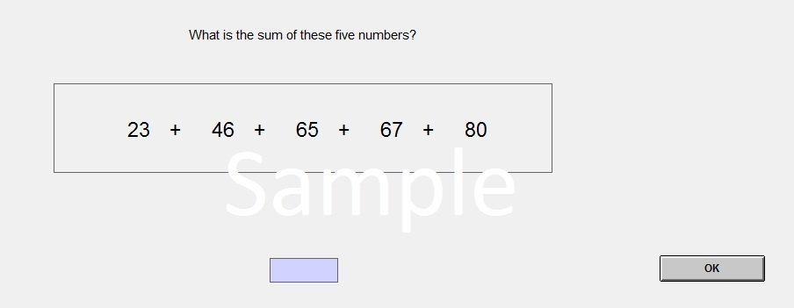

**Press to Continue**

Before starting the Number Adding task, please indicate the probability that your performance score will be one of the top two scores of your group. The accuracy of your stated probability that your performance will be in the top two scores of your group will influence your payment in the same way as before. You have the highest chance to win an additional £1 to your Part 2 earnings if you state the true probability with which you believe that your score is in the top two scores in your group.

At the end of the Number Adding task, you will be informed what your performance score was. At the end of the experimental session, you will also be informed whether your score was in the top two or bottom two of your group.

Before you start the Number Adding task, on a scale from 0 to 100, please indicate the probability that your score will be in the TOP two of your group. You are most likely to win £1 if you are as accurate as possible. (Please assign 0% if you are completely certain you will score in the BOTTOM two and 100% if you are completely certain you will score in the TOP two of your group. Assign intermediary values if you are uncertain whether you will score in the TOP or BOTTOM two of your group).



**Press to Continue**

**Feedback After Part 2:**

This is the end of Part 2. Your performance score for the Number Adding task was [#] correctly solved number additions. Now that you know your score, please indicate the probability that your score in Part 2 was one of the top two scores of your group. The accuracy of your stated probability that your performance will be in the top two scores of your group will influence your payment in the same way as before. You have the highest chance to win an additional £1 to your Part 3 earnings if you state the true probability with which you believe that your score is in the top two scores in your group.

At the end of experiment, you will be informed whether your score was in the TOP or BOTTOM two scorers of your group.

On a scale from 0 to 100, please indicate the probability that your score was in the TOP two of your group. You are most likely to win £1 if you are as accurate as possible. (Please assign 0% if you are completely certain you scored in the BOTTOM two of your group and 100% if you are completely certain you scored in the TOP two of your group. Assign intermediary values if you are uncertain whether you scored in the TOP or BOTTOM two of your group).

**Press to Continue**

**Part 3**

In this part, you do not have to complete any task. Instead you will choose how you want to be paid based on the performance score you received in Part 2, which was the number of correct solved number additions. In the table below, you will choose to be paid either according to Piece Rate or Tournament. You will have to make a choice for each row of the table between Piece Rate (ranging from £0.00 per correctly solved number addition to £1.00 per correct solved number addition) and Tournament.

**If Part 3 is selected for the payment, one of the ten rows will be randomly chosen and you will be paid according to the choice you made on that row.**

If you choose Tournament in the selected row, your performance will be evaluated relative to other members of your group. If you scored in the top two of your group, you will earn £1.00 per each correctly solved number addition. If you scored in the bottom two of your group, you will earn £0.00. Ties in the scores will be randomly resolved by the computer.

If you choose Piece Rate on the selected row, you will earn according to the piece rate of that row for each correctly solved number addition.

Below you can make your choice whether you want to be paid by Piece Rate or Tournament for each row of the table. If you have any questions, please raise your hand and someone will come to your desk to answer it.

|  |  |  |  |
| --- | --- | --- | --- |
| Row | A: Tournament | Your Choice | B: Piece Rate |
| 10 | You get £1.00 per correctly solved number addition if your score in Part 2 was in the TOP two scores of your group and £0.00 if your score in Part 2 was in the Bottom two scores of your group. | □ □ | £1.00 per correct number addition |
| 9 | □ □ | £0.90 per correct number addition |
| 8 | □ □ | £0.80 per correct number addition |
| 7 | □ □ | £0.70 per correct number addition |
| 6 | □ □ | £0.60 per correct number addition |
| 5 | □ □ | £0.50 per correct number addition |
| 4 | □ □ | £0.40 per correct number addition |
| 3 | □ □ | £0.30 per correct number addition |
| 2 | □ □ | £0.20 per correct number addition |
| 1 | □ □ | £0.10 per correct number addition |

**Questionnaire**

End of Part 3: This is the end of the experiment. Before continuing to the final feedback and payment stages, please answer the following questions as accurately as you can. Your answers are anonymous and will not be linked to your identity.

We will be holding different types experiments in the future. If you had a choice, what kind of experiments would you like to participate in?

1. I would STRONGLY prefer participating in the experiments where my earnings depend on my relative performance compared to other participants' performance.

2. I would SLIGHTLY prefer participating in experiments where my earnings depend on my relative performance compared to other participants' performance.

3. I am completely indifferent between the types of experiment.

4. I would SLIGHTLY prefer participating in the experiments where my earnings depend on my own performance NOT compared to other participants' performance.

5. I would STRONGLY prefer participating in the experiments where my earnings depend on my own performance NOT compared to other participants' performance.]

1. What is your gender? Male □ Female □
2. What is your age? __________
3. What is your nationality?

British □ Other □

1. If you are a student, what is your subject area? _____________________
2. On a scale of 1 to 7, how willing are you to take risks in general?

1 □ 2 □ 3 □ 4 □ 5 □ 6 □ 7 □

Not at all willing Very willing

1. On a scale of 1 to 7, how confident are you as a person?

1 □ 2 □ 3 □ 4 □ 5 □ 6 □ 7 □

Not at all confident Extremely confident

1. On a scale of 1 to 7, how competitive are you as a person?

1 □ 2 □ 3 □ 4 □ 5 □ 6 □ 7 □

Not at all competitive Extremely Competitive

1. Do you think that the performance in the Circle task and Number Adding task are related? (that is, people who tend to score high in the Circle Task also score high in the Number Adding task, and vice versa.)

Yes □ No □ Don’t Know □

**End of Study Feedback Screen**

In Part 1, your performance score in the Circle task was [#] correctly judged circles and you were in the [Top or Bottom] two of your group.

In Part 2, your performance score in the Number Adding task was [#] correctly solved number additions and you were in the [Top or Bottom] two of your group.

Part [1, 2 or 3] was chosen for your payment.

You will be paid a show-up fee of £2 and a participation fee of £5 in this experiment. Additionally you will be paid £[#] for your performance in Part [1, 2 or 3]. Your total earnings today are £[#]. Please wait at your desk until the experimenter comes to you.

Thank you for your participation!

**A2 Experimental Instructions for the Pilot Experiments**

**Instructions**

Welcome! You are about to participate in an experiment on decision making.

In this experiment, you will be asked to complete five tasks. Each task is independent from each other. The instructions for each task will be shown on your screens before the start of each task. Please read the instructions on your screens carefully and take notes if necessary as you will not be able to go back to read them again once a task starts.

After you have completed all of the five tasks, you will be asked to fill a survey questionnaire that will end the experiment. At the end of the experiment, one task will be randomly chosen by the computer. You will receive detailed feedback about your performance score and earnings in the selected task. Your final payment will be determined according to your earnings in the selected task. Any one task is equally likely to be selected at the end of the experiment, so you have to perform as well as you can in each task.

Throughout the experiment you must not communicate with other participants. The use of any electronic devices is strictly prohibited. If you break these rules, you will be excluded from the experiment without receiving any payment and be disqualified from future experiments with us.

If you have any questions before the start of the experiment, please raise your hand and someone will come to your desk to answer it.

**Circle task**

In this task, you will be asked to pick a circle with more dots in a series of circle pairs. The figure below shows an example of a circle pair. One of the circles contains 50 dots and the other one 55 dots. Each circle pair will appear on your screens for 1 second only. After the circle pair disappears from your screen, you will be asked to judge whether the right or the left circle contained more dots. You have to indicate your judgement by clicking on the "Left" or "Right" button. When you click the button of your choice, you will move to the next pair of circles. The task consists of three sets of 20 circle pairs and you will be notified when you finish one set of 20 circle pairs on your screens. Your performance score in this task will be the total number of correctly judged circles. You will earn £0.25 per each correct answer.

If you have any question, please raise your hand and someone will come to your desk to answer it. If you are ready click Start the Task button.

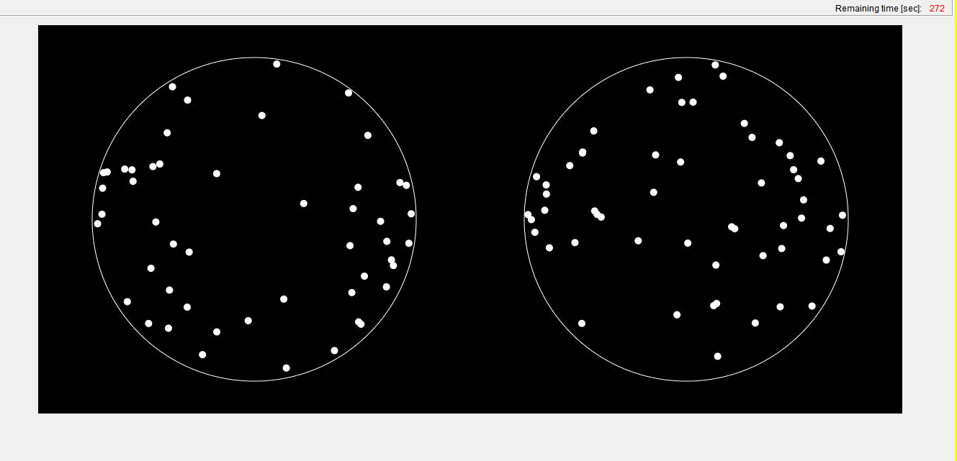

**Counting Zeros task**

In this task, you will be asked to count zeros in a series of tables. The figure below shows the work screen you will work on for this task. You will enter the number of zeros into the box below the table. After you have entered the number, you can click the NEXT button. No matter if the answer is correct or not, a new table will be generated. Your performance score in this task will be the number of correctly solved tables at the end of the 300 seconds. You will earn £0.40 per each table you solved correctly. If you enter a wrong number for a table, you will earn nothing for that table.

If you have any question, please raise your hand and someone will come to your desk to answer it. If you are ready, click Start the Task button.

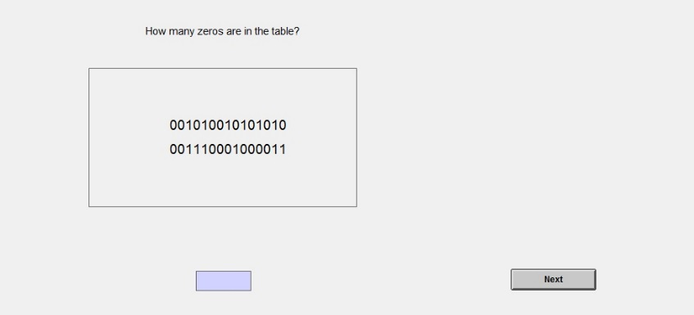

**Slider task**

In this task, you will be asked to position a series of sliders. The figure below shows the work screen you will work on for this task. Each slider is initially positioned at 0 and can be moved as far as 100. Each slider has a number below showing its current position. You can use the mouse or the arrow keys on the keyboard in any way you like to move each slider. You can readjust the position of each slider as many times as you wish. After you have positioned a slider, you can click the NEXT button and a new slider will be generated. Your performance score in this task will be the number of sliders positioned at exactly 50 at the end of the 300 seconds. You will earn £0.10 per each slider you positioned at exactly 50.

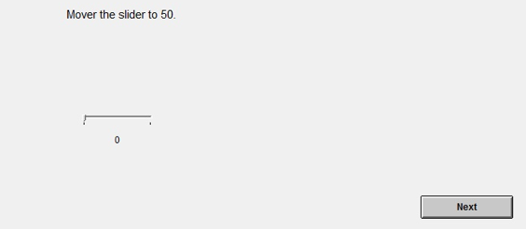

**Number Adding task [Pilot 1]**

In this task, you will be asked to add five single digit numbers in a series of tables. The figure below shows the work screen you will work on for this task. You will enter the answer into the box below the table. After you have entered the answer, you can click the NEXT button. No matter if the answer is correct or not, a new table will be generated. Your performance score in this task will be the number of correct answers at the end of the 300 seconds. You will earn £0.40 per each correct answer. If you enter a wrong answer, you will earn nothing for that table.

If you have any question, please raise your hand and someone will come to your desk to answer it. If you are ready, click Start the Task button.

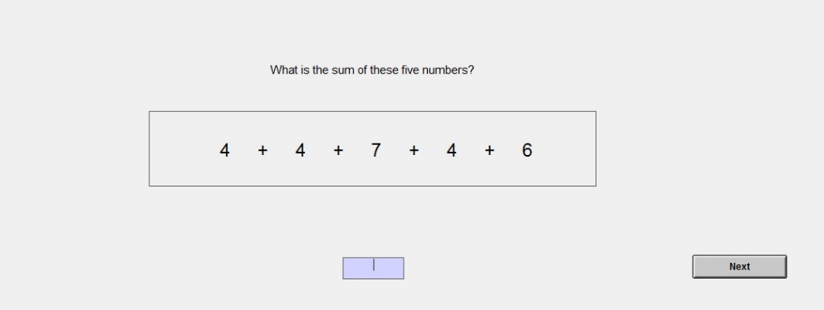

**Ball Catching Task [Pilot 1]**

In this task, you will be asked to catch balls. There will be a box in the middle of the task screen like the one shown below. Once you click on the "Start" button, balls will fall randomly from the top of the task box. You can move the tray at the bottom of the task box to catch the balls by using the mouse to click on the LEFT or RIGHT buttons. To catch a ball, your tray must be below the ball before it touches the bottom of the tray. The number of balls you caught so far (displayed as CATCHES) and the number of clicks you made so far (CLICKS) are shown right above the task box. You will receive a prize of £0.10 for each ball you catch and incur a cost of £0.05 for each mouse click you make. Your performance score will be (CATCHES)*£0.10 - (CLICKS)*£0.05 at the end of the 300 seconds.

If you have any question, please raise your hand and someone will come to your desk to answer it. If you are ready click Start the Task button.

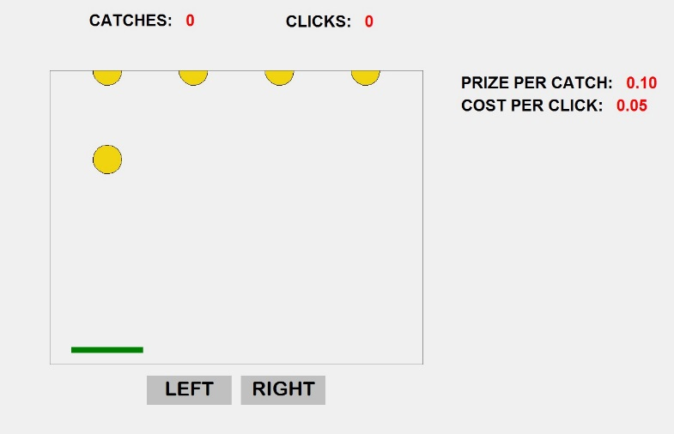

**Number Adding task [Pilot 2]**

In this task, you will be asked to add five single digit numbers in a series of tables. The figure below shows the work screen you will work on for this task. You will enter the answer into the box below the table. After you have entered the answer, you can click the NEXT button. No matter if the answer is correct or not, a new table will be generated. Your performance score in this task will be the number of correct answers at the end of the 300 seconds. You will earn £0.50 per each correct answer. If you enter a wrong answer, you will earn nothing for that task.

If you have any question, please raise your hand and someone will come to your desk to answer it. If you are ready, click Start the Task button.

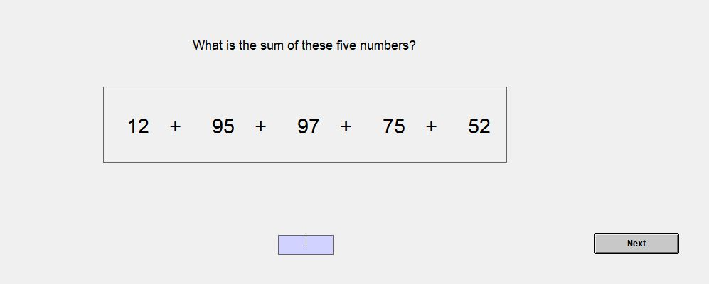

**Anagram Task [Pilot 2]**

In this task, you will be asked to solve a series of anagrams consisting of 5 to 7 letters. An anagram is a word formed by reordering the letters of another word. The figure below shows the work screen you will work on for this task. You will enter the anagram into the box below the letters. After you have entered the anagram, you can click the NEXT button. No matter if the answer is correct or not, new letters will be generated. Your performance score in this task will be the number of correct anagrams at the end of the 300 seconds. You will earn £0.50 per each correct anagram. If you enter a wrong anagram, you will earn nothing for that task.

If you have any question, please raise your hand and someone will come to your desk to answer it. If you are ready click Start the Task button.

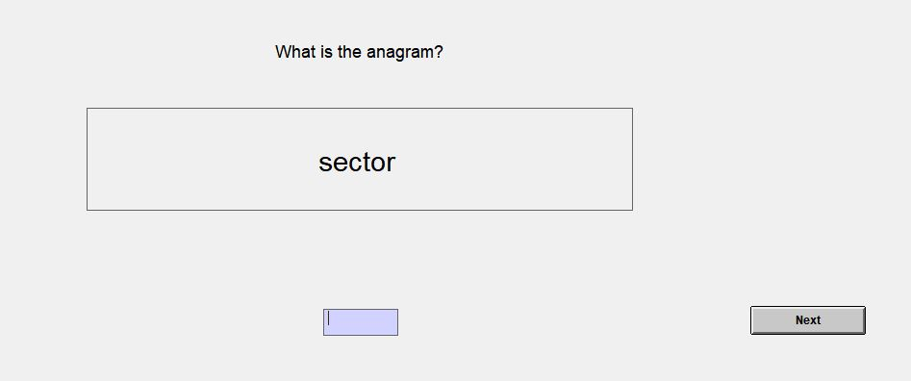

**[Eliciting Preferences for Relative Performance Pay for Each task]**

Everyone has now finished all the tasks. Before proceeding to the payment stage, you have a chance to increase your earnings. You can decide whether you want to compete in each of the five tasks against one randomly selected participant.

After you have indicated your choice to compete or not for every task, the computer will randomly choose one task. If you have chosen to compete in that task, we will compare your performance score on that task to the score of one randomly selected other participant. If your score is higher than the score of the other participant, we will add £2 to your final earnings. If your score is lower than the score of the other participant, we will subtract £2 from your final earnings. If you chose not to compete, your final earnings will not be affected and you will be paid according to your performance score only on the selected task.

Please note that your choice and earnings will not affect the earnings of the other participants.

At the end of the session, you will receive detailed information about your own, the randomly selected participant's score, your choice to compete or not and your earnings resulting from your scores and choices on the selected task.

If you have any question please raise your hand and someone will come to your desk to answer it. If you are ready, please indicate your choices on the next screen.

Please indicate whether you choose to COMPETE or NOT COMPETE for each of the following tasks

Circle Task Compete □ □ Not compete

Ball Catching Task Compete □ □ Not compete

Slider Task Compete □ □ Not compete

Counting Zeros Task Compete □ □ Not compete

Number Adding Task Compete □ □ Not compete

**Questionnaire 1**

**Please answer the following questions trying to be as accurate as you can. Your answers are anonymous and will not be linked to your identity.**

What is your gender? □ Male □ Female

What is your age? __________

What is your nationality?

□ British □ Other (please specify) _____________________

If you are a student, what is your subject area?

□ Humanities □ Natural Sciences □ Engineering □ Medical Sciences

□ Economics □ Business □ Politics □ Law

□ Other (please specify) ___________________

On a scale of 1 to 7, how willing are you to take risks in general?

1 □ 2 □ 3 □ 4 □ 5 □ 6 □ 7 □

Not at all willing Very willing

On a scale of 1 to 7, how confident are you as a person?

1 □ 2 □ 3 □ 4 □ 5 □ 6 □ 7 □

Not at all confident Very confident

On a scale of 1 to 7, how competitive are you as a person?

1 □ 2 □ 3 □ 4 □ 5 □ 6 □ 7 □

Not at all competitive Very competitive

On a scale of 1 to 7, how difficult was each task that you completed?

Circle Task 1 □ 2 □ 3 □ 4 □ 5 □ 6 □ 7 □

Ball Catching 1 □ 2 □ 3 □ 4 □ 5 □ 6 □ 7 □

Number Adding 1 □ 2 □ 3 □ 4 □ 5 □ 6 □ 7 □

Counting Zeros 1 □ 2 □ 3 □ 4 □ 5 □ 6 □ 7 □

Slider 1 □ 2 □ 3 □ 4 □ 5 □ 6 □ 7 □

Anagram [Pilot 2] 1 □ 2 □ 3 □ 4 □ 5 □ 6 □ 7 □

**Questionnaire 2 [Pilot 2]**

On a scale of 1 to 7, please choose whether the cognitive skill described is important for high performance in each task that you completed:

**Attention: Holding attention while completing the task**

|  |  |
| --- | --- |
| Circle Task | Not at all Important 1 □ 2 □ 3 □ 4 □ 5 □ 6 □ 7 □ Very Important □ Can’t Judge |
| Number Adding | Not at all Important 1 □ 2 □ 3 □ 4 □ 5 □ 6 □ 7 □ Very Important □ Can’t Judge |
| Counting Zeros | Not at all Important 1 □ 2 □ 3 □ 4 □ 5 □ 6 □ 7 □ Very Important □ Can’t Judge |
| Slider | Not at all Important 1 □ 2 □ 3 □ 4 □ 5 □ 6 □ 7 □ Very Important □ Can’t Judge |
| Anagram | Not at all Important 1 □ 2 □ 3 □ 4 □ 5 □ 6 □ 7 □ Very Important □ Can’t Judge |

**Working Memory: Ability to learn information and use that information for the current activity**

|  |  |
| --- | --- |
| Circle Task | Not at all Important 1 □ 2 □ 3 □ 4 □ 5 □ 6 □ 7 □ Very Important □ Can’t Judge |
| Number Adding | Not at all Important 1 □ 2 □ 3 □ 4 □ 5 □ 6 □ 7 □ Very Important □ Can’t Judge |
| Counting Zeros | Not at all Important 1 □ 2 □ 3 □ 4 □ 5 □ 6 □ 7 □ Very Important □ Can’t Judge |
| Slider | Not at all Important 1 □ 2 □ 3 □ 4 □ 5 □ 6 □ 7 □ Very Important □ Can’t Judge |
| Anagram | Not at all Important 1 □ 2 □ 3 □ 4 □ 5 □ 6 □ 7 □ Very Important □ Can’t Judge |

**Visual Perception: Ability to see and interpret the visual information**

|  |  |
| --- | --- |
| Circle Task | Not at all Important 1 □ 2 □ 3 □ 4 □ 5 □ 6 □ 7 □ Very Important □ Can’t Judge |
| Number Adding | Not at all Important 1 □ 2 □ 3 □ 4 □ 5 □ 6 □ 7 □ Very Important □ Can’t Judge |
| Counting Zeros | Not at all Important 1 □ 2 □ 3 □ 4 □ 5 □ 6 □ 7 □ Very Important □ Can’t Judge |
| Slider | Not at all Important 1 □ 2 □ 3 □ 4 □ 5 □ 6 □ 7 □ Very Important □ Can’t Judge |
| Anagram | Not at all Important 1 □ 2 □ 3 □ 4 □ 5 □ 6 □ 7 □ Very Important □ Can’t Judge |

**Cognitive Flexibility: Being able to consider several solutions or plans, not only the first one that comes to mind**

|  |  |
| --- | --- |
| Circle Task | Not at all Important 1 □ 2 □ 3 □ 4 □ 5 □ 6 □ 7 □ Very Important □ Can’t Judge |
| Number Adding | Not at all Important 1 □ 2 □ 3 □ 4 □ 5 □ 6 □ 7 □ Very Important □ Can’t Judge |
| Counting Zeros | Not at all Important 1 □ 2 □ 3 □ 4 □ 5 □ 6 □ 7 □ Very Important □ Can’t Judge |
| Slider | Not at all Important 1 □ 2 □ 3 □ 4 □ 5 □ 6 □ 7 □ Very Important □ Can’t Judge |
| Anagram | Not at all Important 1 □ 2 □ 3 □ 4 □ 5 □ 6 □ 7 □ Very Important □ Can’t Judge |

**Numeracy Skills: Ability to reason and to apply simple numerical concepts**

|  |  |
| --- | --- |
| Circle Task | Not at all Important 1 □ 2 □ 3 □ 4 □ 5 □ 6 □ 7 □ Very Important □ Can’t Judge |
| Number Adding | Not at all Important 1 □ 2 □ 3 □ 4 □ 5 □ 6 □ 7 □ Very Important □ Can’t Judge |
| Counting Zeros | Not at all Important 1 □ 2 □ 3 □ 4 □ 5 □ 6 □ 7 □ Very Important □ Can’t Judge |
| Slider | Not at all Important 1 □ 2 □ 3 □ 4 □ 5 □ 6 □ 7 □ Very Important □ Can’t Judge |
| Anagram | Not at all Important 1 □ 2 □ 3 □ 4 □ 5 □ 6 □ 7 □ Very Important □ Can’t Judge |

**Please make a judgement whether the performance in the two tasks are positively related (people who do well in one task also are more likely to do well in the other task), negatively related (people who do well in one task are more likely to do worse in the other task), or not related. If you can't make a judgement please choose the last option.**

□ The two are not related □ Positively related □ Negatively related □ I can’t say/ I don’t know

|  |  |
| --- | --- |
| Circle and Slider task | Slider and Counting Zeros Task |
| Circle and Number adding task | Slider and Anagram Task |
| Circle and Anagram task | Number Adding and Anagram Task |
| Circle and Counting Zeros task | Number Adding and Counting Zeros Task |
| Slider and Number Adding task | Counting Zeros and Anagram task |

**Appendix B Pilot Experiment Results**

|  |  |  |  |  |  |
| --- | --- | --- | --- | --- | --- |
| **Table B1**: Pilot Results on Five Real Effort Tasks | | | | | |
| **Pilot 1**  (N=18) | Number adding  *(single-digit)* | Slider | Circle | Counting zeros | Ball catching |
|  | Mean (SD) | | | | |
| Score | 40 (8.23) | 46 (14.45) | 41 (5.26) | 32 (6.10) | 123 (20.88) |
| Difficulty | 3.00 (1.32) | 3.11 (1.23) | 5.16 (1.20) | 3.50 (0.93) | 3.05 (1.11) |
| Compete Choice | 50% | 29% | 28% | 33% | 55% |
| Spearman correlation coefficients in performance | | | | | |
| Slider | 0.13 |  |  |  |  |
| Circle | 0.38 | -0.21 |  |  |  |
| Count Zeros | 0.40* | 0.42* | -0.03 |  |  |
| Ball Catching | 0.14 | -0.04 | 0.48** | 0.36 |  |
| Spearman correlation coefficients in perceptions of difficulty | | | | | |
| Slider | -0.03 |  |  |  |  |
| Circle | 0.37 | 0.26 |  |  |  |
| Count Zeros | 0.38 | 0.46** | 0.31 |  |  |
| Ball Catching | 0.19 | 0.25 | 0.27 | 0.21 |  |
| Spearman correlation coefficients in choosing competitive pay | | | | | |
| Slider | -0.17 |  |  |  |  |
| Circle | 0.09 | 0.43* |  |  |  |
| Count Zeros | 0.35 | 0.43* | 0.15 |  |  |
| Ball Catching | 0.53** | -0.17 | 0.35 | 0.35 |  |
| **Pilot 2**  (N=24) | Number adding  *(double-digit)* | Slider | Circle | Counting zeros | Anagram |
|  | Mean (SD) | | | | |
| Score | 10 (3.66) | 42 (9.75) | 41 (4.22) | 29 (6.20) | 21 (7.07) |
| Difficulty | 3.58 (1.48) | 2.66 (1.17) | 4.08 (1.38) | 2.91 (1.31) | 4 (1.32) |
| Compete Choice | 67% | 71% | 38% | 51% | 42% |
| Spearman correlation coefficients in performance | | | | | |
| Slider | 0.27 |  |  |  |  |
| Circle | 0.13 | 0.20 |  |  |  |
| Count Zeros | 0.09 | 0.36* | 0.14 |  |  |
| Anagram | 0.10 | -0.04 | 0.55*** | 0.16 |  |
| Spearman correlation coefficients in perceptions of difficulty | | | | | |
| Slider | 0.14 |  |  |  |  |
| Circle | -0.03 | 0.02 |  |  |  |
| Count Zeros | 0.30 | 0.63*** | 0.00 |  |  |
| Anagram | 0.61*** | 0.03 | -0.02 | 0.13 |  |
| Spearman correlation coefficients in choosing competitive pay | | | | | |
| Slider | 0.91*** |  |  |  |  |
| Circle | 0.18 | 0.31 |  |  |  |
| Count Zeros | 0.77*** | 0.70*** | 0.37* |  |  |
| Anagram | 0.60*** | 0.54*** | 0.57*** | 0.61*** |  |
| Correlations with Number Adding Task in Cognitive Skills | | | | |  |
| Attention |  | 0.31 | 0.56*** | 0.67*** | 0.40** |
| Working Memory |  | 0.05 | 0.38* | 0.51** | 0.52*** |
| Cognitive Flexibility |  | 0.23 | 0.33 | 0.62*** | 0.17 |
| Visual Perception |  | 0.31 | 0.21 | 0.24 | 0.66*** |
| Numeracy |  | 0.16 | 0.08 | 0.33 | 0.14 |
| Relatedness Scores with Number Adding: % choosing either not related or don’t know. | | | | | |
| Slider  65% | Circle  50% | Counting Zeros  20% | Anagram  40% |  |  |
| *\* 10%, ** 5%, *** 1% significance levels.* | | | | | |

**Appendix C Additional Tables and Figures**



**Figure C1:** Histogram of the PR-equivalents

**Table C1:** Alternative Tests for Feedback Spillover Effects

|  |  |  |  |
| --- | --- | --- | --- |
|  | | PR-Equivalent | |
|  | | (1) | (2) |
| (a) Symmetrically censored least squares regression with the Table 2 controls | | | |
| Top (vs. no feedback) | 0.09*  (0.05) | | 0.10**  (0.05) |
| Bottom (vs. no feedback) | -0.07  (0.06) | | -0.08  (0.07) |
| **Feedback treatment only** |  | |  |
| Top (vs. bottom) | 0.12*  (0.06) | | 0.11*  (0.06) |
| (b) Tobit regressions with number adding score fixed effects | | | |
| Top (vs. no feedback) | 0.07***  (0.02) | | 0.06**  (0.03) | |
| Bottom (vs. no feedback) | -0.02  (0.07) | | -0.01  (0.06) | |
| **Feedback treatment only** |  | |  | |
| Top (vs. bottom) | 0.06*  (0.04) | | 0.05*  (0.03) | |
| Demographics & psych. measures | N | | Y |
| *Note: Standard errors clustered at session level are in parentheses. All regressions include controls of circle task confidence and number adding task score. Demographics include gender and age. Psychological measures include general risk-taking, confidence, and competitiveness. * 10%, ** 5%, *** 1% significance levels.* | | | |

**Table C2:** Results of the Robustness Study (Tobit Regressions)

|  |  |  |
| --- | --- | --- |
|  | PR-Equivalent | |
|  | (1) | (2) |
|  | | |
| Top (vs. no feedback) | 0.11  (0.12) | 0.11  (0.12) |
| Bottom (vs. no feedback) | - 0.13  (0.13) | - 0.12  (0.12) |
| **Feedback treatments only** |  |  |
| Top (vs. bottom) | 0.28***  (0.09) | 0.25**  (0.12) |
| Demographics & psych. measures | N | Y |
| *Note: Standard errors clustered at session level are in parentheses. All regressions include controls of circle task confidence and number adding task score. Demographics include gender and age. Psychological measures include general risk-taking, confidence, and competitiveness. * 10%, ** 5%, *** 1% significance levels.* | | |