Carbon组件开发教程

基础平台组
2014年09月
目录

第1章 总体说明 1
1.1 修订历史 1
1.2 内容简介 1
1.3 用户范围 1
第2章 Carbon组件开发示例 2
2.1 Best practices 2
2.2 创建maven父项目(stu-manager) 2
2.3 创建maven子项目 4
2.3.1 stu-manager-components 4
2.3.2 stu-manager-features 6
2.3.3 stu-manager-repository 6
2.3.4 创建服务端组件子项目(org.dhcc.carbon.student.mgt) 7
2.4 项目概览 9
2.4.1 目录结构 9
2.4.2 student-manager-components项目pom.xml 9
2.4.3 student-manager-features项目pom.xml 10
2.4.4 student-manager-repository项目pom.xml 10
2.4.5 student-manager项目pom.xml 10
2.5 编写服务端组件(org.dhcc.carbon.student.mgt) 11
2.5.1 转换项目为java项目 11
2.5.2 设置编译路径 12
2.5.3 编写代码 14
2.5.4 编写services.xml 15
2.5.5 Maven install 16
2.6 编写Service Stub 17
2.6.1 org.dhcc.carbon.student.mgt.stub项目pom.xml 18
2.7 编写UI Component 21
2.7.1 org.dhcc.carbon.student.mgt.ui项目pom.xml 21
2.7.2 转换项目为java项目 22
2.7.3 编写代码 22
2.7.4 编写页面 24
2.8 部署运行 28
2.9 由Carbon Component创建feature 28
2.9.1 在stu-manager-features项目下创建3个子项目 29
2.9.2 项目概览 29
2.9.3 更新student-manager-repository的pom文件 35
2.9.4 安装feature 37
第3章 编译carbon kernel源码 39
3.1 SVN地址 39
3.2 使用jdk1.6 39
3.3 Pom文件修改 39
3.3.1 dependencies\axis2\1.6.1-wso2v10\modules\parent 39
3.3.2 dependencies\wss4j\1.5.11-wso2v6 40
第4章 Carbon源码Debug 41
4.1 Carbon在eclipse上运行 41
4.1.1 拷贝必要的文件 41
4.1.2 修改数据库配置 41
4.1.3 入口函数 42
4.1.4 引入相关jar包 42
4.1.5 设置运行参数 43
4.1.6 运行 45
4.2 wso2esb在eclipse上运行 46
4.2.1 拷贝必要的文件 46
4.2.2 修改axis2配置 46
4.2.3 修改数据库配置 47
4.2.4 入口函数 47
4.2.5 引入相关jar包 47
4.2.6 设置运行参数 47
4.2.7 运行 47
4.3 wso2esb在eclipse上debug 47
4.3.1 进入组件页面 47
4.3.2 导入组件代码到eclipse 48
4.3.3 找到相关执行函数，打断点 49
第5章 FAQ（常见问题解答） 50
第6章 附录 51
6.1 maven拷贝文件到指定目录 51
6.2 Carbon代码编译顺序 51
6.3 feature.properties 52

总体说明

修订历史

版本 | 日期 | 状态 | 修订人 | 摘要
V1.0 | 2014-09-28 | C | 于鸿 | 第一版本

状态标识：C –Created A- Added M - Modified D – Deleted

内容简介
第2章用于指导用户开发carbon组件。第3、4章用于指导用户Debug Carbon组件。附录为对本文部分内容的补充。

用户范围
需要开发Carbon组件的开发人员。

Carbon组件开发示例

Best practices
  - Always create the pom from scratch. This will prevent adding unnecessary dependencies
  - If there are any common dependencies for all the sub maven projects, add them to the parent pom
  - Maintain the versions in parent pom as parameters and use them in sub projects to define the versions. Then, whenever there’s an update on the versions, it will be easy to update
  - Do not copy/paste the code, re-use the code through OSGI, Util methods, etc
  - Write tests for your code. This will gain a good percentage of code coverage. Otherwise developers will not know whether changes will break functionality or not until it is too late
  - Understand Multi Tenancy and design for Multi Tenancy. Making code work for multiple tenants needs some careful designing. It may not be straightforward in some cases
  - Click here for more information on best practices

创建maven父项目(stu-manager)
相关属性如下：
  - groupId - org.dhcc.carbon
  - artifactId - stu-manager
  - version - 1.0.0
  - packaging - pom
  - name - DHCC Carbon - Student Manager
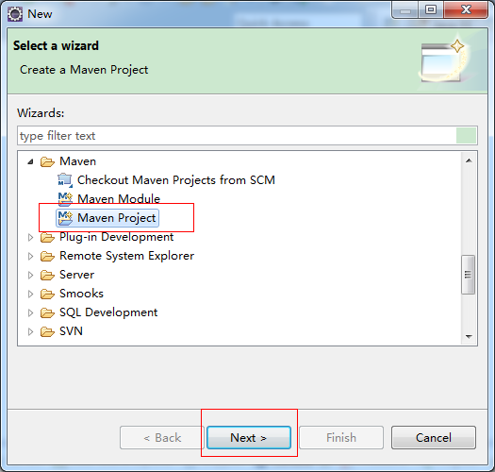
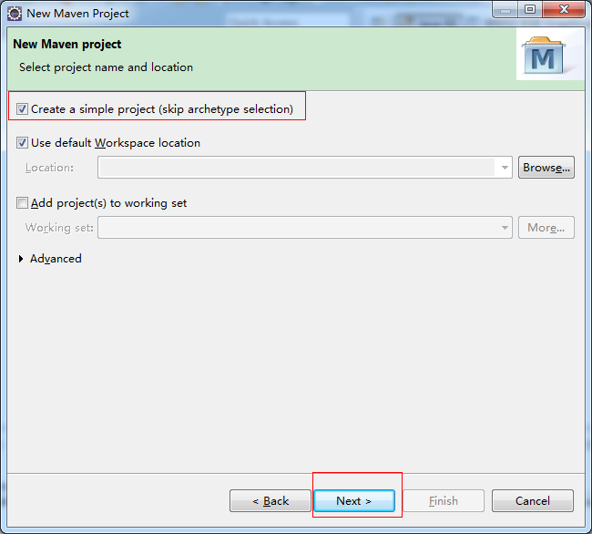
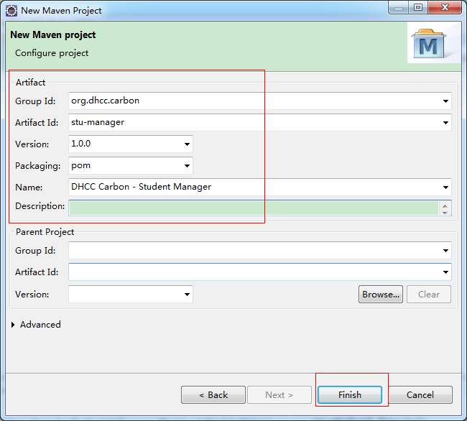
IDE会自动创建src文件夹，由于这是父项目，我们可以删掉src文件夹。
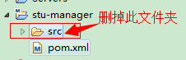
后面会修改pom文件，添加仓库地址指向wso2的maven仓库，以检出依赖包。

创建maven子项目
    - stu-manager-components
相关属性如下：
  - artifactId - stu-manager-components
  - packaging - pom
  - name - DHCC Carbon - Student Manager Components
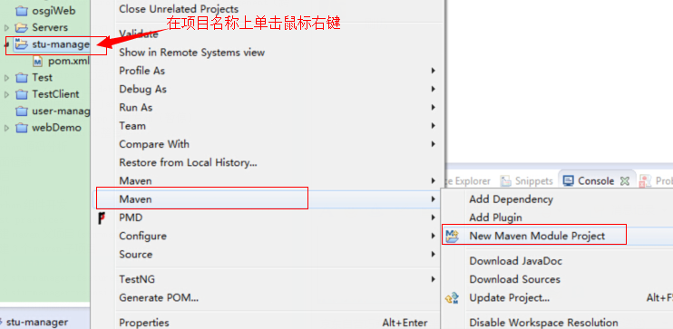
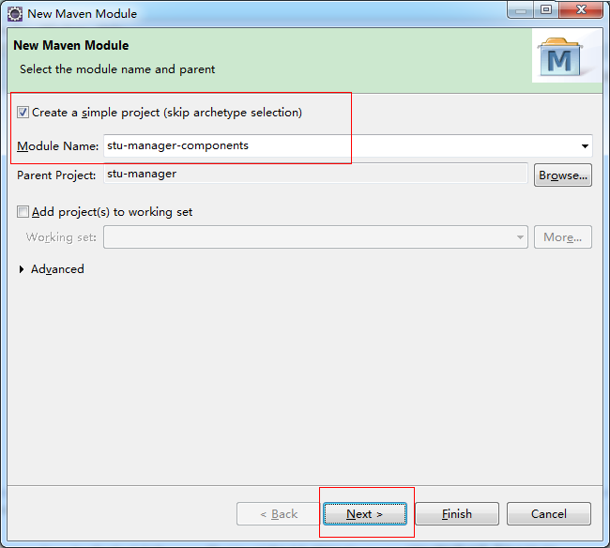
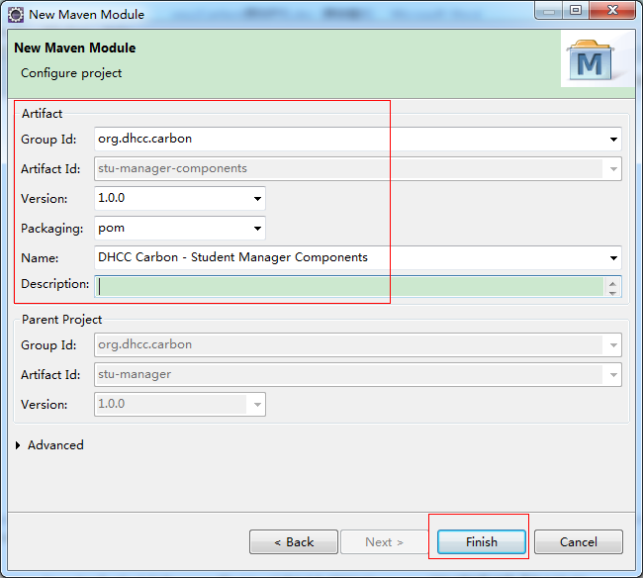
IDE会自动创建src文件夹，由于这是子项目，我们可以删掉src文件夹。
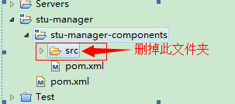
    - stu-manager-features
相关属性如下：
  - artifactId - stu-manager-features
  - packaging - pom
  - name - DHCC Carbon - Student Manager Features
创建过程参考stu-manager-components项目的创建过程。
    - stu-manager-repository
相关属性如下：
  - artifactId - stu-manager-repository
  - packaging - pom
  - name - DHCC Carbon - Student Manager Repository
创建过程参考stu-manager-components项目的创建过程。
    - 创建服务端组件子项目(org.dhcc.carbon.student.mgt)
在stu-manager-components 项目下创建服务端组件。因为这将成为一个osgi bundle，所以需要配置Apache Felix插件来设置配置。
相关属性如下：
  - artifactId - org.dhcc.carbon.student.mgt
  - packaging - bundle
  - name - DHCC Carbon - Student Manager Server Component
  - plugin - maven-bundle-plugin
      - 建立maven项目
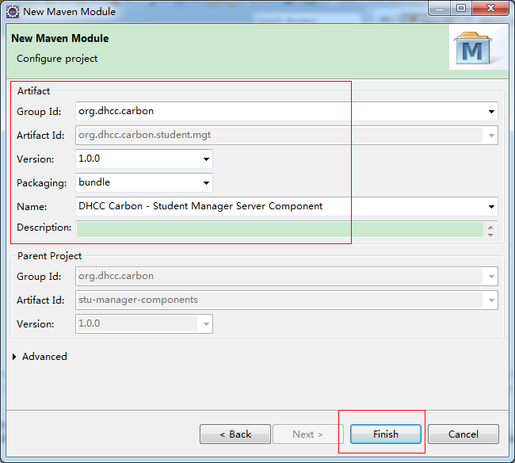
      - 修改pom文件
Pom.xml文件修改为如下所示：
org.dhcc.carbon.student.mgt → pom.xml
<project xmlns="http://maven.apache.org/POM/4.0.0" xmlns:xsi="http://www.w3.org/2001/XMLSchema-instance" xsi:schemaLocation="http://maven.apache.org/POM/4.0.0 http://maven.apache.org/xsd/maven-4.0.0.xsd">
<modelVersion>4.0.0</modelVersion>
<parent>
<groupId>org.dhcc.carbon</groupId>
<artifactId>stu-manager-components</artifactId>
<version>1.0.0</version>
</parent>
<artifactId>org.dhcc.carbon.student.mgt</artifactId>
<packaging>bundle</packaging>
<name>DHCC Carbon - Student Manager Server Component</name>
<build>
<plugins>
<plugin>
<groupId>org.apache.felix</groupId>
<artifactId>maven-bundle-plugin</artifactId>
<extensions>true</extensions>
<configuration>
<instructions>
<Bundle-SymbolicName>${pom.artifactId}</Bundle-SymbolicName>
<Bundle-Name>${pom.artifactId}</Bundle-Name>
<Export-Package>org.dhcc.carbon.student.mgt.*</Export-Package>
</instructions>
</configuration>
</plugin>
</plugins>
</build>
</project>

Note: When you export packages for the OSGI bundle, remember that if you are using any API classes or any other dependency in a separate package you have to export them as well. In this example, we will have our data classes in the org.dhcc.carbon.student.mgt.data package. Exporting the parent mgt package will export everything needed.

项目概览
    - 目录结构
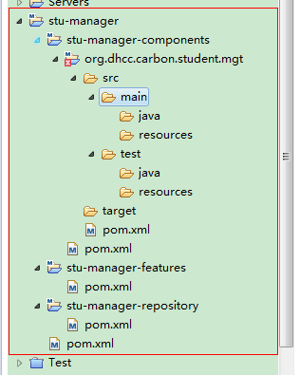
    - student-manager-components项目pom.xml
student-manager-components → pom.xml
<project xmlns="http://maven.apache.org/POM/4.0.0" xmlns:xsi="http://www.w3.org/2001/XMLSchema-instance" xsi:schemaLocation="http://maven.apache.org/POM/4.0.0 http://maven.apache.org/xsd/maven-4.0.0.xsd">
<modelVersion>4.0.0</modelVersion>
<parent>
<groupId>org.dhcc.carbon</groupId>
<artifactId>stu-manager</artifactId>
<version>1.0.0</version>
</parent>
<artifactId>stu-manager-components</artifactId>
<packaging>pom</packaging>
<name>DHCC Carbon - Student Manager Components</name>
<modules>
<module>org.dhcc.carbon.student.mgt</module>
<!-- There are 2 more projects to be added here later in this tutorial stub, ui -->
</modules>
</project>
    - student-manager-features项目pom.xml
student-manager-features→ pom.xml
<project xmlns="http://maven.apache.org/POM/4.0.0" xmlns:xsi="http://www.w3.org/2001/XMLSchema-instance" xsi:schemaLocation="http://maven.apache.org/POM/4.0.0 http://maven.apache.org/xsd/maven-4.0.0.xsd">
<modelVersion>4.0.0</modelVersion>
<parent>
<groupId>org.dhcc.carbon</groupId>
<artifactId>stu-manager</artifactId>
<version>1.0.0</version>
</parent>
<artifactId>stu-manager-features</artifactId>
<packaging>pom</packaging>
<name>DHCC Carbon - Student Manager Features</name>
</project>
<!-- We will be again updating this pom later in this tutorial -->
    - student-manager-repository项目pom.xml
student-manager-repository→ pom.xml
<project xmlns="http://maven.apache.org/POM/4.0.0" xmlns:xsi="http://www.w3.org/2001/XMLSchema-instance" xsi:schemaLocation="http://maven.apache.org/POM/4.0.0 http://maven.apache.org/xsd/maven-4.0.0.xsd">
<modelVersion>4.0.0</modelVersion>
<parent>
<groupId>org.dhcc.carbon</groupId>
<artifactId>stu-manager</artifactId>
<version>1.0.0</version>
</parent>
<artifactId>stu-manager-repository</artifactId>
<packaging>pom</packaging>
<name>DHCC Carbon - Student Manager Repository</name>
</project>
<!-- We will be again updating this pom later in this tutorial -->
    - student-manager项目pom.xml
student-manager→ pom.xml
<project xmlns="http://maven.apache.org/POM/4.0.0" xmlns:xsi="http://www.w3.org/2001/XMLSchema-instance" xsi:schemaLocation="http://maven.apache.org/POM/4.0.0 http://maven.apache.org/xsd/maven-4.0.0.xsd">
<modelVersion>4.0.0</modelVersion>
<groupId>org.dhcc.carbon</groupId>
<artifactId>stu-manager</artifactId>
<version>1.0.0</version>
<packaging>pom</packaging>
<name>DHCC Carbon - Student Manager</name>
<modules>
<module>stu-manager-components</module>
<module>stu-manager-features</module>
<module>stu-manager-repository</module>
</modules>

<repositories>
<repository>
<id>wso2-nexus</id>
<name>WSO2 internal Repository</name>
<url>http://maven.wso2.org/nexus/content/groups/wso2-public/</url>
<releases>
<enabled>true</enabled>
</releases>
<snapshots>
<enabled>false</enabled>
</snapshots>
<layout>default</layout>
</repository>
</repositories>
</project>

编写服务端组件(org.dhcc.carbon.student.mgt)
为了使用IDE工具方便的编写代码，先将org.dhcc.carbon.student.mgt项目转换成java项目。
    - 转换项目为java项目
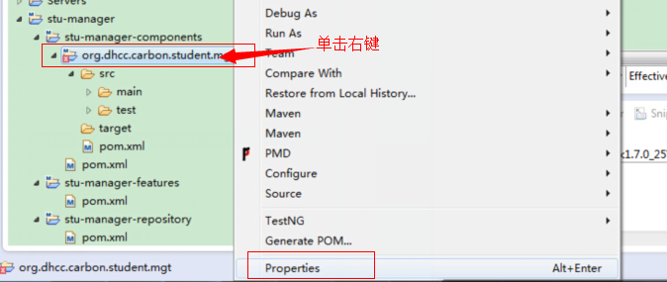
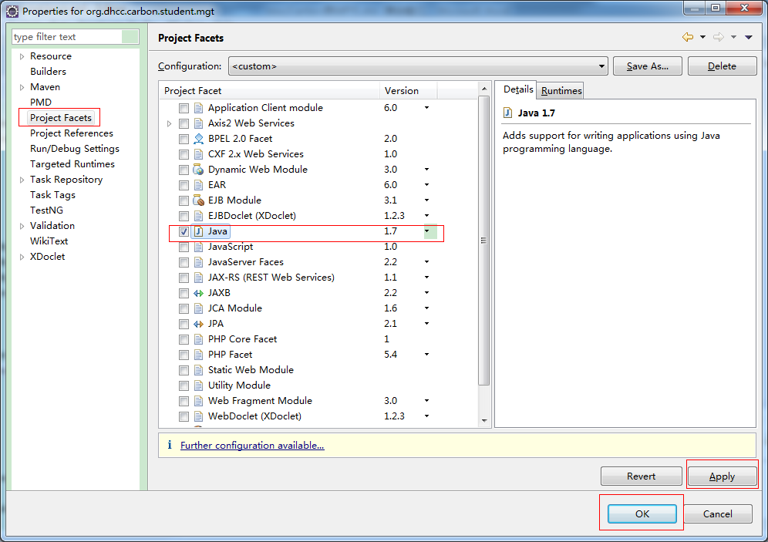
    - 设置编译路径
      - 转换后的目录结构
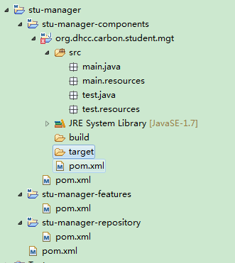
      - 修改文件夹属性
将src.main.java，src.main.resources，src.test.java，src.test.resources设置为资源路径
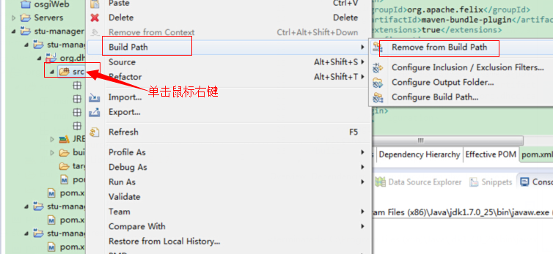
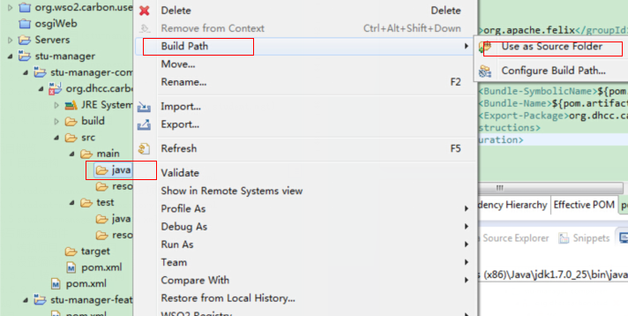
      - 修改后的目录结构
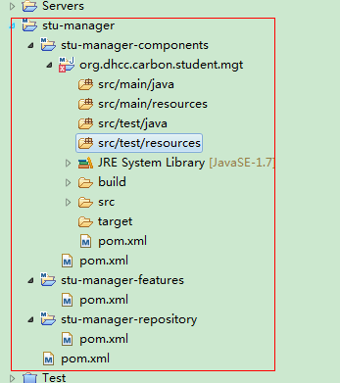
    - 编写代码
在org.dhcc.carbon.student.mgt项目下添加2个java类：
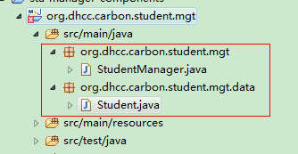
      - Student.java
package org.dhcc.carbon.student.mgt.data;
public class Student {
private int ID;
private String firstName;
private String lastName;

public Student(int ID, String firstName, String lastName) {
this.ID = ID;
this.firstName = firstName;
this.lastName = lastName;
}

public int getID() {
return ID;
}
public void setID(int ID) {
this.ID = ID;
}
public String getFirstName() {
return firstName;
}
public void setFirstName(String firstName) {
this.firstName = firstName;
}
public String getLastName() {
return lastName;
}
public void setLastName(String lastName) {
this.lastName = lastName;
}
}
      - StudentManager.java
package org.dhcc.carbon.student.mgt;
import org.dhcc.carbon.student.mgt.data.Student;
public class StudentManager {
private Student[] students;

public StudentManager() {
students = new Student[2];
students[0] = new Student(1234,"Amal", "Gunatilake");
students[1] = new Student(4321, "John", "Carter");
}

public Student[] getStudents() {
return students;
}
}
    - 编写services.xml
      - 创建services.xml文件
在src/main/resources目录下创建META-INF文件夹，在文件夹下创建services.xml文件，如下图所示：
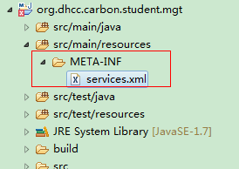
      - services.xml内容
services.xml文件的作用是导出名称为StudentManager的服务。

<serviceGroup>
<service name="StudentManager" scope="transportsession">
<transports>
<transport>https</transport>
</transports>
<parameter name="ServiceClass">org.dhcc.carbon.student.mgt.StudentManager</parameter>
</service>

<parameter name="adminService" locked="true">true</parameter>
<parameter name="hiddenService" locked="true">true</parameter>
<parameter name="AuthorizationAction" locked="true">/permission/protected/manage</parameter>
</serviceGroup>

Note: Here we have exposed StudentManager as our ServiceClass. This will make all the public methods in the StudentManager class as service operations (getStudents).

- <transport>https</transport> - makes the service secure.
- parameter name="adminService" - makes the service an admin service.
- parameter name="hiddenService" - makes the service hidden to public.
- parameter name="AuthorizationAction" - makes the service authorized.
    - Maven install
设置goals参数为clean install。
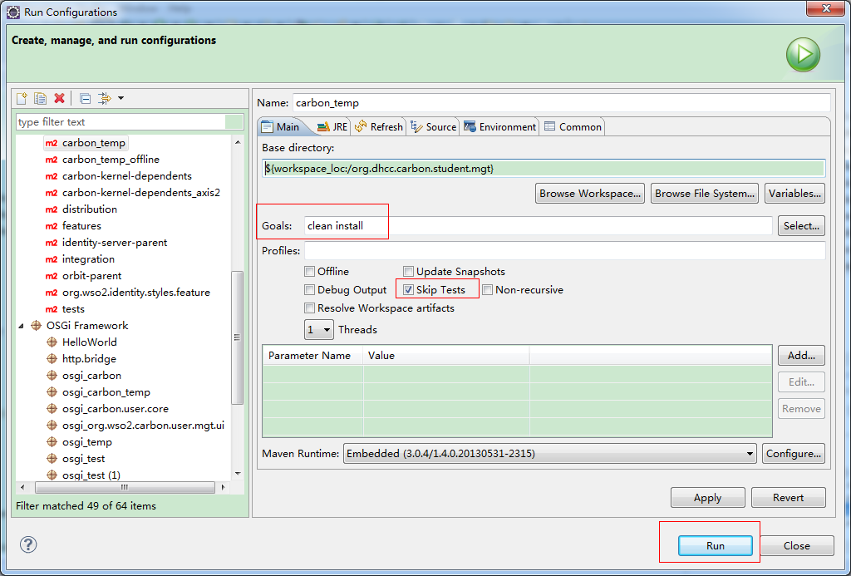

编写Service Stub
为了创建stub，我们需要刚才创建的ws的wsdl。由于设置了安全访问，所以不能直接从浏览器访问刚才创建的ws的wsdl。需要修改[CARBON_HOME]/repository/conf/carbon.xml文件，将<HideAdminServiceWSDLs>标签的值由true改为false。
Maven build刚才的org.dhcc.carbon.student.mgt项目，拷贝在target目录下生成的org.dhcc.carbon.student.mgt-1.0.0.jar文件到[CARBON_HOME]/repository/components/dropins/文件夹下。
启动carbon服务，访问https://localhost:9443/services/StudentManager?wsdl
保存此wsdl，名称为StudentManager.wsdl，之后在stub中使用。
将<HideAdminServiceWSDLs>标签的值改回默认值。
在student-manager-components项目下创建名称为org.dhcc.carbon.student.mgt.stub的maven项目
相关属性如下：
  - artifactId - org.dhcc.carbon.student.mgt.stub
  - packaging - bundle
  - name - DHCC Carbon - Student Manager Stub
  - dependency - axis2
  - dependency - axiom
  - dependency - wsdl4j
  - plugin - maven-antrun-plugin
  - plugin - build-helper-maven-plugin
  - plugin - maven-bundle-plugin
使用wsdl2java与maven-antrun-plugin，能够从wsdl文件生成java类。
拷贝 StudentManager.wsdl 到org.dhcc.carbon.student.mgt.stub项目的 src/main/resources/ 文件夹下。
    - org.dhcc.carbon.student.mgt.stub项目pom.xml
org.dhcc.carbon.student.mgt.stub → pom.xml
<project xmlns="http://maven.apache.org/POM/4.0.0" xmlns:xsi="http://www.w3.org/2001/XMLSchema-instance" xsi:schemaLocation="http://maven.apache.org/POM/4.0.0 http://maven.apache.org/xsd/maven-4.0.0.xsd">
<modelVersion>4.0.0</modelVersion>
<parent>
<groupId>org.dhcc.carbon</groupId>
<artifactId>stu-manager-components</artifactId>
<version>1.0.0</version>
</parent>
<artifactId>org.dhcc.carbon.student.mgt.stub</artifactId>
<packaging>bundle</packaging>
<name>DHCC Carbon - Student Manager Stub</name>
<dependencies>
<dependency>
<groupId>org.apache.axis2.wso2</groupId>
<artifactId>axis2</artifactId>
<version>1.6.1.wso2v10</version>
</dependency>
<dependency>
<groupId>org.apache.ws.commons.axiom.wso2</groupId>
<artifactId>axiom</artifactId>
<version>1.2.11.wso2v4</version>
</dependency>
<dependency>
<groupId>wsdl4j.wso2</groupId>
<artifactId>wsdl4j</artifactId>
<version>1.6.2.wso2v4</version>
</dependency>
</dependencies>
<build>
<plugins>
<plugin>
<groupId>org.apache.maven.plugins</groupId>
<artifactId>maven-antrun-plugin</artifactId>
<version>1.1</version>
<executions>
<execution>
<id>source-code-generation</id>
<phase>process-resources</phase>
<goals>
<goal>run</goal>
</goals>
<configuration>
<tasks>
<path id="wsdl2java.classpath">
<pathelement location="${settings.localRepository}/org/apache/ws/commons/axiom/wso2/axiom/1.2.11.wso2v4/axiom-1.2.11.wso2v4.jar"/>
<pathelement location="${settings.localRepository}/org/apache/axis2/wso2/axis2-client/1.6.1.wso2v10/axis2-client-1.6.1.wso2v10.jar" />
<pathelement location="${settings.localRepository}/org/apache/axis2/wso2/axis2/1.6.1.wso2v10/axis2-1.6.1.wso2v10.jar" />
</path>
<java classname="org.apache.axis2.wsdl.WSDL2Java" fork="true">
<classpath refid="wsdl2java.classpath" />
<arg line="-uri src/main/resources/StudentManager.wsdl -u -uw
-o target/generated-code -p org.dhcc.carbon.student.mgt.stub"/>
</java>
</tasks>
</configuration>
</execution>
</executions>
</plugin>

<plugin>
<groupId>org.codehaus.mojo</groupId>
<artifactId>build-helper-maven-plugin</artifactId>
<executions>
<execution>
<id>add-source</id>
<phase>generate-sources</phase>
<goals>
<goal>add-source</goal>
</goals>
<configuration>
<sources>
<source>target/generated-code/src</source>
</sources>
</configuration>
</execution>
</executions>
</plugin>

<plugin>
<groupId>org.apache.felix</groupId>
<artifactId>maven-bundle-plugin</artifactId>
<extensions>true</extensions>
<configuration>
<instructions>
<Bundle-SymbolicName>${project.artifactId}</Bundle-SymbolicName>
<Bundle-Name>${project.artifactId}</Bundle-Name>
<Private-Package>
</Private-Package>
<Export-Package>
org.dhcc.carbon.student.mgt.*
</Export-Package>
<Import-Package>
!org.dhcc.carbon.student.mgt.*
</Import-Package>
<DynamicImport-Package>*</DynamicImport-Package>
</instructions>
</configuration>
</plugin>
</plugins>
</build>
</project>

Note:
  - Axis2 dependency has been used as the SOAP stack
  - The Apache Axiom library provides an XML Infoset compliant object model implementation, which supports on-demand building of the object tree
  - wsdl4j dependency has been used to generate the Java classes from the existing WSDL document using the wsdl2java
  - wsdl2java.classpath has been configured in the maven-antrun-plugin with the 3 dependencies as path elements.

Maven build后会在target文件夹下生成org.dhcc.carbon.student.mgt.stub-1.0.0.jar bundle文件。

编写UI Component
在student-manager-components项目下创建名称为org.dhcc.carbon.student.mgt.ui的maven项目
相关属性如下：
  - artifactId - org.dhcc.carbon.student.mgt.ui
  - packaging - bundle
  - name - DHCC Carbon - Student Manager UI Component
  - dependency - org.dhcc.carbon.student.mgt.stub
  - plugin - maven-bundle-plugin
    - org.dhcc.carbon.student.mgt.ui项目pom.xml
org.dhcc.carbon.student.mgt.ui→ pom.xml
<project xmlns="http://maven.apache.org/POM/4.0.0" xmlns:xsi="http://www.w3.org/2001/XMLSchema-instance" xsi:schemaLocation="http://maven.apache.org/POM/4.0.0 http://maven.apache.org/xsd/maven-4.0.0.xsd">
<modelVersion>4.0.0</modelVersion>
<parent>
<groupId>org.dhcc.carbon</groupId>
<artifactId>stu-manager-components</artifactId>
<version>1.0.0</version>
</parent>
<artifactId>org.dhcc.carbon.student.mgt.ui</artifactId>
<packaging>bundle</packaging>
<name>DHCC Carbon - Student Manager UI Component</name>
<dependencies>
<dependency>
<groupId>org.dhcc.carbon</groupId>
<artifactId>org.dhcc.carbon.student.mgt.stub</artifactId>
<version>1.0.0</version>
</dependency>
</dependencies>
<build>
<plugins>
<plugin>
<groupId>org.apache.felix</groupId>
<artifactId>maven-bundle-plugin</artifactId>
<extensions>true</extensions>
<configuration>
<instructions>
<Bundle-SymbolicName>${pom.artifactId}</Bundle-SymbolicName>
<Bundle-Name>${project.artifactId}</Bundle-Name>
<Export-Package>
org.dhcc.carbon.student.mgt.*
</Export-Package>
<Import-Package>
*;resolution:=optional
</Import-Package>
<Carbon-Component>UIBundle</Carbon-Component>
</instructions>
</configuration>
</plugin>
</plugins>
</build>
</project>
    - 转换项目为java项目
可参照org.dhcc.carbon.student.mgt项目的做法，把org.dhcc.carbon.student.mgt.ui项目转换为java项目，设置好编译路径。
设置好的目录结构如下图所示：
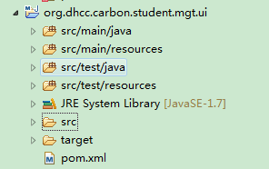
为了编写代码时，能正常引用stub中生成的类，把org.dhcc.carbon.student.mgt.stub项目也转换成java项目，并将target\generated-code\src目录设置成资源路径。
设置好的目录结构如下图所示：
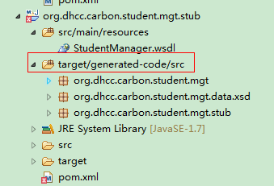
    - 编写代码
在org.dhcc.carbon.student.mgt.ui项目下添加1个java类：
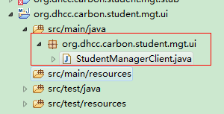
      - StudentManagerClient.java
package org.dhcc.carbon.student.mgt.ui;
import org.apache.axis2.client.Options;
import org.apache.axis2.client.ServiceClient;
import org.apache.axis2.context.ConfigurationContext;
import org.dhcc.carbon.student.mgt.data.xsd.Student;
import org.dhcc.carbon.student.mgt.stub.StudentManagerStub;
import java.rmi.RemoteException;
public class StudentManagerClient {
private StudentManagerStub stub;

public StudentManagerClient(ConfigurationContext configCtx, String backendServerURL, String cookie) throws Exception{
String serviceURL = backendServerURL + "StudentManager";
stub = new StudentManagerStub(configCtx, serviceURL);
ServiceClient client = stub._getServiceClient();
Options options = client.getOptions();
options.setManageSession(true);
options.setProperty(org.apache.axis2.transport.http.HTTPConstants.COOKIE_STRING, cookie);
}

public Student[] getStudents() throws Exception{
try{
return stub.getStudents();
}catch (RemoteException e) {
String msg = "Cannot get the list of students"
+ " . Backend service may be unavailable";
throw new Exception(msg, e);
}
}
}
Note: Here in StudentManagerClient constructor StudentManagerStub has been implemented, which was generated from the stub project. 3 parameters have been taken in the constructor to pass into StudentManagerStub in order to create the HTTPS/SOAP transaction to the server component. The getStudents() method will retrieve the students array from the back-end server and return them to the UI.
    - 编写页面
      - index.jsp
在src/main/resources/web/student-mgt/目录下创建index.jsp页面。
页面内容如下：
<%@ page import="org.apache.axis2.context.ConfigurationContext" %>
<%@ page import="org.wso2.carbon.CarbonConstants" %>
<%@ page import="org.wso2.carbon.ui.CarbonUIUtil" %>
<%@ page import="org.wso2.carbon.utils.ServerConstants" %>
<%@ page import="org.wso2.carbon.ui.CarbonUIMessage" %>
<%@ page import="org.dhcc.carbon.student.mgt.ui.StudentManagerClient" %>
<%@ page import="org.dhcc.carbon.student.mgt.data.xsd.Student" %>
<%@ taglib prefix="fmt" uri="http://java.sun.com/jsp/jstl/fmt" %>
<%@ taglib uri="http://wso2.org/projects/carbon/taglibs/carbontags.jar" prefix="carbon" %>
<%
String serverURL = CarbonUIUtil.getServerURL(config.getServletContext(), session);
ConfigurationContext configContext =
(ConfigurationContext) config.getServletContext().getAttribute(CarbonConstants.CONFIGURATION_CONTEXT);
String cookie = (String) session.getAttribute(ServerConstants.ADMIN_SERVICE_COOKIE);

StudentManagerClient client;
Student[] students;

try {
client = new StudentManagerClient(configContext, serverURL, cookie);
students = client.getStudents();
} catch (Exception e) {
CarbonUIMessage.sendCarbonUIMessage(e.getMessage(), CarbonUIMessage.ERROR, request, e);
%>
<script type="text/javascript">
location.href = "../admin/error.jsp";
</script>
<%
return;
}
%>

<div id="middle">
<h2>Student Management</h2>
<div id="workArea">
<table class="styledLeft" id="moduleTable">
<thead>
<tr>
<th width="20%">ID</th>
<th width="40%">First Name</th>
<th width="40%">Last Name</th>
</tr>
</thead>
<tbody>
<%
for(Student student:students){
%>
<tr>
<td><%=student.getID()%></td>
<td><%=student.getFirstName()%></td>
<td><%=student.getLastName()%></td>
</tr>
<%
}
%>
</tbody>
</table>
</div>
</div>
Note: In order to create the StudentManagerClient, we have created the 3 parameters requested using the carbon core.
String serverURL = CarbonUIUtil.getServerURL(config.getServletContext(), session);
ConfigurationContext configContext = (ConfigurationContext) config.getServletContext().getAttribute(CarbonConstants.CONFIGURATION_CONTEXT);
String cookie = (String) session.getAttribute(ServerConstants.ADMIN_SERVICE_COOKIE);

When creating the content <div id="middle"> tag will set the ui content in the Carbon server page which will load the students information retrieved from the back-end.
      - component.xml
为了在Carbon server导航栏菜单创建一个pannel来加载刚刚创建的jsp页面。需要在src/main/resources/META-INF/文件夹下创建一个component.xml文件。
文件内容如下：
<component xmlns="http://products.wso2.org/carbon">
<menus>
<menu>
<id>studentmgt_menu</id>
<i18n-key>student.menu</i18n-key>
<i18n-bundle>org.dhcc.carbon.student.mgt.ui.i18n.Resources</i18n-bundle>
<parent-menu>manage_menu</parent-menu>
<link>../student-mgt/index.jsp</link>
<region>region1</region>
<order>50</order>
<style-class>manage</style-class>
<icon>../student-mgt/images/students.gif</icon>
<require-permission>/permission/protected/manage</require-permission>
</menu>
</menus>
</component>
Note:
- <id>studentmgt_menu</id> - Gives the id to the new link that points to the index.jsp
- <i18n-key>student.menu</i18n-key> - This points to the link name which defines in the i18n bundle.
- <i18n-bundle>org.dhcc.carbon.student.mgt.ui.i18n.Resources</i18n-bundle> - This loads the i18n Resource.properties file (we will be adding this in the next few steps).
- <parent-menu>manage_menu</parent-menu> - Defined the parent menu for the new link.
- <link>../student-mgt/index.jsp</link> - The relative path to index.jsp
- <region>region1</region> - Defines the region which the link should be locate.
- <order>50</order> - Defines the link order.
- <style-class>manage</style-class> - Load the css styles for the new link.
- <icon>../student-mgt/images/students.gif</icon> - Defines a small icon to appear with the link.
- <require-permission>/permission/protected/manage</require-permission> - Defines authorization category.
      - Resources.properties
在src/main/resources/org/dhcc/carbon/student/mgt/ui/i18n/目录下创建Resources.properties文件。
文件内容如下：
student.menu=Students
目录结构如下：
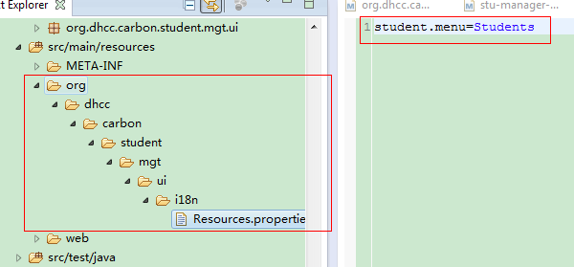
      - 设置菜单图片
将如下图片拷贝到src/main/resources/web/student-mgt/images/文件夹下，命名为students.gif。
      - student-manager-components项目概览
上一步我们完成了UI组件的创建。现在Carbon组件创建完成了。
- org.dhcc.carbon.student.mgt - server component OSGI bundle.
- org.dhcc.carbon.student.mgt.stub - communication stub OSGI bundle.
- org.dhcc.carbon.student.mgt.ui - UI component OSGI bundle.
目录结构如下图所示：
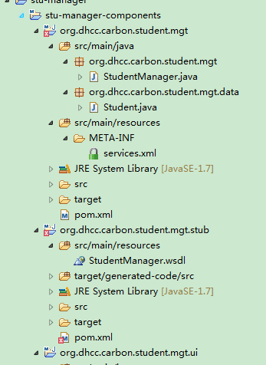
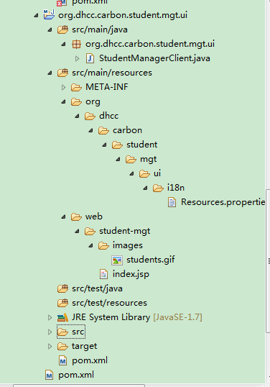

部署运行
现在已经成功创建了Carbon组件(Carbon Component)。
Maven build student-manager-components项目下的3个子项目生成3个OSGi Bundle（jar文件），我们可以把他们放在[CARBON_HOME]/repository/components/dropins/目录下。启动Carbon server，单击左边导航栏的Students链接就能访问我们创建的组件。
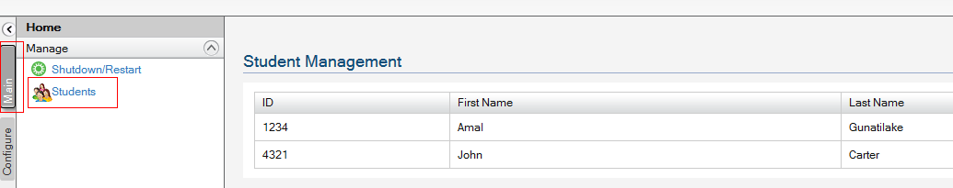

由Carbon Component创建feature
后面的例子展示了如何根据student-manager Carbon component来创建feature。
主要分为以下3步：
- Creating the server feature
- Creating the console (UI) feature
- Creating the composite feature from the above 2 features
    - 在stu-manager-features项目下创建3个子项目
相关属性如下所示：
- org.dhcc.carbon.student.mgt.server.feature
  - artifactId - org.dhcc.carbon.student.mgt.server.feature
  - packaging - pom
  - name - DHCC Carbon - Student Manager Server Feature
  - dependency - org.dhcc.carbon.student.mgt
  - plugin - carbon-p2-plugin
- org.dhcc.carbon.student.mgt.ui.feature
  - artifactId - org.dhcc.carbon.student.mgt.ui.feature
  - packaging - pom
  - name - DHCC Carbon - Student Manager UI Feature
  - dependency - org.dhcc.carbon.student.mgt.stub
  - dependency - org.dhcc.carbon.student.mgt.ui
  - plugin - carbon-p2-plugin
- org.dhcc.carbon.student.mgt.feature
  - artifactId - org.dhcc.carbon.student.mgt.feature
  - packaging - pom
  - name - DHCC Carbon - Student Manager Aggregate Feature
  - dependency - org.dhcc.carbon.student.mgt.server.feature (zip type)
  - dependency - org.dhcc.carbon.student.mgt.ui.feature (zip type)
  - plugin - carbon-p2-plugin
  - plugin - maven-antrun-pluginc
在student-manager-features项目下创建feature.properties文件，将附录feature.properties章节中的文件内容复制到feature.properties文件中。
    - 项目概览
      - 目录结构
项目目录结构如下图所示：
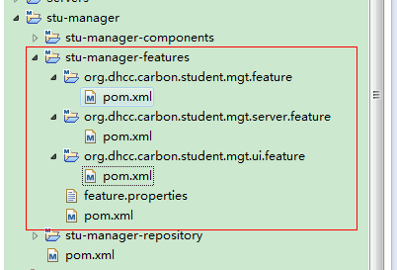
      - org.dhcc.carbon.student.mgt.server.feature项目pom.xml
org.dhcc.carbon.student.mgt.server.feature → pom.xml
<project xmlns="http://maven.apache.org/POM/4.0.0" xmlns:xsi="http://www.w3.org/2001/XMLSchema-instance" xsi:schemaLocation="http://maven.apache.org/POM/4.0.0 http://maven.apache.org/xsd/maven-4.0.0.xsd">
<modelVersion>4.0.0</modelVersion>
<parent>
<groupId>org.dhcc.carbon</groupId>
<artifactId>stu-manager-features</artifactId>
<version>1.0.0</version>
</parent>
<artifactId>org.dhcc.carbon.student.mgt.server.feature</artifactId>
<packaging>pom</packaging>
<name>DHCC Carbon - Student Manager Server Feature</name>

<dependencies>
<dependency>
<groupId>org.dhcc.carbon</groupId>
<artifactId>org.dhcc.carbon.student.mgt</artifactId>
<version>1.0.0</version>
</dependency>
</dependencies>

<build>
<plugins>
<plugin>
<groupId>org.wso2.maven</groupId>
<artifactId>carbon-p2-plugin</artifactId>
<version>1.5.3</version>
<executions>
<execution>
<id>p2-feature-generation</id>
<phase>package</phase>
<goals>
<goal>p2-feature-gen</goal>
</goals>
<configuration>
<id>org.dhcc.carbon.student.mgt.server</id>
<propertiesFile>../feature.properties</propertiesFile>
<adviceFile>
<properties>
<propertyDef>org.wso2.carbon.p2.category.type:server</propertyDef>
<propertyDef>org.eclipse.equinox.p2.type.group:false</propertyDef>
</properties>
</adviceFile>
<bundles>
<bundleDef>org.dhcc.carbon:org.dhcc.carbon.student.mgt</bundleDef>
</bundles>
</configuration>
</execution>
</executions>
</plugin>
</plugins>
</build>
</project>
      - org.dhcc.carbon.student.mgt.ui.feature项目pom.xml
org.dhcc.carbon.student.mgt.ui.feature → pom.xml
<project xmlns="http://maven.apache.org/POM/4.0.0" xmlns:xsi="http://www.w3.org/2001/XMLSchema-instance" xsi:schemaLocation="http://maven.apache.org/POM/4.0.0 http://maven.apache.org/xsd/maven-4.0.0.xsd">
<modelVersion>4.0.0</modelVersion>
<parent>
<groupId>org.dhcc.carbon</groupId>
<artifactId>stu-manager-features</artifactId>
<version>1.0.0</version>
</parent>
<artifactId>org.dhcc.carbon.student.mgt.ui.feature</artifactId>
<packaging>pom</packaging>
<name>DHCC Carbon - Student Manager UI Feature</name>

<dependencies>
<dependency>
<groupId>org.dhcc.carbon</groupId>
<artifactId>org.dhcc.carbon.student.mgt.stub</artifactId>
<version>1.0.0</version>
</dependency>
<dependency>
<groupId>org.dhcc.carbon</groupId>
<artifactId>org.dhcc.carbon.student.mgt.ui</artifactId>
<version>1.0.0</version>
</dependency>
</dependencies>

<build>
<plugins>
<plugin>
<groupId>org.wso2.maven</groupId>
<artifactId>carbon-p2-plugin</artifactId>
<version>1.5.3</version>
<executions>
<execution>
<id>p2-feature-generation</id>
<phase>package</phase>
<goals>
<goal>p2-feature-gen</goal>
</goals>
<configuration>
<id>org.dhcc.carbon.student.mgt.ui</id>
<propertiesFile>../feature.properties</propertiesFile>
<adviceFile>
<properties>
<propertyDef>org.wso2.carbon.p2.category.type:console</propertyDef>
<propertyDef>org.eclipse.equinox.p2.type.group:false</propertyDef>
</properties>
</adviceFile>
<bundles>
<bundleDef>org.dhcc.carbon:org.dhcc.carbon.student.mgt.stub</bundleDef>
<bundleDef>org.dhcc.carbon:org.dhcc.carbon.student.mgt.ui</bundleDef>
</bundles>
</configuration>
</execution>
</executions>
</plugin>
</plugins>
</build>
</project>
      - org.dhcc.carbon.student.mgt.feature项目pom.xml
org.dhcc.carbon.student.mgt.feature → pom.xml
<project xmlns="http://maven.apache.org/POM/4.0.0" xmlns:xsi="http://www.w3.org/2001/XMLSchema-instance" xsi:schemaLocation="http://maven.apache.org/POM/4.0.0 http://maven.apache.org/xsd/maven-4.0.0.xsd">
<modelVersion>4.0.0</modelVersion>
<parent>
<groupId>org.dhcc.carbon</groupId>
<artifactId>stu-manager-features</artifactId>
<version>1.0.0</version>
</parent>
<artifactId>org.dhcc.carbon.student.mgt.feature</artifactId>
<packaging>pom</packaging>
<name>DHCC Carbon - Student Manager Aggregate Feature</name>

<dependencies>
<dependency>
<groupId>org.wso2.carbon</groupId>
<artifactId>org.wso2.carbon.student.mgt.server.feature</artifactId>
<version>4.2.0</version>
<type>zip</type>
</dependency>
<dependency>
<groupId>org.wso2.carbon</groupId>
<artifactId>org.wso2.carbon.student.mgt.ui.feature</artifactId>
<version>4.2.0</version>
<type>zip</type>
</dependency>
</dependencies>

<build>
<plugins>
<plugin>
<groupId>org.wso2.maven</groupId>
<artifactId>carbon-p2-plugin</artifactId>
<version>1.5.3</version>
<executions>
<execution>
<id>p2-feature-generation</id>
<phase>package</phase>
<goals>
<goal>p2-feature-gen</goal>
</goals>
<configuration>
<id>org.dhcc.carbon.student.mgt</id>
<propertiesFile>../feature.properties</propertiesFile>
<adviceFile>
<properties>
<propertyDef>org.eclipse.equinox.p2.type.group:true</propertyDef>
</properties>
</adviceFile>
<includedFeatures>
<includedFeatureDef>org.dhcc.carbon:org.dhcc.carbon.student.mgt.server.feature</includedFeatureDef>
<includedFeatureDef>org.dhcc.carbon:org.dhcc.carbon.student.mgt.ui.feature</includedFeatureDef>
</includedFeatures>
</configuration>
</execution>
</executions>
</plugin>
<plugin>
<groupId>org.apache.maven.plugins</groupId>
<artifactId>maven-antrun-plugin</artifactId>
<executions>
<execution>
<id>clean_target</id>
<phase>install</phase>
<configuration>
<tasks>
<delete dir="src/main/resources"/>
<delete dir="src/main"/>
<delete dir="src"/>
</tasks>
</configuration>
<goals>
<goal>run</goal>
</goals>
</execution>
</executions>
</plugin>
</plugins>
</build>
</project>
      - pom文件说明
Note:
- org.wso2.carbon.p2.category.type: server | console | common - This property is used to define whether the feature is a back-end (server), UI (console) or a common feature. This property is read by the feature manager for BE, FE filtering
- org.eclipse.equinox.p2.type.group: true | false - This property is important to be explicitly defined as ‘false’ when the feature is not a group type feature and you don’t want it to be listed in the feature manager UI (we list the group type features in the feature manager UI). For sub features (console, UI), which are dependencies to the aggregate-feature, use this property as false
- In the server feature, we need to include only the server OSGI bundle <bundleDef>org.dhcc.carbon:org.dhcc.carbon.student.mgt</bundleDef>
- In the UI feature, we have to include both ui and stub OSGI bundles as the UI bundle depends on the stub
- The aggregate feature have dependencies from generated new server and UI features, and when creating the jar to remove the unnecessary src, main, resources folders, maven-antrun-plugin has been used
    - 更新student-manager-repository的pom文件
In order to install the feature to the Carbon server, we have to create a p2-repo。
update the student-manager-repository → pom.xml
<project xmlns="http://maven.apache.org/POM/4.0.0" xmlns:xsi="http://www.w3.org/2001/XMLSchema-instance" xsi:schemaLocation="http://maven.apache.org/POM/4.0.0 http://maven.apache.org/xsd/maven-4.0.0.xsd">
<modelVersion>4.0.0</modelVersion>
<parent>
<groupId>org.dhcc.carbon</groupId>
<artifactId>stu-manager</artifactId>
<version>1.0.0</version>
</parent>
<artifactId>stu-manager-repository</artifactId>
<packaging>pom</packaging>
<name>DHCC Carbon - Student Manager Repository</name>

<build>
<plugins>
<plugin>
<groupId>org.wso2.maven</groupId>
<artifactId>carbon-p2-plugin</artifactId>
<version>1.5.3</version>
<executions>
<execution>
<id>2-p2-repo-generation</id>
<phase>package</phase>
<goals>
<goal>p2-repo-gen</goal>
</goals>
<configuration>
<metadataRepository>file:${basedir}/target/p2-repo</metadataRepository>
<artifactRepository>file:${basedir}/target/p2-repo</artifactRepository>
<publishArtifacts>true</publishArtifacts>
<publishArtifactRepository>true</publishArtifactRepository>
<featureArtifacts>
<featureArtifactDef>
org.dhcc.carbon:org.dhcc.carbon.student.mgt.feature:1.0.0
</featureArtifactDef>
</featureArtifacts>
</configuration>
</execution>
</executions>
</plugin>
</plugins>
</build>
</project>
Note: After successfully building the features, we include the final Aggregate feature bundle to the p2-repo.
编译后的feature bundle在student-manager-repository项目的target/p2-repo目录下面。
如下图所示：
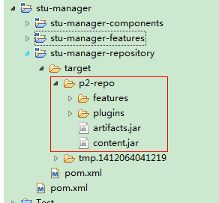
    - 安装feature
进入Carbon server的configurations菜单下，在导航栏单击Features。然后单击Repository Management，单击Add Repository按钮。
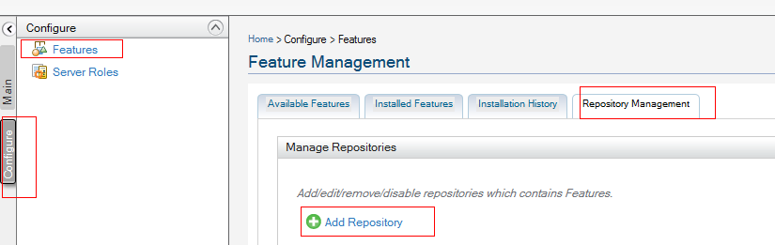
添加Repository
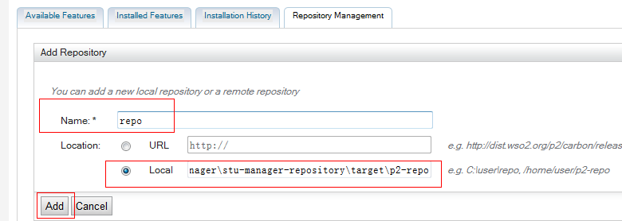
安装features
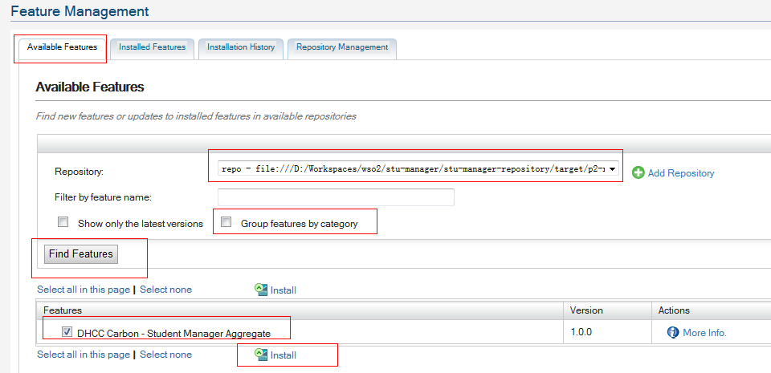
安装完后重启服务。
成功创建安装了Carbon Component feature。

编译carbon kernel源码

SVN地址
源码SVN检出地址：
https://svn.wso2.org/repos/wso2/carbon/kernel/tags/4.2.0

使用jdk1.6
必须使用1.6，使用jdk1.7会出错。

Pom文件修改
    - dependencies\axis2\1.6.1-wso2v10\modules\parent
以下子标题表示均在此目录下：
[kernel4.2.0]\dependencies\axis2\1.6.1-wso2v10\modules\parent
      - parent
[kernel4.2.0]\dependencies\axis2\1.6.1-wso2v10\modules\parent\pom.xml
1、修改maven-compiler-plugin版本号为3.1：
<plugin>
<artifactId>maven-compiler-plugin</artifactId>
<version>2.3.1</version>
</plugin>
修改后如下：
<plugin>
<artifactId>maven-compiler-plugin</artifactId>
<version>3.1</version>
</plugin>
2、修改maven-bundle-plugin版本号为2.5.0：
<plugin>
<groupId>org.apache.felix</groupId>
<artifactId>maven-bundle-plugin</artifactId>
<version>2.1.0</version>
</plugin>
修改后如下：
<plugin>
<groupId>org.apache.felix</groupId>
<artifactId>maven-bundle-plugin</artifactId>
<version>2.5.0</version>
</plugin>
    - dependencies\wss4j\1.5.11-wso2v6
      - pom.xml
[kernel4.2.0]\dependencies\wss4j\1.5.11-wso2v6\pom.xml
1、修改版本号为3.1：
<plugin>
<groupId>org.apache.maven.plugins</groupId>
<artifactId>maven-compiler-plugin</artifactId>
<version>2.1</version>
<configuration>
修改后如下：
<plugin>
<groupId>org.apache.maven.plugins</groupId>
<artifactId>maven-compiler-plugin</artifactId>
<version>3.1</version>
<configuration>

Carbon源码Debug

Carbon在eclipse上运行
    - 拷贝必要的文件
新建carbon-repo文件夹：例如我的目录是 D:\Work\wso2\repo\carbon-repo，后续文档中使用[carbon-repo]表示
从编译后的Carbon目录中将以下3个文件夹拷贝到carbon-repo文件夹中，后续文档中以[carbon]表示能直接运行的carbon的根目录（即编译后的目录）
bin、lib、repository
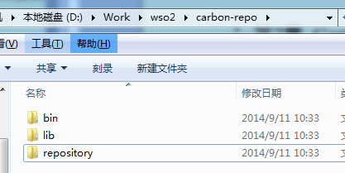
    - 修改数据库配置
      - 使用内嵌的h2数据库
修改数据源配置文件：
[carbon-repo]\repository\conf\datasources\master-datasources.xml
找到以下内容：
<url>jdbc:h2:repository/database/WSO2CARBON_DB;DB_CLOSE_ON_EXIT=FALSE;LOCK_TIMEOUT=60000</url>
修改为使用绝对地址的路径，使用[carbon]/ repository/database/…
例如修改为：
<url>jdbc:h2: D:/Work/wso2/app/wso2carbon-4.2.0/repository/database/WSO2CARBON_DB;DB_CLOSE_ON_EXIT=FALSE;LOCK_TIMEOUT=60000</url>
      - 使用外部mysql数据库
1、拷贝mysql的jsbc包到以下目录：
[carbon-repo]\repository\components\lib
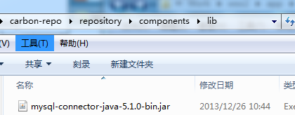
2、修改数据源配置文件
[carbon-repo]\repository\conf\datasources\master-datasources.xml
将datasource标签内的内容修改为（根据实际情况修改数据库名、账户密码等，在wso2esb、carbon等项目文档中均有详细介绍）：
<datasource>
<name>WSO2_CARBON_DB</name>
<description>The datasource used for registry and user manager</description>
<jndiConfig>
<name>jdbc/WSO2CarbonDB</name>
</jndiConfig>
<definition type="RDBMS">
<configuration>
<url>jdbc:mysql://localhost:3306/wso2esbregdb</url>
<username>wso2esbregdb</username>
<password>wso2esbregdb</password>
<driverClassName>com.mysql.jdbc.Driver</driverClassName>
<maxActive>80</maxActive>
<maxWait>60000</maxWait>
<minIdle>5</minIdle>
<testOnBorrow>true</testOnBorrow>
<validationQuery>SELECT 1</validationQuery>
<validationInterval>30000</validationInterval>
</configuration>
</definition>
</datasource>
    - 入口函数
导入Carbon源码，找到入口函数
项目：org.wso2.carbon.bootstrap
入口类：org.wso2.carbon.bootstrap.Bootstrap
    - 引入相关jar包
以下jar都能在编译后的源码中找到：
org.wso2.carbon.server-4.2.0.jar
tomcat-juli-7.0.34.jar
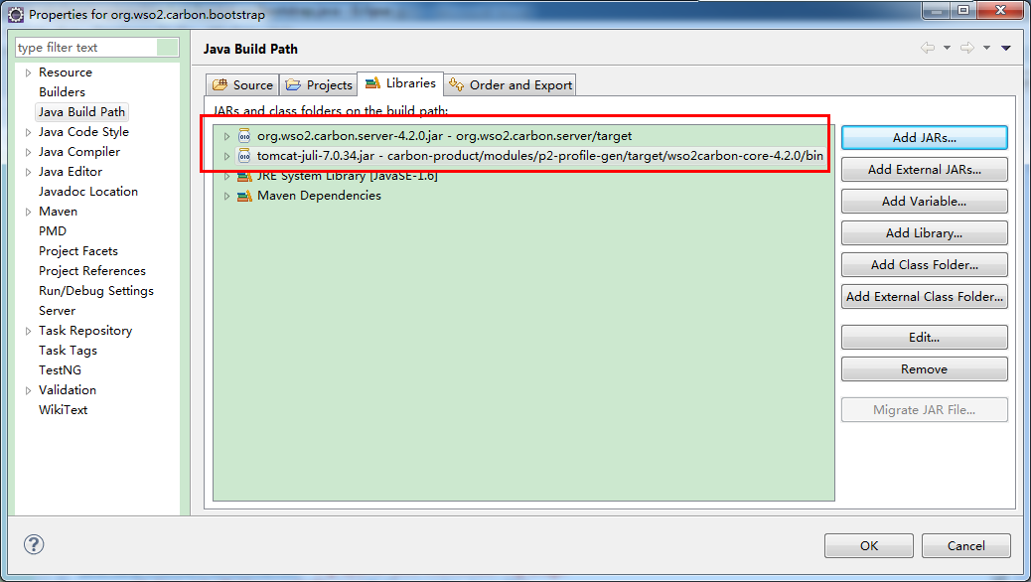
    - 设置运行参数
程序参数：RUN
JVM参数：
-Xbootclasspath/a:${CARBON_XBOOTCLASSPATH}
-Xms256m -Xmx1024m -XX:MaxPermSize=256m
-XX:+HeapDumpOnOutOfMemoryError -XX:HeapDumpPath="${CARBON_HOME}\repository\logs\heap-dump.hprof"
-Dcom.sun.management.jmxremote
-classpath ${CARBON_CLASSPATH} ${JAVA_OPTS}
-Djava.endorsed.dirs=${JAVA_ENDORSED}
-Dcarbon.registry.root=/
-Dcarbon.home=${CARBON_HOME}
-Dwso2.server.standalone=true
-Djava.command="${JAVA_HOME}\bin\java"
-Djava.opts="${JAVA_OPTS}"
-Djava.io.tmpdir="${CARBON_HOME}\tmp"
-Dcatalina.base="${CARBON_HOME}\lib\tomcat"
-Dwso2.carbon.xml=${CARBON_HOME}\repository\conf\carbon.xml
-Dwso2.registry.xml="${CARBON_HOME}\repository\conf\registry.xml"
-Dwso2.user.mgt.xml="${CARBON_HOME}\repository\conf\user-mgt.xml"
-Dwso2.transports.xml="${CARBON_HOME}\repository\conf\mgt-transports.xml"
-Djava.util.logging.config.file="${CARBON_HOME}\repository\conf\etc\logging-bridge.properties"
-Djava.util.logging.manager=org.apache.juli.ClassLoaderLogManager
-Dcarbon.config.dir.path="${CARBON_HOME}\repository\conf"
-Dcarbon.logs.path="${CARBON_HOME}\repository\logs"
-Dcomponents.repo="${CARBON_HOME}\repository\components"
-Dconf.location="${CARBON_HOME}\repository\conf"
-Dcom.atomikos.icatch.file="${CARBON_HOME}\lib\transactions.properties"
-Dcom.atomikos.icatch.hide_init_file_path="true"
-Dorg.apache.jasper.runtime.BodyContentImpl.LIMIT_BUFFER=true
-Dcom.sun.jndi.ldap.connect.pool.authentication=simple
-Dcom.sun.jndi.ldap.connect.pool.timeout=3000
-Dorg.terracotta.quartz.skipUpdateCheck=true
-Dcarbon.classpath=${CARBON_CLASSPATH}
-Dfile.encoding=UTF8
JVM参数中使用到的变量（根据实际情况修改变量的值）：
CARBON_XBOOTCLASSPATH=
CARBON_HOME=D:\Work\wso2\app\wso2carbon-4.2.0-tomcat
CARBON_CLASSPATH="${CARBON_HOME}\lib;${JAVA_HOME}\lib\tools.jar;${CARBON_HOME}\bin\org.wso2.carbon.bootstrap-4.2.0.jar;${CARBON_HOME}\bin\tcpmon-1.0.jar;${CARBON_HOME}\bin\tomcat-juli-7.0.34.jar;${CARBON_HOME}\lib\commons-lang-2.6.0.wso2v1.jar"
JAVA_ENDORSED="${CARBON_HOME}\lib\endorsed;${JAVA_HOME}\jre\lib\endorsed;${JAVA_HOME}\lib\endorsed"
JAVA_OPTS=
JAVA_HOME=C:\Program Files\Java\jdk1.6.0_43

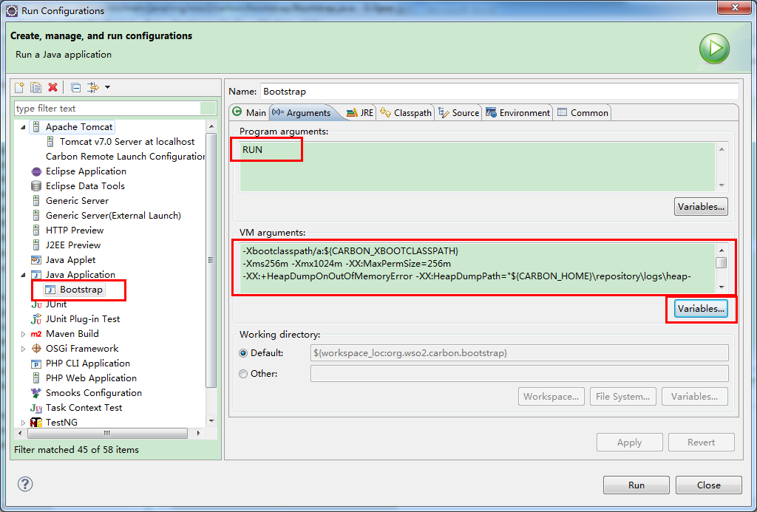
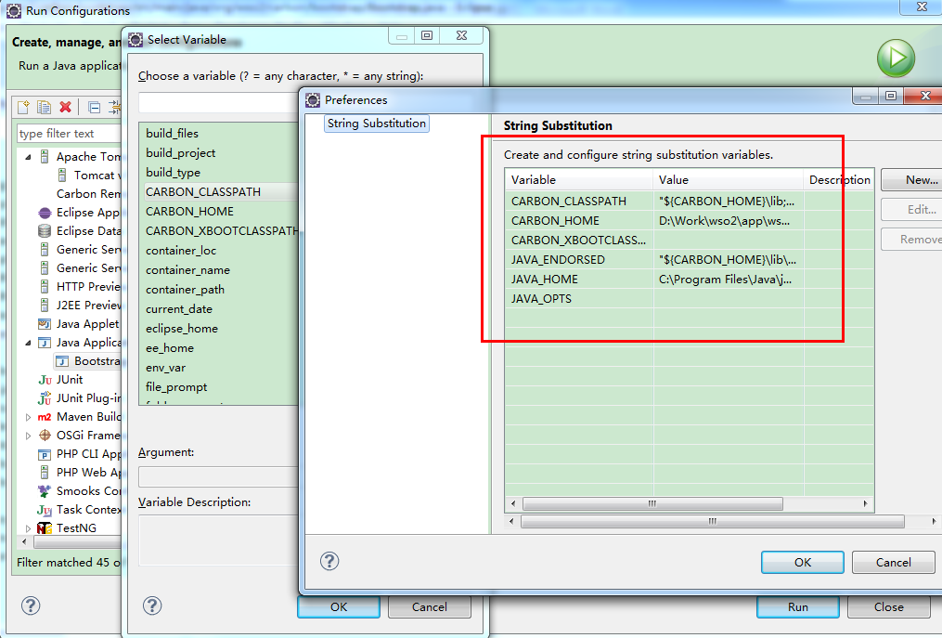
    - 运行
执行org.wso2.carbon.bootstrap.Bootstrap下的main方法，控制台打印出如下信息：
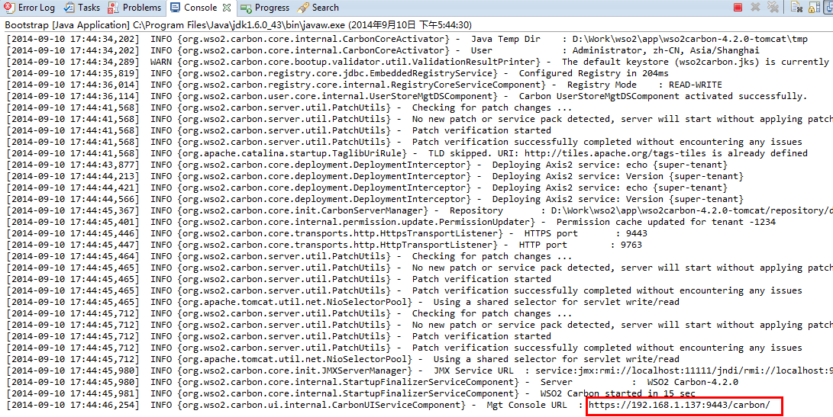
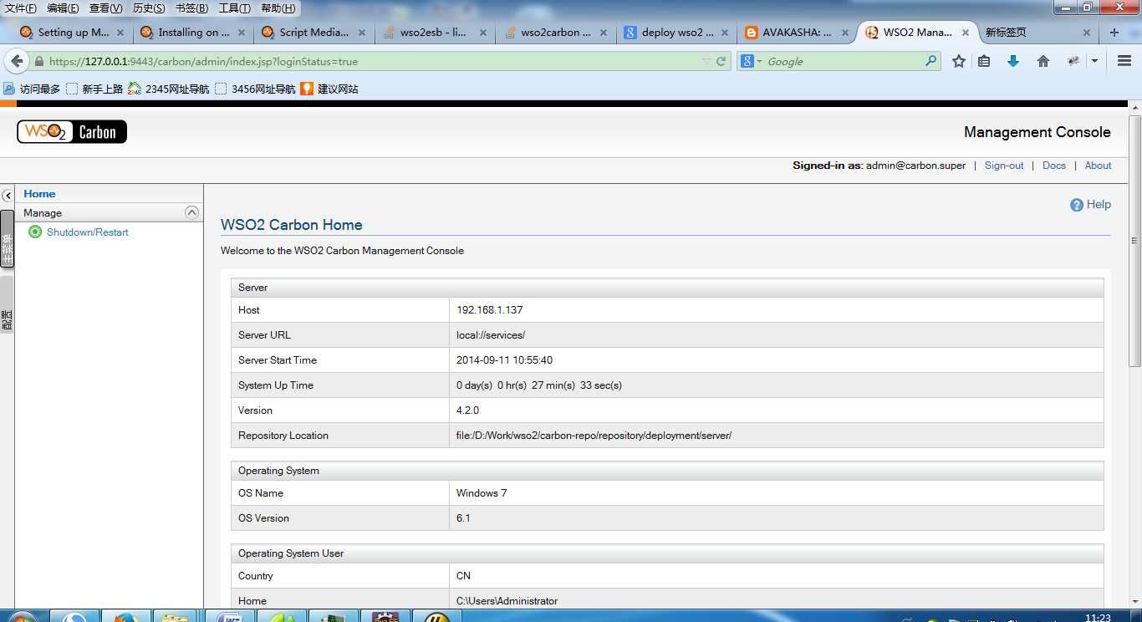

wso2esb在eclipse上运行
    - 拷贝必要的文件
新建wso2esb-repo文件夹：例如我的目录是 D:\Work\wso2\wso2esb-repo，后续文档中使用[wso2esb-repo]表示
从编译后的wso2esb目录中将以下4个文件夹拷贝到wso2esb-repo文件夹中，后续文档中以[wso2esb]表示能直接运行的wso2esb的根目录（即编译后的目录）
bin、lib、repository、resources
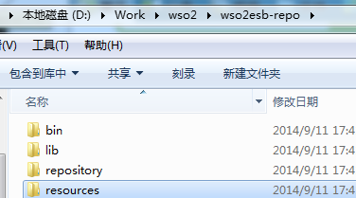
    - 修改axis2配置
D:\Work\wso2\wso2esb-repo\repository\conf\axis2\axis2.xml
修改：将相对路径改为绝对路径
82行：
<parameter name="SynapseConfig.ConfigurationFile" locked="false">D:/Work/wso2/wso2esb-repo/repository/deployment/server/synapse-configs</parameter>
272行：
<Location>D:/Work/wso2/wso2esb-repo/repository/resources/security/wso2carbon.jks</Location>
280行：
<Location>D:/Work/wso2/wso2esb-repo/repository/resources/security/client-truststore.jks</Location>
396行：
<Location>D:/Work/wso2/wso2esb-repo/repository/resources/security/wso2carbon.jks</Location>
404行：
<Location>D:/Work/wso2/wso2esb-repo/repository/resources/security/client-truststore.jks</Location>
    - 修改数据库配置
参考Carbon在eclipse上运行对应章节
    - 入口函数
参考Carbon在eclipse上运行对应章节
    - 引入相关jar包
参考Carbon在eclipse上运行对应章节
    - 设置运行参数
参考Carbon在eclipse上运行对应章节
根据实际环境修改相应的值，例如将CARBON_HOME设置为：
CARBON_HOME=D:\Work\wso2\app\wso2esb-repo
    - 运行
参考Carbon在eclipse上运行对应章节

wso2esb在eclipse上debug
以debug wso2esb的更新角色权限功能为例：
    - 进入组件页面
在页面能看到当前功能所在的jsp页面。如图：
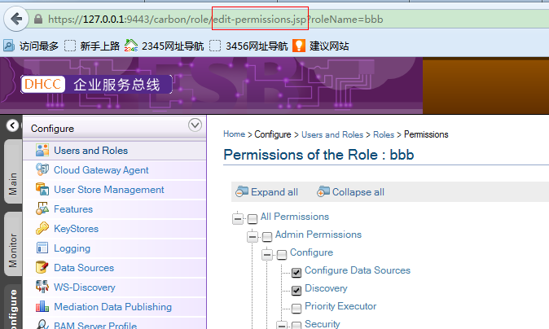
    - 导入组件代码到eclipse
组件的源码均在[turing-chunkxx]\components目录下，例如本例用svn检出的turing-chunk11的源码，则组件代码在[turing-chunk11]\components目录下。根据组件名字就能很容易找到组件代码：
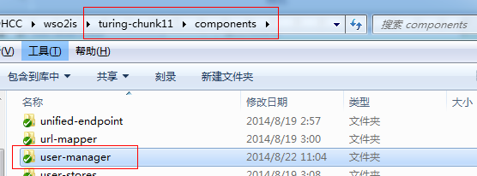
若不知道可能在哪个组件下面，使用文件搜索功能，能快速找到所在组件，例如：
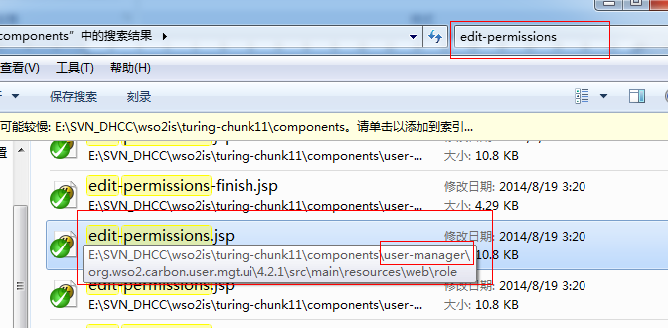
导入组件代码到eclipse中。
    - 找到相关执行函数，打断点
从xxx.ui下面找到对应的jsp，再根据调用方法找到相关的调用函数，在需要的地方打断点。
例如我在setRoleUIPermission处打上端点，可以看到前台传过来的值。
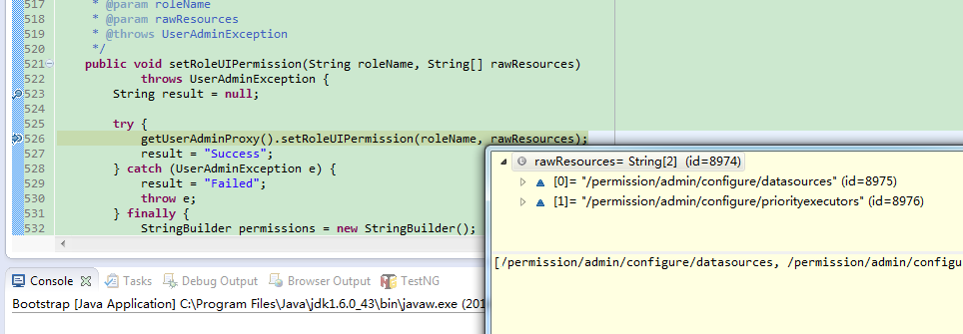

FAQ（常见问题解答）

附录

maven拷贝文件到指定目录
添加到pom.xml的build/plugins标签下面
<!-- copy jar to repo for Test -->
<plugin>
<groupId>org.apache.maven.plugins</groupId>
<artifactId>maven-antrun-plugin</artifactId>
<version>1.7</version>
<executions>
<execution>
<id>install</id>
<phase>install</phase>
<configuration>
<target>
<echo message="**********copy profile propertie file ***********"/>
<copy file="target/${project.artifactId}-${project.version}.jar"
tofile="D:/Work/wso2/repo/carbon-repo/repository/components/plugins/${project.artifactId}_${project.version}.jar" overwrite="true"/>
</target>
</configuration>
<goals>
<goal>run</goal>
</goals>
</execution>
</executions>
</plugin>

Carbon代码编译顺序
The build sequence in platform:
- Dependencies
- Service-stubs
  - UI component - Front End
- Components
  - Server component (Processing) - Back End
  - Note that if the component wsdl is updated, then we have to update it back to the service-stubs again by building the service-stubs and then finally build the feature.
- Features
  - Create the features by combining the server component, service-stubs and UI components together. Therefore, if necessary, those features can be installed into the carbon products when instances are running
- Products
  - Finally, in this section, we build the product
    - Here, if we look at the build sequence, we first build styles then samples and then services
    - Next, we build features first and then p2-profile. This will install the features that are specific to the product.
    - Then we build distribution, which will generate the final product; thereafter, we finally build the integration, which will test the product (test automation).

feature.properties

具体内容参见：
http://svn.wso2.org/repos/wso2/carbon/kernel/branches/4.2.0/samples/student-manager/features/feature.properties

