# 脉搏传感器降噪测试

**降噪算法**

for(i=0;i<jz;i++)

{

b[i] = analogRead(A0);

}

for(i =0;i<jz;i++ )

{

sum = sum+b[i];

}

a = sum/5;

Serial.println(a);

sum = 0;

JZ = 0

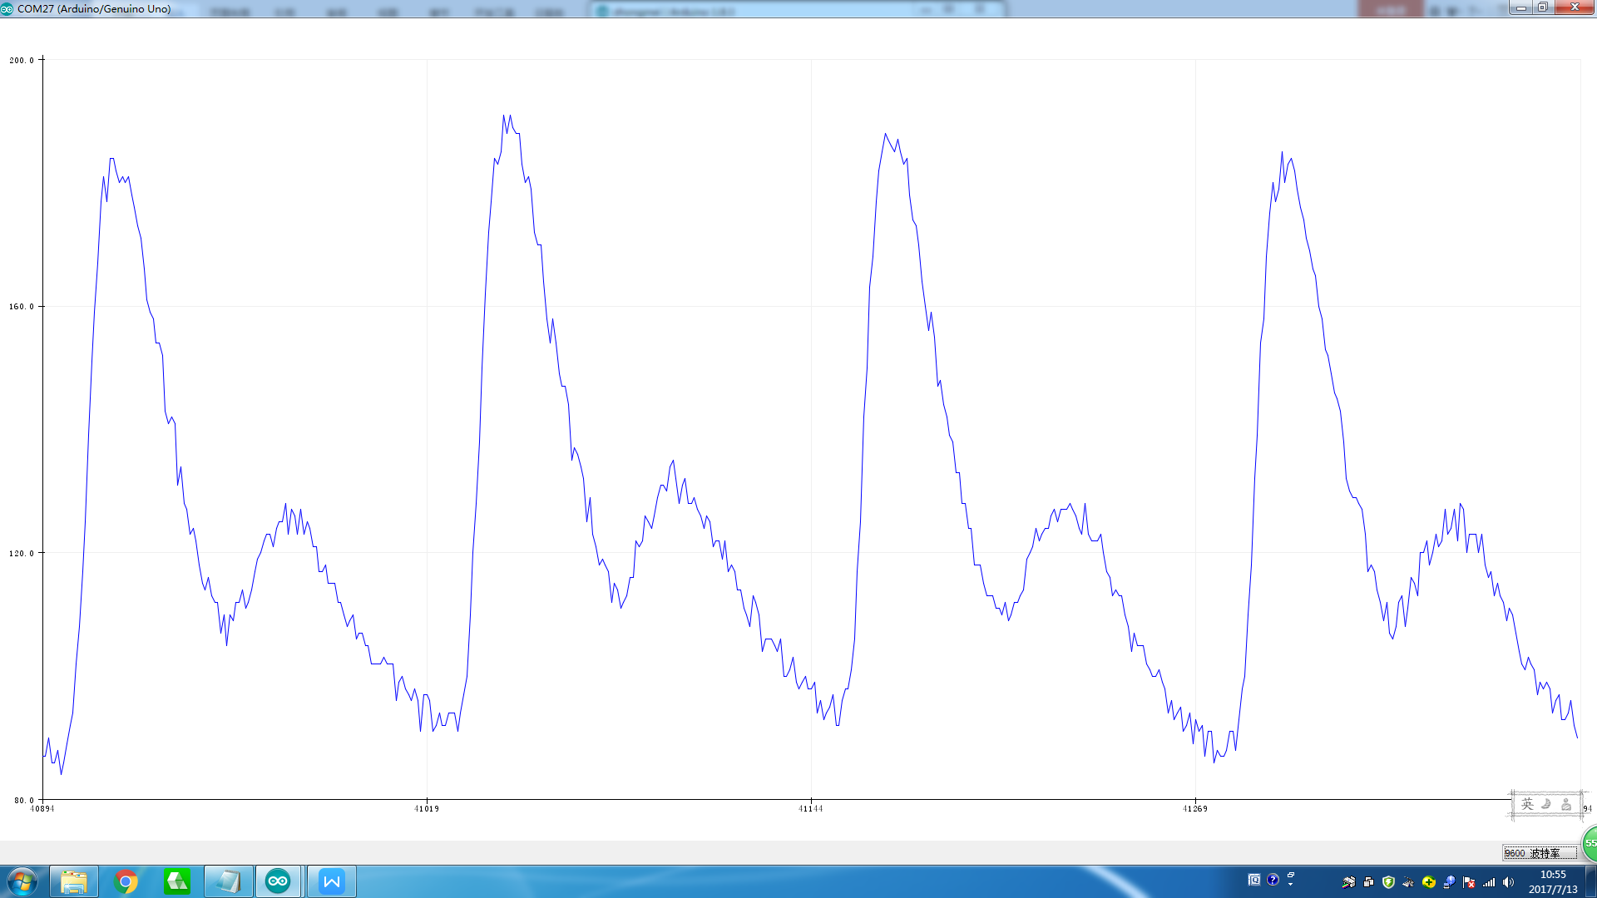

JZ=3

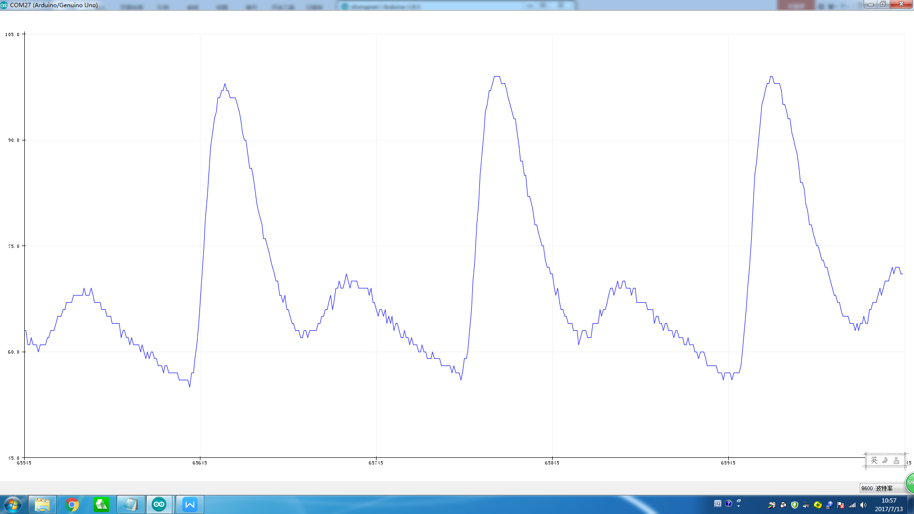

Jz=5

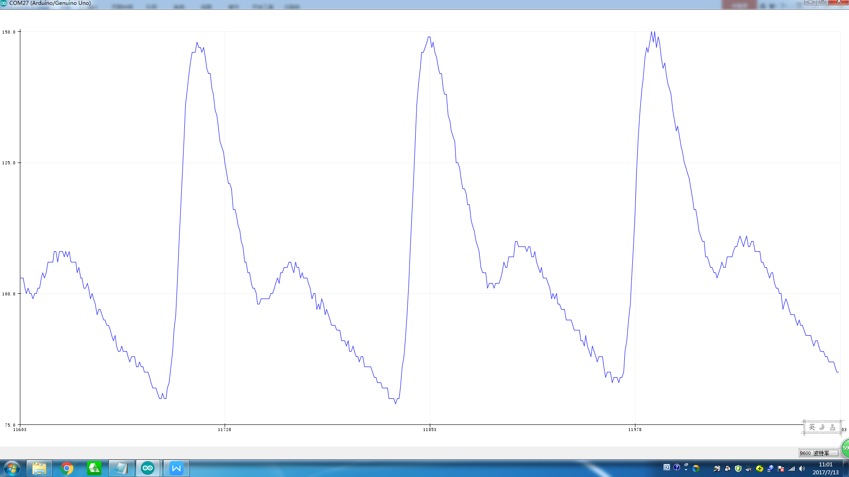

Jz=7

Jz=9

Jz=11