Name |  | Lee Lin Yuan | Gender | Male | Mobile |  | +601116553434 |  | 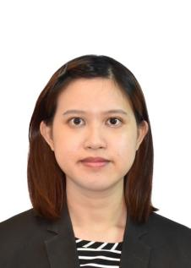
Position |  | Solution Consultant |  |  | Work Location |  | Malaysia
English Name |  | Lin | Email |  | linyuan.lee@trustdecision.com
Social contact |  | Whatsapp： +601116553434, WeChat lly121097
Education
Start |  | End | University |  |  | Major |  |  | Qualification
2016 |  | 2018 | Universiti Tunku Abdul Rahman (UTAR), Selangor |  |  | Bachelor of Science (Hons) Financial Mathematics |  |  | Bachelor Degree
Employment History
Start Date |  | End Date | Full Company Name |  | Department |  |  | Position
2025.1 |  | Now | TrustDecision (Malaysia) Sdn Bhd |  | International Business Department |  |  | Solution Consultant
2019.12 |  | 2025.1 | Huawei Technologies |  | Asia Pacific IT Business Serv Department |  |  | Product & Solution Engineer
2019.7 |  | 2019.12 | Hong Leong Bank |  | Corporate Banking Department |  |  | Corporate Banking Specialist
2016.10 |  | 2017.06 | Royal Bank Canada |  | Global Tax and Account Services Department |  |  | Global Tax Operation Specialist
Project Experience
Start Date |  | End Date | Project Name |  | Project Scope |  |  | Position
2025.1 |  | 2025.3 | Anti Fraud System and Credit Risk Modelling |  | Participate in solution design and technical consulting for financial institutions across the Middle East &  Southeast Asia  Designed and delivered customized proof-of-concepts (POCs). |  |  | Solution Consultant
2024.6 |  | 2025.1 | 5G Business Transaction flow for Telco Business |  | Head of Solutions for the Malaysia Representative Office; led the design and delivery of the Malaysia  5G Transaction Flow project to optimize IT solutions. |  |  | Product & Solution Engineer
2020.12 |  | 2024.5 | Implementation of New ERP system |  | As a Led of PMO in enterprise-level ERP implementation across 22 Asia-Pacific offices, managing a team of over 300 testers and developers |  |  | Product & Solution Engineer
Skill Set
Skill | Google Project Management Certificate  Huawei ERP Consultation Certification  Google IT Automation with Python Specialization  Microsoft Certified: Azure AI Engineer Associate  Google Data Analytics Certificate  Huawei IT Security Certification  Programming Languages (Python, Vue.js, Html,css)

