Most VHDL simulators use the Tool Command Language (Tcl) as their scripting language. When you type a command in the console of the simulator, you are using Tcl. Furthermore, you can create scripts with Tcl that run in the simulator and interact with your VHDL code.
In this article, we will create a self-checking testbench that used Tcl instead of VHDL to verify that a VHDL module behaves correctly.
TCL：是一个tcl语言吗？
lrange — Return one or more adjacent elements from a list
https://www.tcl.tk/man/tcl/TclCmd/lrange.html

The syntax for declaring std_logic_vector signals is:
signal <name> : std_logic_vector(<lsb> to <msb>) := <initial_value>;
or
signal <name> : std_logic_vector(<msb> downto <lsb>) := <initial_value>;

In VHDL there are two assignment symbols:
<= Assignment of Signals -- 下一个时钟才变，或者在process暂停结束后才变，且只根据最后一条赋值语句变，前面的忽略
:= Assignment of Variables and Signal Initialization
例子：
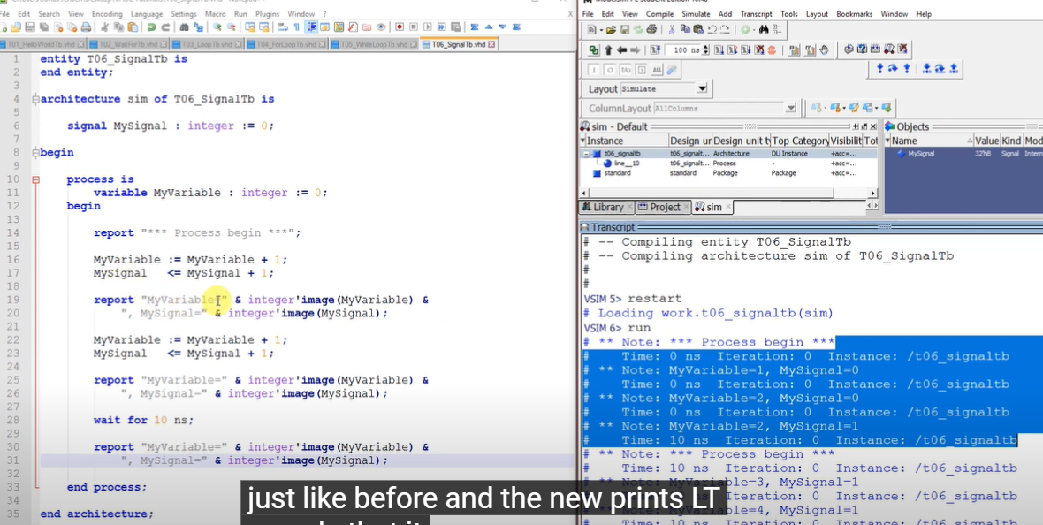

constant ADDRESS_WIDTH : integer := integer(ceil(log2(real(FILTER_TAPS))));
-- ceil 向上取整
比如log2(8)，那就需要3位地址000-111才能装下8个数；向上取整，防止装不下
-- vhdl关键字是不区分大小写的
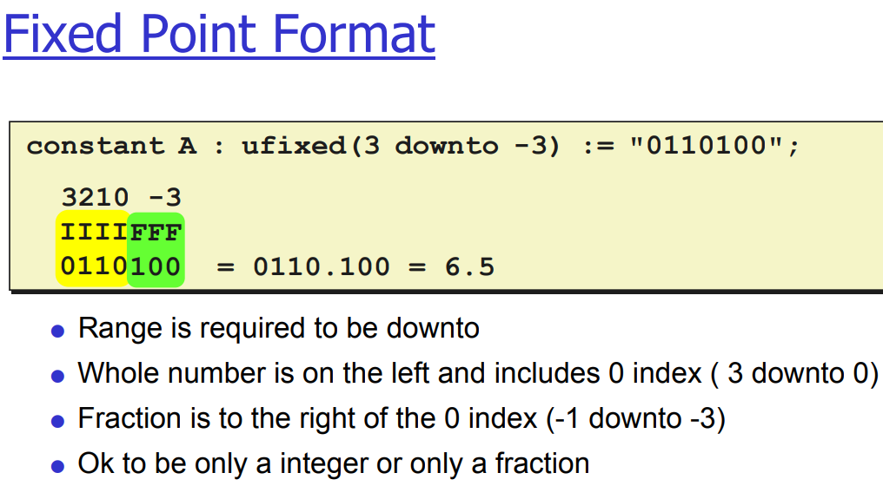
Wait until will suspend a process until the condition of the wait is true. If the keyword wait is not followed by until the code will wait forever on that line.Wait on is equivalent to using a sensitivity list in a process. As soon as any of the signals in the wait on list changes, the code will continue to execute.Wait for is never synthesizable. However it is still very useful for test benches and for bus functional models. Wait for must be followed by some amount of time, for example 10 ns. Ensure that you have a space between your number and your unit of time or your code will not compile.

