## 1.卸载系统自带的mariadb-lib

查看mariadb版本

rpm -qa | grep mariadb

卸载mariadb

rpm -e mariadb-libs-5.5.56-2.el7.x86_64 --nodeps

重启机器

reboot

## 2.上传安装包并解压

将mysql-8.0.18-1.el8.x86_64.rpm-bundle.tar安装包上传到/opt/software目录

解压mysql安装包到/opt/server目录

tar -xvf mysql-8.0.13-1.el7.x86_64.rpm-bundle.tar -C /opt/server

## 3.按顺序安装

必须安装(注意顺序)

rpm -ivh mysql-community-common-8.0.13-1.el7.x86_64.rpm

rpm -ivh mysql-community-libs-8.0.13-1.el7.x86_64.rpm

rpm -ivh mysql-community-client-8.0.13-1.el7.x86_64.rpm

rpm -ivh mysql-community-server-8.0.13-1.el7.x86_64.rpm

非必要安装（注意顺序）

rpm -ivh mysql-community-libs-compat-8.0.13-1.el7.x86_64.rpm

rpm -ivh mysql-community-embedded-compat-8.0.13-1.el7.x86_64.rpm

rpm -ivh mysql-community-devel-8.0.13-1.el7.x86_64.rpm

rpm -ivh mysql-community-test-8.0.13-1.el7.x86_64.rpm

如何报以下错误：

### 错误1:

error:

Failed dependencies:

libnuma.so.1()(64bit) is needed by mysql-community-server-8.0.13-1.el7.x86_64 libnuma.so.1(libnuma_1.1)(64bit) is needed by mysql-community-server-8.0.13-1.el7.x86_64 libnuma.so.1(libnuma_1.2)(64bit) is needed by mysql-community-server-8.0.13-1.el7.x86_64

**解决办法：**

**yum install numactl**

### 错误2:

出现问题：

error:

Failed dependencies:

pkgconfig(openssl) is needed by mysql-community-devel-8.0.13-1.el7.x86_64

**解决办法：**

**yum install openssl-devel.x86_64 openssl.x86_64 -y**

### 错误3:

error:

Failed dependencies:

perl(Data::Dumper) is needed by mysql-community-test-8.0.13-1.el7.x86_64

**解决办法：**

**yum -y install autoconf**

### 错误4:

error:

Failed dependencies:

perl(JSON) is needed by mysql-community-test-8.0.13-1.el7.x86_64

**解决办法：**

**yum install perl.x86_64 perl-devel.x86_64 -y**

**yum install perl-JSON.noarch -y**

## 4.初始化数据库

mysqld --initialize --console

## 5.目录授权，否则启动失败

chown -R mysql:mysql /var/lib/mysql/

## 6.启动msyql服务

systemctl start mysqld

将mysql服务设置为开机启动

systemctl enable mysqld

systemctl daemon-reload

## 7.查看msyql服务的状态

service mysqld status

## 8.在/var/log/mysqld.log下查看临时密码

cat /var/log/mysqld.log

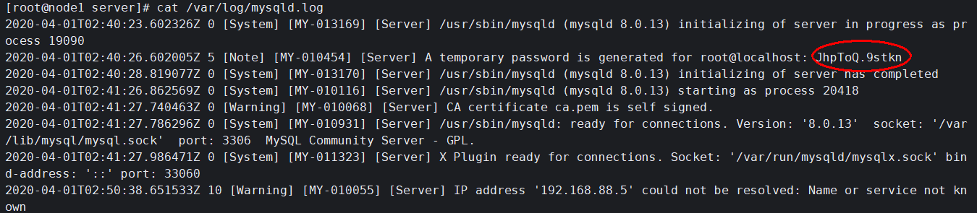

## 9.用临时密码登录到数据库

mysql -u root -p

输入临时密码（输入时不会显示出来，输入完直接回车）

## 10.执行下列mysql命令 修改密码

alter USER 'root'@'localhost' IDENTIFIED BY '新密码';

## 11.依次执行下列mysql命令 授权远程连接

查看所有用户是否可以远程连接，依次执行下列命令：

show databases;

use mysql;

select host, user, authentication_string, plugin from user;

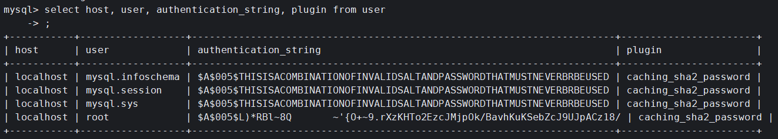

host为localhsot，说明用户只能本地连接msyql服务

修改root用户host值，使root用户可以远程登录

update user set host = "%" where user='root';

刷新

flush privileges;

开启mysql远程访问权限

use mysql;

alter USER 'root'@'%' IDENTIFIED WITH mysql_native_password BY 'root用户的密码';

flush privileges;