The Report of API Test Tool
Lan Yiyuan(55614744), Wang Haipeng(55762913), Sun Jingyao(55880040), Zou Shuang(55911609),
Li Yixin(55975771), Zhao Dongyu(55980768), Du Kejun(56075096)
Computing Sciences Department, City University of Hong Kong, Hong Kong, China

Abstract—The API Test Tool implements most of functions on the basis of Postman that is a popular test tool. The API Test Tool provides HTTP and Web API request debugging, which can send any type of HTTP request with parameters and headers. Moreover, it also provides the import and export of test data and environment configuration data. In the API Test Tool, there are three main parts, which are History, Collection and request builder. Any HTTP request can be created quickly and saved in History to be executed again. Through Collection function, we can well classify and manage the API provided by the test software. In the part of testing request, there are many different types of request, such as get, post, put and delete. API Test Tool has a variety of methods to define variables, which are used in different domain. No matter what kind of variable, it uses {{variable}} to represent variables, which is useful in developing and testing.
Keywords—API Test Tool; HTTP request; Web API

I. Introduction

A. Background
With the increasing importance of API interface testing, the traditional manual API interface testing method is inefficient and the quality is not guaranteed. In practice, some bugs cannot be found on web page’s operation, but interface testing can find the bugs[1]. In addition, it also can check the system's ability to handle exception and the safety and stability of the system. Interface is more stable than front end page and can test the concurrency which allows two events processed at the same time. Also the request parameters of interface testing can be modified to break through the front end page input limit.
When developing or debugging web programs or web B/S mode programs, users need some methods to track web page requests. There is some web monitoring tools such as firebug, which is a web page debug tool. But in order to meet users’ further requirements, a more powerful HTTP request simulation tool Postman is selected. In this project, we also design the tool based on Postman.

B. Objective
The API Test Tool is aimed to be applied the interactive development of multiple systems and application systems with multiple subsystems. It is used to the underlying framework system and central service system that provide services for other systems. It mainly tests the interfaces provided by these systems to the external to verify their correctness and stability. In the process of developing products, the tool acts as the bridge of this interaction mode. It can send all kinds of data simulating user’s HTTP requests to the server, so that developers can make the correct response in time, or deal with the error information before a product is released in advance, so as to ensure the security after the product is launched.

C. Signification
Interface, also known as API, is a contract for connecting different components of a software system, such as the interface between modules, or the interface between front-end and back-end. From the perspective of system architecture, the interface is often developed by the back-end personnel, which has a wide range of influence, so when there is a problem with the interface, it often affects the progress of research and development. The interface is the boundary of each module [2]. When testing the interface, you can find more important bugs, because borders are the most problematic place, whether it is the boundary of the module or the boundary of the personnel.
The API Test Tool is a convenient web debugging tool with JSON automatic typesetting function and supports recording. It can record the parameters and return values of each post or get method. It also integrates base64 encryption and decryption to provide the security of Web Data. The development of server would be done in Java Programming Language and the html page is implemented by css technology.

II. The Working Principles of Firewalls and VPNs

A. The working principle of Firewalls
Firewall technology has been developing continuously since its birth. Various kinds of firewalls with different structures and functions are built into a network of defense embankments. Traditional firewall technology falls into three categories: Packet Filtering, Application Proxy, and Stateful Inspection. No matter how sophisticated the implementation of a firewall is, it is ultimately extended based on the following three technologies:
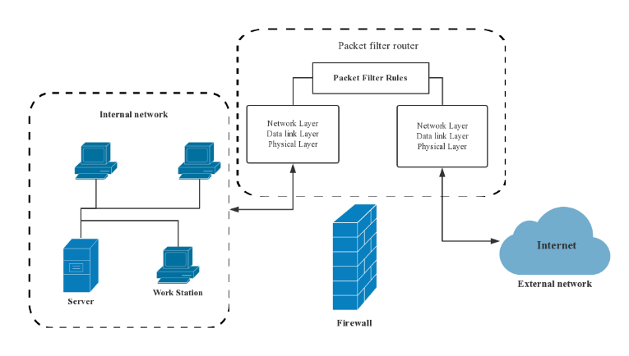
Fig. 2. The principle of Packet Filtering

Packet Filtering：The working principle behind the Packet filtering firewall can be called as a network firewall because it works in the network layer. It usually decides whether to let the data packets pass, by examining the address, protocols, and ports of each packet. Fig.2 shows the principles of Packet filtering. The packet filter can be divided to a static packet filter and dynamic packet filter. [5]

Static packet filter: Static packet filter technology is a traditional packet filter. It decides whether these data packets can be passed according to the IP addresses of these data packets. If attackers set their mainframe IP addresses as legal addresses, they can quickly pass the static packet filtering firewall. Therefore, this kind of firewall is not secure enough.

b) Dynamic packet filter: It can automatically apply to create or delete packet filter rules according to dynamic practice application without administrators’ intervention. However, the dynamic packet filter technology can only filter against data’s IP address instead of the legality of users. It also does not have log records to check which brings enormous difficulties to daily network security management. Therefore, it has been replaced by a new technology called the Adaptive Proxy Protection firewall.

2) Application Proxy： Application Proxy firewall is also called as Application Gateway firewall. This firewall participates in the entire process of a TCP connection through Proxy technology. The data packets sent from the inside are processed by the firewall, to hide the Intranet structure. Network security experts recognize this type of firewall as the most secure firewall. Its core technology is the proxy server technology. The proxy server refers to the program that represents the client's connection request on the server. When the proxy server gets connection intentions from a client, they will verify the client’s request, and then handle connection requests through the specific secure proxy applications. The request is transferred to the real server, which then accepts the server response. After further processing, the proxy will reply to the final client who makes a request. The proxy server plays the role of interconnecting the application of the external network to the internal network. [5]

a) Adaptive Proxy Firewall: Adaptive proxy is a revolutionary technology implemented recently in commercial application firewalls. It combines the advantages of the safety of the Proxy firewall and the high speed of Packet filtering firewall and improves the performance of the proxy firewall 10 times without losing the security.

3) Stateful Inspection: Stateful Inspection is an extension of the packet-by-packet filtering process, which tracks individual flows, enabling policy checks that extend across series of packets. [6] It checks the handshakes in a communication network by exploiting detailed information of the communication protocol. It detects malicious activities by monitoring a connection packet-by-packet and predicting the next move based on what happened, which makes it a more advanced tool than other firewalls. [7] These firewalls maintain a table of open connections, inspecting the payload of some packets and intelligently associating new connection requests with existing legitimate connections. [8] With modern firewalls, network administrators can control the network traffic in a more fine-grained fashion.

B. The working principle of VPNs
The mainstream applications that claim to provide VPN services are using one of the following three techniques: Proxy, IPSec, and SSH. [4]

1). Proxy Server: A proxy server is like a courier service that is responsible for nothing but transcending the message. The work of proxy servers is conducted in the HTTP layer and Socket layer in the Open System Interconnection (OSI) model under most circumstances. Fig 3 [4] explains how proxy server functions.
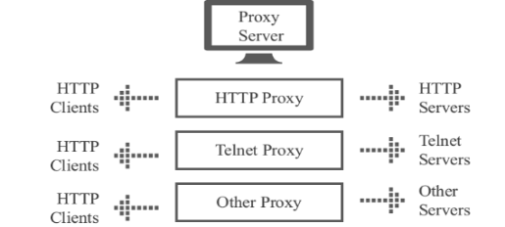
Fig. 3. The working architecture of a Proxy Server

2). IPSec: IP security is the most common method used by the VPN applications. It works in the third layer of the OSI model, which is the Network layer.

3). SSH: It is an encrypted channel that needs to be combined with the proxy server to overcome the blocked network. The tool that is used to scale the blocked network which is usually called SSH is, in fact, an SSH agent. In the TCP/IP 5-tier model, SSH is the security protocol that applies to the application layer and the transport layer. SSH is a remote shell, an application based on SSL. Although many people use SSH to transmit data, they merely use the SSL proxy function of SSHD software to get this job done.

C. Architecture of a system using both Firewall and VPN
Figure 4 shows a typical security network architecture based on firewall and VPN technology [9]. The system has a master node, under which there are large nodes and links between them. Under the big node, there are intermediate nodes, and under the intermediate nodes, there are small nodes. The intermediate node and the small node are only connected with their own upper and lower levels. Between nodes, special wire connection can also support other ways of connecting people, such as wireless connections. Security between nodes ensures the safe transmission of data through the virtual encryption channel between VPN array devices and VPN receiver devices.
The entire network adopts a network management system to manage, control and report congestion for various security devices, routers, switches and servers in the network, as well as fault management. The network management system will monitor equipment utilization, bandwidth utilization, packet loss rate, etc. Two firewalls with the same configuration are used in the same network node, and they communicate with each other through a direct connection. Under normal circumstances, one is working, which is the Primary, and the other is in the backup state.
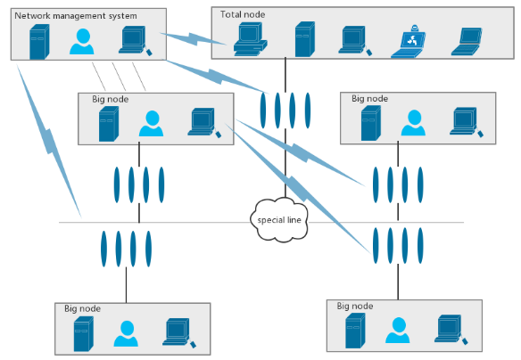
Fig. 4. A typical security network architecture based on firewall and VPN technology
High availability is achieved through "heartbeat" mode. A direct connection between two firewalls of the same type creates the heartbeat line that uses fixed interval, master-slave equipment to exchange information. When the host accidentally crashes, or network fails, hardware failure happens. Master-slave firewall switch working state from the machine instead of the standard work of the host, to guarantee the regular use of the network. Switching process does not require a human operator. They also do not need the participation of other systems. The primary firewall’s restore function will automatically return the control to the firewall, to assure the safety of the network.
By deploying this network security system with firewall technology as the core, a VPN can realize the secure exchange of confidential information between nodes.

III. Preliminaries
The project uses the standard scrum for development and management. The implementation of the scrum process in the project is based on an iterative and incremental process framework. The team firstly defines project theme and requirements (which is API Test Tool) and estimates each members' advantages and capabilities. Then implement the function by sprint process, holding daily meetings to deal with new complex problems, difficulties and emergencies.

Scrum Roles

1) Scrum Master
The Scrum Master is responsible for the scrum process, supervising all members to follow scrum rules and ensure that the project is completed within the expected timeframe. Help scrum members achieve the highest level of performance. Through the guidance of the scrum master, our project successfully completed the iteration and incremental of the scrum.

2) Product owner
The product owner is responsible for prioritizing the backlog and supervise the team to do the tasks with the highest priority. In this project, the product owner assigns the following priorities to the backlog (the following items are ranked from highest to lowest): design test cases and user stories, drawing product prototypes, function development, and testing.

3) Team
Team is responsible for developing software features. Our project team size is 7 people, completing subtasks with self-management, self-organization and cross-functional work.

Scrum Implementation Process
All work is done during the sprint cycle. Before each sprint starts, scrum master holds a 1-2 hours' sprint plan meeting. The user story for each sprint plan is selected based on priority. At the sprint plan meeting, the entire user story and functional requirements according to the flow chart are showed to the group members, then team members jointly split into subtasks. After splitting the task, all members discuss and evaluate the difficulty and time consuming of each subtask, finally the scrum team members respectively pick the subtask.
Throughout the sprint process, scrum master holds a daily online meeting via WeChat every day. The time-consuming is controlled within 10 minutes, each group members are asked to simply state the tasks that have done, the tasks are in processing, and the difficulties we are currently experiencing.
We use the online tool Leangoo to track tasks. Leangoo is an online project scrum tool which provides an end-to-end project management and team collaboration platform to help achieve efficient and visual collaboration and management. Different from the traditional tabular project management tools, Leangoo supports multi-person collaboration and real-time information synchronization. In addition, a variety of project templates are built in Leangoo, covering different application scenarios such as agile development, phased projects, lightweight collaboration, and problem tracking. All subtasks are uploaded to the Leangoo's task board and labelled different time mark. These subtasks are assigned to the team members by the scrum master. Through the product backlog, burndown chart and task board, we can clearly analyse the current progress of the project and make corresponding plan. The estimated time of the task, the actual execution time, and the time required for completion are recorded in the tracking table. According to the tracking table and burndown chart, the completion of the task can be visually displayed. The task board allows the scrum master to keep track of each subtask and the current project status.
When the project member completes the subtask, it is submitted to the scrum master for checking. If there is no problem, then the subtask card would be moved to the done group. At the end of each sprint, the scrum master holds a sprint review meeting. The main purpose is to summarize the completed tasks, record happened difficulty, and develop a next sprint to-do list.

Scrum Tools

1) Product Backlog
The product backlog lists all the features desired for our projects. The product owner determines the content, priority, and availability of the product backlog. This list is constantly changing as the project progresses.

2) Sprint Backlog
The sprint backlog is a list of tasks to complete during the sprint. The team design a preliminary task list in the sprint planning meeting. In this process, our team uses the way of discussion to estimate the duration of the task. In the event of a dispute, the scrum master makes the final decision. Only subtask responsible personnel have the right to change the sprint backlog.

The table above is an example of a sprint backlog in the API Test Tool project. The horizontal axis represents the pending task of the sprint, and the vertical axis represents the period of the sprint (15 days). After the tasks are determined, the relevant responsible person can mark the estimated time of completing the task on the backlog. During the sprint meeting, the scrum master encourages every member to choose tasks that they prefer or be good at. For example, the task "Building the server" is assigned to the members Wang and Zhao. This task is in progress and the remaining workload is 40 hours. All the tasks about drawing diagrams are already completed and the remaining workload is zero.

3) Release burndown chart
The release burndown chart is a work chart used for indicating the remaining workload and tracking progress on a project. The horizontal axis represents time and the vertical axis represents workload. This chart can be used to visually predict when work will be completed and team efficiency at each stage. Through the release burndown chart, when the slope of the open estimate curve has an upward trend, scrum master needs to focus on this stage, track the member's work efficiency, find the difficulties in technical implementation and communicate. If the open estimate curve tends to be stable, it indicates that the project is progressing favourably.

IV. The Solution of Designing API Test Tool

Requirements
API Test Tool is a web application inspired by Postman, which is an API and network test tool. The main function is to send different types of HTTP request with parameters and headers and display all the request response information. The main purpose of this tool is to provide HTTP and Web API request debugging. The detailed functional requirements are as follows.

1) Test API
There are four kinds of authorization types, namely Normal, Basic Auth, Digest Auth and OAuth 1.0. Depending on the type of authorization, the inputs are different. For all the four types, the input URL, interface request method (GET, POST, PUT, PATCH, DELETE, COPY, HEAD, OPTIONS, LINK, UNLINK and PURGE), URL parameters and Headers are essential.
Besides, for the other three types except Normal, the authorization headers are needed and it will be generated and added as a custom header. Specifically, for Basic Auth, the authorization headers are Username and Password; for Digest Auth, the authorization headers are Username, Realm, Password, Nonce, Algorithm, qop, Nonce count, Client nonce and Opaque; and for OAuth 1.0, the authorization headers are Consumer key, Consumer secret, Token, Token secret, Signature Method, Timestamp, Nonce, Version and Realm.

2) History
HISTORY is a storage of the request history using the form of “request + URL”. It stores all the request information in TEST API, and each entry in it can be deleted individually or completely. The implementation of this function enables the executed requests to be executed again quickly.

3) Collections
In COLLECTIONS, new collections can be created, and multiple requests can be categorized and stored in different collections. Also, collections can be import from disk or URL. The existing collections can be edited, deleted and shared as a link or downloaded as a JSON file. The implementation of this function enables the requests to be ordered and well-classified.

4) Information
INFORMATION shows the response to the request in TEST API, which includes Body, Cookies, Headers and Status. In Body, the response information can be shown in different content-type, including Pretty (JSON or XML), Raw and Preview. The cookies information and the headers information in response are displayed in Cookies and Headers, respectively. In Status section, there is the response time and the response status in the form of HTTP status code.

5) Settings
In SETTINGS section, the shortcuts that can be used and the basic preferences (such as Max history items, Auto save request, Send no-cache header, Language detection and so on) can be set and modified.

6) Testcase
In summary, the testcase of the above functional requirements is shown in Figure 4.1.

Design
In accordance with the requirements in 4.1, the prototyping, workflow, use case diagram, state diagram and sequence diagram is shown in detail in this section.

1) Prototyping
It is a web application inspired by Postman. An example of the prototype is shown in Figure 4.2., and the detailed prototype is in our Git repository.

2) Workflow
The workflow generated from the prototype design is shown in Figure 4.3.

3) Workflow
The use case diagram is shown in Figure 4.4. As the use case diagram shown, there is only one participant, the User, and there is the following use case. Firstly, the user Input URL to choose the request method, and input the request URL and other request information (such as authentication information) to finish the whole request information. And then user Send URL to send the request to get the response information. Meanwhile, the user can also Add Collections to add the request to a collection. Secondly, user can Check Collections to do the operations (such as edit, deletion, import and share) on the existing or new collections. Thirdly, user can Check History to view the history list. Lastly, user Set Settings to set the shortcuts and basic preferences.

4) State diagram
The state diagram is shown in Figure 4.5. As the state diagram shown, the initial state is Input Pattern, and the system waits for user input in this state. After the system obtains the user’s input, it changes to Sending mode, and it waits for response from the server. If the user’s input is a wrong URL, the system Fail to Return Response and return to Input Pattern state. Otherwise, if the user’s input is correct, the state changes to Return Response, and the whole process finishes.

5) Sequence diagram
The sequence diagram is shown in Figure 4.6. As the sequence diagram shown, APITestTool sends the request message to the controller Send, and it calls getMethod() function to get the optional request method, and calls getInfo(input, method) function to get the response information, and the information is added to the history. Besides, APITestTool can calls addToCollection(request) function to add the request to an existing collection, or calls createCollection() to create a new collection. To set the shortcuts and basic preferences, system calls set() function, and the controller calls update() function to modify the current settings.

Implement
- Content

2) Server

V. Evaluation

A. The Functional Test for API Test Tool
Figure X shows the testcase that we plan to realize. There are three main areas in this tool. The first one is about the URL be entered in and the kinds of interface client want to get. In this area, we design five main input condition. They are Normal, Basic Auth, Digest Auth, OAth 1.0 and No environment. The testcase of the Normal can be seen as a basic model for all the other three conditions. The client can input the URL and send it in this area. The several kinds of interface requests also can be chosen here. The preview bottom in this area can check the basic data of previous URL. The add to collection bottom can save the URL client want to collect. The Basic Auth, Digest Auth, OAth 1.0 all have different additional conditions. In this area, we realize all Normal, Basic Auth, Digest Auth and OAth 1.0 conditions. The function of No environment is what we didn’t complete. Besides, when it comes to interface request, we realize Get, Post, Put and Delete here.
The second main area shows the data of the interface in different kinds of types. Client can choose the Pretty version, Raw version or click preview to see the website of the URL they enter in. There also a toggle bottom which can used to zoom in or out. The Cookies and Headers of the URL also can be checked in this area. We basically implemented all the functions here.
The third main area contains the collections and history, all the history query log and collections can be found in this area. We also complete all the functions as planned in this area.
For the testcase, we can design it from the following aspects. When it comes to the input area, we must make sure how many characters it can enter. Besides, what kinds of content can be entered should also be paid attention to. We should design the testcase including letter of alphabet, number and symbol, even the negative number should also be considered.
Therefore, first of all, we should design the testcase only including numbers. The first kind should be a very small negative number, such as -231. The second kind can be 0. The third kind should be the very large number like 231.
Then, the testcase only contains letter of alphabet should be designed. Besides, the testcase with letter and number, letter and symbol or number and letter should also be considered.

B. The Perforance Test for API Test Tool
Apache JMeter is a Java-based stress testing tool developed by the Apache organization, which is used to stress test software, originally designed for web application testing, and later extended to other test areas. It can be used to test static and dynamic resources such as static files, Java servlets, CGI scripts, Java objects, databases, FTP servers, and more. JMeter can be used to simulate large loads on servers, networks, or objects, testing their strength and analyzing overall performance from different stress categories. In addition, JMeter can perform functional/regressive testing of the application by verifying that your program returns the results you expect by creating a script with assertions.
Our project mainly uses this tool to perform performance tests. On the http request page, we enter the server name or IP, port number, request protocol, request method, encoding, path. Through performance testing, we can view the monitored response time, error, throughput and other data. We test some of these interfaces as examples.

1) The Immune-Based Firewall System: After an intruder enters a firewall, he must control the firewall system or break the work of the firewall system. To achieve this goal, they must destroy the vital information of the firewall. Therefore, the immune-based firewall system security model centers on the critical information files of the firewall and uses the change of these files as a means to determine whether there is an intrusion. Because the intruder is the "differences" in the firewall system. The critical information file is the body of the firewall system. If an intruder destroys the body of the firewall system, the firewall will find and resist it to protect the critical files that are on record. It will also record the destruction and control of the network communication. The basic structure of the system security model is shown in Figure 5 [26], centered on the critical information file of a firewall and file information database. It also uses the immune subsystem as the core to build a relatively perfect firewall system. However, when it comes to the actual application effect, the filtering mechanism of firewall against these attacks is still not perfect yet, and there is no effective strategy to solve this problem. This model aims to build an ideal firewall filtering mechanism, and the security policy model is shown in Figure 6 [26].
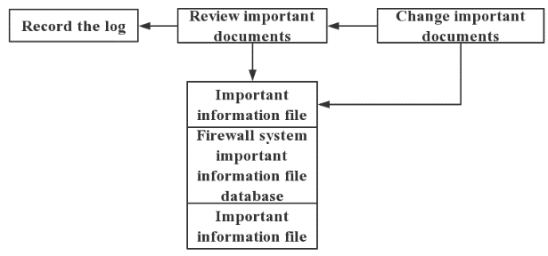
Fig. 5. The model of Immune -Based Security Firewall
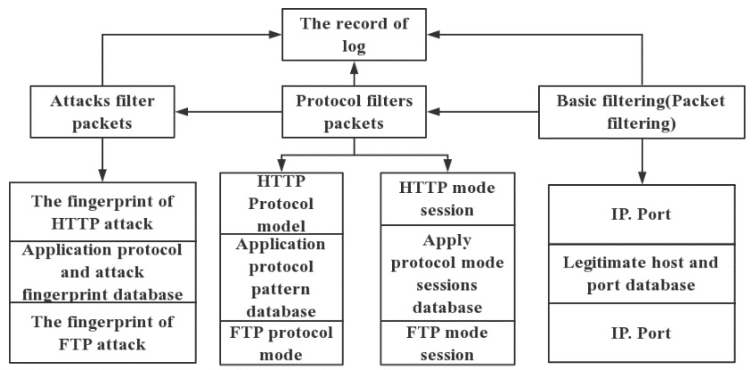
Fig. 6. Protocol-based firewall security policy model

2) Multi-stage filter: The Multi-stage filter uses multilevel filtering in the firewall to filter out all source routing packets and the fake IP sources at the level of packet filtering. The multi-stage filter is a technology that is now widely used by firewalls as packet filtering to efficiently help the protection of firewalls. This method is evident in the layer and can expand many new contents from this concept.

3) Next Generation Firewall: Next-Generation Firewall (NGFW) is the latest buzz in the firewall market at present. Through in-depth insight into users, applications, and content in network traffic, and with the help of a new high-performance single-path heterogeneous parallel processing engine, NGFW can provide users with active application layer integrated security protection. It can help users to conduct business safely and simplify their network security architecture. The technical route of NGFW is shown in Figure 7 [27]. Application recognition is the most critical technology in the route.
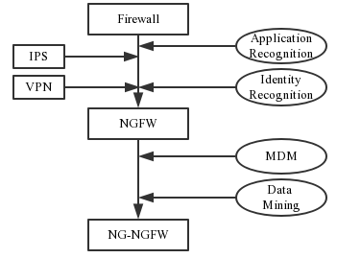
Fig. 7. Technical Route of NGFW

4) The Secure Web Gateway: The Secure Web Gateway (SWG) is a kind of product solution for Internet exportation. It has the functions like URL filtering, malicious code protection and control functions and the application control functions including the Web functions. This means it can enforce the enterprise's Internet access strategy while protecting from the security threats. Most of the mainstream SWG products also provide the user identification and the DLP (Data Leakage Protection) function on this basis. Some company such as Intel uses SWG to protect their company’s security. Furthermore, Fig 8 and Fig 9 shows the structure of this kind of firewall. [28]
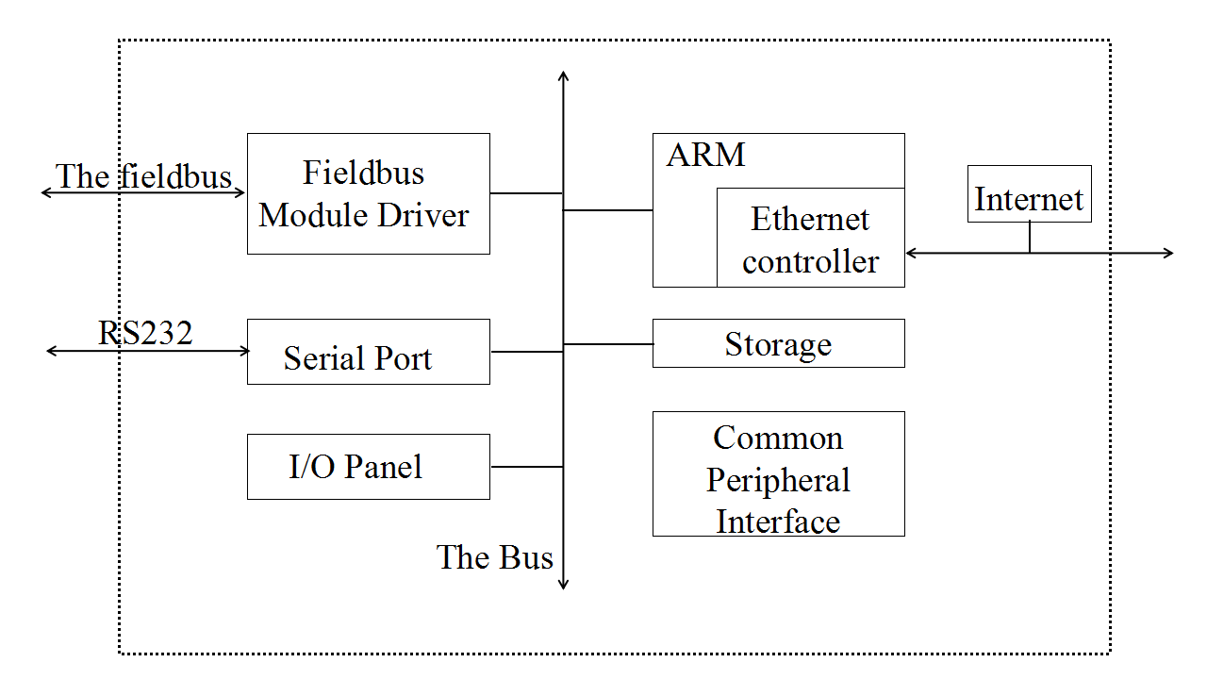
Fig. 8. The Hardware Structure of Embedded Gateway
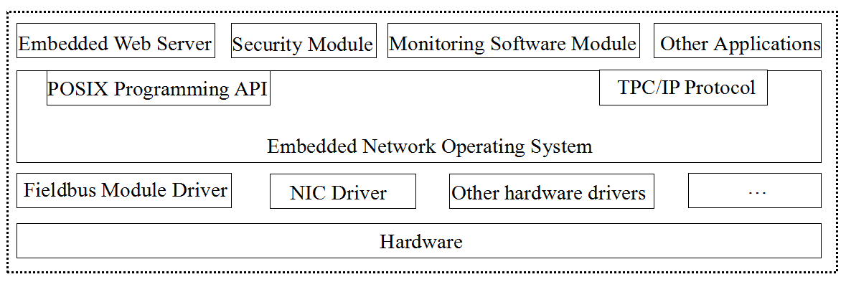
Fig. 9. The Overall Structure of Gateway Software

5) Web Application Firewall: Web Application firewall is mainly used for the Web-specific intrusion methods to strengthen protection against methods such as DDOS attacks, SQL injection, XML injection, XSS, etc. WAF can be divided into four majors as front-end capture, rule setting and monitoring (brain), regulation action (monitoring or blocking), log storage/monitoring display, corresponding processing unit as shown in Figure. 10. [29] Currently, there are three types of WAFs in the market, namely: Hardware Web firewall, Web protection software and Cloud WAF.
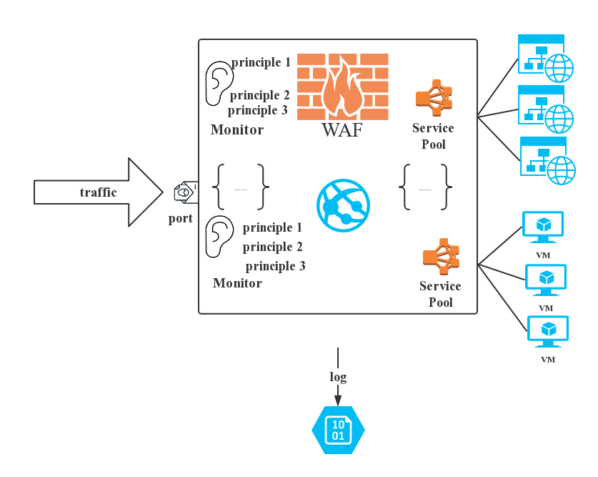
Fig. 10. WAF working principle

B. The Solutions for the Security Issues of VPNs

1) Wi-Fi wall: It is a useful technology to protect the VPNs when the user connects to the Wi-Fi. This technology can monitor the Wi-Fi traffic, and it can constantly check if there are attacks. The Wi-Fi wall will disconnect the Wi-Fi once an attack is detected.

2) Authentication Service: The VPN service providers need the authentication services to help them to keep identity information about the potential end-users. [30]

3) Access control: This service can maintain the security and prevent the use of unauthorized VPN service features and access to the unauthorized resources. [30]

4) Data integrity and confidentiality: This service can keep the integrity of information and prevent the leakage of information and counter threats. The cryptographic hardware can protect the integrity and confidentiality of management data. [30]

5) VPN audit requirement: The suitable auditing system is necessary to detect potential abuse, since the present security service and security mechanisms may be compromised or bypassed. Therefore, the abusers may gain the unauthorized access and damage the VPN protected by them. Enumerating and understanding the VPN service behavior is necessary for providing enough information for the studying of VPN auditing requirements. [30]

6) VPN Firewall: VPN Firewall is a kind of firewall that is installed at the server end or the front of a VPN server. It is configured with the filters only to let the VPN specific packets to access when it is installed at the server end of the VPN. Furthermore, when it is installed at the front of a VPN, it will only allow the tunnel data on its Internet interface to access the server. [31]

7) HAIPE security gateway: In this model, VPN client edge device is intended to use network hardware encryption device HAIPE as a security gateway to protect the communication between VPN client sites. It is shown in figure 11 [32] that the VPN user network consists of A and B stations. The edge of station A is deployed with the HAIPE_A security gateway, and the edge of station B is deployed with the HAIPE_B security gateway. HAIPE_A and HAIPE_B are equal and establish ESP encrypted tunnel between them, which let any information stream between station A and station B be protected by the ESP encrypted tunnel. Only the flow of the network to peer protection or the flow of the network from the peer protection network will pass through the gateway, and the rest of the traffic is stopped by the secure gateway of ESP encrypted tunnel.
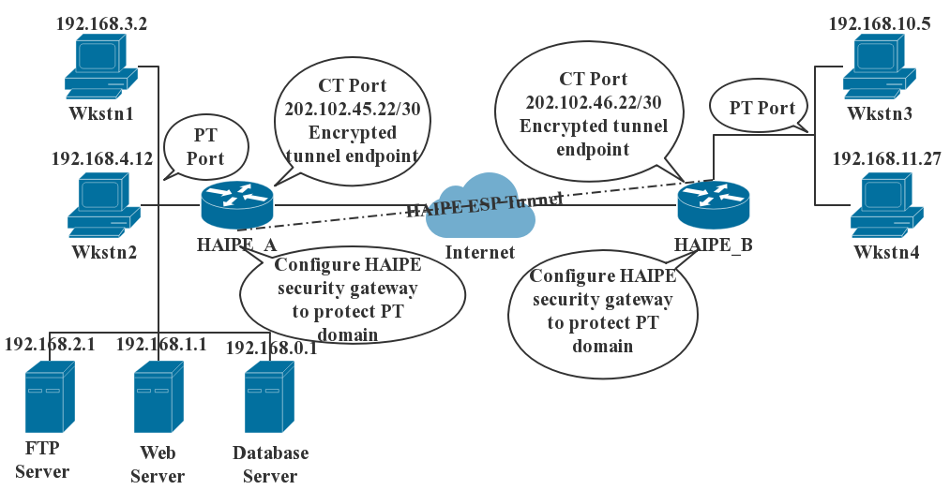
Fig. 11. Diagram of HAIPE security gateway protecting PT (Plain Text) domain communication
VI. Conclusion
This project aims to develop an API test tool which is essential for developing an application, especially when the development progress of front end and back end is inconsistent. In design of main web page, an interface request history and interface collection is on the left, and the interface request area is on the right, which supports get, post and other common request methods. This tool mainly aims to simulate network request package, create requests quickly, playback and manage request and set up network agent quickly. It can also process pressure test and interface function test which can set assertion, batch test interface, batch import and export, set global variables, set environment variables, etc.
Although the implementation of API Test Tool has finished, it has insufficient and limitation. It implements some request methods not included options, link and purge, etc. And it can’t manipulate file related operations and use non HTTP protocol. Thorough the whole project, there are much more consideration than what we expected. For example, the technique required for server programming and the insufficient knowledge about vue used to develop front end. Every problem has driven us to brainstorm more potential ways, not limited to one single way, to improve the solution.
As for the work to be improved in the future, first test the tool’s function and find other problems on techniques, and then add other request methods to make the tool more perfect. In the development of other projects in the future, we can use the test tool to help us accelerate the exploitation plan.

Reference
- Patents; Researchers Submit Patent Application, "System and Method for Automatically Testing an Application Programming Interface (Api)", for Approval (USPTO 20160283364)[J]. Computer Weekly News,2016.
- Yang Mengmeng, Liu Meng. Design and implementation of interface test data generation tool [J]. Science and technology economics guide, 2019.
- Su, Jie, and Yuan, Junpeng. “Firewall Technology and Its Development.” Computer Engineering and Application. 21 Mar. 2004: 147-149.H
- Zhang et al. “VPN: Boon or Trap? A Comparative Study of MPLS, IPSec, and SSL Virtual Private Network” ICCMC 2018, in the press.
- Sun, Jianming and Wei, Jichang, “Computer Network Technology and Application”. Xi ‘an China: Xi 'an University of Electronic Science and Technology, 2010.
- Stateful-inspection firewall: The Netscreen way, in http://www.netscreen.com/products /firewallwpaper.html.
- Shaomeng Li, Jim Tørresen, Oddvar Sorasen. “Exploiting Stateful Inspection of Network Security in Re-Configurable Hardware”.
- Suehring, Steve (Jan 29, 2015). Linux Firewalls: Enhancing Security with Nftables and Beyond (Illustrated ed.). Pearson Education. p. 25. ISBN 0134000021.
- Successful case: hanbo firewall to build a safe and efficient enterprise Intranet [N]. Network World, 2011-12-12(021).
- Qing, Yuhang. “Shortcomings and improvements in firewall security [I].” Science technology and engineering. 2005(14):1009-1012.
- Sun, keeping. “Concrete application of firewall technology in computer network security [J].” Science and technology economics guide, 2017(17):38.
- Wang, dong. “Research on deep packet inspection technology of firewall [D].” Xi ’an university of electronic science and technology, 2005.
- Zhang, tingbo. “Design and implementation of firewall based on content filtering software [D].” University of electronic science and technology, 2012.
- Security analysis of VPN technology. 19, Sept. 2014. Web. http://sec.chinabyte.com/368/13082868.shtml
- Comparison between professional VPN and firewall with VPN. Web. https://wenku.baidu.com/view/6e89ab1055270722192ef791.html
- “Network Security: A Simple Guide to Firewalls.” Network Security. 2000:2-3.
- Yadav, Arjunsingh Sushil, et al. “Prevention of Spoofing Attacks in Wireless Networks.” International Conference on Computing Communication Control and Automation IEEE, 2015:164-171.
- Ken Hollis, “The Rose Attack Explained”. Retrieved on 2013-11-25
- Sakurai, Shoji, and S. Ushirozawa. “Input method against Trojan horse and replay attack”. IEEE International Conference on Information Theory and Information Security IEEE, 2010:384-389.
- Chen, Dongsheng, and P. Wang. “Study and Implementation of Tunnel Attack in MANET.” Computer Engineering 33.9(2007):140-141.
- Jiaozuo, and Zheng Zhou. “A new method of measuring Passive FTP traffic.” Microcomputer Information (2008).
- Zhao, Tian Fu, et al. “Detecting Rebound Port Trojan Based on Network Behavior Analysis” Netinfo Security (2011).
- VPN helps you scale the wall? Let's put our privacy first. 6, Jun. 2016, Web. https://www.jb51.net/hack/471867.html
- Mauro, Conti., Nicola, Dragoni and Viktor, Lesyk. “A Survey of Man In The Middle Attacks” IEEE Communications Surveys & Tutorials 18(2016):2027-2051.
- Muhammad Murad, Khan, Majid, Bakhtiari and Saeid, Bakhtiari. “An HTTPS approach to Resist Man in the Middle Attack in Secure SMS Using ECC and RSA” 2013 13th International Conference on Intelligent Systems Design and Applications Dec (2013):115-120.
- Yang, Zanguo, and Cheng, Quanzhou. “Research of Immune-Based Technology for the Firewall System Security.” Microcomputer information. Vol 21, 9-3
- Network behavior management and the next generation of firewalls, SWG relations. Web. https://jingyan.baidu.com/article/cbf0e50095f63a2eaa2893cc.html
- Zhao, Yuehua, and Du, Yunhai. “Design and implementation of embedded secure web gateway.” Computer Engineering and Design. Feb Jun. Vol. 27, No. 4 2006.
- Metin Sahin, Ibrahim Sogukpınar, “An efficient firewall for web applications (EFWA)” Computer Science and Engineering (UBMK) 2017 International Conference on, pp. 1150-1155, 2017.
- Nora, Boukari, Ali, Aljane. “Security and Auditing of VPN” Proceedings of Third International Workshop on Services in Distributed and Networked Environments. 6 Aug. (1996): 132-138
- VPN Firewall Techopedia. 28, Jun. 2017. Web. https://www.techopedia.com/definition/30753/vpn-firewall
- Dian, Aimin. “Security research and improvement of mainstream VPN technology.” May 2009.

