5.2 Performance Testing

In performance testing of the interface, we chose JMeter, which can be used to simulate large loads on servers, networks, or objects to test their strength and analyze overall performance under different stress categories.

On the http request page, we enter the server name or ip, port number, request protocol, request method, encoding, path. Through performance testing, we can view the monitored response time, error, throughput and other data. We test some of these interfaces as examples.

5.2.1 GetMethods ()

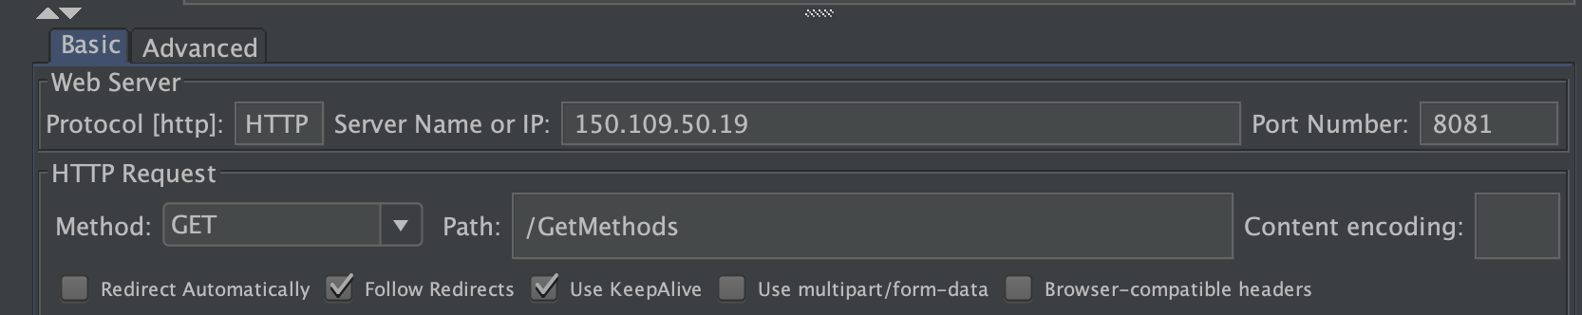

5.2.2 GetAllHistory ()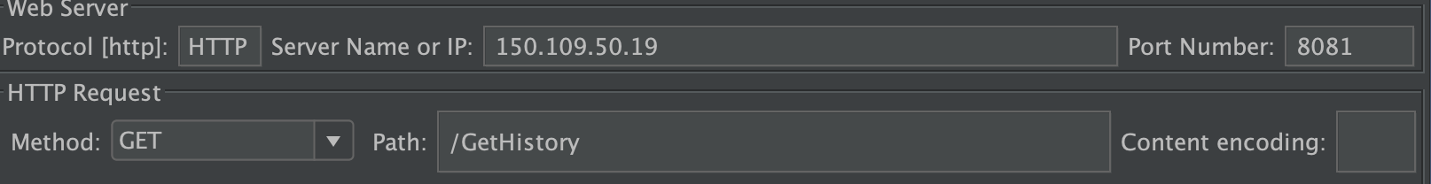



5.2.3 GetHistoryById (id)



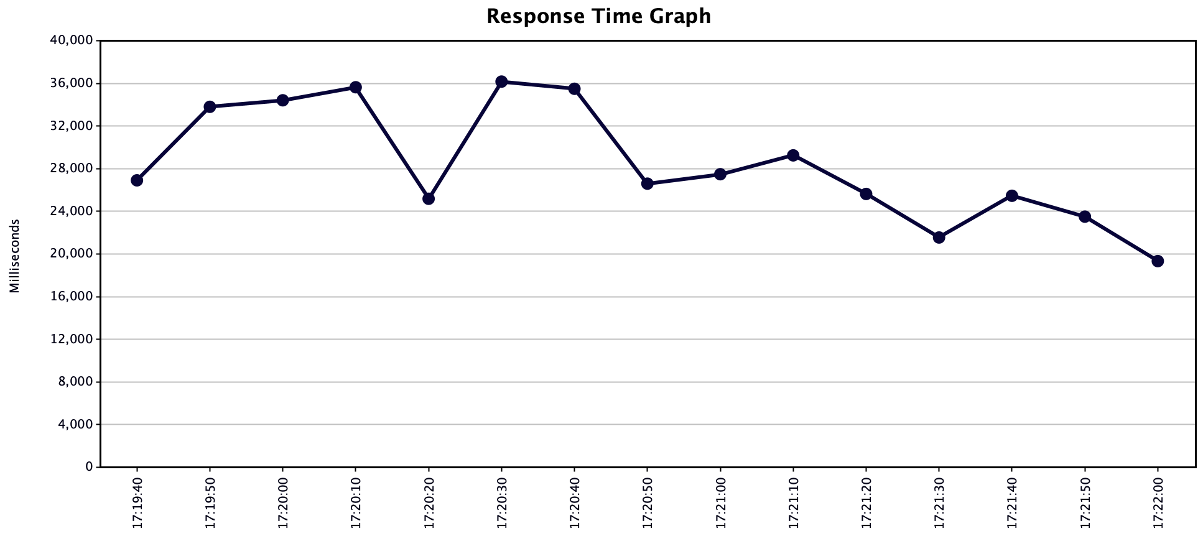

5.2.4 DeleteHistoryById (id)

