**Unity Creative Navigation Test:**

Using only Unity engine; create a basic scene that illustrates your knowledge of unity’s user interface, native 3D assets, and any other native asset creation tool. Your scene can use any of Unity’s library of tools to complete this project quickly. Feel free to drag and drop, rotate, and scale assets in any way you see fit.

**Here’s what we are looking for:**

-A residential yard, and house that works as place holder.

-We’d love to see shadows casted using a good balance of artistry and efficacy.

-Be creative, and show you’re familiar with the Unity engine.

-Reflection probes, Terrain tool usage, and physics are welcome.

-No downloading or importing any assets; let your creative juices flow.

**Example:**

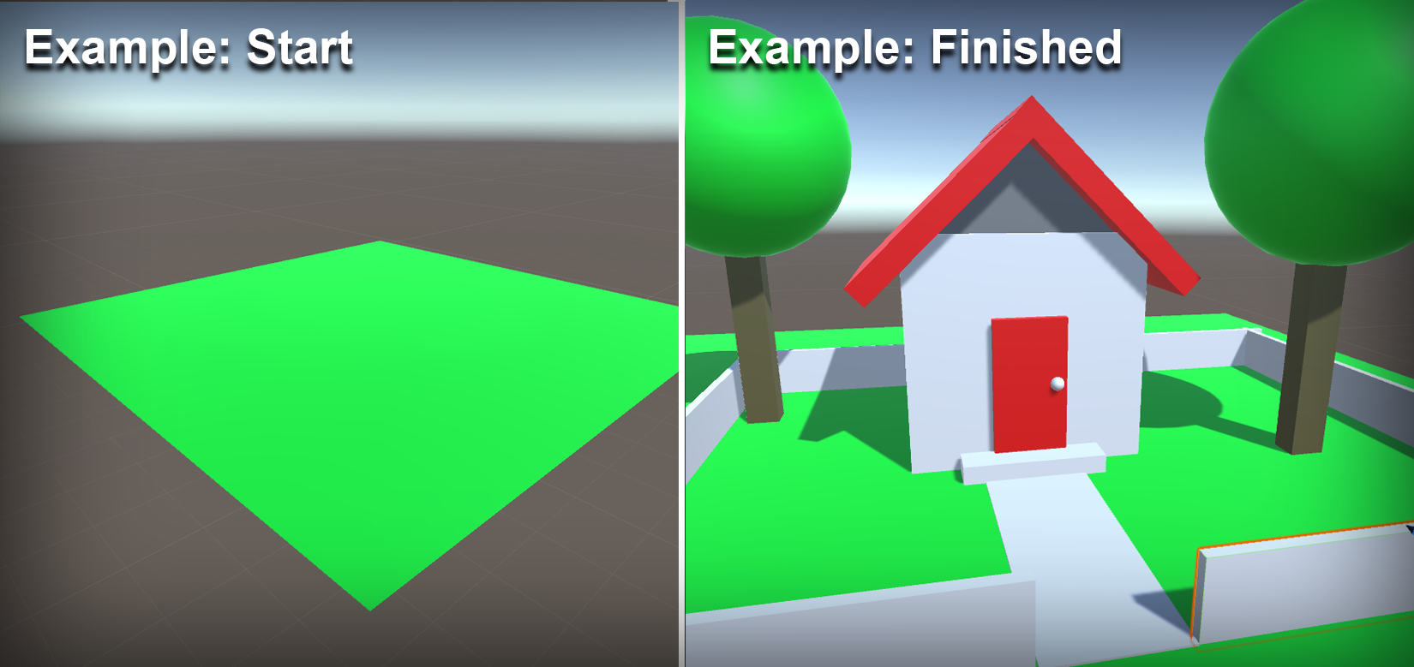

*(We’re hoping your rendition looks better.)*

**Unity Computational Logic Test:**

Using only Unity engine; and no 3rd party tools or packages, create the logic for a wrench, and bolt. The idea here is to think carefully about the relationships 3D objects have with one another via code, and 3D world space. We want to see your thought process, so commented code is highly appreciated. While we’d love to see you complete this task; more important is how you utilize your time and resources to solve it. (Internet Allowed)

These are the types of tasks we frequently encounter in Creative labs. Feel free to leverage Unity’s native assets in any way you see fit to complete this project.

**Here’s what we are looking for:**

-Allow the hand (object) to connect/ interact with the wrench.

-Allow the wrench (object) to interact with the bolt.

-Constrain the motion/rotation of each object relative to its partner (3D object). Think about how this task is performed in real life.

-Comment your code, explain your thought process. Show us how you think.

-Try to make the bolt screw down into the table, tidal locking the rotation and height of respected 3D objects/assets appropriately.

**Example:**

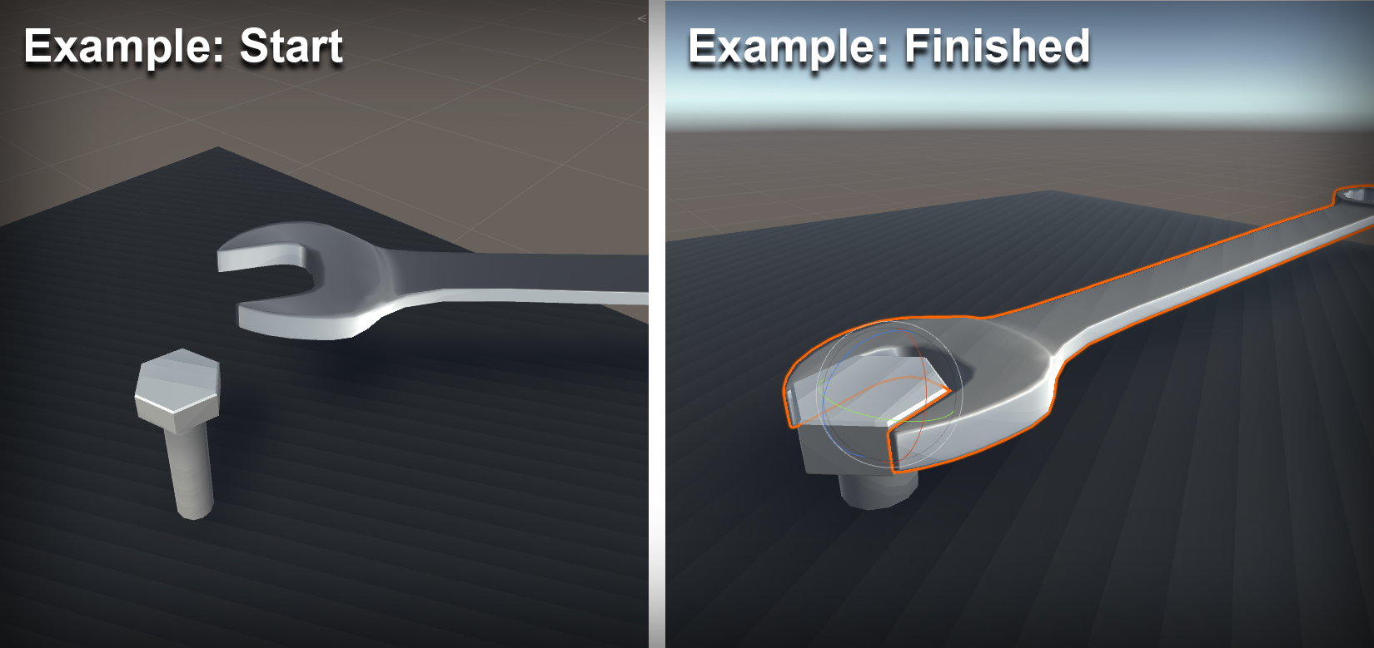

*(More important than project completion, is your programmatic process.)*