**Check build.gradle File**

When importing someone else’s code into Android Studio, you usually want to use the same package versions and target SDK settings that the original code was designed to use, however keeping your own projects up-to-date is always a good practice.

Because Android keeps releasing new SDK package versions, whenever you open up or import an old project in Android Studio, you might get a warning saying that the plugin is too old:

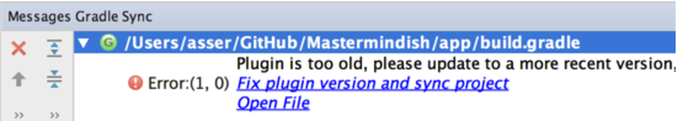

Luckily Android Studio offers to fix this for you by updating the *build.gradle* file automatically. So clicking “Fix plugin and sync” should do the trick.

However, if - for any reason - you wanted to update the build.gradle yourself, you can find it by browsing to Gradle Scripts and then double click on the build.gradle (Module: app) file:

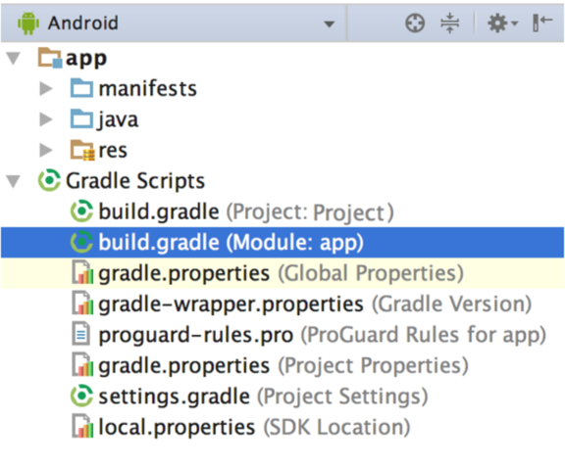

Make sure that they include the most up-to-date versions of:

* compileSdkVersion
* buildToolsVersion
* targetSdkVersion

Also, in the same file check that all your dependencies are up-to-date as well, for example when the Constraint Layout beta version was released it would complain about using an alpha version since it’s now obsolete:

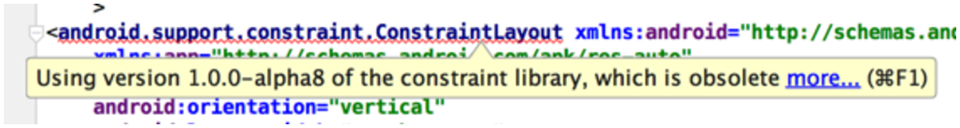

Usually Android Studio would usually highlight any out-of-date packages like for example:

