FreeNAS任务说明

1. 凌剑聪 第七周 内容说明

## 截图

成功添加后，会显示组的信息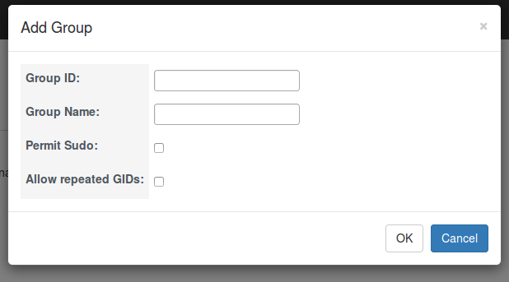

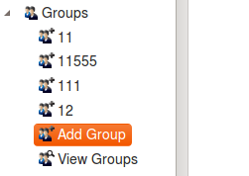

## 核心代码：

### Models:

**class** Groups(models.Model):

groupID=models.IntegerField()

groupName=models.CharField(max_length=50)

permitSudo=models.BooleanField(default=True)

allowedRepeat=models.BooleanField(default=True)

**def** __unicode__(self):

**return** str(self.groupID)+**'\t'**+str(self.groupName)+**'\t'**+str(self.permitSudo)+**'\t'**+str(self.allowedRepeat)

### HTML:(bootstrap框架)

*<!-- Modal -->*

<**div class="modal fade" id="lingjiancongModalAddGroup" tabindex="-1" role="dialog" aria-labelledby="myModalLabel" aria-hidden="true"**>

<**div class="modal-dialog"**>

<**div class="modal-content"**>

<**div class="modal-header"**>

<**button type="button" class="close" data-dismiss="modal" aria-label="Close"**><**span aria-hidden="true"**>**&times;**</**span**></**button**>

<**h4 class="modal-title" id="myModalLabel"**>Add Group</**h4**>

</**div**>

<**div class="modal-body"**>

<**form action="/addGroup/" method="get" id="formAddGroupPopover"**>

<**table id='addGroupPopover'** >

<**tbody**>

<**tr**>

<**th**><**label for="addGroupID"**>Group ID:</**label**></**th**>

<**td**><**div**><**input type="text" name="addGroupID" id="addGroupID"**/><**div id="addGroupIDCheck" style="display**:**none"**>The id already exits</**div**></**div**></**td**>

</**tr**>

<**tr**>

<**th**><**label for="addGroupName"**>Group Name:</**label**></**th**>

<**td**><**div**><**input type="text" name="addGroupName" id="addGroupName"**/></**div**><**div id="addGroupNameCheck" style="display**:**none"**>The name already exits</**div**></**td**>

</**tr**>

<**tr**>

<**th**><**label for="permitSudo"**>Permit Sudo:</**label**></**th**>

<**td**><**div**><**input type="checkbox" name="permitSudo" id="permitSudo"**/></**div**></**td**>

</**tr**>

<**tr**>

<**th**><**label for="allowRepeatedGIDs"**>Allow repeated GIDs:</**label**></**th**>

<**td**><**div**><**input type="checkbox" name="allowRepeatedGIDs" id="allowRepeatedGIDs"**/></**div**></**td**>

</**tbody**>

</**table**>

</**form**>

</**div**>

<**div class="modal-footer"**>

<**button type="button" class="btn btn-default" onclick="***addGroup*();**" id="buttonAddGroup"**>OK</**button**>

<**button type="button" class="btn btn-primary"**>Cancel</**button**>

</**div**>

</**div**>

</**div**>

</**div**>

*<!-- lingjiancong end -->*

### JS代码：

*/\*\**

*\* Created by ling on 15-4-17.*

*\*/*

<script>

$("#formAddGroupPopover").validate({

rules:{

addGroupID:{

required:true,

digits:true,

remote:"/checkAddGroup"

},

addGroupName:{

required:true,

minlength:2,

remote:"/checkAddGroup"

}

},

messages:{

addGroupID:{

remote:"The groupID already exits"

},

addGroupName:{

remote:"The groupName already exits"

}

}

});

</script>

function handleSelectedEvent(e) {

var model = this.dataItem(e.node);

if (model.text == "Add Group") {

$('#lingjiancongModalAddGroup').modal({backdrop: "static"});

document.getElementById("addGroupID").value="";

document.getElementById("addGroupName").value="";

document.getElementById("permitSudo").checked=false;

document.getElementById("allowRepeatedGIDs").checked=false;

}

}