实验二：工厂模式

实验内容:
简单工厂方法模式：利用简单工厂方法模式创建pad, phone, watch的对象，并使用这些对象娱乐。
工厂模式：利用工厂模式创建pad, phone, watch的对象，并使用这些对象娱乐。
抽象工厂模式：利用抽象工厂模式创建华为、小米、苹果的pad, phone, watch的对象，并使用这些对象娱乐。

简单工厂方法模式

UML图
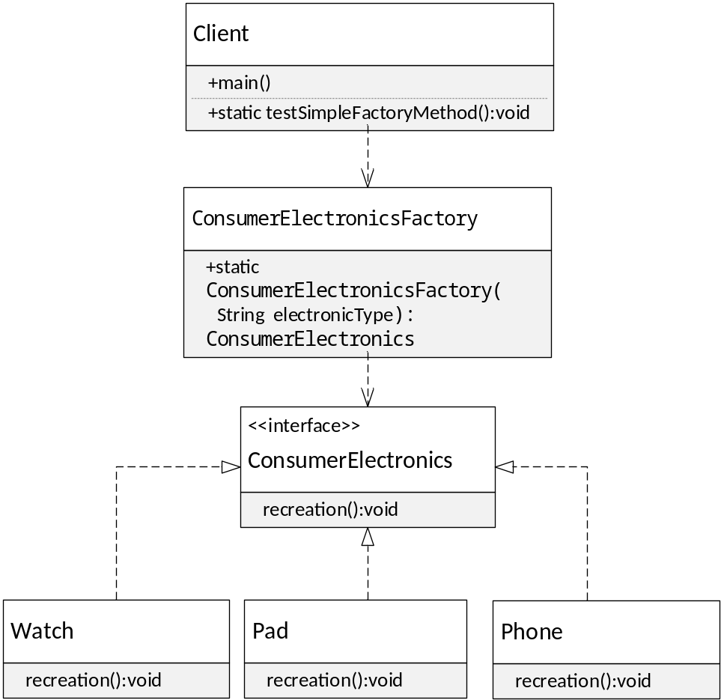

核心代码
ComsumerElectronicsFactory.java
//通过传入的参数来选择pad，phone，watch工厂
public class ConsumerElectronicsFactory {
public static ConsumerElectronics getElectronic(String electronicType) {
ConsumerElectronics electronics = null;
switch(electronicType) {
case "Pad":

electronics = new Pad();
break;
case "Phone":
electronics = new Phone();
break;
case "Watch":
electronics = new Watch();
break;
}
//以超类ConsumerElectronics返回给用户，所以不必关心返回的具体的对象类型
return electronics;
}
}

ConsumerElectronics.java
//定义统一的电子产品接口
public interface ConsumerElectronics {
void recreation();
}

ConsumerElectronics.java
public class Pad implements ConsumerElectronics {
@Override
public void recreation() {
// TODO Auto-generated method stub
System.out.println("使用平板娱乐");
}
}

Phone.java
public class Phone implements ConsumerElectronics{
@Override
public void recreation() {
// TODO Auto-generated method stub
System.out.println("使用手机娱乐");
}
}

Watch.java
public class Watch implements ConsumerElectronics{
@Override
public void recreation() {
// TODO Auto-generated method stub
System.out.println("使用手表娱乐");
}
}

public static void testSimpleFactoryMethod() {
//简单工厂方法生产平板，手机，手表
ConsumerElectronics pad = ConsumerElectronicsFactory.getElectronic("Pad");
ConsumerElectronics phone = ConsumerElectronicsFactory.getElectronic("Phone");
ConsumerElectronics watch = ConsumerElectronicsFactory.getElectronic("Watch");
pad.recreation();
phone.recreation();
watch.recreation();
}

实验效果
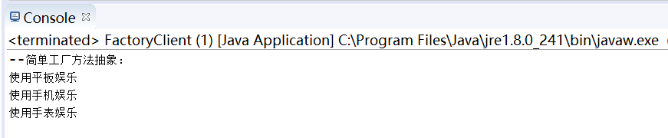

工厂方法模式

UML图
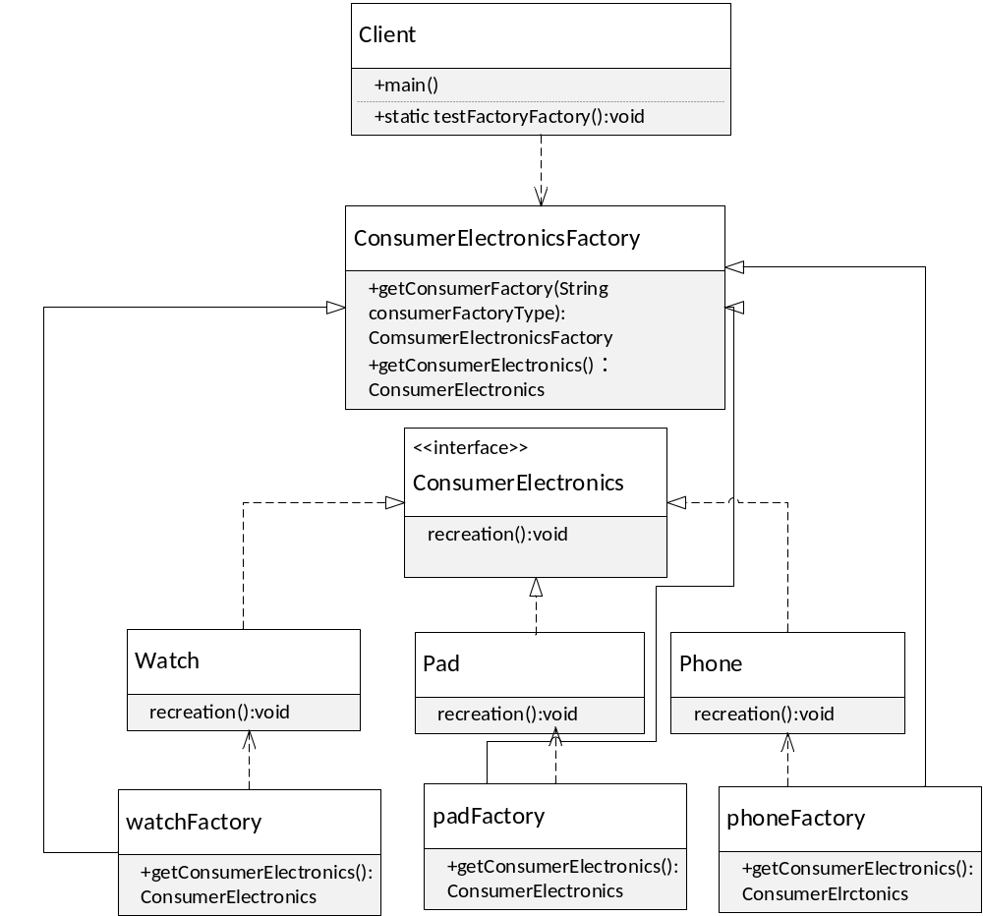

核心代码
ConsumerElectronicsFactory.java
//根据传入的参数选择平板，手机，手表工厂
public abstract class ConsumerElectronicsFactory {
public static ConsumerElectronicsFactory getConsumerElectronicsFactory(String consumerFactoryType) {
ConsumerElectronicsFactory factory = null;
switch (consumerFactoryType) {
case "Pad":
factory = new padFactory();
break;
case "Phone":
factory = new phoneFactory();

break;
case "Watch":
factory = new watchFactory();
break;
}
return factory;
}
public abstract ConsumerElectronics getConsumerElectronics();
}

padFactory.java
public class padFactory extends ConsumerElectronicsFactory{
public ConsumerElectronics getConsumerElectronics() {
return new Pad();
}
}

phoneFactory.java
public class phoneFactory extends ConsumerElectronicsFactory {
public ConsumerElectronics getConsumerElectronics() {
return new Phone();
}
}

watchFactory.java
public class watchFactory extends ConsumerElectronicsFactory{
public ConsumerElectronics getConsumerElectronics() {
return new Watch();
}
}

public static void testFactoryMethod() {
String[] electronicName = {"Pad","Phone","Watch"};
//生产平板，手机，手表
for (String item : electronicName) {
//得到电子产品的工厂
cn.edu.scau.sec.lingjielin.factoryPattern.factory.ConsumerElectronicsFactory factory = cn.edu.scau.sec.lingjielin.factoryPattern.factory.ConsumerElectronicsFactory.getConsumerElectronicsFactory(item);
ConsumerElectronics electronic = factory.getConsumerElectronics();
electronic.recreation();
}
}

实验效果
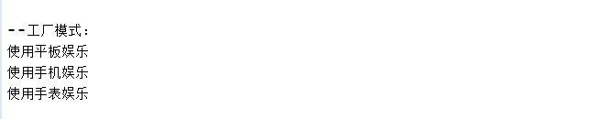

抽象工厂模式

UML图
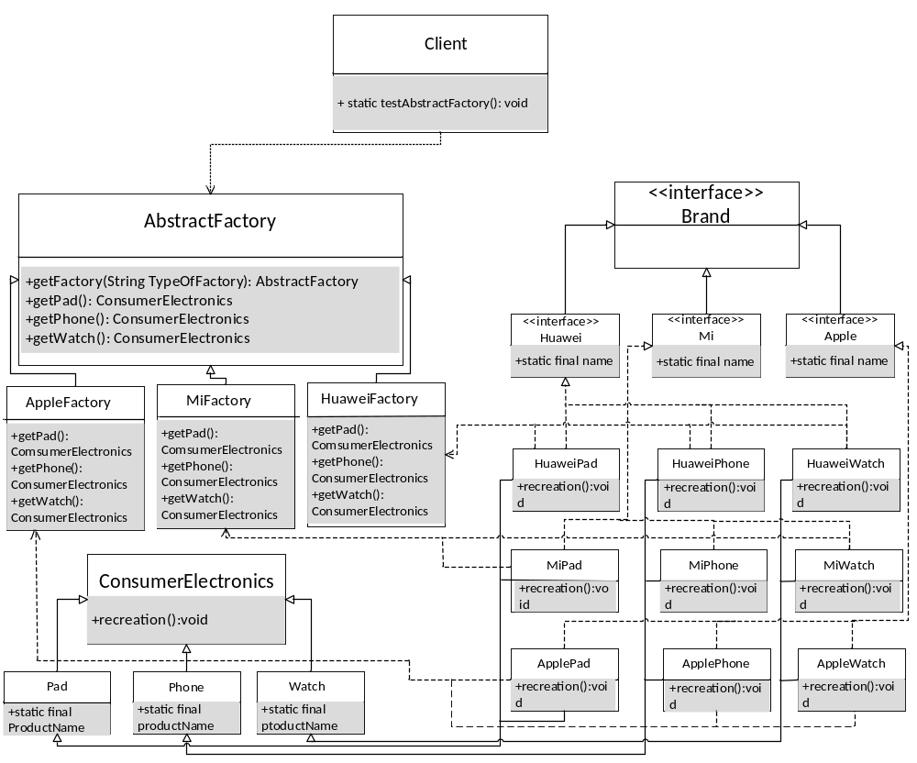

核心代码
Brand.java
//品牌接口
public interface Brand {
}

Apple.java
public interface Apple extends Brand{
public static final String name = “苹果”;
}

Huawei.java
public interface Huawei extends Brand{
public static final String name = “华为”;
}

Mi.java
public interface Mi extends Brand{
public static final String name = "小米";
}

ConsumerElectronics.java
public abstract class ConsumerElectronics {
abstract public void recreation();
}

Pad.java
public abstract class Pad extends ConsumerElectronics{
protected String productName = "平板";
}

Phone.java
public abstract class Phone extends ConsumerElectronics{
protected String productName = “手机”;
}

Watch.java
public abstract class Watch extends ConsumerElectronics{
protected String productName = "手表";
}

AbstractFactory.java
public abstract class AbstractFactory {
public static AbstractFactory getFactory(String factoryName) {
AbstractFactory factory = null;
switch(factoryName) {
case "Apple":
factory = new AppleFactory();
break;
case "Huawei":
factory = new HuaweiFactory();
break;
case "Mi":
factory = new MiFactory();
break;
}
return factory;
}
public abstract ConsumerElectronics getPad();
public abstract ConsumerElectronics getPhone();
public abstract ConsumerElectronics getWatch();
}

AppleFactory.java
public class AppleFactory extends AbstractFactory{
@Override
public ConsumerElectronics getPad() {
// TODO Auto-generated method stub
return new iPad();
}
@Override
public ConsumerElectronics getPhone() {

// TODO Auto-generated method stub
return new iPhone();
}
@Override
public ConsumerElectronics getWatch() {
// TODO Auto-generated method stub
return new iWatch();
}
}

HuaweiFactory.java
public class HuaweiFactory extends AbstractFactory{
@Override
public ConsumerElectronics getPad() {
// TODO Auto-generated method stub
return new MiPad();
}
@Override
public ConsumerElectronics getPhone() {
// TODO Auto-generated method stub
return new MiPhone();
}
@Override
public ConsumerElectronics getWatch() {
// TODO Auto-generated method stub
return new MiWatch();
}
}

MiFactory.java
public class MiFactory extends AbstractFactory{
@Override
public ConsumerElectronics getPad() {
// TODO Auto-generated method stub
return new HuaweiPad();
}
@Override
public ConsumerElectronics getPhone() {
// TODO Auto-generated method stub
return new HuaweiPhone();
}
@Override
public ConsumerElectronics getWatch() {
// TODO Auto-generated method stub
return new HuaweiWatch();
}
}

HuaweiPad.java
public class HuaweiPad extends Pad implements Huawei {

@Override
public void recreation() {
// TODO Auto-generated method stub
System.out.println(name+productName);
}
}

HuaweiPhone.java
public class HuaweiPhone extends Phone implements Huawei {
@Override
public void recreation() {
// TODO Auto-generated method stub
System.out.println(name+productName);
}
}

HuaweiWatch.java
public class HuaweiWatch extends Watch implements Huawei{
@Override
public void recreation() {
// TODO Auto-generated method stub
System.out.println(name+productName);
}
}

Ipad.java
public class iPad extends Pad implements Apple{
@Override
public void recreation() {
// TODO Auto-generated method stub
System.out.println(name+productName);
}
}

iPhone.java
public class iPhone extends Phone implements Apple{
@Override
public void recreation() {
// TODO Auto-generated method stub
System.out.println(name+productName);
}
}

iWatch.java
public class iWatch extends Watch implements Apple{
@Override
public void recreation() {
// TODO Auto-generated method stub
System.out.println(name+productName);
}
}

MiPad.java
public class MiPad extends Pad implements Mi{
@Override
public void recreation() {
// TODO Auto-generated method stub
System.out.println(name+productName);
}
}

MiPhone.java
public class MiPhone extends Phone implements Mi{
@Override
public void recreation() {
// TODO Auto-generated method stub
System.out.println(name+productName);
}
}

MiWatch.java
public class MiWatch extends Watch implements Mi {
@Override
public void recreation() {
// TODO Auto-generated method stub
System.out.println(name+productName);
}
}

public static void testAbstractFactory() {
String[] name = {"Apple","Huawei","Mi"};
for (String item : name) {
//得到一个品牌的工厂
AbstractFactory factory = AbstractFactory.getFactory(item);
//生产某一品牌平板
factory.getPad().recreation();
//生产某一品牌手机
factory.getPhone().recreation();
//生产某一品牌手表
factory.getWatch().recreation();
}
}

实验效果
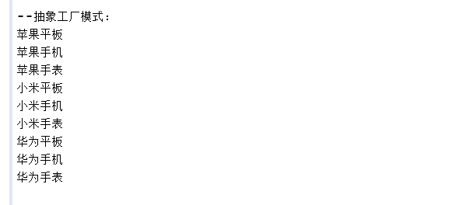

实验体会
通过这次的实验，我了解了工厂方法，可以通过一个类来生产对象，简化了应用程序，隐藏了创建对象的不同方法的细节，我们并不必要知道那个具体的对象被创建，我们方法返回的是一个父类对象，使得应用程序无需处理这些细节。在简单工厂方法模式中，只需要从一个类的结构中选择初始类，客户类只消费对象，不直接创建类，实现了责任分离，而且条件选择语句减少。但是简单工厂方法模式不符合开闭原则，增加类时，要修改工厂类的代码。抽象工厂模式中，抽象出产品类的相同结构，设计接口，一系列实的工厂类实现抽象工厂类提供的接口，抽象工厂模式，避免了重复的，复杂的条件语句，提供了必要的创建对象的接口。

