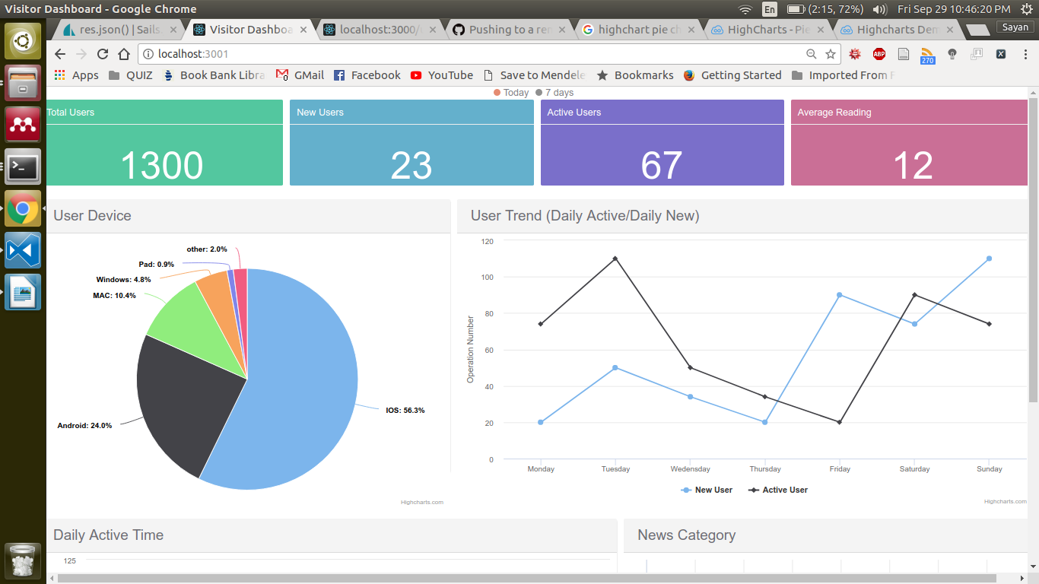

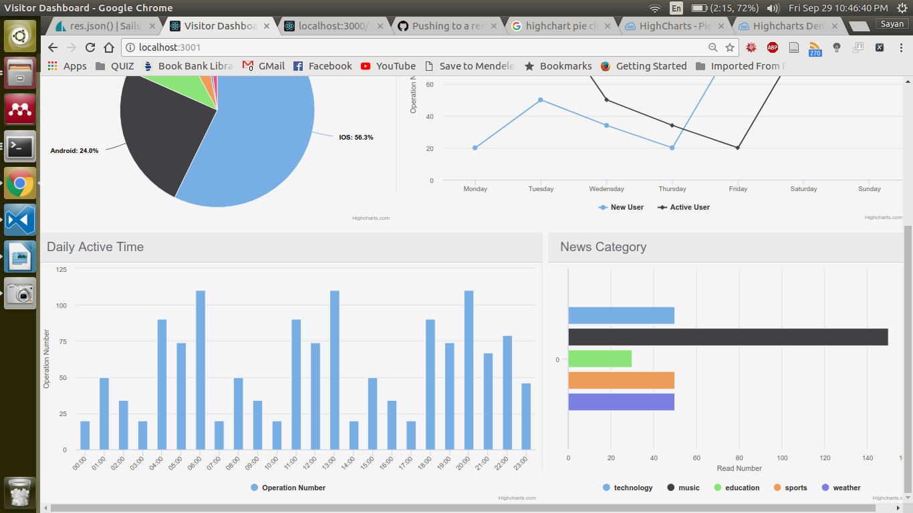

**How to get data from Data Visualization Server?**

## 1. Using RESTful API from front end to request data

### User Statistics Data

|  |  |
| --- | --- |
| Data Content | Total User: All registered user number till now  Today’s New User: Today’s new signed in user number  Today’s Active User: Today’s active user number  Average Usage Time: Average time users using this system (login – logout) |
| API | Method: GET  URI: <http://localhost:3000/userdata/statistic> |
| Data Type | Data Type: JSON  Data Example:  const user_data = [  {  'title': 'Total Users',  'num':1300  },  {  'title': 'New Users (Today)',  'num':23  },  {  'title': 'Active Users (Today)',  'num':67  },  {  'title': 'Average Usage Time',  'num':12  }  ]; |

### User Device

|  |  |
| --- | --- |
| Data Content | User device’s category and its ratio |
| API | Method: GET  URI: http://localhost:3000/userdata/userdevice |
| Data Type | Data Type: JSON  Schema:  [  {  name: string,  y: number  }  ]  Data Example:  const deviceData = [  {  name: 'IOS',  y: 56.33,  }, {  name: 'Android',  y: 24.03,  }, {  name: 'MAC',  y: 10.38,  }, {  name: 'Windows',  y: 4.77,  }, {  name: 'Pad',  y: 0.91,  }  ]; |

### User Trend

|  |  |
| --- | --- |
| Data Content | 7 Days new signed in user number  7 days active user number |
| API | Method: GET  URI: http://localhost:3000/userdata/usertrend |
| Data Type | Data Type: JSON  Schema:  [  {  name: string,  data: [number]  }  ]  Data Example:  const userTrend = [  {  name: 'New User',  data: [20, 50, 34, 20, 90,74, 110]  },  {  name: 'Active User',  data: [74, 110,50, 34, 20, 90,74]  }  ]; |

### User Active Time

|  |  |
| --- | --- |
| Data Content | 24 hours user active time distribution ( Calendar Day) |
| API | Method: GET  URI: http://localhost:3000/userdata/activetime |
| Data Type | Data Type: JSON  Schema:  Schema:  [  {  name: string,  data: [number]  }  ]  Data Example:  const activeTime = [  {  name: 'Operation Number',  data: [20, 50, 34, 20, 90,74, 110,20, 50, 34, 20, 90,74, 110,20, 50, 34, 20, 90,74, 110,67,79,46]  }  ]; |

### User News Category

|  |  |
| --- | --- |
| Data Content | User read users category and its ratio |
| API | Method: GET  URI: http://localhost:3000/userdata/newscategory |
| Data Type | Data Type: JSON  Schema:  [  {  name: string,  y: number  }  ]  Data Example:  const newCategory = [  {  name: 'technology',  y: 50  },  {  name: 'music',  y: 150  },  {  name: 'education',  y: 30  },  {  name: 'sports',  y: 50  }  ]; |