LAB 2 GROUP 7

Member :

Nguyễn Hoàng Nhân : SE172841

Bùi Mạnh Cường : CE171488

Nguyễn Thế Hiển : SS171243

Trần Anh Toàn : SE173384

Văn Quốc Thịnh : SE171286

SNOW BOARDER GAME 2D UNITY

### Overview:

**Genre**: Sports, Arcade

**Platform**: PC

"Snow Boarder Game 2D Unity" is a 2D arcade sports game where players control a snowboarder through challenging levels. Collect snowflakes, avoid traps, and hit the red pole to complete the level. Use the arrow keys to move and tumble. The game ends when you run out of lives or your head hits the ground. 5 levels, friendly interface, and achievements make for a fun experience on PC."

Highlights from this description:

* Genre and Platform: Clearly identify the game genre (arcade sports) and platform (PC).
* Game Objective and Mechanics: Summarize the player's goals, control mechanics, and scoring.
* Game Challenges and Ending: Highlight challenging elements (traps, collisions, etc.) and the ending conditions.
* Additional Features: Mention features such as tutorial screens, achievements, and levels.
* User Experience: Emphasize the engaging entertainment experience the game provides.
* Art and Interface: Mention character images, snowflakes, traps, home screen, tutorial screen, achievement screen, and level screen.

Gameplay:

Game Elements:

Player, Snowflake, Trap.

Game Input:

* Right:
  + Action: The character performs a forward somersault, moves in that direction, and receives 10 points.
* Left
  + Action: The character performs posture adjustments to maintain balance on the snowboard. This helps prevent the character from falling when moving on rough terrain or when moving at too high a speed.
* Down:
  + Action: Decreases the character's movement speed.
* Up:
  + Action: Increases the character's movement speed.
* Jump:
  + Input: "Space" key
  + Action: The character jumps into the air.

Mechanism:

* Navigate the player, avoid trap, and collect snowflake for points.
* The game ends if the player hits a trap with 5 lives.
* The player will pass the level if the character touches the red column at the end of the map.
* Each snowflake collected will get 1 point.
* Each trap will deduct 1 life from the character.
* Each somersault will be worth 10 points.
* The game will end as soon as the character's head touches the ground.

End Game Scene:

* Displays player's score, play time.
* Options to return to the main menu or quit game.

In Game:

Character images in the game:

Image showing character's life:

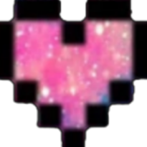

Snowflake image:



Trap image:



Main Screen:

Tutorial screen:

Achievement screen:

Level 1:

Level 2:

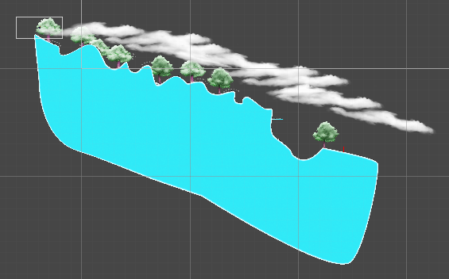

Level 3:

Level 4:

Level 5:

Game Flow:

1. Start Button: Display a list of screens for players to choose from.
2. Play Button: Transitions to the Gameplay Scene.

Help Button: Displays a UI panel with game instructions.

Achievement Button: Show highest score information.

Quit Button: Exit game

1. Play Game:
   1. Win: Displays the wingame interface with options to exit the main menu and continue to the next level.
   2. Lose: Show losegame interface with option to exit main menu or play again