C4-2

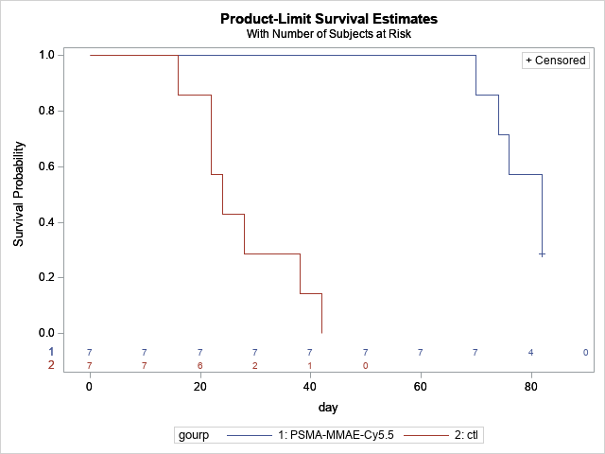

|  |  |  |  |
| --- | --- | --- | --- |
| **Test of Equality over Strata** | | | |
| **Test** | **Chi-Square** | **DF** | **Pr > Chi-Square** |
| **Log-Rank** | 14.5874 | 1 | 0.0001 |