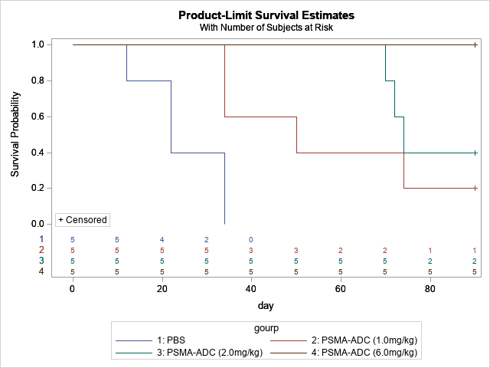

|  |  |  |  |  |
| --- | --- | --- | --- | --- |
| Adjustment for Multiple Comparisons for the Logrank Test | | | | |
| Strata Comparison | | **Chi-Square** | **p-Values** | |
| gourp | **gourp** | **Raw** | **Sidak** |
| PBS | **PSMA-ADC (1.0mg/kg)** | 2.3063 | 0.1289 | 0.5629 |
| PBS | **PSMA-ADC (2.0mg/kg)** | 5.6428 | 0.0175 | 0.1007 |
| PBS | **PSMA-ADC (6.0mg/kg)** | 17.1314 | <.0001 | 0.0002 |
| PSMA-ADC (1.0mg/kg) | **PSMA-ADC (2.0mg/kg)** | 0.5403 | 0.4623 | 0.9758 |
| PSMA-ADC (1.0mg/kg) | **PSMA-ADC (6.0mg/kg)** | 4.5163 | 0.0336 | 0.1853 |
| PSMA-ADC (2.0mg/kg) | **PSMA-ADC (6.0mg/kg)** | 1.6998 | 0.1923 | 0.7224 |