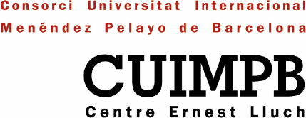

Mr. Bob Carpenter
Chief Software Architect, Alias I

1st April, 2004

Dear Mr. Carpenter,

We will inform you about your participation in the course Language technologies: latest advances directed by Dr. Marsal Gavaldà that will take place in Barcelona from 12th to 16th of July. Specifically, your conference is programmed on Tuesday 13th of July from 9.30 a.m. to 13.30 h.

For travel details, the organisation of Menéndez Pelayo International University will get the hotel bookings as soon as you tell us how many days you will stay in Barcelona. As far as the travel plans, the usual in these cases, when the person is coming from United States, is that you buy the plane tickets on your own. The only restrictions are that the tickets have to be in economy class fare –trying to pass one weekend in Barcelona city– and not more expensive than 900 €.

In case you will travel with another person, the University will only cover his/her accommodation in a double room.

About meals, the University will cover lunch for the duration of the course and one official dinner with all the participants. Other meals, will be covered by the participants themselves.

Your fees including taxes are 765 €. The University needs some documents for the reimbursement process which are the followings:

- Photocopy of your passport.
- Photocopy of your plane tickets, the price has to be visible, or the receipt of them.
- Fill in a document emitted by University concerning your personal and bank dates, including the International Bank Account Number (IBAN).

The honoraries will be paid by bank transfer in a reasonable time. If you wish to avoid paying taxes in Spain you must present Fiscal Residence Certificate. This document is usually expended by the Financial Ministry of the country in which the person pay his/her taxes.

I hope that this letter will be useful in order to prepare your stay in Barcelona.

We look forward to hearing form you very soon.

Yours Sincerely,

Esther Masclans
Coordinate Courses
CUIMPB – Centre Ernest Lluch

