-- 创建用户表
CREATE TABLE users (
id INT PRIMARY KEY AUTO_INCREMENT,
username VARCHAR(50) NOT NULL UNIQUE,
password VARCHAR(50) NOT NULL
) ENGINE=InnoDB DEFAULT CHARSET=utf8mb4 COMMENT='用户表';
--插入用户数据
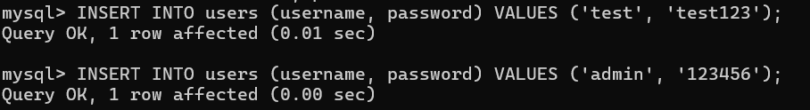

-- 创建城市表
CREATE TABLE cities (
id INT PRIMARY KEY AUTO_INCREMENT,
name VARCHAR(100) NOT NULL,
province VARCHAR(100) NOT NULL
) ENGINE=InnoDB DEFAULT CHARSET=utf8mb4 COMMENT='城市表';

-- 插入城市数据
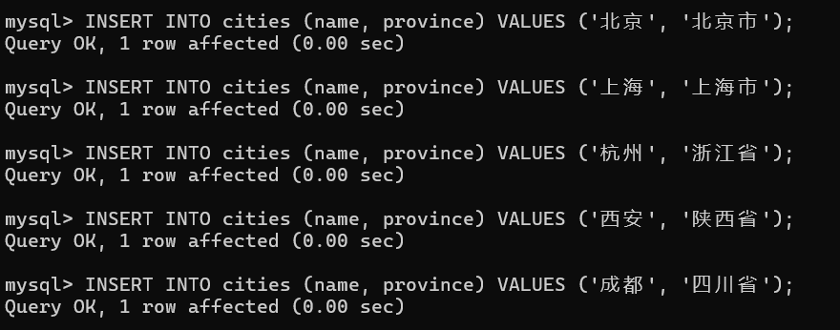

-- 创建景点表
CREATE TABLE attractions (
id INT PRIMARY KEY AUTO_INCREMENT,
name VARCHAR(200) NOT NULL,
ticket_price DECIMAL(10,2) NOT NULL,
description TEXT,
image_path VARCHAR(500),
city_id INT,
FOREIGN KEY (city_id) REFERENCES cities(id) ON DELETE CASCADE
) ENGINE=InnoDB DEFAULT CHARSET=utf8mb4 COMMENT='景点表';

--插入景点数据
