HBase命令行

HBase服务停止：

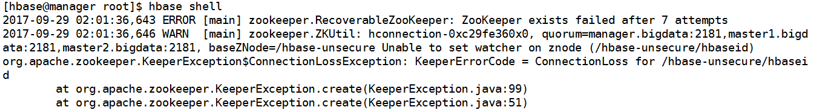

HBase Shell,

当前版本：1.1.2.2.5.5.0-157

如果想查看命令使用详细时，可以采用：'help "COMMAND"

例如：

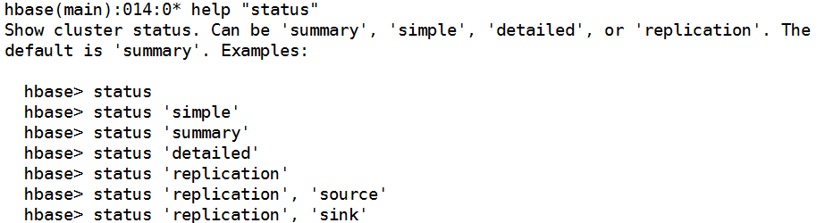

HBase命令分为许多组。

查看组命令同样可以使用help命令，例如：

help “general”

HBase命令分为如下几组：

Group name: general

Commands: status, table_help, version, whoami

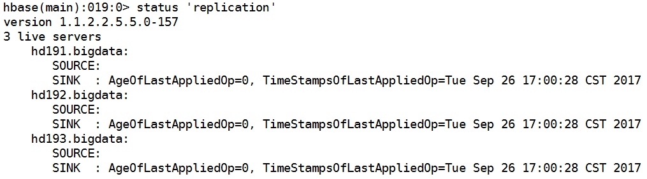

Group name: ddl

Commands: alter, alter_async, alter_status, create, describe, disable, disable_all, drop, drop_all, enable, enable_all, exists, get_table, is_disabled, is_enabled, list, locate_region, show_filters

|  |
| --- |
| create a table    create 'wxh:t1',{NAME=>'f1',VERSIONS=>5}    create 'lz:t1',{NAME=>'f1'},{NAME=>'f2'},{NAME=>'f3'} |

|  |
| --- |
| Desc table  Desc wxh:t1    desc 'lz:t1' |

|  |
| --- |
| Get a reference |

|  |
| --- |
| 插入记录：  puts a row 'r' with column family 'cf', qualifier 'q' and value 'v' into table t.    put 'lz:t3','r9','f1:col1','o' |

|  |
| --- |
| 读取全部行：  read all the rows in table 't'. |

|  |
| --- |
| List 当前所有表，或者名空间下的表 |

|  |
| --- |
| Locate_region table and rowkey |

|  |
| --- |
| Is_disabled    Enable |

|  |
| --- |
|  |

Group name: namespace

Commands: alter_namespace, create_namespace, describe_namespace, drop_namespace, list_namespace, list_namespace_tables

|  |
| --- |
| List_namespace |

|  |
| --- |
| Create_namespace |

|  |
| --- |
| describe_namespace 'qzj' |

Group name: dml

Commands: append, count, delete, deleteall, get, get_counter, get_splits, incr, put, scan, truncate, truncate_preserve

|  |
| --- |
| 获取table 引用  T= get_table ‘table _name’    t.append 'r15','f1:col1','g'  .    append 'lz:t3','r16','f1:col1','h',{VISIBILITY=>'SECRET'}    表计数，指定显示数量间隔  大表计数，采用MR任务进行，如下：  '$HADOOP_HOME/bin/hadoop jar hbase.jar rowcount' to run a counting mapreduce job    count 'lz:t3',INTERVAL=>4    get 'lz:t3','r16',{COLUMN=>'f1:col1',TIMESTAMP=>1506754027302}    Help incr    incr 'lz:t3','r1','f1:age'    Truncate  注意：truncate ‘表引用’不能正常执行  命令格式： truncate ‘ns1:t1’ |

Group name: tools

Commands: assign, balance_switch, balancer, balancer_enabled, catalogjanitor_enabled, catalogjanitor_run, catalogjanitor_switch, close_region, compact, compact_rs, flush, major_compact, merge_region, move, normalize, normalizer_enabled, normalizer_switch, split, splitormerge_enabled, splitormerge_switch, trace, unassign, wal_roll, zk_dump

Group name: replication

Commands: add_peer, append_peer_tableCFs, disable_peer, disable_table_replication, enable_peer, enable_table_replication, list_peers, list_replicated_tables, remove_peer, remove_peer_tableCFs, set_peer_tableCFs, show_peer_tableCFs

|  |
| --- |
| HBase集群副本备份：  Add_peer    enable_table_replication 'table_name' |

Group name: snapshots

Commands: clone_snapshot, delete_all_snapshot, delete_snapshot, list_snapshots, restore_snapshot , snapshot, snapshot_all, snapshot_restore

|  |
| --- |
| Snapshot    以下操作是为表做快照，然后利用快照进行恢复插入前状态。  snapshot 'lz:t3','lz-t3'    list_snapshots    put 'lz:t3','r11','f1:col1','a'    scan 'lz:t3'      disable 'lz:t3'    restore_snapshot 'lz-t3'    enable 'lz:t3'    scan 'lz:t3'    snapshot_all 'lz:t.*'      Delete snapshot  delete_snapshot 'lz-t3'    help "clone_snapshot"    clone_snapshot 'lz_ns_sep_t3-ru-20170929','lz:t4' |

Group name: configuration

Commands: update_all_config, update_config

Group name: quotas

Commands: list_quotas, set_quota

|  |
| --- |
| 设置指标：限制用户对于某命名空间下的 某张表的读写权限和速度 |

Group name: security

Commands: grant, revoke, user_permission

Group name: procedures

Commands: abort_procedure, list_procedures

Group name: visibility labels

Commands: add_labels, clear_auths, get_auths, list_labels, set_auths, set_visibility

Group name: rsgroup

Commands: add_rsgroup, balance_rsgroup, get_rsgroup, get_server_rsgroup, get_table_rsgroup, list_rsgroups, move_rsgroup_servers, move_rsgroup_tables, remove_rsgroup

SHELL USAGE:

在HBase Shell中引用表名或者列名，均以逗号分隔。

Type <RETURN> after entering a command to run it.

使用Ruby Hashes，创建和更改HBase中表的配置字典。

例如：

{'key1' => 'value1', 'key2' => 'value2', ...}

and are opened and closed with curley-braces.

Key与values 使用'=>' character combination分隔。

一般情况下，keys是预先定义的，其中包含：

NAME, VERSIONS, COMPRESSION等。

Constants d不需要被调用。

Type

'Object.constants'查看集群环境中的constants'

如果在命令行中使用二进制值作为key或value 的数值，则需要使用双单引号。

例如：

If you are using binary keys or values and need to enter them in the shell, use

double-quote'd hexadecimal representation. For example:

hbase> get 't1', "key\x03\x3f\xcd"

hbase> get 't1', "key\003\023\011"

hbase> put 't1', "test\xef\xff", 'f1:', "\x01\x33\x40"

更多请访问http://hbase.apache.org/book.html