《数值计算》
实验报告

班级 计算机201班
姓名 龚开宸
学号 6103120034

实验一
- 实验名称
用Hermite分段三次线性插值绘制`T`,`F`,`5`
- 实验原理
1由于单变量函数不能描述复杂的曲线图形，我们考虑引入参数$t∈\left[0,1\right]$, 分别求$x\left(t\right),y\left(t\right)$的插值函数。在根据(x(t), y(t)), t $∈$ [0,1] 绘制曲线。
2 Hermite 分段三次线性插值公式
$$\begin{matrix}H_{2n+1}(t) & =H_{1,0}f(t_{0})+H_{1,1}f(t_{1})+{\overset{^}{H}}_{1,0}f^{'}(t_{0})+{\overset{^}{H}}_{1,1}f^{'}(t_{1}) \\ H_{n,j}(t) & =[1-2(t-t_{j})⋅L_{n,j}^{'}(t)]⋅L_{n,j}^{2}(t) \\ {\overset{^}{H}}_{n,j} & =(t-t_{j})⋅L_{n,j}^{2}(t)\end{matrix}$$
2.1 n代表插值的节点数-1,(n从0开始)；
2.2$L_{n,j}$代表，在n节点的拉格朗日插值下，第j节点的拉格朗日插值基；
带入 n=1
$$\begin{matrix}H_{3}(t) & =H_{1,0}f(t_{0})+H_{1,1}f(t_{1})+{\overset{^}{H}}_{1,0}f^{'}(t_{0})+{\overset{^}{H}}_{1,1}f^{'}(t_{1}) \\ H_{1,0}(t) & =[1-2(t-t_{0})⋅L_{1,0}^{'}(t)]⋅L_{1,0}^{2}(t) \\ H_{1,1}(t) & =[1-2(t-t_{1})⋅L_{1,1}^{'}(t)]⋅L_{1,1}^{2}(t) \\ {\overset{^}{H}}_{1,0} & =(t-t_{0})⋅L_{1,0}^{2}(t) \\ {\overset{^}{H}}_{1,1} & =(t-t_{1})⋅L_{1,1}^{2}(t) \\ L_{1,0}(t) & =\frac{t-t_{1}}{t_{0}-t_{1}} \\ L_{1,1}(t) & =\frac{t-t_{0}}{t_{1}-t_{0}}\end{matrix}$$
3.初始条件为(以第一段插值为例)
$$\begin{matrix}t_{0}=0, & t_{1}=1 \\ x(t_{0})=x_{0},x(t_{1})=x_{1} & ,x^{'}(t_{0})={3α}_{0},x^{'}(t_{1})={3α}_{1} \\ y(t_{0})=y_{0},y(t_{1})=y_{1} & ,y^{'}(t_{0})={3β}_{0},y^{'}(t_{1})={3β}_{1}\end{matrix}$$
带入可得
$$\begin{matrix}H_{3}(t) & =H_{1,0}x_{0}+H_{1,1}x_{1}+{\overset{^}{H}}_{1,0}α_{0}+{\overset{^}{H}}_{1,1}α_{1} \\ H_{1,0}(t) & =[1-2(t)⋅(-1)]⋅(t-1)^{2} \\ H_{1,1}(t) & =[1-2(t-1)⋅(1)]⋅t^{2} \\ {\overset{^}{H}}_{1,0} & =(t)⋅(t-1)^{2} \\ {\overset{^}{H}}_{1,1} & =(t-1)⋅t^{2}\end{matrix}$$
化简可得
$$\begin{matrix}x_{3}(t) & =(2(x_{0}-x_{1})+(α_{0}+α_{1}))⋅t^{3}+(3(x_{1}-x0)-(2α_{0}+α_{1}))⋅t^{2}+tα \\ y_{3}(t) & =(2(y_{0}-y_{1})+(β_{0}+β_{1}))⋅t_{1}^{3}+(3(y_{1}-y0)-(2α_{0}+β_{1}))⋅t^{2}+tβ_{0}+y_{0}\end{matrix}$$
为方便计算，再令
$$\begin{matrix}x_{0}^{'}=x_{0}+α_{0},x_{1}^{'}=x_{1}-α_{1} \\ y_{0}^{'}=y_{0}+β_{0},y_{1}^{'}=y_{1}-β_{1}\end{matrix}$$
($x_{0}^{'},x_{1}^{'},y_{0}^{'},y_{1}^{'} 为guidepoint$)

- 算法描述
Input: $n;\left(x_{0},y_{0}\right)⋯\left(x_{n}\right),\left(y_{n}\right);\left(x_{0}^{+},y_{0}^{+}\right)⋯\left(x_{n-1}^{+},y_{n+1}^{+}\right);\left(x_{1}^{-},y_{1}^{-}\right)⋯\left(x_{n}^{+},y_{n}^{+}\right)$
Output: 系数 {$a_{0}^{i},a_{1}^{i},a_{2}^{i},a_{3}^{i},b_{0}^{i},b_{1}^{i},b_{2}^{i},b_{3}^{i},for i in 1 →n-1$}
Step 1 for each $i = 0, 1, 2, ⋯, n-1$ do step 2 and 3
Step 2
$\begin{matrix}a_{0}^{(1)}=x_{i}; & b_{0}^{(1)}=y_{i}; \\ a_{1}^{(1)}=3(x_{i}^{+}-x_{i}); & b_{1}^{(1)}=3(y_{i}^{+}-y_{i}); \\ a_{2}^{(1)}=3(x_{1}+x_{i+1}^{-}-2x_{i}^{-}); & b_{2}^{(1)}=3(y_{1}+y_{i+1}^{-}-2y_{i}^{-}); \\ a_{3}^{(1)}=x_{i+1}-x_{i}+3x_{i}^{+}-3x_{i+1}^{-}; & b_{3}^{(1)}=y_{i+1}-y_{i}+3y_{i}^{+}-3y_{i+1}^{-};\end{matrix}$
- 实验数据
五的数据 f的数据
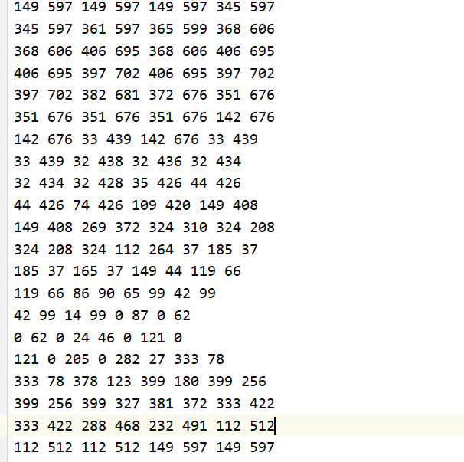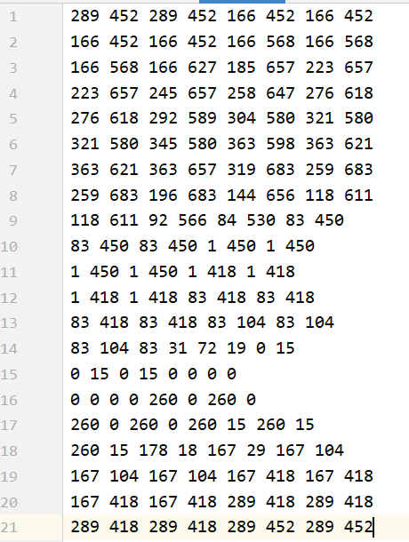
T的数据
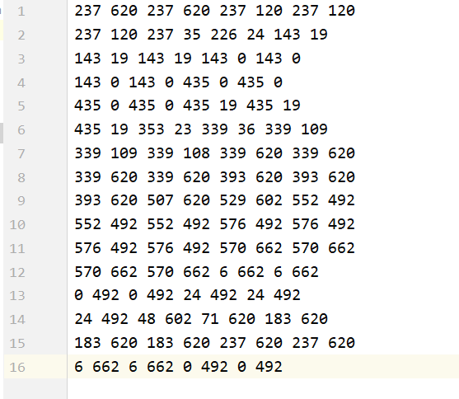
- 实验环境
Windows 10
IDE: CLion
- 实验程序及结果
程序
- #include <windows.h>
- #include "iostream"
- #include "fstream"
- #include "cmath"
- using namespace std;
- const double PI = 3.1415;
- static HWND sHwnd;
- static COLORREF redColor=RGB(255,0,0);
- static COLORREF blueColor=RGB(0,0,255);
- static COLORREF greenColor=RGB(0,255,0);

- void SetWindowHandle(HWND hwnd)
- {
- sHwnd=hwnd;
- }

- void setPixel(int x, int y, COLORREF& color=redColor)
- {
- if(sHwnd == NULL)
- {
- MessageBoxA(NULL,"sHwnd was not initialized !","Error",MB_OK|MB_ICONERROR);
- exit(0);
- }
- HDC hdc=GetDC(sHwnd);
- SetPixel(hdc,x,y,color);
- ReleaseDC(sHwnd,hdc);
- return;
- }

- double Bezier(double c0, double c1, double c2, double c3, double t) {
- return c3*t*t*t + c2*t*t + c1*t + c0;
- }

- void drawCurve(string filename, int len) {

- ifstream infile;
- infile.open(filename);
- int data[8];
- for (int i = 0 ; i < len ; i ++) {
- double a0, a1, a2, a3;
- double b0 ,b1, b2, b3;
- for (int i = 0 ; i < 8 ; i ++) {
- infile >> data[i];
- }

- a0 = data[0];
- b0 = data[1];
- a1 = 3*(data[2] - data[0]);
- b1 = 3*(data[3] - data[1]);
- a2 = 3*(data[0] + data[4] - 2*data[2]);
- b2 = 3*(data[1] + data[5] - 2*data[3]);
- a3 = data[6] - data[0] + 3*(data[2] - data[4]);
- b3 = data[7] - data[1] + 3*(data[3] - data[5]);

- printf("%lf %lf %lf %lf %lf %lf %lf %lf \n",
- a0, a1, a2, a3, b0, b1, b2, b3);

- double t = 0;
- double dt = 1.0/1000;
- while (fabs(t - 1) > 1e-6) {
- double dx = Bezier(a0, a1, a2, a3, t);
- double dy = Bezier(b0, b1, b2, b3, t);
- //setPixel(dx + 100, 742 - dy , blueColor);
- if(sHwnd == NULL)
- {
- MessageBoxA(NULL,"sHwnd was not initialized !","Error",MB_OK|MB_ICONERROR);
- exit(0);
- }
- HDC hdc=GetDC(sHwnd);
- SetPixel(hdc,dx + 100,742 - dy,blueColor);
- ReleaseDC(sHwnd,hdc);
- // 742- 为了保证图像不是倒立的
- t += dt;
- }

- }
- }

- LRESULT CALLBACK WndProc(HWND hwnd,UINT message,WPARAM wParam,LPARAM lParam)
- {
- switch(message)
- {
- case WM_PAINT:
- SetWindowHandle(hwnd);
- //drawSin();
- drawCurve("D:\\learning\\c\\clion\\t.dat", 16);
- //drawCurve("D:\\learning\\c\\clion\\f.dat", 21);
- //drawCurve("D:\\learning\\c\\clion\\5.dat", 21);
- break;
- case WM_CLOSE: // Failure to call DefWindowProc
- break;
- case WM_DESTROY:
- PostQuitMessage(0);
- return 0;
- default:
- break; // Failure to call DefWindowProc //
- }
- return DefWindowProc(hwnd,message,wParam,lParam);
- }

- int WINAPI WinMain(HINSTANCE hInstance,HINSTANCE hPrevInstance,LPSTR lpCmdLine,int iCmdShow)
- {
- static TCHAR szAppName[] = TEXT("Test");
- WNDCLASS wndclass;
- wndclass.style = CS_HREDRAW|CS_VREDRAW ;
- wndclass.lpfnWndProc = WndProc ;
- wndclass.cbClsExtra = 0 ;
- wndclass.cbWndExtra = 0 ;
- wndclass.hInstance = hInstance ;
- wndclass.hIcon = LoadIcon (NULL, IDI_APPLICATION) ;
- wndclass.hCursor = LoadCursor (NULL, IDC_ARROW) ;
- wndclass.hbrBackground = (HBRUSH) GetStockObject (WHITE_BRUSH) ;
- wndclass.lpszMenuName = NULL ;
- wndclass.lpszClassName = szAppName ;

- // Register the window
- if(!RegisterClass(& wndclass))
- {
- MessageBoxA(NULL,"Registering the class failed","Error",MB_OK|MB_ICONERROR);
- exit(0);
- }

- // CreateWindow
- HWND hwnd=CreateWindow(szAppName,TEXT("SetPixel example - codewithc.com"),
- WS_OVERLAPPEDWINDOW,
- CW_USEDEFAULT,
- CW_USEDEFAULT,
- CW_USEDEFAULT,
- CW_USEDEFAULT,
- NULL,
- NULL,
- hInstance,
- NULL);
- if(!hwnd)
- {
- MessageBoxA(NULL,"Window Creation Failed!","Error",MB_OK);
- exit(0);
- }

- // ShowWindow and UpdateWindow
- ShowWindow(hwnd,iCmdShow);
- UpdateWindow(hwnd);

- // Message Loop
- MSG msg;
- while(GetMessage(& msg,NULL,0,0))
- {
- TranslateMessage(& msg);
- DispatchMessage(& msg);
- }

- return 0;
- }
实验结果
T: F


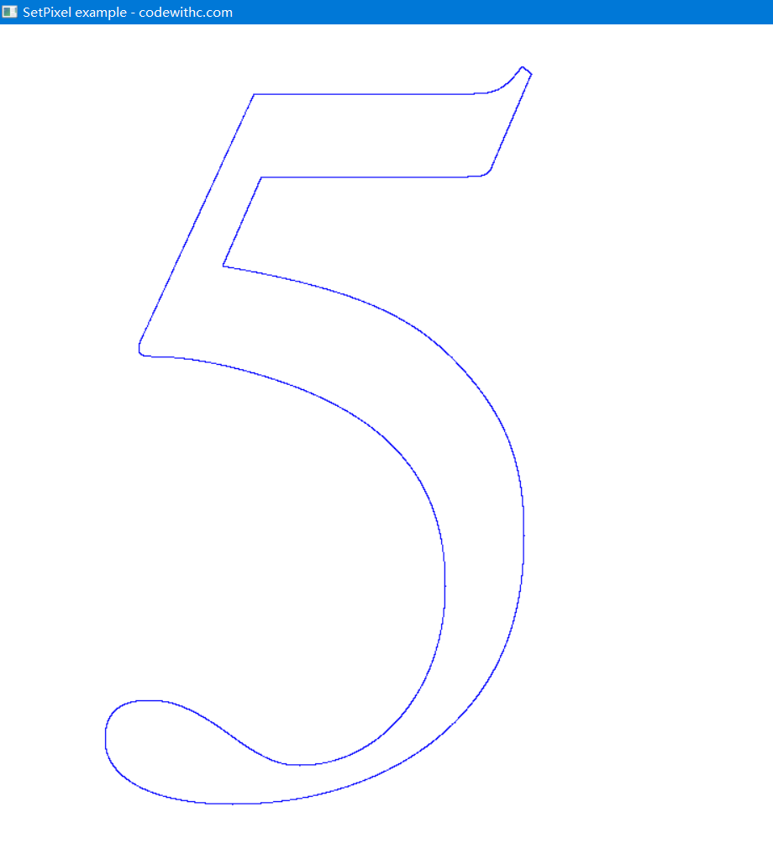
- 实验总结
直接使用曲线方程生成的x,y坐标绘制的结果是倒立的像，需要对y坐标取符号，再偏移适当位置即可。(x, y) -> (x, 742-y)。

实验二
- 实验名称
使用PageRank算法计算网页的权重
- 实验原理
- PageRank 定义
PageRank 是定义在网页集合上的一个函数，他对存在与某一个文档中的超链接赋予一个数值权重(0,1),表示网页的重要程度，整体构成一个向量。我们使用$PR\left(u\right)$,来表示网页u的PageRank值。$PR\left(u\right)$值越高，网页就越重要，在互联网的排序中可能就被排在前面。
- 原理描述
假定只有A,B,C,D四个网页，设A,B,C,D四个网页的初始PR值均为$\frac{1}{4}$,仅存在B->A,C->A,D->A三条链接，那么一次迭代后，A的PR值为：
$$PR\left(A\right)=\frac{PR\left(B\right)}{1}+\frac{PR\left(C\right)}{1}+\frac{PR\left(D\right)}{1}=\frac{1}{4}+\frac{1}{4}+\frac{1}{4}=0.75$$
再假设存在B->C,A; C->A; D->A,B,C;六条链接，那么一次迭代后各个网页的PR值为：
$$PR\left(A\right)=\frac{PR\left(B\right)}{2}+PR\left(C\right)+\frac{PR\left(D\right)}{3}=0.125+0.25+\frac{0.25}{3}=0.458$$
$$PR\left(B\right)=0*PR\left(A\right)+0*PR\left(B\right)+\frac{PR\left(D\right)}{3}=\frac{0.25}{3}=0.083$$
$$PR\left(C\right)=0*PR\left(A\right)+\frac{PR\left(B\right)}{2}+\frac{PR\left(D\right)}{3}=\frac{0.25}{3}+0.125=0.203$$
$$PR\left(D\right)=0*PR\left(A\right)+0*PR\left(B\right)+0*PR\left(C\right)= 0$$
$$总结：PR\left(u\right)=\sum{\left(\frac{PR\left(v\right)}{L\left(v\right)}\right)}$$
上述公式可写成矩阵的形式
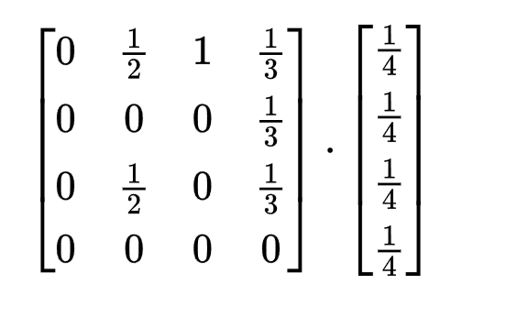
推广成一般形式
$$R_{\left\{i+1\right\}}=MR_{i}$$
求$R_{i}$实际上就是求矩阵M特征值为1的特征向量。即求：
$$\left(M-λI\right)R=λR$$
$$λ取1$$
易得M-I这个矩阵的行列式为零，故1为M特征值成立。
之后用幂法求解特征向量即可。

- 算法描述
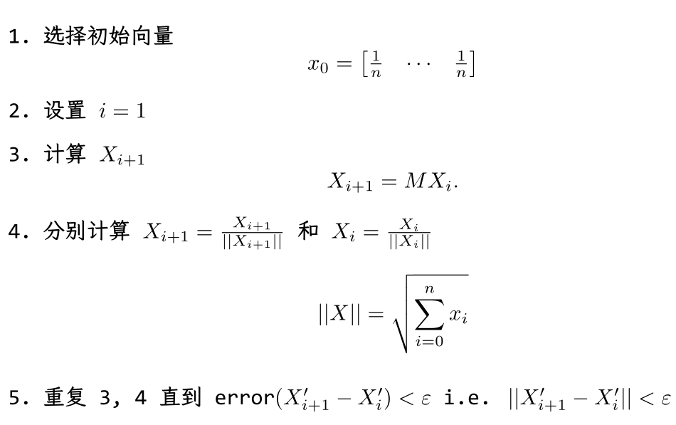
- 实验数据
输入的邻接矩阵
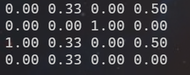
- 实验环境
OS: Windows 10
IDE: VScode
- 实验代码与结果
代码
- #include "iostream"
- #include "fstream"
- #include "math.h"
- using namespace std;
- const int N = 200;

- typedef struct web
- {
- double web_m[N][N];
- int n;
- }Web;

- typedef struct vec
- {
- double vect[N];
- int n;

- double norm () {
- double sum = 0;
- for (int i = 0; i < n; i++) {
- sum += vect[i]*vect[i];
- }
- return sqrt(sum);
- }

- double distance (vec v) {
- double sum = 0;
- for (int i = 0; i < n; i++) {
- sum += (vect[i]-v.vect[i])*(vect[i]-v.vect[i]);
- }
- return sqrt(sum);
- }

- vec normarliaztion() {
- vec temp;
- temp.n = n;
- double nor = norm();
- for (int i = 0; i < n; i++) {
- temp.vect[i] = vect[i] / nor;
- }
- return temp;
- }

- }Vec;

- Web network;
- Vec R;

- void init() {
- ifstream infile;
- infile.open("pagerank.dat");

- infile >> network.n;
- R.n = network.n;

- for (int i = 0; i < R.n; i++) {
- R.vect[i] = 1.0/R.n;
- }

- // 读取连接数
- for (int i = 0; i < network.n; i++) {
- for (int j = 0; j < network.n; j++ ) {
- infile >> network.web_m[i][j];
- }
- }
- // 读取每个节点的最大出度
- int temp[network.n];
- for (int i = 0; i < network.n; i++) {
- int cnt = 0;
- for (int j = 0; j < network.n; j++ ) {
- if (network.web_m[j][i] == 1) {
- cnt +=1;
- }
- }
- temp[i] = cnt;
- }
- // 构造M矩阵
- for (int i = 0; i < network.n; i++) {
- for (int j = 0; j < network.n; j++ ) {
- network.web_m[j][i] /= temp[i];
- }
- }

- infile.close();
- }

- void print() {
- for (int i = 0; i < network.n; i++) {
- for (int j = 0; j < network.n; j++) {
- printf("%.2lf ", network.web_m[i][j]);
- }
- printf("\n");
- }
- }

- void print_v() {
- for (int i = 0; i < R.n; i++) {
- printf("%.3lf ", R.vect[i]);
- }
- putchar('\n');
- }

- Vec mul(Web n, Vec R) {
- Vec temp;

- for (int i = 0; i < R.n; i++) {
- temp.vect[i] = 0;
- temp.n = R.n;
- }

- for (int i = 0; i < network.n; i++) {
- for (int j = 0; j < network.n; j++) {
- temp.vect[i] += n.web_m[i][j]*R.vect[j];
- }
- }
- for (int i = 0; i < R.n; i++) {
- R.vect[i] = temp.vect[i];
- }
- return temp;

- }

- int main (int argc, char*argv[])
- {
- init();
- print();

- printf("___________________________\n");

- Vec prev;
- do {
- prev = R;
- R = mul(network, R);
- } while (R.normarliaztion().distance(prev.normarliaztion()) >= 0.01);

- print_v();
  - for (int i = 0; i < R.n; i++) {
  - R.vect[i] /= sum;
  - }
  - printf("After normailization:\n");
  - print_v();
return 0;
}
实验结果：
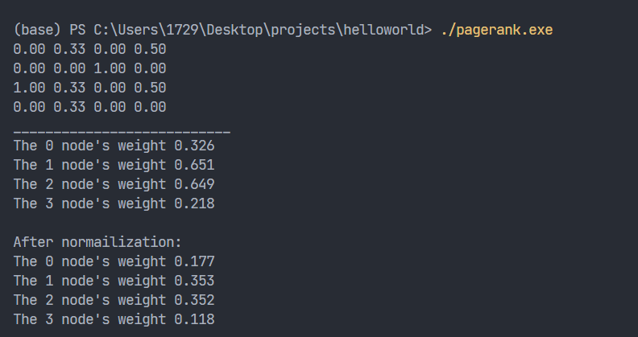
- 实验总结
在使用幂法的时候，在每一次循环中，都要对计算出来的X进行归一化，即(x = x/||x||),不然不能算出正确结果

