实验2
一、实验目的
1. 加深对 SQL 数据更新语句的基本语法格式的掌握。
2. 掌握单个元组及多个元组的插入、修改及删除操作的实现过程。
3. 加深对约束条件在数据更新操作执行中的作用问题的了解。
4. 加深对更新操作时数据库中数据一致性问题的了解。
二、实验内容
1.在实验一中的三个表中添加数据，要求 student 表中插入不少
于 30 条数据，course 表中插入不少于 10 条数据，grade 表中不少于
90 条数据。（数据见附件）
2.求选修了“数据库原理”课程的学生姓名。
3.查询“陈雪”所选修的课程的课程号，课程名称以及成绩。
4.查询参与了所有课程选修的学生学号、姓名和学生所在的系别。
5.查询没有选修任何一个课程的学生学号、姓名和所在系别。
6.查询课程没有学生选修的课程号、课程名称。
7.查询选修了“白一阁”老师的所有课程的学生学号、姓名和所
在系别。
8.列出每门课程的平均分、最高分、最低分。
9.对所有学生求出所选修课程的最高分、平均分。
10.对“付大鹏”老师的授课的课程的分数增加 1 分。
11.查询全体学生的学号、姓名、性别和年龄。
12.查询姓“陈”的且全名为两个字的学生的学号、姓名和系别。
13.查询没有选修“数据库原理”课程编号的学生的学号、姓名
和系别。
14.查询“数据库原理”课程在 80 分以上的学生的学号和姓名以
及分数。
15.统计各门课程的平均分、最高分、最低分，结果集按平均分
降序排列。
16.查询有三门以上的不及格的学生，列出学号、姓名和不及格
的门数。
17.查询选修了“数据库原理”且成绩比此门课程的平均分要高
的学生的学号、姓名和成绩。
18.列出选修了“数据库原理”课程编号的成绩在前三名的学生
的学号、姓名、成绩。（如果第三名有多个学生都列出）。
19.查询出所有课程中 60 分以下的同学相关信息。
20.删除 grade 表中分数为空的学生信息。
三、实验结果
第一部分：sql语句
- # grade
- INSERT INTO grade VALUES("001", "05", 82, NULL);
- INSERT INTO grade VALUES("011", "05", 96, NULL);
- INSERT INTO grade VALUES("003", "05", 97, NULL);
- INSERT INTO grade VALUES("004", "05", 65, NULL);
- INSERT INTO grade VALUES("017", "05", 76, NULL);
- INSERT INTO grade VALUES("017", "01", 86, NULL);
- INSERT INTO grade VALUES("017", "02", 96, NULL);
- INSERT INTO grade VALUES("017", "03", 88, NULL);
- INSERT INTO grade VALUES("017", "04", 89, NULL);
- INSERT INTO grade VALUES("017", "06", 92, NULL);
- INSERT INTO grade VALUES("017", "07", 90, NULL);
- INSERT INTO grade VALUES("017", "08", 75, NULL);
- INSERT INTO grade VALUES("017", "09", 84, NULL);
- INSERT INTO grade VALUES("017", "10", 83, NULL);
- INSERT INTO grade VALUES("012", "01", 86, NULL);
- INSERT INTO grade VALUES("012", "02", 96, NULL);
- INSERT INTO grade VALUES("012", "03", 88, NULL);
- INSERT INTO grade VALUES("012", "04", 89, NULL);
- INSERT INTO grade VALUES("012", "05", 89, NULL);
- INSERT INTO grade VALUES("012", "06", 92, NULL);
- INSERT INTO grade VALUES("012", "07", 90, NULL);
- INSERT INTO grade VALUES("012", "08", 88, NULL);
- INSERT INTO grade VALUES("012", "09", 84, NULL);
- INSERT INTO grade VALUES("012", "10", 83, NULL);
- INSERT INTO grade VALUES("007", "01", 52, NULL);
- INSERT INTO grade VALUES("007", "02", 52, NULL);
- INSERT INTO grade VALUES("007", "03", 52, NULL);
- INSERT INTO grade VALUES("007", "04", 52, NULL);
- INSERT INTO grade VALUES("007", "05", 53, NULL);
- INSERT INTO grade VALUES("007", "06", 59, NULL);
- INSERT INTO grade VALUES("007", "07", 56, NULL);
- INSERT INTO grade VALUES("007", "08", 52, NULL);
- INSERT INTO grade VALUES("007", "09", 52, NULL);
- INSERT INTO grade VALUES("007", "10", 52, NULL);
- INSERT INTO grade VALUES("014", "05", 52, NULL);
- INSERT INTO grade VALUES("014", "06", 59, NULL);
- INSERT INTO grade VALUES("014", "07", 58, NULL);
- INSERT INTO grade VALUES("014", "08", 59, NULL);
- INSERT INTO grade VALUES("030", "05", 52, NULL);
- INSERT INTO grade VALUES("030", "06", 59, NULL);
- INSERT INTO grade VALUES("030", "07", 58, NULL);
- INSERT INTO grade VALUES("002", "01", 88, NULL);
- INSERT INTO grade VALUES("002", "02", 78, NULL);
- INSERT INTO grade VALUES("002", "03", 92, NULL);
- INSERT INTO grade VALUES("002", "04", 96, NULL);
- INSERT INTO grade VALUES("002", "05", 83, NULL);
- INSERT INTO grade VALUES("002", "06", 91, NULL);
- INSERT INTO grade VALUES("002", "07", 70, NULL);
- INSERT INTO grade VALUES("002", "08", 68, NULL);
- INSERT INTO grade VALUES("002", "09", 58, NULL);
- INSERT INTO grade VALUES("002", "10", 88, NULL);
- INSERT INTO grade VALUES("001", "02", 58, NULL);
- INSERT INTO grade VALUES("001", "03", 68, NULL);
- INSERT INTO grade VALUES("001", "08", 78, NULL);
- INSERT INTO grade VALUES("004", "10", 88, NULL);
- INSERT INTO grade VALUES("004", "09", 88, NULL);
- INSERT INTO grade VALUES("004", "08", 88, NULL);
- INSERT INTO grade VALUES("006", "09", 88, NULL);
- INSERT INTO grade VALUES("006", "10", 88, NULL);
- INSERT INTO grade VALUES("006", "05", 88, NULL);
- INSERT INTO grade VALUES("006", "04", 88, NULL);
- INSERT INTO grade VALUES("005", "07", 83, NULL);
- INSERT INTO grade VALUES("005", "08", 98, NULL);
- INSERT INTO grade VALUES("005", "09", 86, NULL);
- INSERT INTO grade VALUES("005", "05", 59, NULL);
- INSERT INTO grade VALUES("005", "02", 88, NULL);
- INSERT INTO grade VALUES("005", "10", 88, NULL);
- INSERT INTO grade VALUES("008", "04", 83, NULL);
- INSERT INTO grade VALUES("008", "05", 79, NULL);
- INSERT INTO grade VALUES("008", "10", 66, NULL);
- INSERT INTO grade VALUES("009", "01", 66, NULL);
- INSERT INTO grade VALUES("009", "03", 86, NULL);
- INSERT INTO grade VALUES("009", "06", 96, NULL);
- INSERT INTO grade VALUES("009", "08", 86, NULL);
- INSERT INTO grade VALUES("009", "10", 86, NULL);
- INSERT INTO grade VALUES("010", "10", 66, NULL);
- INSERT INTO grade VALUES("010", "05", 79, NULL);
- INSERT INTO grade VALUES("010", "06", 89, NULL);
- INSERT INTO grade VALUES("010", "07", 80, NULL);
- INSERT INTO grade VALUES("010", "09", 75, NULL);
- INSERT INTO grade VALUES("013", "02", 75, NULL);
- INSERT INTO grade VALUES("013", "04", 85, NULL);
- INSERT INTO grade VALUES("013", "05", 55, NULL);
- INSERT INTO grade VALUES("013", "06", 65, NULL);
- INSERT INTO grade VALUES("013", "08", 75, NULL);
- INSERT INTO grade VALUES("013", "09", 95, NULL);
- INSERT INTO grade VALUES("015", "05", 75, NULL);
- INSERT INTO grade VALUES("015", "10", 75, NULL);
- INSERT INTO grade VALUES("015", "09", 75, NULL);
- INSERT INTO grade VALUES("015", "03", 75, NULL);
- # student
- INSERT INTO `student`(`Sno`, `Sname`, `Ssex`, `Smajor`, `Sdept`, `Srxsj`, `Sclass`, `Snumber`, `Sbirth`, `Sregion`, `Schange`, `Snation`, `monitor`, `political_status`, `tot_credits`) VALUES ('001', '李春刚', '男', '计算机应用', '计算机', '2019-09-01 00:00:00', '02', '12345678910', '2000-09-01 00:00:00', '呼和浩特市', '无', NULL, 'shen', '团员', 132);
- INSERT INTO `student`(`Sno`, `Sname`, `Ssex`, `Smajor`, `Sdept`, `Srxsj`, `Sclass`, `Snumber`, `Sbirth`, `Sregion`, `Schange`, `Snation`, `monitor`, `political_status`, `tot_credits`) VALUES ('002', '童雪婷', '女', '计算机应用', '计算机', '2019-09-01 00:00:00', '03', '12345678910', '2000-09-01 00:00:00', '呼和浩特市', '无', NULL, 'shen', '团员', 132);
- INSERT INTO `student`(`Sno`, `Sname`, `Ssex`, `Smajor`, `Sdept`, `Srxsj`, `Sclass`, `Snumber`, `Sbirth`, `Sregion`, `Schange`, `Snation`, `monitor`, `political_status`, `tot_credits`) VALUES ('003', '陈男', '男', '电子商务', '管理系', '2019-09-01 00:00:00', '01', '12345678910', '2000-09-01 00:00:00', '呼和浩特市', '无', NULL, 'shen', '团员', 132);
- INSERT INTO `student`(`Sno`, `Sname`, `Ssex`, `Smajor`, `Sdept`, `Srxsj`, `Sclass`, `Snumber`, `Sbirth`, `Sregion`, `Schange`, `Snation`, `monitor`, `political_status`, `tot_credits`) VALUES ('004', '刘波', '男', '电子商务', '管理系', '2019-09-01 00:00:00', '02', '12345678910', '2000-09-01 00:00:00', '呼和浩特市', '无', NULL, 'shen', '团员', 132);
- INSERT INTO `student`(`Sno`, `Sname`, `Ssex`, `Smajor`, `Sdept`, `Srxsj`, `Sclass`, `Snumber`, `Sbirth`, `Sregion`, `Schange`, `Snation`, `monitor`, `political_status`, `tot_credits`) VALUES ('005', '吴辉', '男', '计算机应用', '计算机', '2019-09-01 00:00:00', '03', '12345678910', '2000-09-01 00:00:00', '呼和浩特市', '无', NULL, 'shen', '团员', 132);
- INSERT INTO `student`(`Sno`, `Sname`, `Ssex`, `Smajor`, `Sdept`, `Srxsj`, `Sclass`, `Snumber`, `Sbirth`, `Sregion`, `Schange`, `Snation`, `monitor`, `political_status`, `tot_credits`) VALUES ('006', '陈惠惠', '女', '软件开发', '软件', '2019-09-01 00:00:00', '02', '12345678910', '2000-09-01 00:00:00', '呼和浩特市', '无', NULL, 'shen', '团员', 132);
- INSERT INTO `student`(`Sno`, `Sname`, `Ssex`, `Smajor`, `Sdept`, `Srxsj`, `Sclass`, `Snumber`, `Sbirth`, `Sregion`, `Schange`, `Snation`, `monitor`, `political_status`, `tot_credits`) VALUES ('007', '陈慧', '女', '软件开发', '软件', '2019-09-01 00:00:00', '01', '12345678910', '2000-09-01 00:00:00', '呼和浩特市', '无', NULL, 'shen', '团员', 132);
- INSERT INTO `student`(`Sno`, `Sname`, `Ssex`, `Smajor`, `Sdept`, `Srxsj`, `Sclass`, `Snumber`, `Sbirth`, `Sregion`, `Schange`, `Snation`, `monitor`, `political_status`, `tot_credits`) VALUES ('008', '王涛', '男', '计算机应用', '计算机', '2019-09-01 00:00:00', '03', '12345678910', '2000-09-01 00:00:00', '呼和浩特市', '无', NULL, 'shen', '团员', 132);
- INSERT INTO `student`(`Sno`, `Sname`, `Ssex`, `Smajor`, `Sdept`, `Srxsj`, `Sclass`, `Snumber`, `Sbirth`, `Sregion`, `Schange`, `Snation`, `monitor`, `political_status`, `tot_credits`) VALUES ('009', '郭凤丽', '女', '应用电子', '电子', '2019-09-01 00:00:00', '01', '12345678910', '2000-09-01 00:00:00', '呼和浩特市', '无', NULL, 'shen', '团员', 132);
- INSERT INTO `student`(`Sno`, `Sname`, `Ssex`, `Smajor`, `Sdept`, `Srxsj`, `Sclass`, `Snumber`, `Sbirth`, `Sregion`, `Schange`, `Snation`, `monitor`, `political_status`, `tot_credits`) VALUES ('010', '贾慧', '女', '应用电子', '电子', '2019-09-01 00:00:00', '03', '12345678910', '2000-09-01 00:00:00', '呼和浩特市', '无', NULL, 'shen', '团员', 132);
- INSERT INTO `student`(`Sno`, `Sname`, `Ssex`, `Smajor`, `Sdept`, `Srxsj`, `Sclass`, `Snumber`, `Sbirth`, `Sregion`, `Schange`, `Snation`, `monitor`, `political_status`, `tot_credits`) VALUES ('011', '陈小琴', '女', '计算机应用', '计算机', '2019-09-01 00:00:00', '03', '12345678910', '2000-09-01 00:00:00', '呼和浩特市', '无', NULL, 'shen', '团员', 132);
- INSERT INTO `student`(`Sno`, `Sname`, `Ssex`, `Smajor`, `Sdept`, `Srxsj`, `Sclass`, `Snumber`, `Sbirth`, `Sregion`, `Schange`, `Snation`, `monitor`, `political_status`, `tot_credits`) VALUES ('012', '钟志', '男', '计算机应用', '计算机', '2019-09-01 00:00:00', '02', '12345678910', '2000-09-01 00:00:00', '呼和活持市', '无', NULL, 'shen', '团员', 132);
- INSERT INTO `student`(`Sno`, `Sname`, `Ssex`, `Smajor`, `Sdept`, `Srxsj`, `Sclass`, `Snumber`, `Sbirth`, `Sregion`, `Schange`, `Snation`, `monitor`, `political_status`, `tot_credits`) VALUES ('013', '彭志莺', '男', '计算机应用', '计算机', '2019-09-01 00:00:00', '02', '12345678910', '2000-09-01 00:00:00', '呼和浩特市', '无', NULL, 'shen', '团员', 132);
- INSERT INTO `student`(`Sno`, `Sname`, `Ssex`, `Smajor`, `Sdept`, `Srxsj`, `Sclass`, `Snumber`, `Sbirth`, `Sregion`, `Schange`, `Snation`, `monitor`, `political_status`, `tot_credits`) VALUES ('014', '熊小胖', '男', '计算机应用', '计算机', '2019-09-01 00:00:00', '02', '12345678910', '2000-09-01 00:00:00', '呼和浩特市', '无', NULL, 'shen', '团员', 132);
- INSERT INTO `student`(`Sno`, `Sname`, `Ssex`, `Smajor`, `Sdept`, `Srxsj`, `Sclass`, `Snumber`, `Sbirth`, `Sregion`, `Schange`, `Snation`, `monitor`, `political_status`, `tot_credits`) VALUES ('015', '魏泽丽', '女', '计算机应用', '计算机', '2019-09-01 00:00:00', '01', '0', '2000-09-01 00:00:00', '呼和浩特市', '无', NULL, 'shen', '团员', 132);
- INSERT INTO `student`(`Sno`, `Sname`, `Ssex`, `Smajor`, `Sdept`, `Srxsj`, `Sclass`, `Snumber`, `Sbirth`, `Sregion`, `Schange`, `Snation`, `monitor`, `political_status`, `tot_credits`) VALUES ('016', '刀妹', '女', '计算机应用', '计算机', '2019-09-01 00:00:00', '02', '0', '2000-09-01 00:00:00', '呼和浩特市', '无', NULL, 'shen', '团员', 132);
- INSERT INTO `student`(`Sno`, `Sname`, `Ssex`, `Smajor`, `Sdept`, `Srxsj`, `Sclass`, `Snumber`, `Sbirth`, `Sregion`, `Schange`, `Snation`, `monitor`, `political_status`, `tot_credits`) VALUES ('017', '陈雪', '女', '计算机应用', '计算机', '2019-09-01 00:00:00', '02', '12345678910', '2000-09-01 00:00:00', '呼和浩特市', '无', NULL, 'shen', '团员', 132);
- INSERT INTO `student`(`Sno`, `Sname`, `Ssex`, `Smajor`, `Sdept`, `Srxsj`, `Sclass`, `Snumber`, `Sbirth`, `Sregion`, `Schange`, `Snation`, `monitor`, `political_status`, `tot_credits`) VALUES ('018', '陈艾克', '男', '计算机应用', '计算机', '2019-09-01 00:00:00', '01', '0', '2000-09-01 00:00:00', '呼和浩特市', '无', NULL, 'shen', '团员', 132);
- INSERT INTO `student`(`Sno`, `Sname`, `Ssex`, `Smajor`, `Sdept`, `Srxsj`, `Sclass`, `Snumber`, `Sbirth`, `Sregion`, `Schange`, `Snation`, `monitor`, `political_status`, `tot_credits`) VALUES ('019', '卡萨丁', '男', '计算机应用', '计算机', '2019-09-01 00:00:00', '03', '0', '2000-09-01 00:00:00', '呼和浩特市', '无', NULL, 'shen', '团员', 132);
- INSERT INTO `student`(`Sno`, `Sname`, `Ssex`, `Smajor`, `Sdept`, `Srxsj`, `Sclass`, `Snumber`, `Sbirth`, `Sregion`, `Schange`, `Snation`, `monitor`, `political_status`, `tot_credits`) VALUES ('020', '莫甘娜', '女', '计算机应用', '计算机', '2019-09-01 00:00:00', '01', '0', '2000-09-01 00:00:00', '呼和浩特市', '无', NULL, 'shen', '团员', 132);
- INSERT INTO `student`(`Sno`, `Sname`, `Ssex`, `Smajor`, `Sdept`, `Srxsj`, `Sclass`, `Snumber`, `Sbirth`, `Sregion`, `Schange`, `Snation`, `monitor`, `political_status`, `tot_credits`) VALUES ('021', '基兰', '女', '计算机应用', '计算机', '2019-09-01 00:00:00', '02', '0', '2000-09-01 00:00:00', '呼和浩特市', '无', NULL, 'shen', '团员', 132);
- INSERT INTO `student`(`Sno`, `Sname`, `Ssex`, `Smajor`, `Sdept`, `Srxsj`, `Sclass`, `Snumber`, `Sbirth`, `Sregion`, `Schange`, `Snation`, `monitor`, `political_status`, `tot_credits`) VALUES ('022', '寒冰', '女', '计算机应用', '计算机', '2019-09-01 00:00:00', '02', '0', '2000-09-01 00:00:00', '呼和浩特市', '无', NULL, 'shen', '团员', 132);
- INSERT INTO `student`(`Sno`, `Sname`, `Ssex`, `Smajor`, `Sdept`, `Srxsj`, `Sclass`, `Snumber`, `Sbirth`, `Sregion`, `Schange`, `Snation`, `monitor`, `political_status`, `tot_credits`) VALUES ('023', '塔姆', '男', '计算机应用', '计算机', '2019-09-01 00:00:00', '02', '0', '2000-09-01 00:00:00', '呼和浩特市', '无', NULL, 'shen', '团员', 132);
- INSERT INTO `student`(`Sno`, `Sname`, `Ssex`, `Smajor`, `Sdept`, `Srxsj`, `Sclass`, `Snumber`, `Sbirth`, `Sregion`, `Schange`, `Snation`, `monitor`, `political_status`, `tot_credits`) VALUES ('024', '蛮王', '男', '计算机应用', '计算机', '2019-09-01 00:00:00', '02', '0', '2000-09-01 00:00:00', '呼和浩特市', '无', NULL, 'shen', '团员', 132);
- INSERT INTO `student`(`Sno`, `Sname`, `Ssex`, `Smajor`, `Sdept`, `Srxsj`, `Sclass`, `Snumber`, `Sbirth`, `Sregion`, `Schange`, `Snation`, `monitor`, `political_status`, `tot_credits`) VALUES ('025', '寡妇', '女', '计算机应用', '计算机', '2019-09-01 00:00:00', '02', '0', '2000-09-01 00:00:00', '呼和浩特市', '无', NULL, 'shen', '团员', 132);
- INSERT INTO `student`(`Sno`, `Sname`, `Ssex`, `Smajor`, `Sdept`, `Srxsj`, `Sclass`, `Snumber`, `Sbirth`, `Sregion`, `Schange`, `Snation`, `monitor`, `political_status`, `tot_credits`) VALUES ('026', '炸弹人', '男', '计算机应用', '计算机', '2019-09-01 00:00:00', '01', '0', '2000-09-01 00:00:00', '呼和浩特市', '无', NULL, 'shen', '团员', 132);
- INSERT INTO `student`(`Sno`, `Sname`, `Ssex`, `Smajor`, `Sdept`, `Srxsj`, `Sclass`, `Snumber`, `Sbirth`, `Sregion`, `Schange`, `Snation`, `monitor`, `political_status`, `tot_credits`) VALUES ('027', '维克多', '男', '计算机应用', '计算机', '2019-09-01 00:00:00', '02', '0', '2000-09-01 00:00:00', '呼和浩特市', '无', NULL, 'shen', '团员', 132);
- INSERT INTO `student`(`Sno`, `Sname`, `Ssex`, `Smajor`, `Sdept`, `Srxsj`, `Sclass`, `Snumber`, `Sbirth`, `Sregion`, `Schange`, `Snation`, `monitor`, `political_status`, `tot_credits`) VALUES ('028', '狐狸', '女', '计算机应用', '计算机', '2019-09-01 00:00:00', '02', '0', '2000-09-01 00:00:00', '呼和浩特市', '无', NULL, 'shen', '团员', 132);
- INSERT INTO `student`(`Sno`, `Sname`, `Ssex`, `Smajor`, `Sdept`, `Srxsj`, `Sclass`, `Snumber`, `Sbirth`, `Sregion`, `Schange`, `Snation`, `monitor`, `political_status`, `tot_credits`) VALUES ('029', '茜欧娜', '女', '计算机应用', '计算机', '2019-09-01 00:00:00', '01', '0', '2000-09-01 00:00:00', '呼和浩特市', '无', NULL, 'shen', '团员', 132);
- INSERT INTO `student`(`Sno`, `Sname`, `Ssex`, `Smajor`, `Sdept`, `Srxsj`, `Sclass`, `Snumber`, `Sbirth`, `Sregion`, `Schange`, `Snation`, `monitor`, `political_status`, `tot_credits`) VALUES ('030', '卡莎', '女', '计算机应用', '计算机', '2019-09-01 00:00:00', '01', '0', '2000-09-01 00:00:00', '呼和浩特市', '无', NULL, 'shen', '团员', 132);

- # course
- insert into table course values("01","计算机基础","王晓梅","101",4,60,1);
- insert into table course values("02","电子商务","李丽","102",6,80,2);
- insert into table course values("03","网页制作","张铁柱","103",6,NULL,NULL);
- insert into table course values("04","软件工程","付大鹏","104",4,NULL,4);
- insert into table course values("05","数据库原理","白一阁","105",6,90,3);
- insert into table course values("06","软件测试","白展堂","201",4,NULL,5);
- insert into table course values("07","安卓应用设计","魏小雨","201",2,NULL,4);
- insert into table course values("08","UML","陈乾","201",5,70,6);
- insert into table course values("09","编译原理","熊军","207",5,NULL,7);
- insert into table course values("10","计算机网络","白一阁","207",4,60,4);
- #
- -- 2.
- SELECT
- sname
- FROM
- student
- WHERE
- Sno IN (
- SELECT
- sno
- FROM
- grade
- WHERE
- Cno = ( SELECT cno FROM course WHERE cname = '数据库原理' ));
- -- 3.
- SELECT
- cno,
- cname,
- grades
- FROM
- course
- JOIN grade USING ( cno )
- WHERE
- sno = (
- SELECT
- Sno
- FROM
- student
- WHERE
- sname = '陈雪')
- -- 4.
- SELECT
- sno,
- sname,
- Sdept
- FROM
- student
- WHERE
- sno IN ( SELECT sno FROM grade );
- -- 5
- SELECT
- sno,
- sname,
- Sdept
- FROM
- student
- WHERE
- sno not IN ( SELECT sno FROM grade );
- -- 6
- SELECT
- cno,
- cname
- FROM
- course
- WHERE
- cno not IN ( SELECT cno FROM grade );
- -- 7
- SELECT
- sname,
- Ssex,
- Sdept
- FROM
- student
- WHERE
- sno IN (
- SELECT
- sno
- FROM
- grade
- WHERE
- cno IN ( SELECT cno FROM course WHERE Cteacher = '白一阁' ))
- -- 8
- SELECT
- cno,
- cname,
- avg( grades ),
- max( grades ),
- min( grades )
- FROM
- grade
- JOIN course USING ( cno )
- GROUP BY
- Cno,
- cname
- ORDER BY
- cno;
- -- 9
- SELECT
- max( grades ),
- avg( grades )
- FROM
- grade
- GROUP BY
- sno
- -- 10
- UPDATE grade
- SET grades = grades + 1
- WHERE
- cno IN (
- SELECT
- cno
- FROM
- course
- WHERE
- Cteacher = "付大鹏")
- -- 11
- SELECT
- sno,
- sname,
- Ssex,
- EXTRACT(year from Srxsj) - EXTRACT(year from Sbirth) as age
- FROM
- student
- -- 12
- SELECT
- sno,
- sname,
- Sdept
- FROM
- student
- where
- sname like '陈_'
- -- 13 ***
- SELECT
- sno,
- sname,
- Sdept
- FROM
- student
- WHERE
- sno NOT IN (
- SELECT
- sno
- FROM
- grade
- WHERE
- cno IN ( SELECT cno FROM course WHERE Cname = "数据库原理" ))
- -- 14
- SELECT
- t1.sname,
- t2.Sno,
- t2.grades
- FROM
- student AS t1,
- ( SELECT sno, grades FROM grade WHERE cno = ( SELECT cno FROM course WHERE cname = '数据库原理' ) AND grades > 80 ) AS t2
- WHERE
- t1.sno = t2.sno
- -- 15
- SELECT
- cno,
- cname,
- avg( grades ) as '平均分',
- max( grades ) as '最高分',
- min( grades ) as '最低分'
- FROM
- grade
- JOIN course USING ( cno )
- GROUP BY
- Cno,
- cname
- ORDER BY
- '平均分';
- -- 16 **
- SELECT
- *
- FROM
- student
- JOIN ( SELECT sno, count(*) AS cnt FROM grade WHERE Grades < 60 GROUP BY sno ) AS t1 USING ( sno )
- WHERE
- t1.cnt > 3
- --17
- SELECT
- sno,
- sname,
- grades
- FROM
- student
- JOIN grade USING ( sno )
- WHERE
- grades > (
- SELECT
- avg( grades ) AS average
- FROM
- grade
- WHERE
- cno = ( SELECT cno FROM course WHERE cname = '数据库原理' ))
- AND sno IN ( SELECT sno FROM grade WHERE cno = ( SELECT cno FROM course WHERE cname = '数据库原理' ) )
- -- 18 **
- CREATE TEMPORARY TABLE tmp AS
- SELECT
- t2.grades
- FROM
- student AS t1,
- ( SELECT sno, grades FROM grade WHERE cno = ( SELECT cno FROM course WHERE cname = '数据库原理' ) ) AS t2
- WHERE
- t1.sno = t2.sno
- LIMIT 3;
- SELECT
- sno,
- Grades
- FROM
- grade
- WHERE
- cno = ( SELECT cno FROM course WHERE cname = '数据库原理' )
- AND grades IN (
- SELECT
- Grades
- FROM
- tmp)

- -- 19
- SELECT
- *
- FROM
- student
- WHERE
- sno IN (
- SELECT
- sno
- FROM
- grade
- WHERE
- Grades < 60
- )
- -- 20
- delete from grade where grades = NULL
第二部分结果截图
1.在实验一中的三个表中添加数据，要求 student 表中插入不少
于 30 条数据，course 表中插入不少于 10 条数据，grade 表中不少于
90 条数据。（数据见附件）
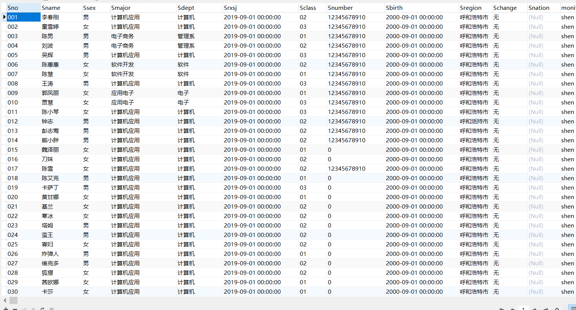
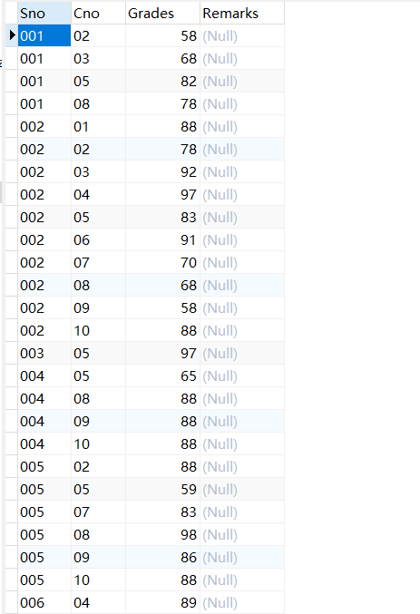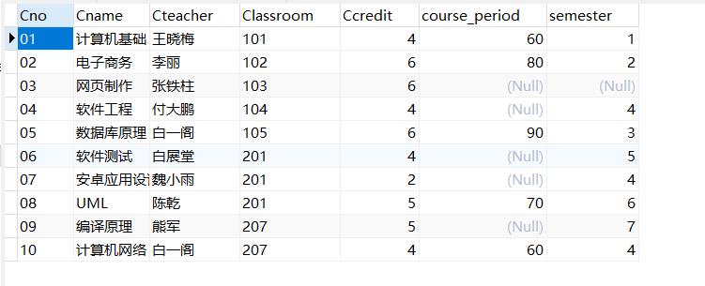
2.求选修了“数据库原理”课程的学生姓名。
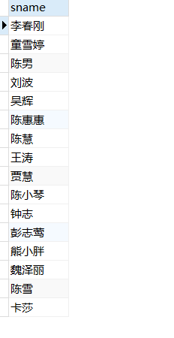
3查询“陈雪”所选修的课程的课程号，课程名称以及成绩。
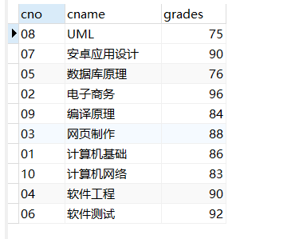

- 查询参与了所有课程选修的学生学号、姓名和学生所在的系别。
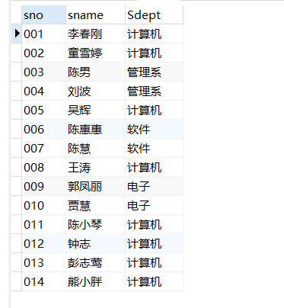
- 查询没有选修任何一个课程的学生学号、姓名和所在系别。
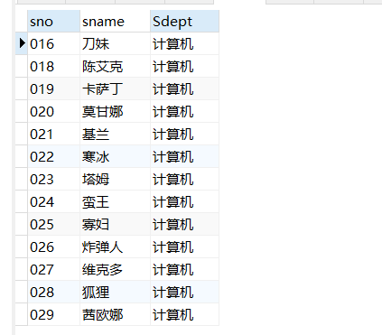
- 查询课程没有学生选修的课程号、课程名称。
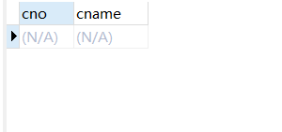
7.查询选修了“白一阁”老师的所有课程的学生学号、姓名和所
在系别。
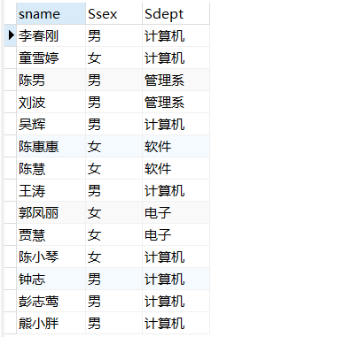
8列出每门课程的平均分、最高分、最低分。
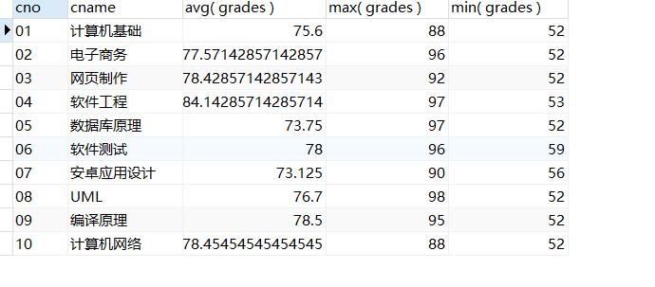
9对所有学生求出所选修课程的最高分、平均分。
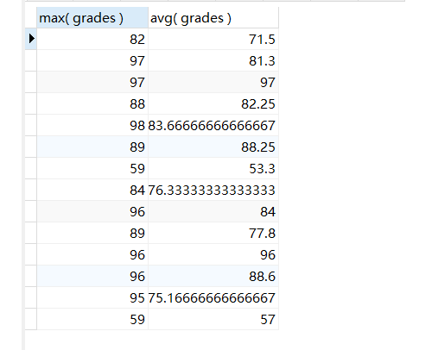
10对“付大鹏”老师的授课的课程的分数增加 1 分。

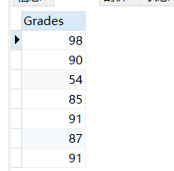
运行之后
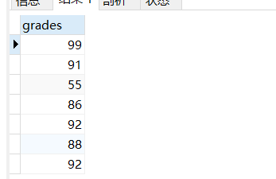
11查询全体学生的学号、姓名、性别和年龄。
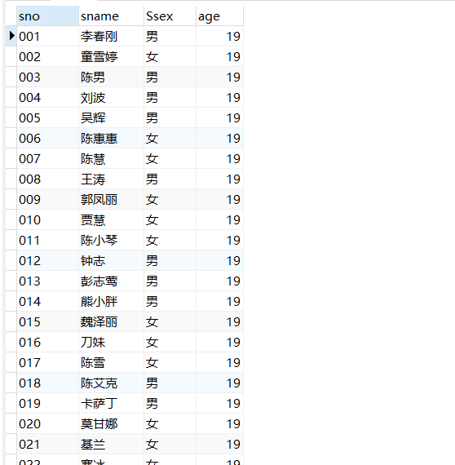
12查询姓“陈”的且全名为两个字的学生的学号、姓名和系别。
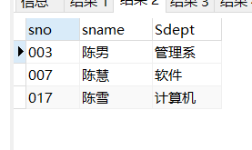
13.查询没有选修“数据库原理”课程编号的学生的学号、姓名
和系别。
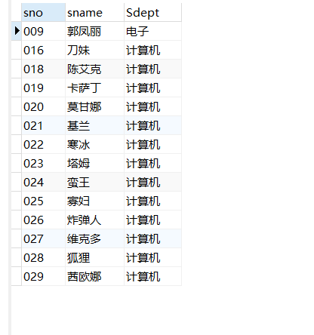
14.查询“数据库原理”课程在 80 分以上的学生的学号和姓名以
及分数。
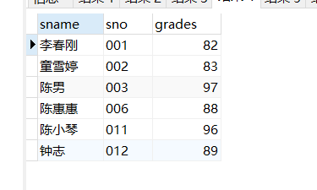
15.统计各门课程的平均分、最高分、最低分，结果集按平均分
降序排列。
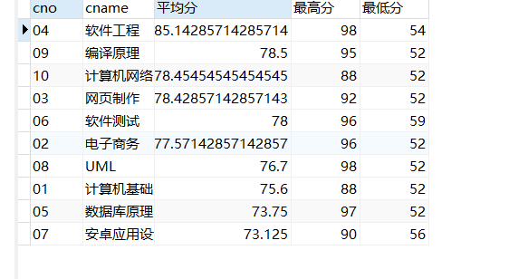
16.查询有三门以上的不及格的学生，列出学号、姓名和不及格
的门数。
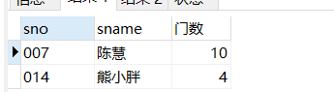
17.查询选修了“数据库原理”且成绩比此门课程的平均分要高
的学生的学号、姓名和成绩。
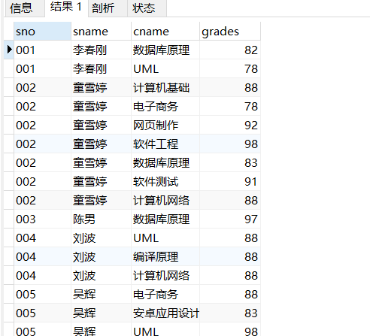
18.列出选修了“数据库原理”课程编号的成绩在前三名的学生
的学号、姓名、成绩。（如果第三名有多个学生都列出）。
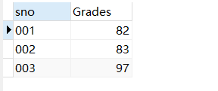
19.查询出所有课程中 60 分以下的同学相关信息。
20 删除成绩为空的学生信息。
四、实验心得
1. sql的执行顺序
1. 如果没有聚合函数， from 的子句最先计算 ，得到一个关系
2. 如果有where从句，那么就使用where的predicate语句对元组进行筛选
3. 符合关系的元组按照 group by 从句 进行分组（如果有的话）
4. 如果有having从句的话，再使用having 的条件对组进行筛选
5. 最后执行select 语句 $\Pi$ , 以及聚合函数
2. 值得注意的是，select clause**如果有聚合函数** 那么 select clause 中除聚合函数外的其他属性 一定出现在group by clause中
3. having clause 中的聚合函数 一定要出现在select clause 的聚合函数

