《数据库原理
及应用开发》

实验报告

班级 计算机201班
姓名 龚开宸
学号 6103120034

数学与计算机学院计算机

实验项目列表

序号 | 实验项目名称 | 成绩
1 | 数据库和表的操作
2 | 数据库表的 CRUD 操作
3 | 实验三 数据库表的 CRUD 操作

实验1
一、实验目的
- 了解数据库的结构特点、领会数据库中三种类型的文件特点
- 学会创建和管理数据库的方法
- 了解SQL 的基本数据类型
了解表结构的特点，学会创建和管理表的
二、实验内容
1. 设计和创建数据库，及管理数据库
2. 设计和创建数据表，及表基本操作一插入数据。

三、实验结果
Student表结构图：
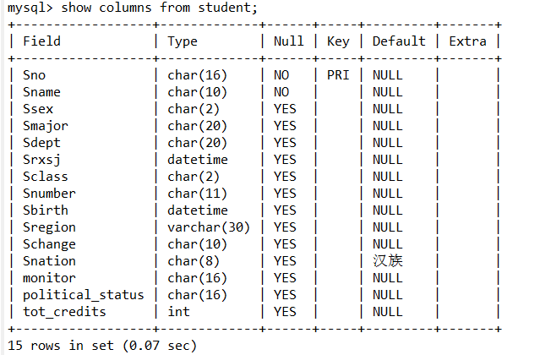
Course 表结构图：
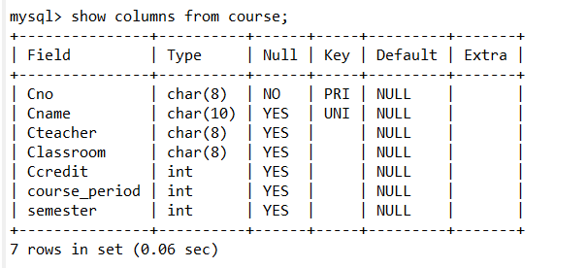
Grade 结构图：
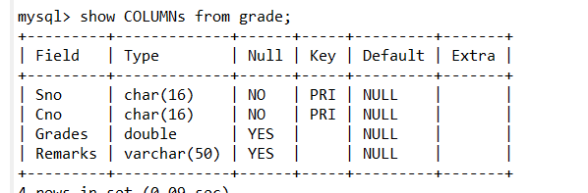
ER图
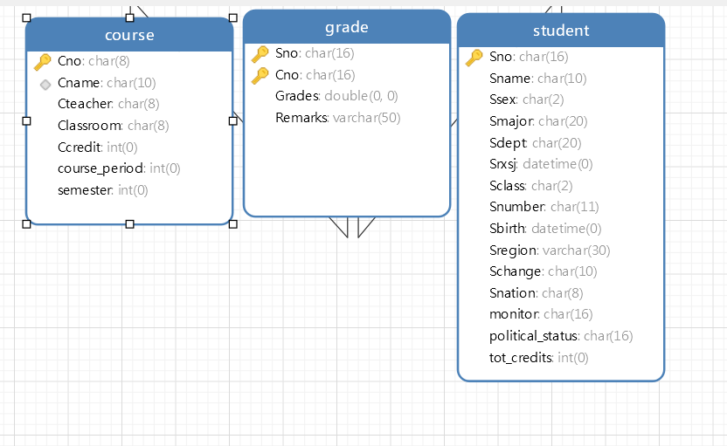
代码：
- CREATE TABLE `student` (
- `Sno` char(16) NOT NULL,
- `Sname` char(10) NOT NULL,
- `Ssex` char(2) DEFAULT NULL,
- `Smajor` char(20) DEFAULT NULL,
- `Sdept` char(20) DEFAULT NULL,
- `Sgrade` char(2) DEFAULT NULL,
- `Sclass` char(2) DEFAULT NULL,
- `Snumber` char(11) DEFAULT NULL,
- `Sbirth` datetime DEFAULT NULL,
- `Sregion` varchar(30) DEFAULT NULL,
- `Schange` char(10) DEFAULT NULL,
- `Snation` char(8) DEFAULT '汉族',
- PRIMARY KEY (`Sno`),
- CONSTRAINT `student_chk_1` CHECK ((`Ssex` in (_utf8mb4'男',_utf8mb4'女')))
- )
- create table Course (
- Cno char(8),
- Cname char(10) UNIQUE,
- Cteacher char(8),
- Classroom char(8),
- Ccredit int,
- primary key(Cno)
- );
- create table Grade (
- Sno char(16),
- Cno char(16),
- Grades real,
- Remarks varchar(50),
- primary key(Sno, Cno),
- foreign key(Sno) references Student(Sno),
- foreign key(Cno) references course(Cno),
- check(Grades <= 100 and Grades >= 0)
- );
- 1. alter table student add monitor char(16);
- 2. alter table student add political_status char(16);
- alter table student add tot_credits int;
- 3. alter table Course add course_period int
- alter table Course add semester int
- 4. alter table student modify Sgrade datetime;
- alter table course add project char(16);
- alter table course drop project;

- 5. create TEMPORARY table demo (
- i int,
- c char(20),
- d datetime
- );
- drop table demo;

四、实验心得
1. 字符集不匹配
2．可以使用show columns from table命令来显示一个表的所有属性

实验2
一、实验目的
1. 加深对 SQL 数据更新语句的基本语法格式的掌握。
2. 掌握单个元组及多个元组的插入、修改及删除操作的实现过程。
3. 加深对约束条件在数据更新操作执行中的作用问题的了解。
4. 加深对更新操作时数据库中数据一致性问题的了解。
二、实验内容
1.在实验一中的三个表中添加数据，要求 student 表中插入不少
于 30 条数据，course 表中插入不少于 10 条数据，grade 表中不少于
90 条数据。（数据见附件）
2.求选修了“数据库原理”课程的学生姓名。
3.查询“陈雪”所选修的课程的课程号，课程名称以及成绩。
4.查询参与了所有课程选修的学生学号、姓名和学生所在的系别。
5.查询没有选修任何一个课程的学生学号、姓名和所在系别。
6.查询课程没有学生选修的课程号、课程名称。
7.查询选修了“白一阁”老师的所有课程的学生学号、姓名和所
在系别。
8.列出每门课程的平均分、最高分、最低分。
9.对所有学生求出所选修课程的最高分、平均分。
10.对“付大鹏”老师的授课的课程的分数增加 1 分。
11.查询全体学生的学号、姓名、性别和年龄。
12.查询姓“陈”的且全名为两个字的学生的学号、姓名和系别。
13.查询没有选修“数据库原理”课程编号的学生的学号、姓名
和系别。
14.查询“数据库原理”课程在 80 分以上的学生的学号和姓名以
及分数。
15.统计各门课程的平均分、最高分、最低分，结果集按平均分
降序排列。
16.查询有三门以上的不及格的学生，列出学号、姓名和不及格
的门数。
17.查询选修了“数据库原理”且成绩比此门课程的平均分要高
的学生的学号、姓名和成绩。
18.列出选修了“数据库原理”课程编号的成绩在前三名的学生
的学号、姓名、成绩。（如果第三名有多个学生都列出）。
19.查询出所有课程中 60 分以下的同学相关信息。
20.删除 grade 表中分数为空的学生信息。
三、实验结果
第一部分：sql语句
- # grade
- INSERT INTO grade VALUES("001", "05", 82, NULL);
- INSERT INTO grade VALUES("011", "05", 96, NULL);
- INSERT INTO grade VALUES("003", "05", 97, NULL);
- INSERT INTO grade VALUES("004", "05", 65, NULL);
- INSERT INTO grade VALUES("017", "05", 76, NULL);
- INSERT INTO grade VALUES("017", "01", 86, NULL);
- INSERT INTO grade VALUES("017", "02", 96, NULL);
- INSERT INTO grade VALUES("017", "03", 88, NULL);
- INSERT INTO grade VALUES("017", "04", 89, NULL);
- INSERT INTO grade VALUES("017", "06", 92, NULL);
- INSERT INTO grade VALUES("017", "07", 90, NULL);
- INSERT INTO grade VALUES("017", "08", 75, NULL);
- INSERT INTO grade VALUES("017", "09", 84, NULL);
- INSERT INTO grade VALUES("017", "10", 83, NULL);
- INSERT INTO grade VALUES("012", "01", 86, NULL);
- INSERT INTO grade VALUES("012", "02", 96, NULL);
- INSERT INTO grade VALUES("012", "03", 88, NULL);
- INSERT INTO grade VALUES("012", "04", 89, NULL);
- INSERT INTO grade VALUES("012", "05", 89, NULL);
- INSERT INTO grade VALUES("012", "06", 92, NULL);
- INSERT INTO grade VALUES("012", "07", 90, NULL);
- INSERT INTO grade VALUES("012", "08", 88, NULL);
- INSERT INTO grade VALUES("012", "09", 84, NULL);
- INSERT INTO grade VALUES("012", "10", 83, NULL);
- INSERT INTO grade VALUES("007", "01", 52, NULL);
- INSERT INTO grade VALUES("007", "02", 52, NULL);
- INSERT INTO grade VALUES("007", "03", 52, NULL);
- INSERT INTO grade VALUES("007", "04", 52, NULL);
- INSERT INTO grade VALUES("007", "05", 53, NULL);
- INSERT INTO grade VALUES("007", "06", 59, NULL);
- INSERT INTO grade VALUES("007", "07", 56, NULL);
- INSERT INTO grade VALUES("007", "08", 52, NULL);
- INSERT INTO grade VALUES("007", "09", 52, NULL);
- INSERT INTO grade VALUES("007", "10", 52, NULL);
- INSERT INTO grade VALUES("014", "05", 52, NULL);
- INSERT INTO grade VALUES("014", "06", 59, NULL);
- INSERT INTO grade VALUES("014", "07", 58, NULL);
- INSERT INTO grade VALUES("014", "08", 59, NULL);
- INSERT INTO grade VALUES("030", "05", 52, NULL);
- INSERT INTO grade VALUES("030", "06", 59, NULL);
- INSERT INTO grade VALUES("030", "07", 58, NULL);
- INSERT INTO grade VALUES("002", "01", 88, NULL);
- INSERT INTO grade VALUES("002", "02", 78, NULL);
- INSERT INTO grade VALUES("002", "03", 92, NULL);
- INSERT INTO grade VALUES("002", "04", 96, NULL);
- INSERT INTO grade VALUES("002", "05", 83, NULL);
- INSERT INTO grade VALUES("002", "06", 91, NULL);
- INSERT INTO grade VALUES("002", "07", 70, NULL);
- INSERT INTO grade VALUES("002", "08", 68, NULL);
- INSERT INTO grade VALUES("002", "09", 58, NULL);
- INSERT INTO grade VALUES("002", "10", 88, NULL);
- INSERT INTO grade VALUES("001", "02", 58, NULL);
- INSERT INTO grade VALUES("001", "03", 68, NULL);
- INSERT INTO grade VALUES("001", "08", 78, NULL);
- INSERT INTO grade VALUES("004", "10", 88, NULL);
- INSERT INTO grade VALUES("004", "09", 88, NULL);
- INSERT INTO grade VALUES("004", "08", 88, NULL);
- INSERT INTO grade VALUES("006", "09", 88, NULL);
- INSERT INTO grade VALUES("006", "10", 88, NULL);
- INSERT INTO grade VALUES("006", "05", 88, NULL);
- INSERT INTO grade VALUES("006", "04", 88, NULL);
- INSERT INTO grade VALUES("005", "07", 83, NULL);
- INSERT INTO grade VALUES("005", "08", 98, NULL);
- INSERT INTO grade VALUES("005", "09", 86, NULL);
- INSERT INTO grade VALUES("005", "05", 59, NULL);
- INSERT INTO grade VALUES("005", "02", 88, NULL);
- INSERT INTO grade VALUES("005", "10", 88, NULL);
- INSERT INTO grade VALUES("008", "04", 83, NULL);
- INSERT INTO grade VALUES("008", "05", 79, NULL);
- INSERT INTO grade VALUES("008", "10", 66, NULL);
- INSERT INTO grade VALUES("009", "01", 66, NULL);
- INSERT INTO grade VALUES("009", "03", 86, NULL);
- INSERT INTO grade VALUES("009", "06", 96, NULL);
- INSERT INTO grade VALUES("009", "08", 86, NULL);
- INSERT INTO grade VALUES("009", "10", 86, NULL);
- INSERT INTO grade VALUES("010", "10", 66, NULL);
- INSERT INTO grade VALUES("010", "05", 79, NULL);
- INSERT INTO grade VALUES("010", "06", 89, NULL);
- INSERT INTO grade VALUES("010", "07", 80, NULL);
- INSERT INTO grade VALUES("010", "09", 75, NULL);
- INSERT INTO grade VALUES("013", "02", 75, NULL);
- INSERT INTO grade VALUES("013", "04", 85, NULL);
- INSERT INTO grade VALUES("013", "05", 55, NULL);
- INSERT INTO grade VALUES("013", "06", 65, NULL);
- INSERT INTO grade VALUES("013", "08", 75, NULL);
- INSERT INTO grade VALUES("013", "09", 95, NULL);
- INSERT INTO grade VALUES("015", "05", 75, NULL);
- INSERT INTO grade VALUES("015", "10", 75, NULL);
- INSERT INTO grade VALUES("015", "09", 75, NULL);
- INSERT INTO grade VALUES("015", "03", 75, NULL);
- # student
- INSERT INTO `student`(`Sno`, `Sname`, `Ssex`, `Smajor`, `Sdept`, `Srxsj`, `Sclass`, `Snumber`, `Sbirth`, `Sregion`, `Schange`, `Snation`, `monitor`, `political_status`, `tot_credits`) VALUES ('001', '李春刚', '男', '计算机应用', '计算机', '2019-09-01 00:00:00', '02', '12345678910', '2000-09-01 00:00:00', '呼和浩特市', '无', NULL, 'shen', '团员', 132);
- INSERT INTO `student`(`Sno`, `Sname`, `Ssex`, `Smajor`, `Sdept`, `Srxsj`, `Sclass`, `Snumber`, `Sbirth`, `Sregion`, `Schange`, `Snation`, `monitor`, `political_status`, `tot_credits`) VALUES ('002', '童雪婷', '女', '计算机应用', '计算机', '2019-09-01 00:00:00', '03', '12345678910', '2000-09-01 00:00:00', '呼和浩特市', '无', NULL, 'shen', '团员', 132);
- INSERT INTO `student`(`Sno`, `Sname`, `Ssex`, `Smajor`, `Sdept`, `Srxsj`, `Sclass`, `Snumber`, `Sbirth`, `Sregion`, `Schange`, `Snation`, `monitor`, `political_status`, `tot_credits`) VALUES ('003', '陈男', '男', '电子商务', '管理系', '2019-09-01 00:00:00', '01', '12345678910', '2000-09-01 00:00:00', '呼和浩特市', '无', NULL, 'shen', '团员', 132);
- INSERT INTO `student`(`Sno`, `Sname`, `Ssex`, `Smajor`, `Sdept`, `Srxsj`, `Sclass`, `Snumber`, `Sbirth`, `Sregion`, `Schange`, `Snation`, `monitor`, `political_status`, `tot_credits`) VALUES ('004', '刘波', '男', '电子商务', '管理系', '2019-09-01 00:00:00', '02', '12345678910', '2000-09-01 00:00:00', '呼和浩特市', '无', NULL, 'shen', '团员', 132);
- INSERT INTO `student`(`Sno`, `Sname`, `Ssex`, `Smajor`, `Sdept`, `Srxsj`, `Sclass`, `Snumber`, `Sbirth`, `Sregion`, `Schange`, `Snation`, `monitor`, `political_status`, `tot_credits`) VALUES ('005', '吴辉', '男', '计算机应用', '计算机', '2019-09-01 00:00:00', '03', '12345678910', '2000-09-01 00:00:00', '呼和浩特市', '无', NULL, 'shen', '团员', 132);
- INSERT INTO `student`(`Sno`, `Sname`, `Ssex`, `Smajor`, `Sdept`, `Srxsj`, `Sclass`, `Snumber`, `Sbirth`, `Sregion`, `Schange`, `Snation`, `monitor`, `political_status`, `tot_credits`) VALUES ('006', '陈惠惠', '女', '软件开发', '软件', '2019-09-01 00:00:00', '02', '12345678910', '2000-09-01 00:00:00', '呼和浩特市', '无', NULL, 'shen', '团员', 132);
- INSERT INTO `student`(`Sno`, `Sname`, `Ssex`, `Smajor`, `Sdept`, `Srxsj`, `Sclass`, `Snumber`, `Sbirth`, `Sregion`, `Schange`, `Snation`, `monitor`, `political_status`, `tot_credits`) VALUES ('007', '陈慧', '女', '软件开发', '软件', '2019-09-01 00:00:00', '01', '12345678910', '2000-09-01 00:00:00', '呼和浩特市', '无', NULL, 'shen', '团员', 132);
- INSERT INTO `student`(`Sno`, `Sname`, `Ssex`, `Smajor`, `Sdept`, `Srxsj`, `Sclass`, `Snumber`, `Sbirth`, `Sregion`, `Schange`, `Snation`, `monitor`, `political_status`, `tot_credits`) VALUES ('008', '王涛', '男', '计算机应用', '计算机', '2019-09-01 00:00:00', '03', '12345678910', '2000-09-01 00:00:00', '呼和浩特市', '无', NULL, 'shen', '团员', 132);
- INSERT INTO `student`(`Sno`, `Sname`, `Ssex`, `Smajor`, `Sdept`, `Srxsj`, `Sclass`, `Snumber`, `Sbirth`, `Sregion`, `Schange`, `Snation`, `monitor`, `political_status`, `tot_credits`) VALUES ('009', '郭凤丽', '女', '应用电子', '电子', '2019-09-01 00:00:00', '01', '12345678910', '2000-09-01 00:00:00', '呼和浩特市', '无', NULL, 'shen', '团员', 132);
- INSERT INTO `student`(`Sno`, `Sname`, `Ssex`, `Smajor`, `Sdept`, `Srxsj`, `Sclass`, `Snumber`, `Sbirth`, `Sregion`, `Schange`, `Snation`, `monitor`, `political_status`, `tot_credits`) VALUES ('010', '贾慧', '女', '应用电子', '电子', '2019-09-01 00:00:00', '03', '12345678910', '2000-09-01 00:00:00', '呼和浩特市', '无', NULL, 'shen', '团员', 132);
- INSERT INTO `student`(`Sno`, `Sname`, `Ssex`, `Smajor`, `Sdept`, `Srxsj`, `Sclass`, `Snumber`, `Sbirth`, `Sregion`, `Schange`, `Snation`, `monitor`, `political_status`, `tot_credits`) VALUES ('011', '陈小琴', '女', '计算机应用', '计算机', '2019-09-01 00:00:00', '03', '12345678910', '2000-09-01 00:00:00', '呼和浩特市', '无', NULL, 'shen', '团员', 132);
- INSERT INTO `student`(`Sno`, `Sname`, `Ssex`, `Smajor`, `Sdept`, `Srxsj`, `Sclass`, `Snumber`, `Sbirth`, `Sregion`, `Schange`, `Snation`, `monitor`, `political_status`, `tot_credits`) VALUES ('012', '钟志', '男', '计算机应用', '计算机', '2019-09-01 00:00:00', '02', '12345678910', '2000-09-01 00:00:00', '呼和活持市', '无', NULL, 'shen', '团员', 132);
- INSERT INTO `student`(`Sno`, `Sname`, `Ssex`, `Smajor`, `Sdept`, `Srxsj`, `Sclass`, `Snumber`, `Sbirth`, `Sregion`, `Schange`, `Snation`, `monitor`, `political_status`, `tot_credits`) VALUES ('013', '彭志莺', '男', '计算机应用', '计算机', '2019-09-01 00:00:00', '02', '12345678910', '2000-09-01 00:00:00', '呼和浩特市', '无', NULL, 'shen', '团员', 132);
- INSERT INTO `student`(`Sno`, `Sname`, `Ssex`, `Smajor`, `Sdept`, `Srxsj`, `Sclass`, `Snumber`, `Sbirth`, `Sregion`, `Schange`, `Snation`, `monitor`, `political_status`, `tot_credits`) VALUES ('014', '熊小胖', '男', '计算机应用', '计算机', '2019-09-01 00:00:00', '02', '12345678910', '2000-09-01 00:00:00', '呼和浩特市', '无', NULL, 'shen', '团员', 132);
- INSERT INTO `student`(`Sno`, `Sname`, `Ssex`, `Smajor`, `Sdept`, `Srxsj`, `Sclass`, `Snumber`, `Sbirth`, `Sregion`, `Schange`, `Snation`, `monitor`, `political_status`, `tot_credits`) VALUES ('015', '魏泽丽', '女', '计算机应用', '计算机', '2019-09-01 00:00:00', '01', '0', '2000-09-01 00:00:00', '呼和浩特市', '无', NULL, 'shen', '团员', 132);
- INSERT INTO `student`(`Sno`, `Sname`, `Ssex`, `Smajor`, `Sdept`, `Srxsj`, `Sclass`, `Snumber`, `Sbirth`, `Sregion`, `Schange`, `Snation`, `monitor`, `political_status`, `tot_credits`) VALUES ('016', '刀妹', '女', '计算机应用', '计算机', '2019-09-01 00:00:00', '02', '0', '2000-09-01 00:00:00', '呼和浩特市', '无', NULL, 'shen', '团员', 132);
- INSERT INTO `student`(`Sno`, `Sname`, `Ssex`, `Smajor`, `Sdept`, `Srxsj`, `Sclass`, `Snumber`, `Sbirth`, `Sregion`, `Schange`, `Snation`, `monitor`, `political_status`, `tot_credits`) VALUES ('017', '陈雪', '女', '计算机应用', '计算机', '2019-09-01 00:00:00', '02', '12345678910', '2000-09-01 00:00:00', '呼和浩特市', '无', NULL, 'shen', '团员', 132);
- INSERT INTO `student`(`Sno`, `Sname`, `Ssex`, `Smajor`, `Sdept`, `Srxsj`, `Sclass`, `Snumber`, `Sbirth`, `Sregion`, `Schange`, `Snation`, `monitor`, `political_status`, `tot_credits`) VALUES ('018', '陈艾克', '男', '计算机应用', '计算机', '2019-09-01 00:00:00', '01', '0', '2000-09-01 00:00:00', '呼和浩特市', '无', NULL, 'shen', '团员', 132);
- INSERT INTO `student`(`Sno`, `Sname`, `Ssex`, `Smajor`, `Sdept`, `Srxsj`, `Sclass`, `Snumber`, `Sbirth`, `Sregion`, `Schange`, `Snation`, `monitor`, `political_status`, `tot_credits`) VALUES ('019', '卡萨丁', '男', '计算机应用', '计算机', '2019-09-01 00:00:00', '03', '0', '2000-09-01 00:00:00', '呼和浩特市', '无', NULL, 'shen', '团员', 132);
- INSERT INTO `student`(`Sno`, `Sname`, `Ssex`, `Smajor`, `Sdept`, `Srxsj`, `Sclass`, `Snumber`, `Sbirth`, `Sregion`, `Schange`, `Snation`, `monitor`, `political_status`, `tot_credits`) VALUES ('020', '莫甘娜', '女', '计算机应用', '计算机', '2019-09-01 00:00:00', '01', '0', '2000-09-01 00:00:00', '呼和浩特市', '无', NULL, 'shen', '团员', 132);
- INSERT INTO `student`(`Sno`, `Sname`, `Ssex`, `Smajor`, `Sdept`, `Srxsj`, `Sclass`, `Snumber`, `Sbirth`, `Sregion`, `Schange`, `Snation`, `monitor`, `political_status`, `tot_credits`) VALUES ('021', '基兰', '女', '计算机应用', '计算机', '2019-09-01 00:00:00', '02', '0', '2000-09-01 00:00:00', '呼和浩特市', '无', NULL, 'shen', '团员', 132);
- INSERT INTO `student`(`Sno`, `Sname`, `Ssex`, `Smajor`, `Sdept`, `Srxsj`, `Sclass`, `Snumber`, `Sbirth`, `Sregion`, `Schange`, `Snation`, `monitor`, `political_status`, `tot_credits`) VALUES ('022', '寒冰', '女', '计算机应用', '计算机', '2019-09-01 00:00:00', '02', '0', '2000-09-01 00:00:00', '呼和浩特市', '无', NULL, 'shen', '团员', 132);
- INSERT INTO `student`(`Sno`, `Sname`, `Ssex`, `Smajor`, `Sdept`, `Srxsj`, `Sclass`, `Snumber`, `Sbirth`, `Sregion`, `Schange`, `Snation`, `monitor`, `political_status`, `tot_credits`) VALUES ('023', '塔姆', '男', '计算机应用', '计算机', '2019-09-01 00:00:00', '02', '0', '2000-09-01 00:00:00', '呼和浩特市', '无', NULL, 'shen', '团员', 132);
- INSERT INTO `student`(`Sno`, `Sname`, `Ssex`, `Smajor`, `Sdept`, `Srxsj`, `Sclass`, `Snumber`, `Sbirth`, `Sregion`, `Schange`, `Snation`, `monitor`, `political_status`, `tot_credits`) VALUES ('024', '蛮王', '男', '计算机应用', '计算机', '2019-09-01 00:00:00', '02', '0', '2000-09-01 00:00:00', '呼和浩特市', '无', NULL, 'shen', '团员', 132);
- INSERT INTO `student`(`Sno`, `Sname`, `Ssex`, `Smajor`, `Sdept`, `Srxsj`, `Sclass`, `Snumber`, `Sbirth`, `Sregion`, `Schange`, `Snation`, `monitor`, `political_status`, `tot_credits`) VALUES ('025', '寡妇', '女', '计算机应用', '计算机', '2019-09-01 00:00:00', '02', '0', '2000-09-01 00:00:00', '呼和浩特市', '无', NULL, 'shen', '团员', 132);
- INSERT INTO `student`(`Sno`, `Sname`, `Ssex`, `Smajor`, `Sdept`, `Srxsj`, `Sclass`, `Snumber`, `Sbirth`, `Sregion`, `Schange`, `Snation`, `monitor`, `political_status`, `tot_credits`) VALUES ('026', '炸弹人', '男', '计算机应用', '计算机', '2019-09-01 00:00:00', '01', '0', '2000-09-01 00:00:00', '呼和浩特市', '无', NULL, 'shen', '团员', 132);
- INSERT INTO `student`(`Sno`, `Sname`, `Ssex`, `Smajor`, `Sdept`, `Srxsj`, `Sclass`, `Snumber`, `Sbirth`, `Sregion`, `Schange`, `Snation`, `monitor`, `political_status`, `tot_credits`) VALUES ('027', '维克多', '男', '计算机应用', '计算机', '2019-09-01 00:00:00', '02', '0', '2000-09-01 00:00:00', '呼和浩特市', '无', NULL, 'shen', '团员', 132);
- INSERT INTO `student`(`Sno`, `Sname`, `Ssex`, `Smajor`, `Sdept`, `Srxsj`, `Sclass`, `Snumber`, `Sbirth`, `Sregion`, `Schange`, `Snation`, `monitor`, `political_status`, `tot_credits`) VALUES ('028', '狐狸', '女', '计算机应用', '计算机', '2019-09-01 00:00:00', '02', '0', '2000-09-01 00:00:00', '呼和浩特市', '无', NULL, 'shen', '团员', 132);
- INSERT INTO `student`(`Sno`, `Sname`, `Ssex`, `Smajor`, `Sdept`, `Srxsj`, `Sclass`, `Snumber`, `Sbirth`, `Sregion`, `Schange`, `Snation`, `monitor`, `political_status`, `tot_credits`) VALUES ('029', '茜欧娜', '女', '计算机应用', '计算机', '2019-09-01 00:00:00', '01', '0', '2000-09-01 00:00:00', '呼和浩特市', '无', NULL, 'shen', '团员', 132);
- INSERT INTO `student`(`Sno`, `Sname`, `Ssex`, `Smajor`, `Sdept`, `Srxsj`, `Sclass`, `Snumber`, `Sbirth`, `Sregion`, `Schange`, `Snation`, `monitor`, `political_status`, `tot_credits`) VALUES ('030', '卡莎', '女', '计算机应用', '计算机', '2019-09-01 00:00:00', '01', '0', '2000-09-01 00:00:00', '呼和浩特市', '无', NULL, 'shen', '团员', 132);

- # course
- insert into table course values("01","计算机基础","王晓梅","101",4,60,1);
- insert into table course values("02","电子商务","李丽","102",6,80,2);
- insert into table course values("03","网页制作","张铁柱","103",6,NULL,NULL);
- insert into table course values("04","软件工程","付大鹏","104",4,NULL,4);
- insert into table course values("05","数据库原理","白一阁","105",6,90,3);
- insert into table course values("06","软件测试","白展堂","201",4,NULL,5);
- insert into table course values("07","安卓应用设计","魏小雨","201",2,NULL,4);
- insert into table course values("08","UML","陈乾","201",5,70,6);
- insert into table course values("09","编译原理","熊军","207",5,NULL,7);
- insert into table course values("10","计算机网络","白一阁","207",4,60,4);
- #
- -- 2.
- SELECT
- sname
- FROM
- student
- WHERE
- Sno IN (
- SELECT
- sno
- FROM
- grade
- WHERE
- Cno = ( SELECT cno FROM course WHERE cname = '数据库原理' ));
- -- 3.
- SELECT
- cno,
- cname,
- grades
- FROM
- course
- JOIN grade USING ( cno )
- WHERE
- sno = (
- SELECT
- Sno
- FROM
- student
- WHERE
- sname = '陈雪')
- -- 4.
- SELECT
- sno,
- sname,
- Sdept
- FROM
- student
- WHERE
- sno IN ( SELECT sno FROM grade );
- -- 5
- SELECT
- sno,
- sname,
- Sdept
- FROM
- student
- WHERE
- sno not IN ( SELECT sno FROM grade );
- -- 6
- SELECT
- cno,
- cname
- FROM
- course
- WHERE
- cno not IN ( SELECT cno FROM grade );
- -- 7
- SELECT
- sname,
- Ssex,
- Sdept
- FROM
- student
- WHERE
- sno IN (
- SELECT
- sno
- FROM
- grade
- WHERE
- cno IN ( SELECT cno FROM course WHERE Cteacher = '白一阁' ))
- -- 8
- SELECT
- cno,
- cname,
- avg( grades ),
- max( grades ),
- min( grades )
- FROM
- grade
- JOIN course USING ( cno )
- GROUP BY
- Cno,
- cname
- ORDER BY
- cno;
- -- 9
- SELECT
- max( grades ),
- avg( grades )
- FROM
- grade
- GROUP BY
- sno
- -- 10
- UPDATE grade
- SET grades = grades + 1
- WHERE
- cno IN (
- SELECT
- cno
- FROM
- course
- WHERE
- Cteacher = "付大鹏")
- -- 11
- SELECT
- sno,
- sname,
- Ssex,
- EXTRACT(year from Srxsj) - EXTRACT(year from Sbirth) as age
- FROM
- student
- -- 12
- SELECT
- sno,
- sname,
- Sdept
- FROM
- student
- where
- sname like '陈_'
- -- 13 ***
- SELECT
- sno,
- sname,
- Sdept
- FROM
- student
- WHERE
- sno NOT IN (
- SELECT
- sno
- FROM
- grade
- WHERE
- cno IN ( SELECT cno FROM course WHERE Cname = "数据库原理" ))
- -- 14
- SELECT
- t1.sname,
- t2.Sno,
- t2.grades
- FROM
- student AS t1,
- ( SELECT sno, grades FROM grade WHERE cno = ( SELECT cno FROM course WHERE cname = '数据库原理' ) AND grades > 80 ) AS t2
- WHERE
- t1.sno = t2.sno
- -- 15
- SELECT
- cno,
- cname,
- avg( grades ) as '平均分',
- max( grades ) as '最高分',
- min( grades ) as '最低分'
- FROM
- grade
- JOIN course USING ( cno )
- GROUP BY
- Cno,
- cname
- ORDER BY
- '平均分';
- -- 16 **
- SELECT
- *
- FROM
- student
- JOIN ( SELECT sno, count(*) AS cnt FROM grade WHERE Grades < 60 GROUP BY sno ) AS t1 USING ( sno )
- WHERE
- t1.cnt > 3
- --17
- SELECT
- sno,
- sname,
- grades
- FROM
- student
- JOIN grade USING ( sno )
- WHERE
- grades > (
- SELECT
- avg( grades ) AS average
- FROM
- grade
- WHERE
- cno = ( SELECT cno FROM course WHERE cname = '数据库原理' ))
- AND sno IN ( SELECT sno FROM grade WHERE cno = ( SELECT cno FROM course WHERE cname = '数据库原理' ) )
- -- 18 **
- CREATE TEMPORARY TABLE tmp AS
- SELECT
- t2.grades
- FROM
- student AS t1,
- ( SELECT sno, grades FROM grade WHERE cno = ( SELECT cno FROM course WHERE cname = '数据库原理' ) ) AS t2
- WHERE
- t1.sno = t2.sno
- LIMIT 3;
- SELECT
- sno,
- Grades
- FROM
- grade
- WHERE
- cno = ( SELECT cno FROM course WHERE cname = '数据库原理' )
- AND grades IN (
- SELECT
- Grades
- FROM
- tmp)

- -- 19
- SELECT
- *
- FROM
- student
- WHERE
- sno IN (
- SELECT
- sno
- FROM
- grade
- WHERE
- Grades < 60
- )
- -- 20
- delete from grade where grades = NULL
第二部分结果截图
1.在实验一中的三个表中添加数据，要求 student 表中插入不少
于 30 条数据，course 表中插入不少于 10 条数据，grade 表中不少于
90 条数据。（数据见附件）
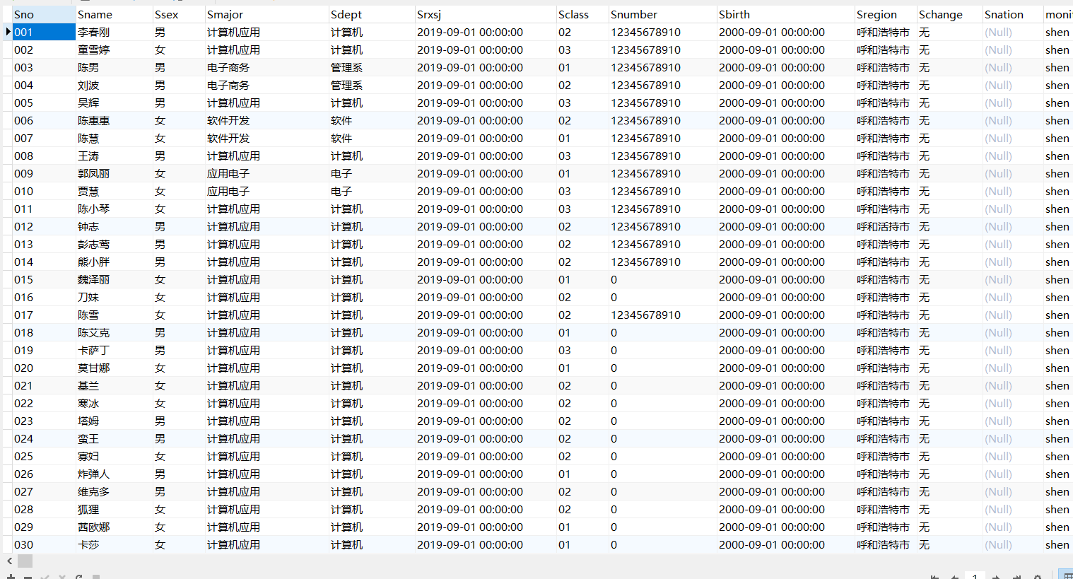
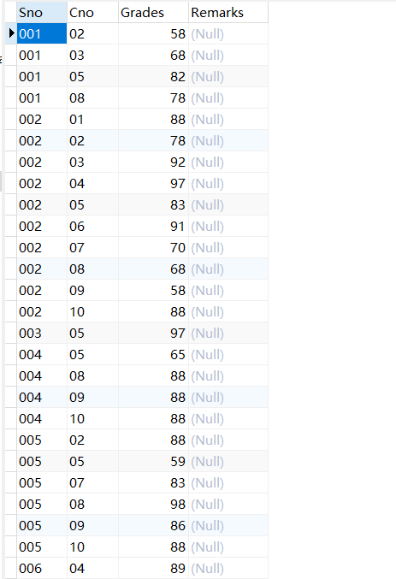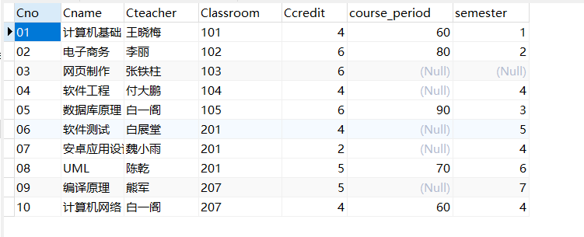
2.求选修了“数据库原理”课程的学生姓名。
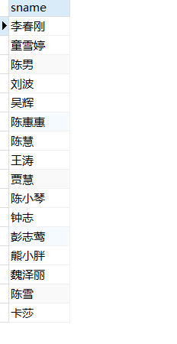
3查询“陈雪”所选修的课程的课程号，课程名称以及成绩。
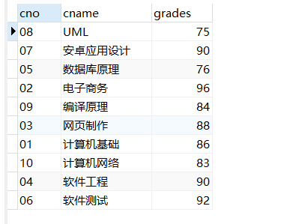

- 查询参与了所有课程选修的学生学号、姓名和学生所在的系别。
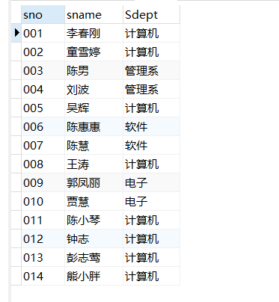
- 查询没有选修任何一个课程的学生学号、姓名和所在系别。
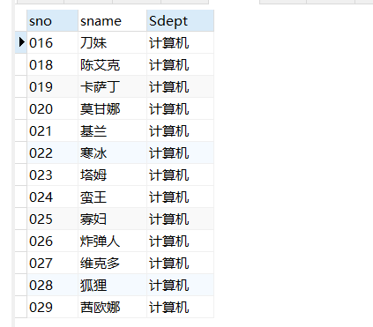
- 查询课程没有学生选修的课程号、课程名称。
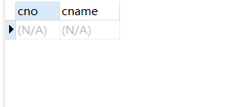
7.查询选修了“白一阁”老师的所有课程的学生学号、姓名和所
在系别。
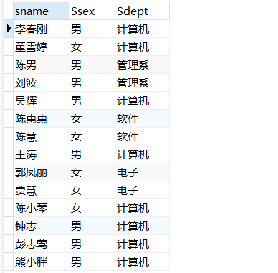
8列出每门课程的平均分、最高分、最低分。
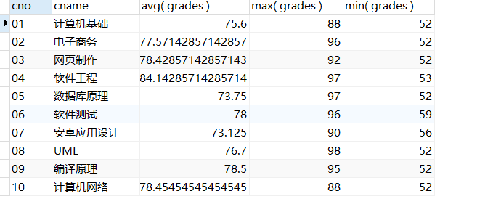
9对所有学生求出所选修课程的最高分、平均分。
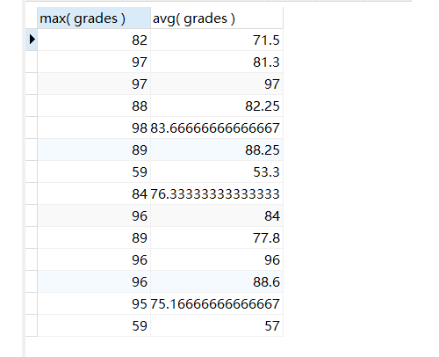
10对“付大鹏”老师的授课的课程的分数增加 1 分。

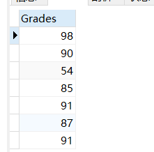
运行之后
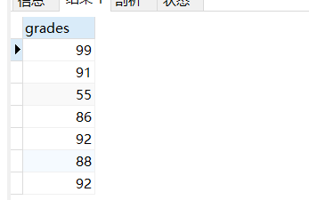
11查询全体学生的学号、姓名、性别和年龄。
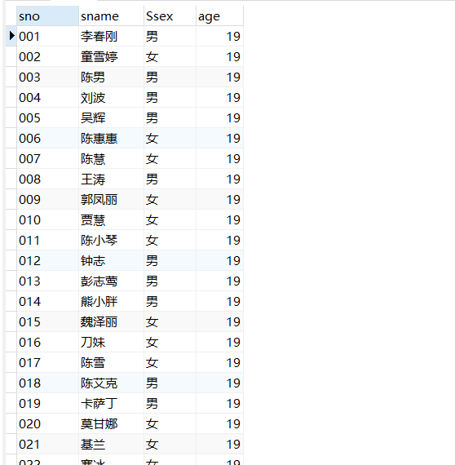
12查询姓“陈”的且全名为两个字的学生的学号、姓名和系别。
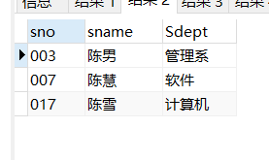
13.查询没有选修“数据库原理”课程编号的学生的学号、姓名
和系别。
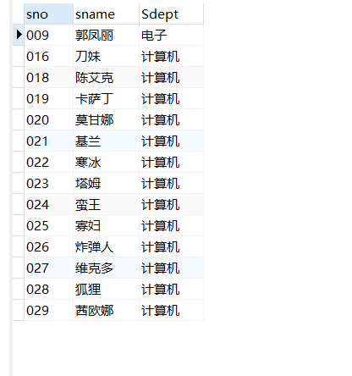
14.查询“数据库原理”课程在 80 分以上的学生的学号和姓名以
及分数。
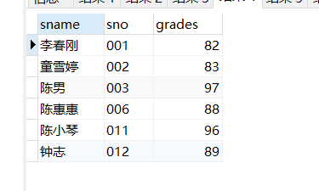
15.统计各门课程的平均分、最高分、最低分，结果集按平均分
降序排列。
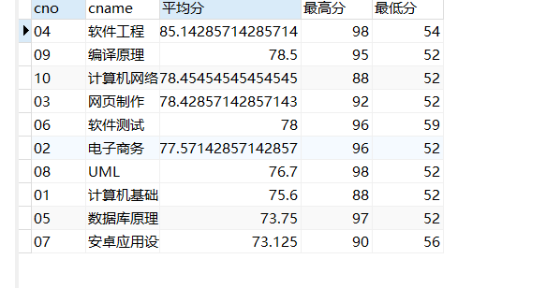
16.查询有三门以上的不及格的学生，列出学号、姓名和不及格
的门数。
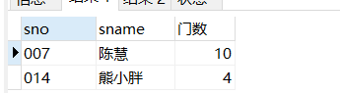
17.查询选修了“数据库原理”且成绩比此门课程的平均分要高
的学生的学号、姓名和成绩。
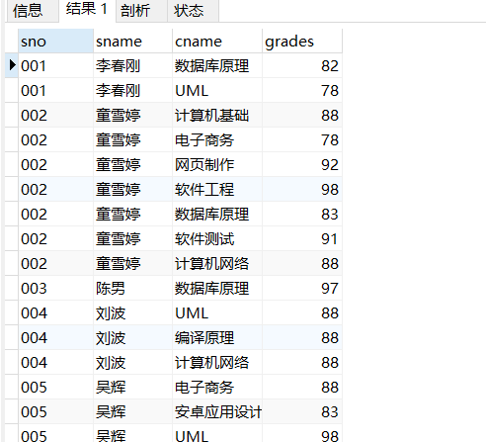
18.列出选修了“数据库原理”课程编号的成绩在前三名的学生
的学号、姓名、成绩。（如果第三名有多个学生都列出）。
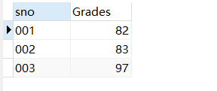
19.查询出所有课程中 60 分以下的同学相关信息。
20 删除成绩为空的学生信息。
四、实验心得
1. sql的执行顺序
1. 如果没有聚合函数， from 的子句最先计算 ，得到一个关系
2. 如果有where从句，那么就使用where的predicate语句对元组进行筛选
3. 符合关系的元组按照 group by 从句 进行分组（如果有的话）
4. 如果有having从句的话，再使用having 的条件对组进行筛选
5. 最后执行select 语句 $\Pi$ , 以及聚合函数
2. 值得注意的是，select clause**如果有聚合函数** 那么 select clause 中除聚合函数外的其他属性 一定出现在group by clause中
3. having clause 中的聚合函数 一定要出现在select clause 的聚合函数
实验3
一、实验目的
1. 掌握用户、视图、视图的创建及管理；
2. 掌握用户权限的授予各回收
二、实验内容
1、用户权限控制
（1）创建用户 jim，登录密码为‘123456’
（2）将用户 jim 的名称修改为你自己的名字。
（3）将这个用户的密码自定义修改。
（4）授予用户对之前实验的 xskc 数据库 student 表的所有操作权限
及查询操作权限。
（5）授予用户对 course 表进行插入，删除，查询操作权限。
（6）授予用户在 grade 表上的 SELECT 权限，并允许其将该权限授予
其他用户。
（7）授予用户对数据库 xskc 的所有权限。
（8）回收 grade 表上的 insert 权限。
（9）授予用户所有的权限
（10）取消用户所有的权限。
（11）删除此用户。
2、创建、删除视图
（1）创建 xskc 上的视图 student_view,视图包含学号、姓名、系别
（2）创建 xskc 数据库上的视图 course_view,视图包含 course 表的
全部列。
（3）从视图 student_view 中查看姓“陈”且名字长度为三个字的学
生全部信息。
（4）从视图 course_view 中查看“白一阁”老师教的所有课程信息。
（5）向视图 student_view 中插入一行数据（50, '机械熊', '电子
系'）。
（6）删除视图中刚刚添加的那条数据。
（7）删除视图 course_view。
3、数据库角色
（1）创建角色 role1。
（2）给角色赋予 student 表的 SELECT、UPDATE、INSERT 权限。
（3）查看角色的权限。
（4）回收角色的 UPDATE 权限。
（5）创建用户 jim，登录密码为‘123456’。
（6）给用户授予这个角色并激活。
（7）撤销用户的角色。
（8）删除该角色。
三、实验结果
- -- 1
- create user jim@'%' identified by '123456';
- -- 2
- update user set user='gongkaichen' where user='jim';
- -- 3
- alter user jim@'%' identified by 'aptx4869'
- -- 4
- grant all privileges on xsks.student to gongkaichen@'%';
- -- 5
- grant select, delete, insert on xsks.course to gongkaichen@'%';
- -- 6
- grant select on course to xsks.gongkaichen with grant option;
- -- 7
- grant all privileges on xsks to gongkaichen@'%';
- -- 8
- revoke insert on grade from gongkaichen@'%';
- -- 9
- GRANT ALL ON *.* TO gongkaichen@'%' WITH GRANT OPTION;
- -- 10
- revoke ALL ON *.* from gongkaichen@'%';
- -- 11
- drop user gongkaichen@'%'

- -- 1
- create view student_view as
- select sno, sname, sdept from student
- -- 2
- create view course_view as
- select * from course
- -- 3
- select * from student_view where sname like '陈__'
- -- 4
- select * from course_view where Cteacher = '白一阁'
- -- 5
- insert into student_view(sno, sname, Sdept) VALUES(50, '机器熊', '电子系')
- -- 6
- delete from student_view where sno = '50';
- -- 7
- drop view student_view;
- drop view course_view;

- -- 1
- create role role1;
- -- 2
- grant SELECT, update, insert on student to role1;
- -- 3
- show grants for role1;
- -- 4
- revoke update on student from role1;
- -- 5
- create user jim@'%' identified by '123456'
- -- 6
- grant role1 to jim;
- --7
- revoke role1 from jim;
- -- 8
- drop role role1;
实验结果截图：
1、用户权限控制
（1）创建用户 jim，登录密码为‘123456’
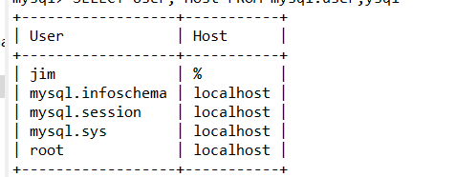
（2）将用户 jim 的名称修改为你自己的名字。 Terminal 中运行
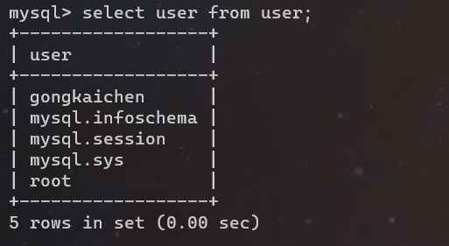
（3）将这个用户的密码自定义修改。
（4）授予用户对之前实验的 xskc 数据库 student 表的所有操作权限
及查询操作权限。
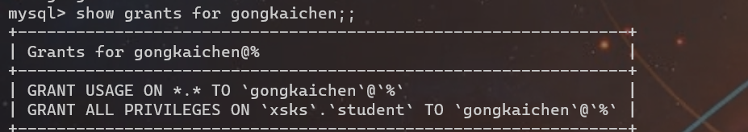
（5）授予用户对 course 表进行插入，删除，查询操作权限。
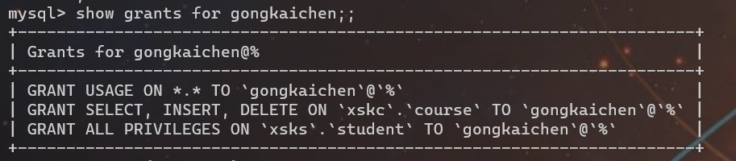
（6）授予用户在 grade 表上的 SELECT 权限，并允许其将该权限授予
其他用户。
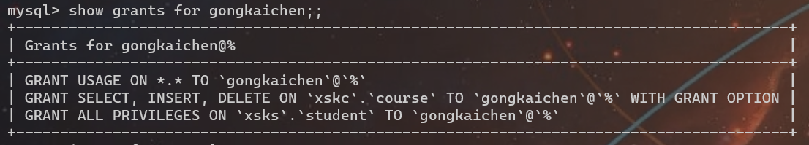
（7）授予用户对数据库 xskc 的所有权限。
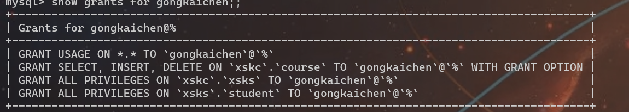
（8）回收 grade 表上的 insert 权限。
（9）授予用户所有的权限
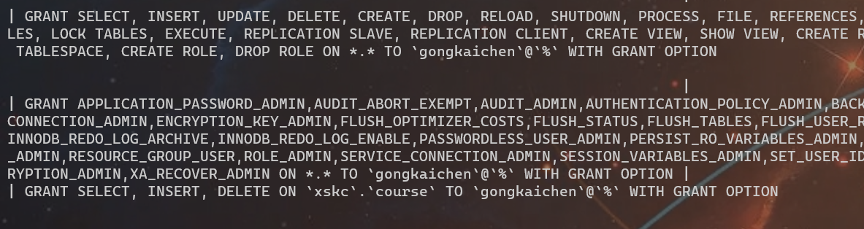
（10）取消用户所有的权限。
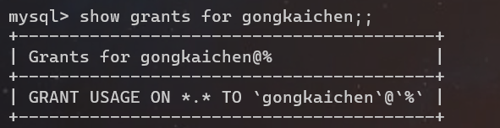
（11）删除此用户。
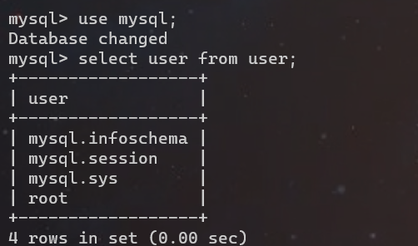
2、创建、删除视图
（1）创建 xskc 上的视图 student_view,视图包含学号、姓名、系别
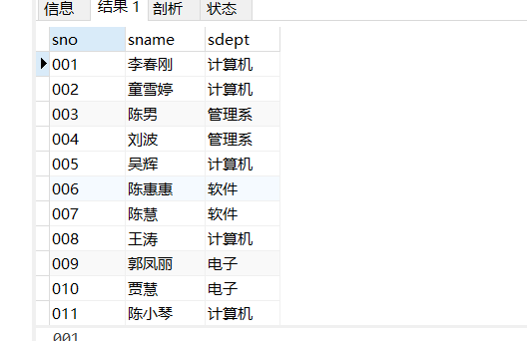
（2）创建 xskc 数据库上的视图 course_view,视图包含 course 表的
全部列。
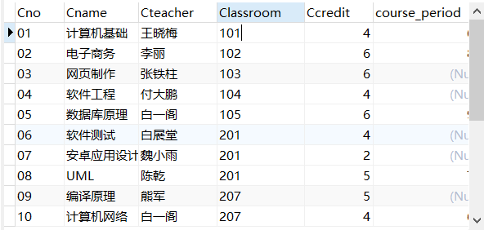
（3）从视图 student_view 中查看姓“陈”且名字长度为三个字的学
生全部信息。
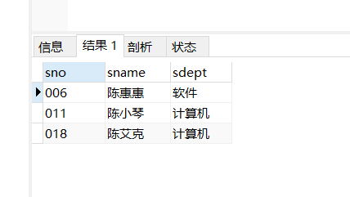
（4）从视图 course_view 中查看“白一阁”老师教的所有课程信息。
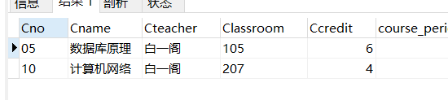
（5）向视图 student_view 中插入一行数据（50, '机械熊', '电子
系'）。
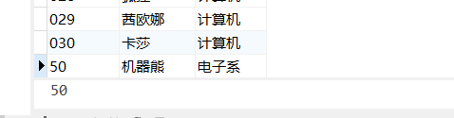
（6）删除视图中刚刚添加的那条数据。
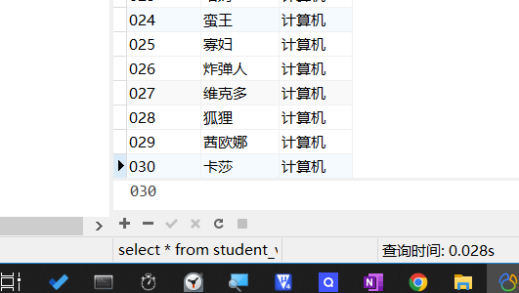
（7）删除视图 course_view。
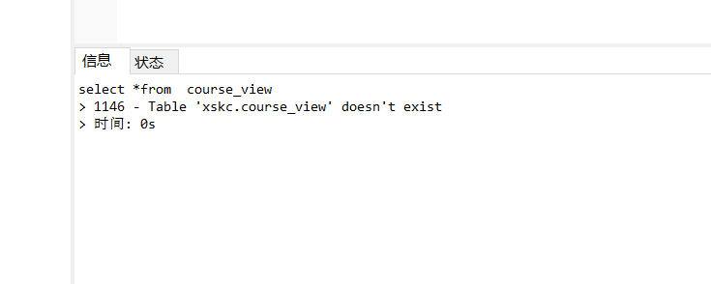
3、数据库角色

（1）创建角色 role1。
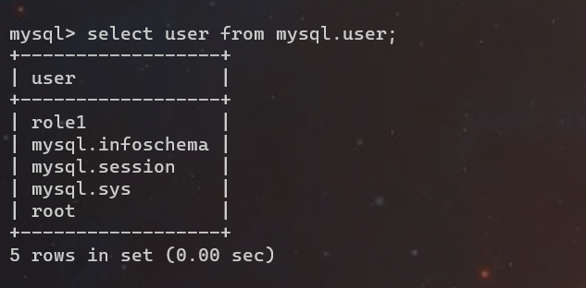
（2）给角色赋予 student 表的 SELECT、UPDATE、INSERT 权限。
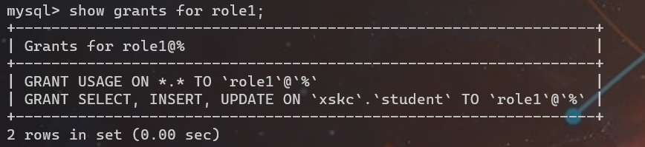
（3）查看角色的权限。
（4）回收角色的 UPDATE 权限。
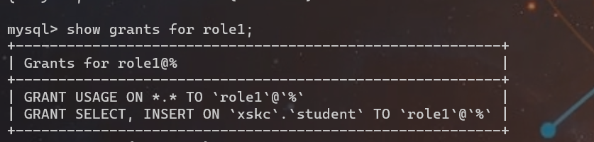
（5）创建用户 jim，登录密码为‘123456’。
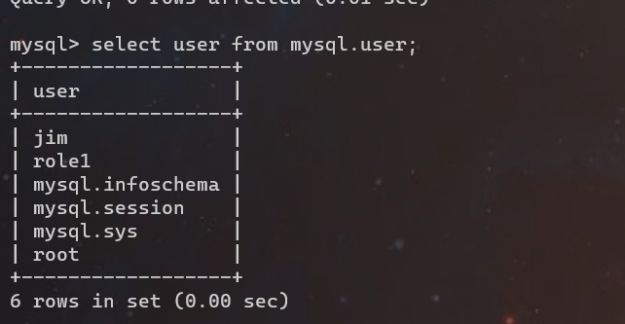
（6）给用户授予这个角色并激活。
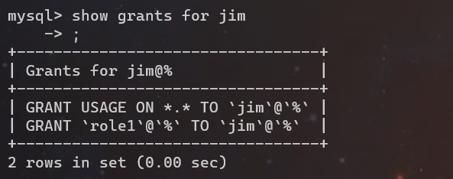
（7）撤销用户的角色。
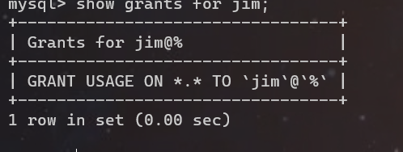
（8）删除该角色。
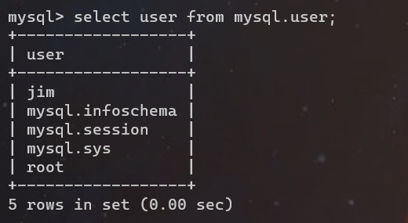
四、实验心得
1. 用户名由两部分构成, 由@分割--‘username’, ‘机器名用户名’。
2. view 用于 sql 查询时 注意
1 在定义view的时候，数据库只存储view的定义，而不执行view中的语句
2 每当 使用view做查询的时候，数据才会将用户输入的查询语句和view中的定义结合，作为查询结果
- 当对视图进行修改时，由于视图本身并不存储数据 对视图的修改最终会反映到表中。
3. 数据库有四种权限 增删改查（select, in2sert, update, and delete）， all privilegesg 可以作为四种权限的简写​
4. 在授权时带有‘with grant option​’，用户才可以传递这个权限

