Week 1
1. A 500 g block slides along a frictionless surface at a speed of 0.35m/s. It runs into a horizontal(水平的) massless(无质量的) spring(弹簧) with spring constant(劲度系数) 50 N/m that extends(延伸) outward from(类似: push forward to) a wall. It compresses(压缩) the spring, and then is pushed back in the opposite direction(反方向的) by the spring, eventually losing contact with(脱离) the spring.
(a) How long (多长时间) does the block remain in contact with the spring? (It might help to draw a diagram of the system at several points in time.)
undergo(经历)
(b) How would your answer to part (a) change if the block’s initial speed were doubled?
2. A 5.0 kg block hangs from(悬挂在) a spring with spring constant 2000 N/m. The block is pulled down(拉长) 5.0 cm from the equilibrium position and given an initial velocity of 1.0 m/s back toward equilibrium(平衡位置).
(a) What is the frequency of the motion?
(b) What is the amplitude of the motion?

(c) What is the total mechanical-energy (机械能=K+U) of the motion?
3. The figure below is the velocity-versus(与)-time (not position-versus-time!) graph of a particle in simple harmonic motion.
(a) What is the amplitude of the oscillation?
(b) What is the phase constant?
(c) What is the position at ｔ=0 s?
Week 2
1. 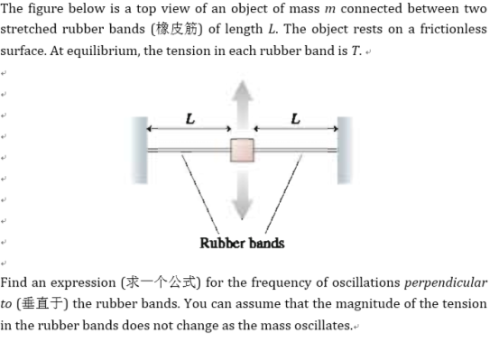

2. A 15-cm-long, 200 g rod (杆) is pivoted at one end. A 20 g ball of clay (黏土) is stuck on the other end. What is the period if the rod and clay swing as a pendulum?
inertia(惯性), pendulum(摆)

3. It is said (据说) that Galileo (伽里略) discovered a basic principle of the pendulum that the period is independent of the amplitude – by using his pulse (脉搏) to time the period of swinging lamps (吊灯) in the cathedral (大教堂) as they swayed(摆动) in the breeze(微风). Suppose that one oscillation(振动) of a swinging lamp takes 5.5 s.
(a) How long is the lamp chain?
simple pendulum(单摆)
(b) What maximum speed does the lamp have if its maximum angle from the
vertical is 3.0°?

Week 3
1. A wave on a string is described by $D\left(x,t\right)=(2.0cm)×sin\left[\left(12.57rad/m\right)x-\left(638rad/s\right)t\right]$, where x is in meters(in+单位) and t is in seconds. The linear density(线密度) of the string is 5.00 g/m. What are
displacement位移,

2. The figure below is a snapshot(快照) graph at t = 0 s of a 5.0 Hz wave traveling to the left.
(a) What is the wave speed?
(b) What is the phase constant of the wave?
(c) Write the displacement(位移) equation $D(x,t)$ of the wave.

3. A spherical(球形的) sound source at the origin emits(发出) a sound wave with frequency 13,100 Hz and wave speed 346 m/s. What is the phase difference between the two locations $〈1.00,3.00,2.00〉$ cm and $〈-1.00,1.50,2.50〉$ cm? Give your answer in both degrees and radians.

Week 4
1. Two train whistles(发出汽笛声), A and B, each have a frequency of 392 Hz. A is stationary(静止的) and B is moving toward the right (away from A) at a speed of 35.0m/s. A listener is between the two whistles and is moving toward the right with a speed of 15.0m/s (Figure below). No wind is blowing.
(a) What is the frequency from A as heard by the listener?
(b) What is the frequency from B as heard by the listener?
(c) What is the beat frequency detected by the listener?
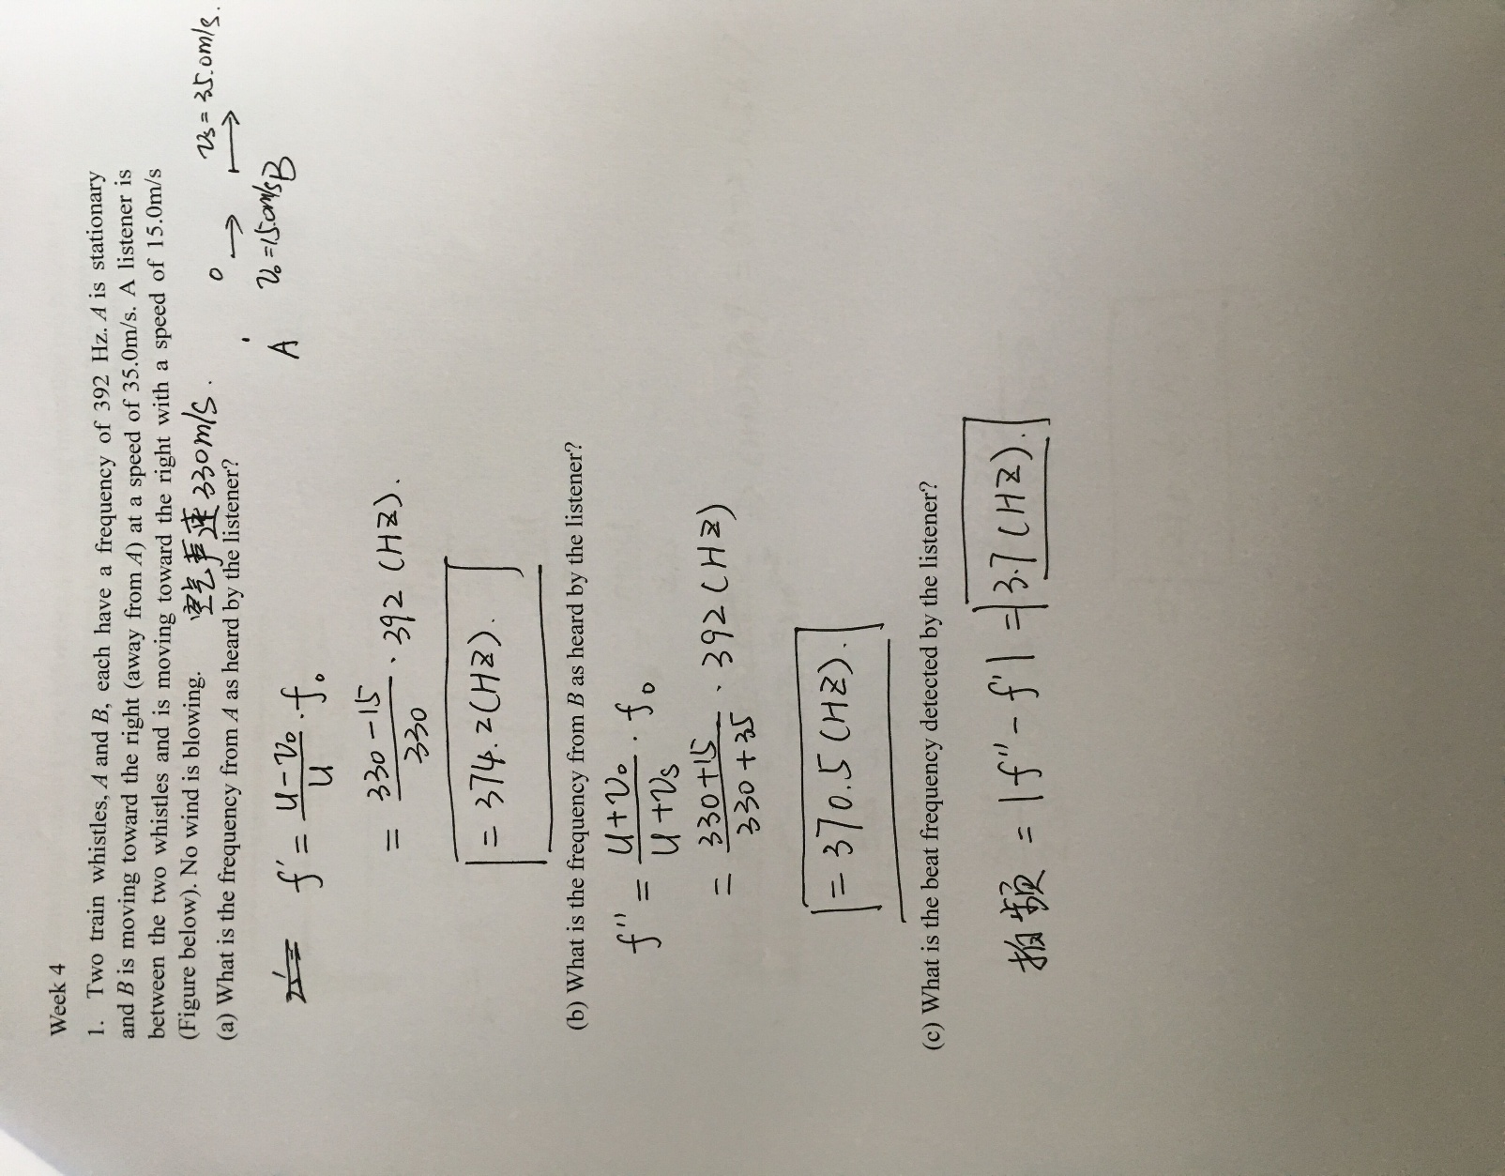

2. The 40-cm-long tube of Figure below has a 40-cm-long insert(插入物) that can be pulled in and out. A vibrating tuning fork(振动音叉) is held next to the tube. As the insert is slowly pulled out, the sound from the tuning fork creates standing wave in the tube when the total length L is 42.5cm, 56.7cm and 70.9cm. What is the frequency of tuning fork? Assume the speed of sound is 343 m/s.
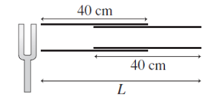
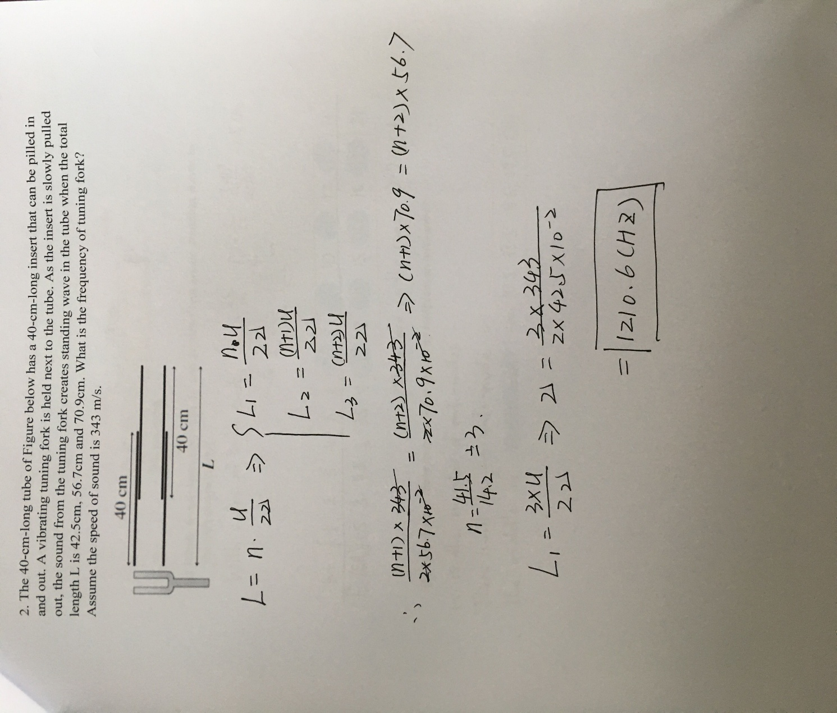
3. The microwave(微波) generator(产生器) in the figure below can produce microwaves at any frequency between 10 GHz and 20 GHz. The microwaves are aimed(对准), through a small hole, into a “microwave cavity(腔)” that consists of a 10-cm-long cylinder(圆柱) with reflective ends.

Week 5
essentially(本质上地), film(薄膜)
constructive interference(相干加强), destructive interference(相干减弱)
1. 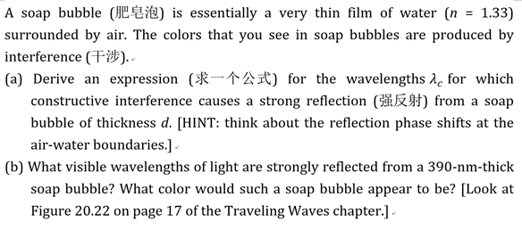

2. You are standing 2.5 m directly in front of one of the two loud speakers (音响) shown in the figure below. They are 3.0 m apart and both are playing a 686 Hz tone, in phase(同相位). As you begin to walk directly away from the speaker, at what distances from the speaker do you hear a minimum sound intensity(强度)? Assume the speed of sound in air is 343 m/s.
3. Standing waves on a wire are described by $y\left(x,t\right)=\left(A_{SW}sinkx\right)sinωt$ , with $A_{SW}=2.50mm$,$ω=942rad/s$and $k=0.75π rad/m$.The left end of the wire is at x=0 . At what distances from the left end are (a) the nodes of the standing wave and (b) the antinodes of the standing wave?
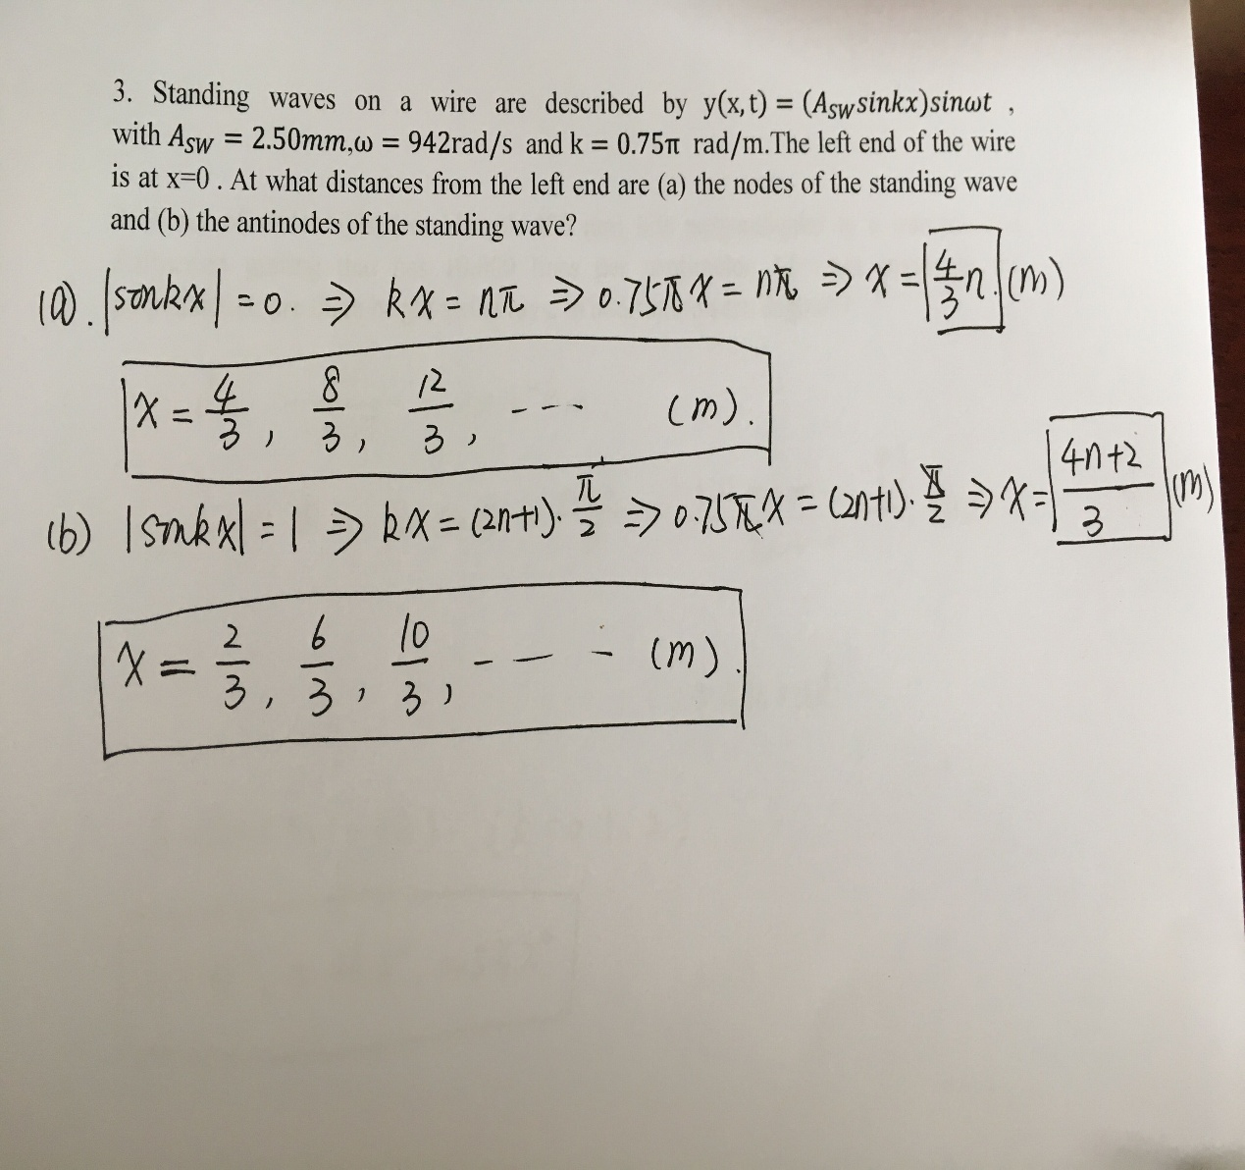

Week6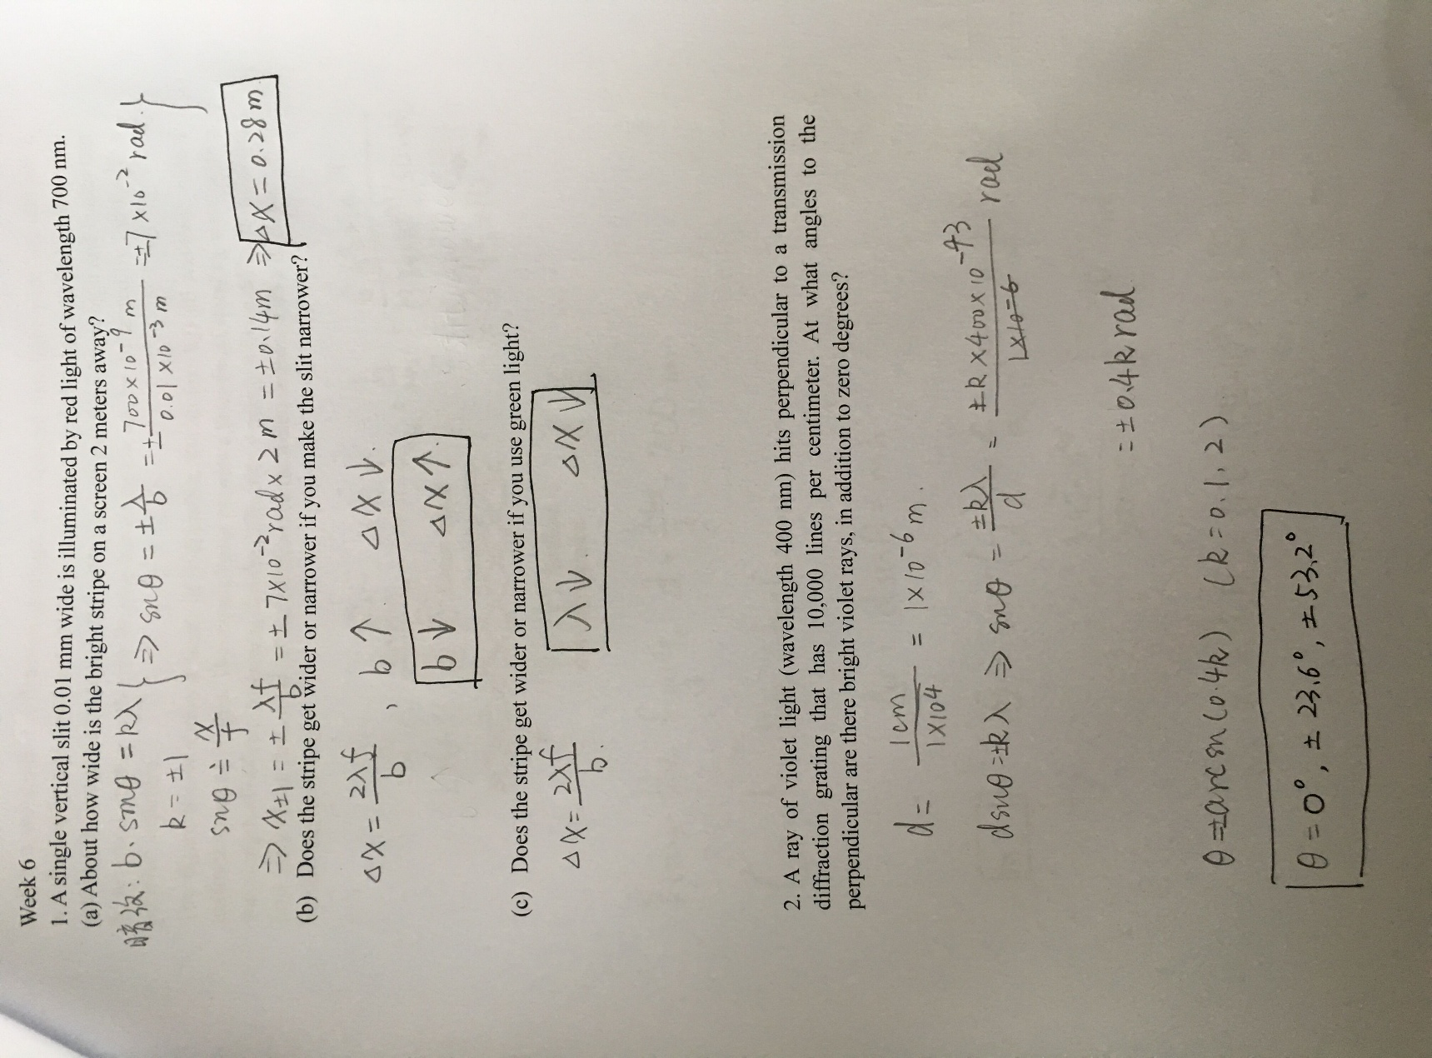

3. When we studied diffraction gratings, you learned that light with wavelength λ is diffracted by a piece of matter (the grating) with a periodic(周期性的) structure (many slits with spacing d). Experiments done in the 1990s showed that the roles of light and matter can be reversed; matter with a de Broglie wavelength λ can be diffracted by light with a periodic structure.
The figure below shows a beam(束) of sodium(Na, 钠) atoms (kg) all traveling with a uniform speed of 50 m/s. The atomic beam(原子束) crosses a laser beam(激光光束) standing wave with a wavelength of 600nm. Assuming that the diffraction works just like a diffraction grating, how far will the first-order diffracted atoms be deflected(使偏移) sideways on a detector 1.0 m behind the laser beam?
4. A diffraction grating with 600 lines/mm is illuminated with light of wavelength 500 nm. A very wide viewing screen is 2.0 m behind the grating.
(a) What is the distance between the two m = 1 bright fringes(边缘)?
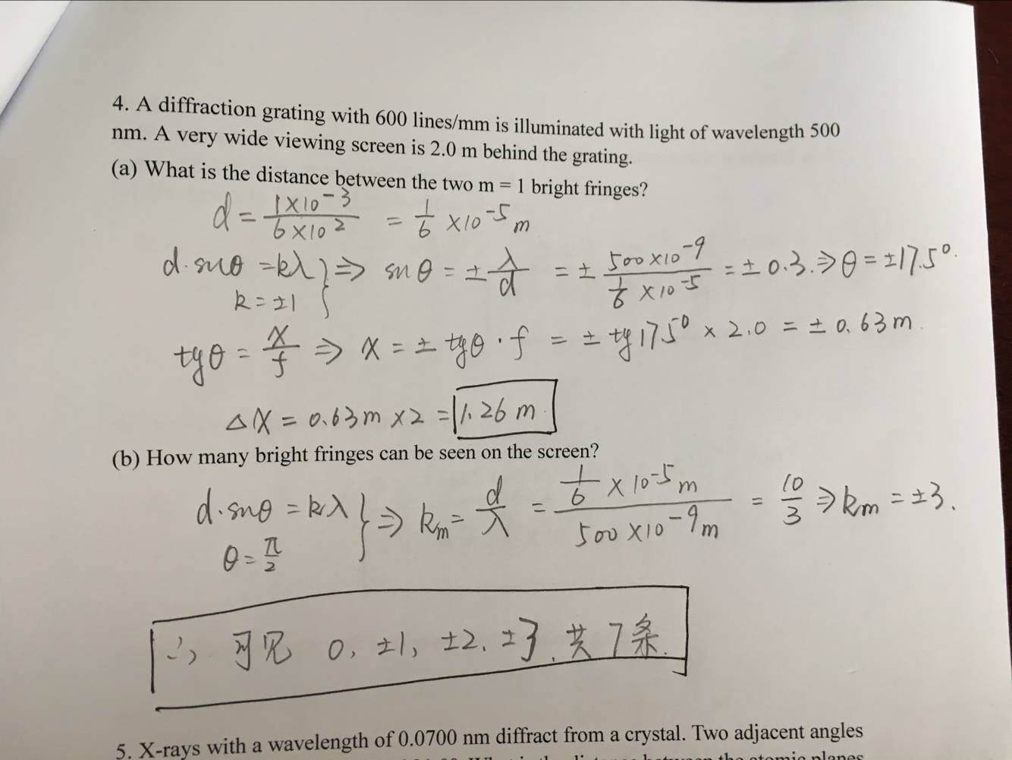
(b) How many bright fringes can be seen on the screen?
5. X-rays with a wavelength of 0.0700 nm diffract from a crystal. Two adjacent angles of x-ray diffraction are 45.6° and 21.0°. What is the distance between the atomic planes responsible for(由于) the diffraction?
Week 7
1. If a photon(光子) of wavelength 0.04250 nm strikes a free electron(自由电子) and is scattered(散射) at an angle of 35.0° from its original direction, find
(a) the change in the wavelength of this photon;
(b) the wavelength of the scattered light;
(c) the change in energy of the photon (is it a loss or a gain?);
(d) the energy gained by the electron.
2. (a) A proton is moving at a speed much slower than the speed of light. It has kinetic energy(动能) K₁ and momentum(动量) p₁. If the momentum of the proton is doubled, so p₂=2p₁, how is its new kinetic energy K₂ related to K₁.
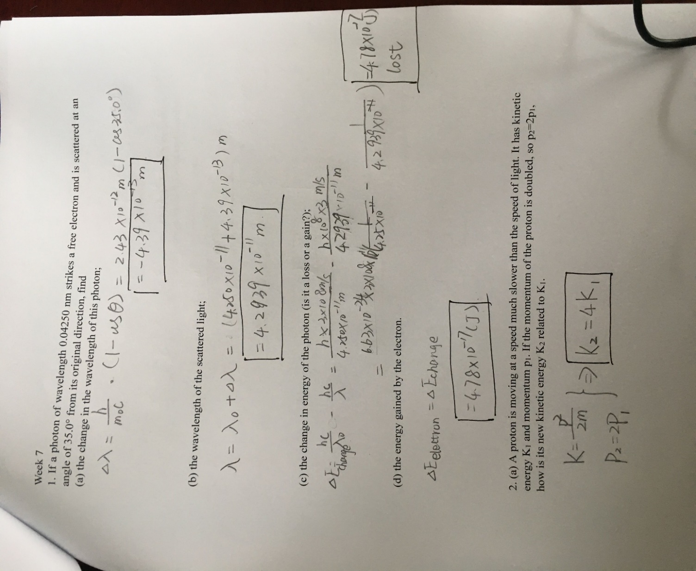
(b) A photon with energy E₁ has momentum p₁. If another photon has momentum p₂ that is twice p₁, how is the energy E₂ of the second photon related to E₁?
3. A photon of green light has a wavelength of 520 nm. Find the photon’s frequency, magnitude(大小) of momentum, and energy. Express the energy in both joules(焦耳) and electron volts(电子伏特).
