2021192010 王曦

3．老师实验课上选取单表查询的难度较高的题目（要有题目语句和运行结果截屏）
(1) 1.13 Find all the employees whose last names end with S.
思路：‘%S’ 表示匹配以S结尾的字符串.
代码：
SELECT * FROM EMP2021192010
WHERE ENAME LIKE '%S';
运行结果：
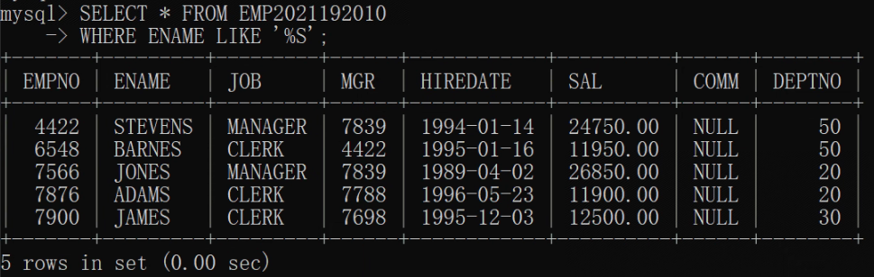

(2) 1.18 List all salesmen in descending order by commission divided by their salary.
思路：用WHERE指定选取的JOB为’SALESMAN’，用ORDER BY指定排序规则，用DESC表示降序排列。
代码：
SELECT * FROM EMP2021192010
WHERE JOB = "SALESMAN"
ORDER BY (COMM / SAL) DESC;
运行结果：
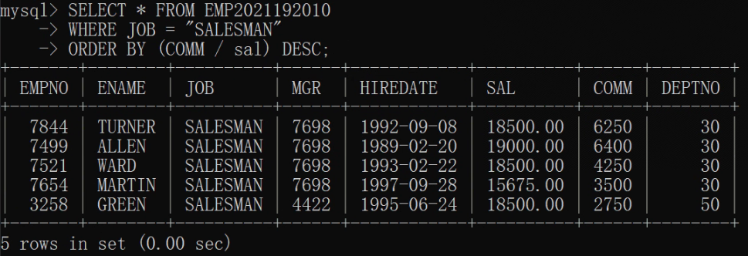

(3) 3.8 Compute the daily and hourly salary for employees in department 30, round to the nearest penny. Assume there are 22 working days in a month and 8 working hours in a day.
思路：
- 表中的 SAL 为月薪（设单位为dollar），求日薪需除以 22 ，求时薪需再除以 8 。
- ROUND() 函数可实现四舍五入。
- 为四舍五入到penny，因 1 dollar = 100 penny ，可将数值乘 100 后用 ROUND() 函数取整后再除以 100 。
代码：
SELECT * FROM
(SELECT (ROUND(SUM(SAL) / COUNT(*) / 22 * 100) / 100) AS 'Daily Salary'
FROM EMP2021192010 WHERE DEPTNO = 30) tmp1, # 别名不可省略, 下同
(SELECT (ROUND(SUM(SAL) / COUNT(*) / 22 / 8 * 100) / 100) AS 'Hourly Salary'
FROM EMP2021192010 WHERE DEPTNO = 30) tmp2;
运行结果：
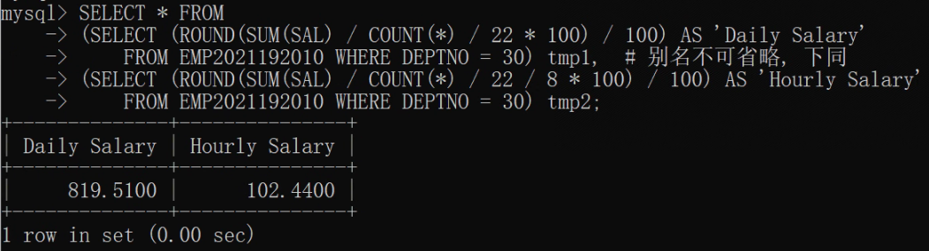

(4) 5.4 List the average annual salary for all job groups having more than 2 employees in the group.
思路：
- COUNT(*) 可统计数据表中非空表项的个数。
- 因 COUNT(*) > 2 不是表的属性，故查询时需用 HAVING 指定。
- 用 GROUP BY 指定按 JOB 分组。
代码：
SELECT JOB, AVG(SAL)
FROM EMP2021192010
GROUP BY JOB
HAVING COUNT(*) > 2;
运行结果：
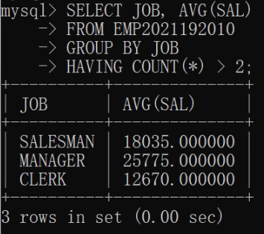

(5) 5.5 Find all departments with an average commission greater than 25% of average salary.
思路：AVG() 函数可对指定属性的所有非空值取平均。
代码：
SELECT DEPTNO
FROM EMP2021192010
GROUP BY DEPTNO
HAVING (AVG(COMM) > 0.25 * AVG(SAL));
运行结果：
