2021192010 王曦

(1) 2.5 For each employee whose salary exceeds his manager's salary, list the employee's name and salary and the manager's name and salary.
代码：
SELECT worker.ename 'worker name', worker.sal 'worker salary', manager.ename 'manager name', manager.sal 'manager salary'
FROM emp2021192010 worker, emp2021192010 manager
WHERE worker.mgr = manager.mgr AND worker.sal > manager.sal;
运行结果：
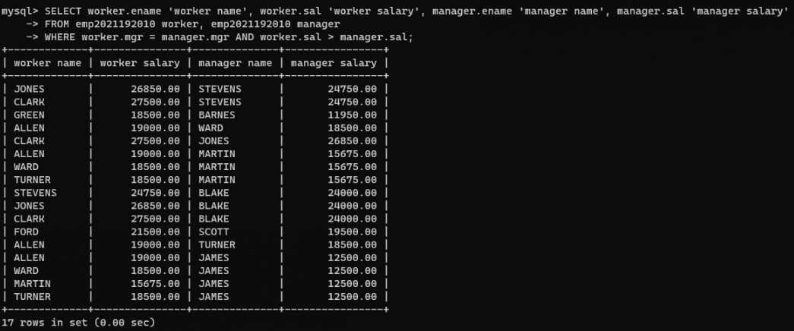

(2) 6.3 List the name, job, and department of employees who have the same job as Jones or a salary greater than or equal to Ford.
代码：
SELECT ename, job, deptno
FROM emp2021192010
WHERE
(job = (SELECT job FROM emp2021192010 WHERE ename = 'JONES') AND ename != 'JONES')
OR (sal >= (SELECT sal FROM emp2021192010 WHERE ename = 'FORD') AND ename != 'FORD');
运行结果：
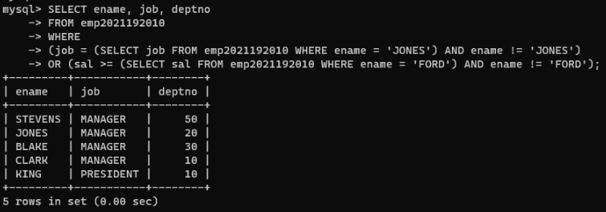

(3) Find all the employees that earn more than the average salary of employees in their department.
建表代码：
CREATE DATABASE exp2;
USE exp2;

CREATE TABLE A2021192010 (
sno VARCHAR(2),
pno VARCHAR(2)
) ENGINE = InnoDB;

INSERT INTO A2021192010 VALUES
('s1', 'p1'),
('s1', 'p2'),
('s1', 'p3'),
('s1', 'p4'),
('s2', 'p1'),
('s2', 'p2'),
('s3', 'p2'),
('s4', 'p2'),
('s4', 'p4');

SELECT * FROM `A2021192010`;

CREATE TABLE B2021192010 (
pno VARCHAR(2)
) ENGINE = InnoDB;

INSERT INTO B2021192010 VALUES ('p2');

SELECT * FROM `B2021192010`;
查询代码：
SELECT DISTINCT sno FROM A2021192010 seller WHERE NOT EXISTS
(SELECT * FROM B2021192010 part WHERE NOT EXISTS
(SELECT * FROM A2021192010 relation WHERE seller.sno = relation.sno AND part.pno = relation.pno));
运行结果：
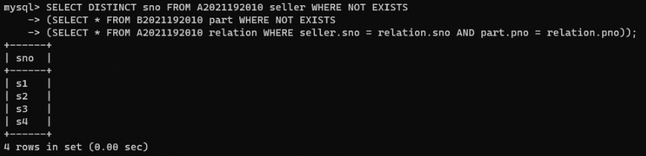
向B表中插入数据 p4 ，再次查询：
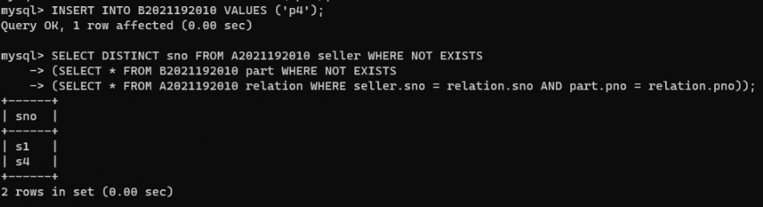
向B表中插入数据 p1 ，再次查询：
