Contents
About Me 2
Outline 2
Data analytics 3
Job Outlook 5
Essential Math for Data Science 6
Statistical Thinking 7
Optimization 8
A little bit of Calculus 9
Get started with Python 10
The Jupyter Notebook 11
Essential Packages 12
Uses of Data Analytics/Data Mining/Machine Learning 13
Become an Analytics Professional 14

About Me
- Xiao Ling
- Xiao is pronounced “sh-ow”
- Assistant Professor
- Ph.D in Math from VCU
- Machine Learning, Optimization, Radiomics

Outline
- 08:45 -10:15— Module 1: Introduction to Data Analytics and Statistical Thinking
- 10:30 -12:00— Module 2: Data Science Tools and Environment Setup

Data analytics
- Bureau of Labor: use analytical tools and techniques to extract meaningful insights from data.
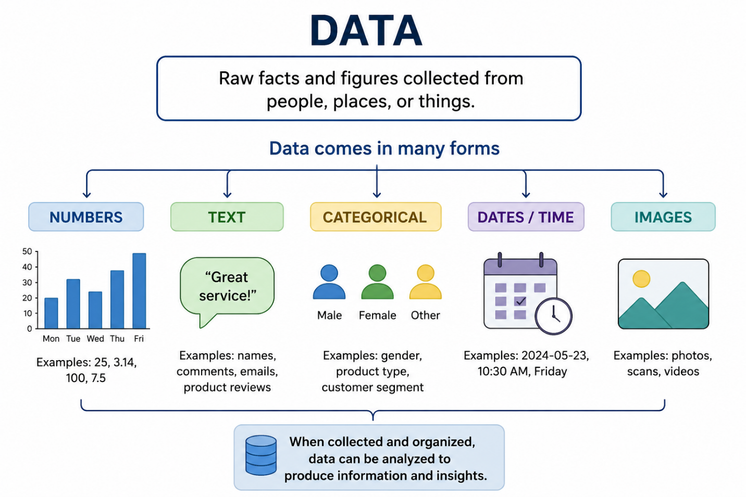
- Tools + Data output the insights or address hypothesis.

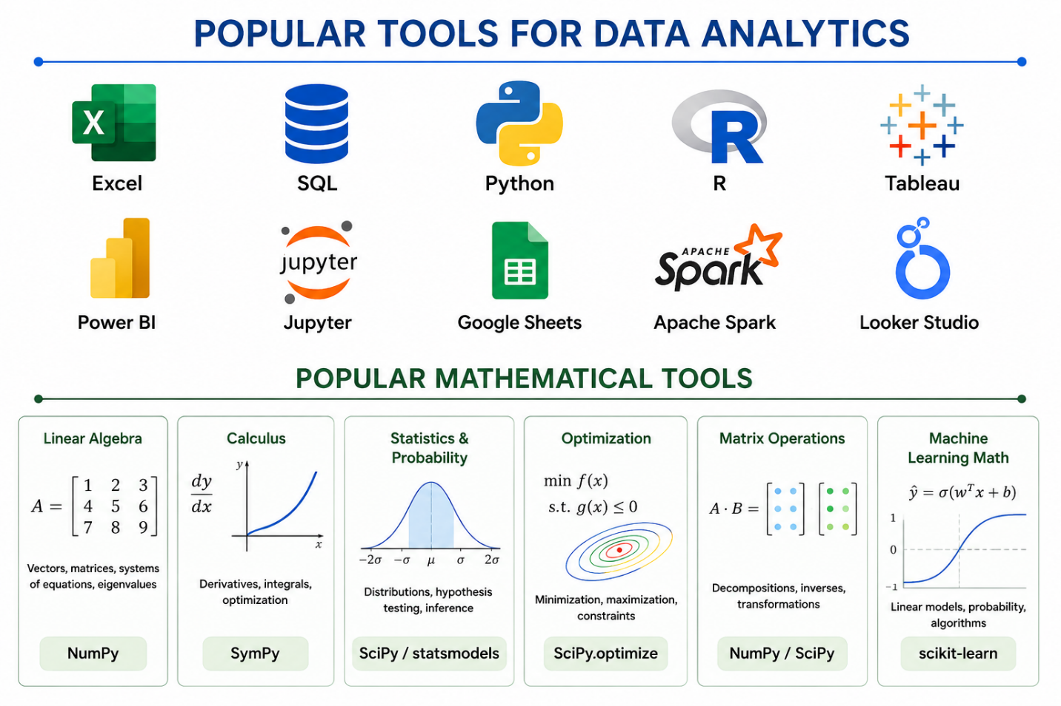

- Data Wrangling
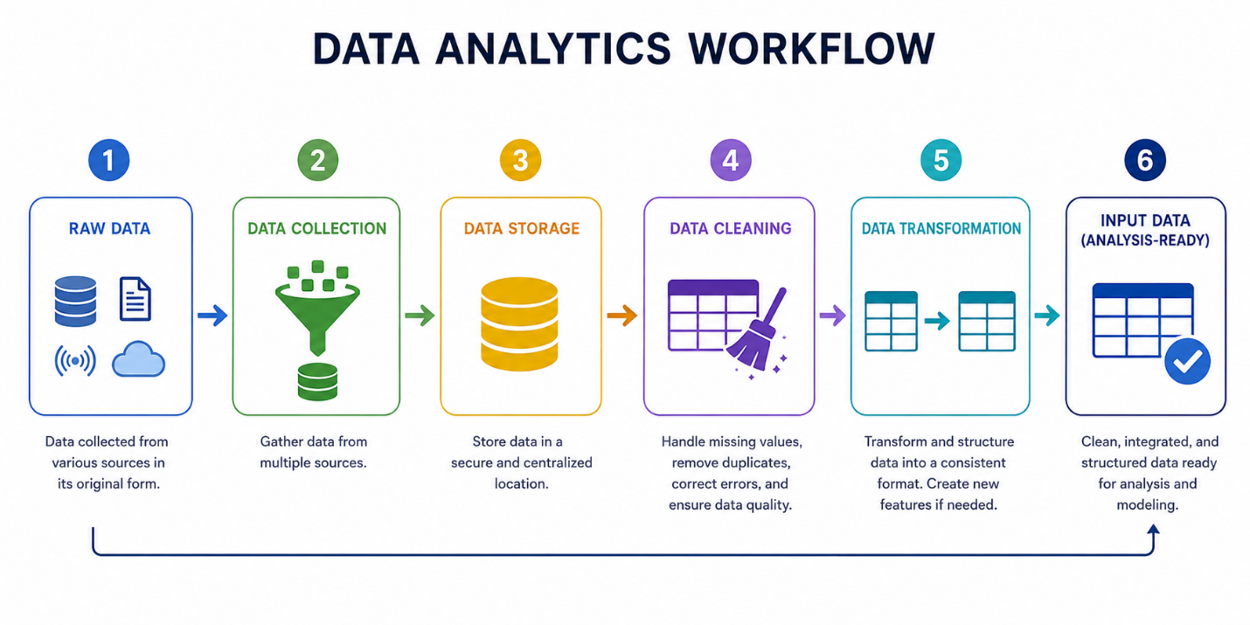

Job Outlook
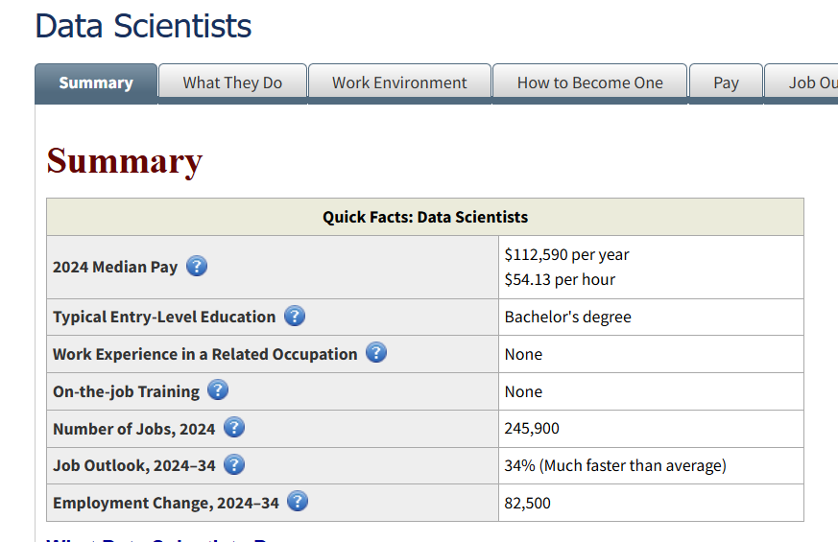
The projected percent change in employment from 2024 to 2034. The average growth rate for all occupations is 3 percent.
Sample of reported job titles: Business Analyst, Business Intelligence Analyst (BI Analyst), Business Intelligence Consultant (BI Consultant), Business Intelligence Coordinator (BI Coordinator), Business Intelligence Specialist (BI Specialist), Competitive Intelligence Analyst, Intelligence Analyst, Market Intelligence Analyst, Market Intelligence Consultant, Strategic Business and Technology Intelligence Consultant

- Formal definition O*NET Online Definition: Develop and implement a set of techniques or analytics applications to transform raw data into meaningful information using data-oriented programming languages and visualization software.
Once get the certification, add the following items to your résumé
  - Python: numpy, pandas, statsmodel, scikit-learn, regression
  - Data Science: data wrangling, visualization, classification, regression, clustering
  - Experience with real-world data

Essential Math for Data Science
- Vectors: organize numbers in a way that machine can understand

- Matrix Notation
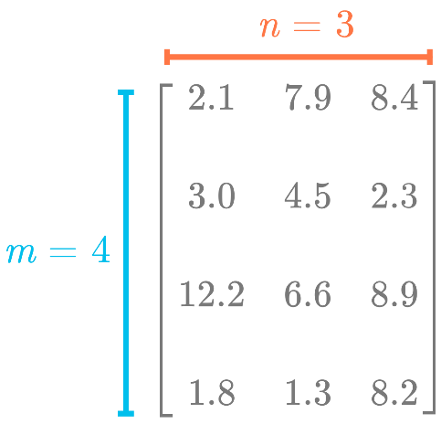

- Distance

- Projection

Statistical Thinking
Data analytics is not just programming. It is a way of thinking logically with data.
- Summarize data using statistics
  - Measures of Center

  - Measures of Spread

  - Correlation

- The notion of Sample and Population

- Distribution

Optimization
finding the “best” solution among many possible choices.
- Examples 1: Map navigators search for the shortest route, fastest route
- Examples 2: Company wants to maximize profit, minimize cost

Line fit example

A little bit of Calculus
In optimization, we often want:
- the minimum error,
- lowest cost,
- or highest accuracy.
So algorithms try to move toward these stable points.

Get started with Python
We will use Python via Google Colaboratory which is an app in Google Drive. To get started:
- Open Google Drive.
- Select New->More->Connect More Apps.
- Search for "Google Colaboratory".
- Click Install.
To test it out,
- Create a new folder in Google Drive called "Data Analytics".
- Enter the folder and click New->More->Google Colaboratory.
- In the first cell, type "print (“Hello world!”) ".
- To run, hold the Shift key and press Enter. If successful, there should be a small green check mark and no messages.

You can install Python locally by Download package

The Jupyter Notebook
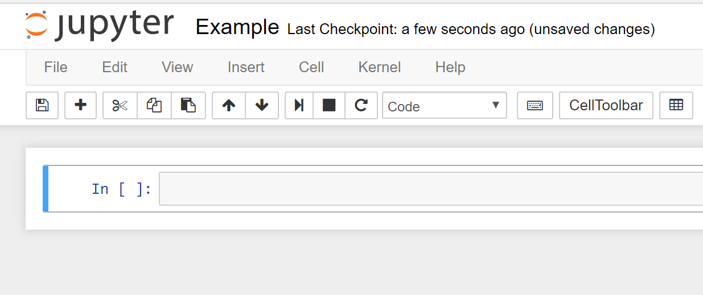
- An environment to incorporate code, formatted (html) text, charts, and other images
- Each cell can contain code or text (called markdown)
- Each cell can be executed with SHIFT+ENTER or CTRL+ENTER
- Executing a code cell prints the result
- Executing a markdown cell formats it and displays it
- Two modes:
  - Command mode
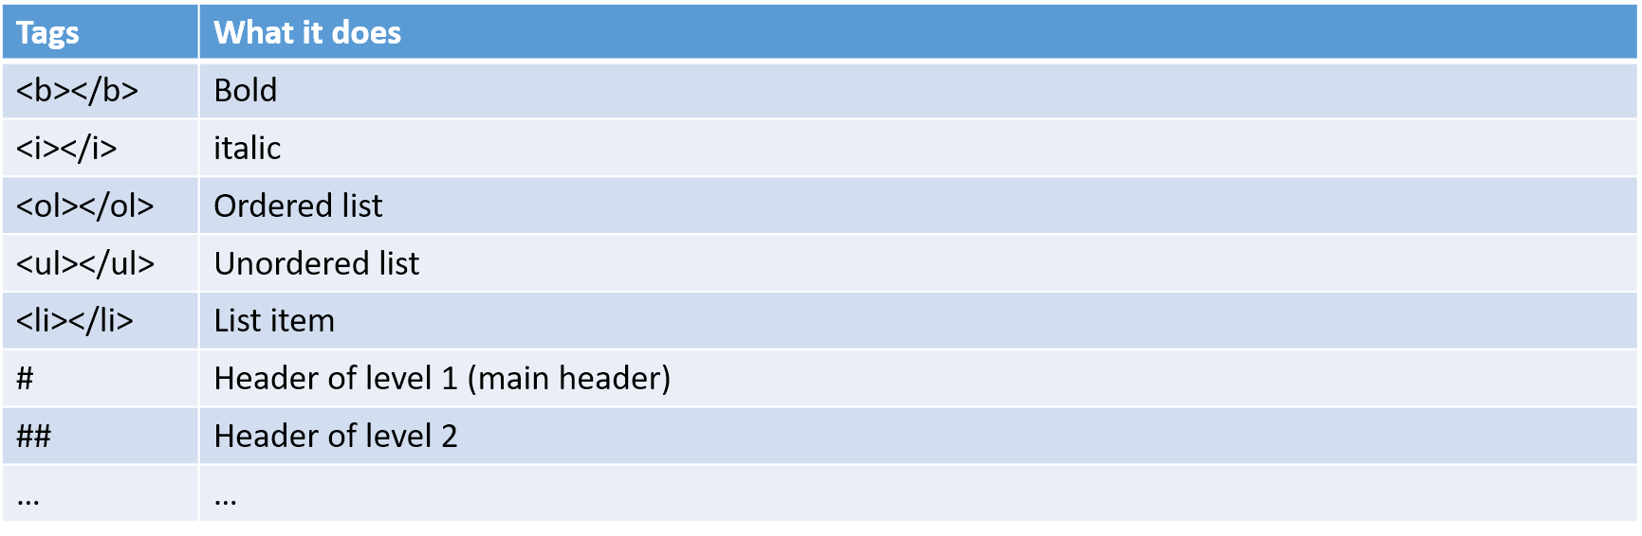
  - Edit mode

- https://www.cheatography.com/weidadeyue/cheat-sheets/jupyter-notebook/

Essential Packages
- Numpy : ndarray
- Pandas: DataFrame
Index + ccolumns + ndarray

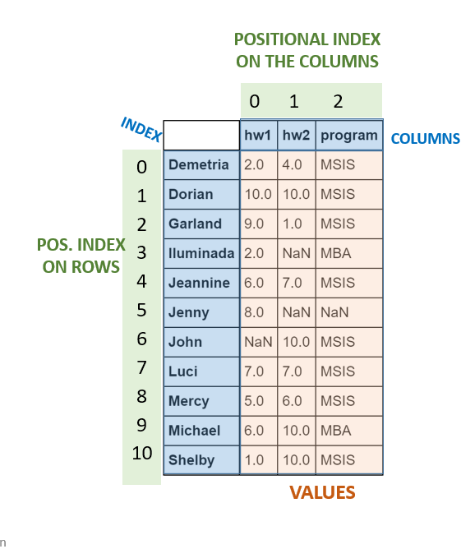

- Matplotlib: plot
- Scikit-learn: Models
- Statsmodle

Uses of Data Analytics/Data Mining/Machine Learning
- Digital marketing (what ad to show a consumer?)
- Medical diagnosis
- Healthcare (which patients will fail to show for appointments?)
- Fraud detection
- Market basket analysis
- Human resources
- Inventory management/demand forecasts
- Data mining competitions
- Student retention
- Accounting
- Tax
- Audit

Become an Analytics Professional
Online Communities
- KDNuggets
- Kaggle
- Github

