Contents
Outlines 2
Data cleaning 3
Missing data: None, NaN, 3
Handling Missing Data 3
Duplicate data 3
other 3
Data Wrangling 4
Data Visualization: making data understandable 5
Pandas 6
Matplotlib 6
Basic Definitions 7
Types of Measurement 7
Choosing an Appropriate Visualization(for exploration) 8
Data Visualisation Catalogue 9
Data Summarization 9
Normalization 9
Linear Regression 10
The Regression Line 12
The p-value 13
Simpler Model 13
Criteria 13
Train-test split for prediction 14

Outlines
Load data → Clean data → Wrangle data → Visualize data
Raw data is rarely ready for analysis. Before we can make charts, reports, predictions, or business decisions, we must clean, reshape, and understand the data.
Goal:
- Data cleaning & Wrangling: making data usable
- Data Visualization: making data Understandable

- Cleaning: fixes the quality of data
Example: A company wants to know its most profitable region, but the region column contains:
North, north, NORTH, N. Region, Northern
A simple summary will treat these as different regions unless we clean them.
Common Data Probelsm:
- Missing values
- Duplicates
- Inconsistent labels
- Wrong data type
- Outliers
- Irrelevant columns
- Messy text

- Wrangling: changes the structure
Wrangling Task | Plain-English Meaning
Filtering | Keep only the rows we need
Selecting columns | Keep only relevant variables
Sorting | Arrange data in a useful order
Grouping | Summarize by category
Aggregating | Calculate totals, averages, counts
Merging | Combine information from multiple tables
Reshaping | Change the layout of data for analysis

Data cleaning

Missing data: None, NaN,
We can use pd.isna() to identify na

Handling Missing Data
Drop vs impute
Drop on a series, it only returns the nonnull values.
Drop on a dataframe, you may want to drop rows or columns that are all NA, or containing any Nas.

Filling in 0, mean, or some random number

Duplicate data
duplicated (): indicating whether each row is a duplicate

other
Extra spaces, inconsistent capitalization

Demonstrate

Data Wrangling
After cleaning
Filtering | Keep only the rows we need
Selecting columns | Keep only relevant variables
Sorting | Arrange data in a useful order
Grouping | Summarize by category
Aggregating | Calculating totals, averages, counts
Merging | Combine information from multiple tables
Reshaping | Change the layout of data for analysis

Data Visualization: making data understandable
- Visualization
Question | Recommended Chart
Summary | Box plot
Compare groups | Bar chart
Change over time | Line chart
Distribution | Histogram
Relationship | scatter

- A bar chart is used when we want to compare categories.
- Showing Change Over Time: Line Chart
  - How did Nasdaq change over time?
  - A line chart is useful when the horizontal axis represents time. It helps us see whether values are increasing, decreasing, or fluctuating.
- showing Distribution: Histogram
  - A histogram shows how values are distributed. It helps us see whether most purchases are small, large, or spread out.
- Showing Relationship: Scatter Plot
  - Do higher purchase amounts relate to higher satisfaction scores?
  - A scatter plot helps us examine the relationship between two numeric variables. Each dot represents one customer record.

Pandas

Matplotlib
Pandas helps us store and clean data. Matplotlib helps us visualize data.
We should create a canvas to hold the chart. We want to customize chart

Simple chart: plt.figure() is optional.
Professional or classroom chart: use plt.figure(figsize=(...)).
Multiple charts: use plt.figure() before each chart.

demonstrate

Basic Definitions
- Data set
- Rows - observation, entity, vector, point, record
- Columns - attribute, variable, feature
item_id | asin | brand | rating | totalReviews | price | originalPrice
i0001 | B0000SX2UC | NaN | 3.0 | 14 | 0.0 | 0.0
i0002 | B0009N5L7K | Motorola | 3.0 | 7 | 49.95 | 0.0
i0003 | B000SKTZ0S | Motorola | 2.7 | 22 | 99.99 | 0.0
i0004 | B001AO4OUC | Motorola | 3.3 | 21 | 0.0 | 0.0

Types of Measurement
- Nominal: categorical data w no order, ex blood type, zip code
- Ordinal: categorical data w/o no order, ex. Grade drink size,
- Interval: numerical data where differences have meaning. Interval data are numbers where subtraction makes sense, but multiplication-style comparisons do not. For example, the difference between 80°F and 70°F is meaningful, but we should not say 80°F is twice as hot as 40°F.
- Ratio: where both subtraction and ratio comparisons make sense. For example, 100 miles is twice as far as 50 miles, and 200 dollars is twice as much as 100 dollars. The key difference is that ratio data have a true zero.
A rating scale is usually ordinal because the values have a clear order, but the gaps between values may not be exactly equal. In practice, analysts often treat rating scales like interval data
5 is higher than 4, and 4 is higher than 3. But the distance between ratings is not guaranteed to be equal. The psychological difference between 1 and 2 may not be the same as the difference between 4 and 5.

Choosing an Appropriate Visualization(for exploration)
Data Type | Visualization
One continuous variable | Histogram, Empirical CDF
One categorical variable | Barplot
One continuous and one categorical variable | Box-and-whisker plot
Two categorical variables | Mosaic plot
Two continuous variables | Scatter plot
Two continuous variables, one categorical variable | Scatter plot with symbols/color
Three continuous variables | 3-D scatter plot

Data Visualisation Catalogue https://datavizcatalogue.com/

Data Summarization
Centrality dispersion
Mean, median , mode Variance, Standard, Deviation, range quantile, percentile

Normalization
Some methods work best with scaled or normalized data. Methods for normalization:
- Subtract the mean and divide by the standard deviation: $\frac{x-\overline{x}}{s}$
- Subtract the minimum and divide by the range: $\frac{x - min}{max - min}$

Linear Regression

Simple linear regression is a method for studying the relationship between one input variable and one output variable. Simple linear regression helps us understand how one variable changes when another variable changes.

Question | Input Variable | Output Variable
Does advertising spending affect sales? | Advertising budget | Sales
Does study time affect test score? | Hours studied | Test score
Does home size affect house price? | Square footage | House price
Does experience affect salary? | Years of experience | Salary

The word simple means we use only one input variable.
The word linear means we try to describe the relationship using a straight line.

Example
Suppose we have data about study hours and exam scores.
 | Hours_Studied | Exam_Score
0 | 1 | 55
1 | 2 | 60
2 | 3 | 65
3 | 4 | 70
4 | 5 | 75
5 | 6 | 80
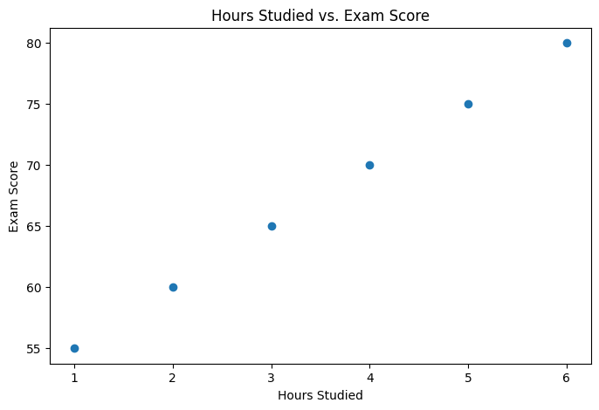
Each dot represents one student. The horizontal axis shows the number of hours studied. The vertical axis shows the exam score. The chart suggests a positive relationship: as study time increases, the exam score tends to increase.

The Regression Line
Simple linear regression fits a straight line through the data.
The equation is:
$$y=mx+b$$In statistics, we often write it as:
$$y=β_{0}+β_{1}x$$
For the study example:
$$\text{Exam Score}=β_{0}+β_{1}(\text{Hours Studied})$$
Lecture explanation:
The regression line gives us a simple mathematical summary of the relationship. It does not pass through every point exactly. Instead, it tries to find the line that best represents the overall pattern.
The slope tells us how much the predicted output changes when the input increases by one unit.
For example, if the regression equation is:
$$\text{Exam Score}=50+5(\text{Hours Studied})$$
Then:
Part | Meaning
50 | predicted score when study hours are 0
5 | for each additional hour studied, predicted score increases by 5 point

The p-value
how strong the evidence is that the effect is not just random noise.
The significance helps us decide whether the relationship is statistically convincing.
A small p-value means the data provides strong evidence that this variable is related to the outcome, after accounting for the other variables in the model.
A large p-value means we do not have enough evidence to say this variable has a meaningful relationship with the outcome in this model.

Simpler Model
A good model should be useful, but not unnecessarily complicated.

A model should be as simple as possible, but still strong enough to answer the question.

For prediction:
The best model is the one that predicts new data most accurately.
For explanation:
The best model is the one that gives clear, interpretable relationships.
For decision-making:
The best model is the one that is accurate enough, stable enough, and understandable enough to support a decision.
So model selection is not only mathematical. It also depends on the goal.

Criteria
Regular $R^{2}$, Adjusted $R^{2}$
Adjusted R-squared asks: did the new variable improve the model enough to be worth adding?
If adjusted $R^{2}$increases, the added variable may be useful.
If adjusted $R^{2}$decreases, the added variable may not be worth keeping.

Train-test split for prediction
MAE
- First, define the goal.
Are we trying to explain relationships, or are we trying to predict accurately?
- Second, compare model performance.
Check adjusted R-squared, AIC, BIC, or test-set error.
- Third, consider simplicity.
If two models perform similarly, choose the simpler one.
- Fourth, consider interpretability.
Can we explain the model to the intended audience?
- Fifth, check whether the model makes practical sense.
A statistically good model that makes no real-world sense should not be used blindly.

Stepwise
Forward selection: start with no variables, then add useful variables one by one.
Backward selection: start with all variables, then remove less useful variables one by one.

