Contents
What problem does regression solve? 2
Example 3

What problem does regression solve?
Regression helps us answer three questions:

- Is there a relationship/ correlation/assoication? Just because two variables move together does not mean one causes the other.
  - Cities with more hospitals tend to have more sick people. Do hospitals make people sick? Larger cities have more people, which means both more hospitals and more sick individuals.
  - Children with larger shoe sizes tend to read better. Does buying bigger shoes improve reading? Older children have bigger feet and better reading skills.
- How strong is it?
- Can we use it to make predictions and decisions?"

Regression is the study of the relationships between variables. Predicting future outcomes. Measuring the impact of one factor on another. Predictors are usually something easy to measure.
- For example, does a change in BMI lead to a change in cholesterol level? To what extent does BMI affect cholesterol?
- Does online advertising reach more people than newspaper advertising? If so, by what factor is the reach different?
- Does investing in higher education lead to higher income after five years? If so, at what rate does income increase?

Making decisions
- Should a health program target BMI reduction?
- Should a company spend more on online ads?
- Is additional education likely to provide a worthwhile return?

Example
Let's start with a simple question. Looking at this scatter plot, what do you notice?
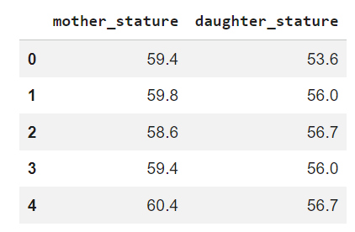

What are your observations?
- Each dot represents a mother-daughter pair.
- There appears to be an upward trend
- There is a positive correlation meaning. As mother's height increases, daughter's height tends to increase.
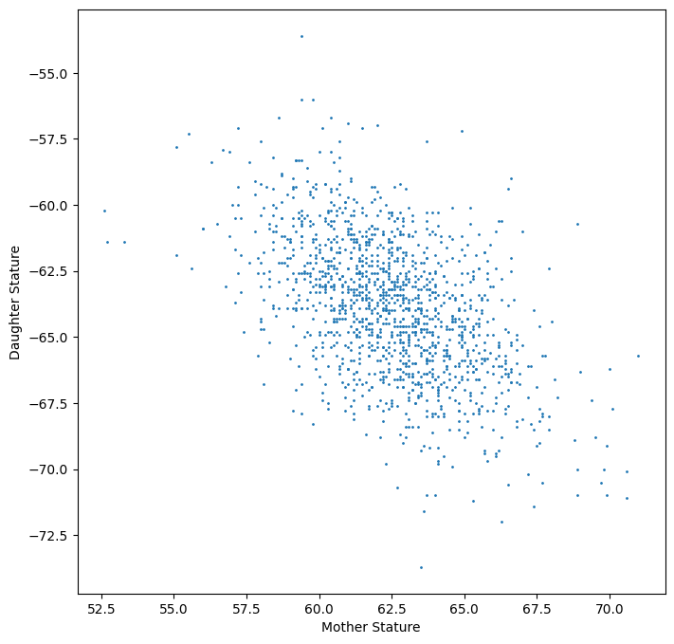
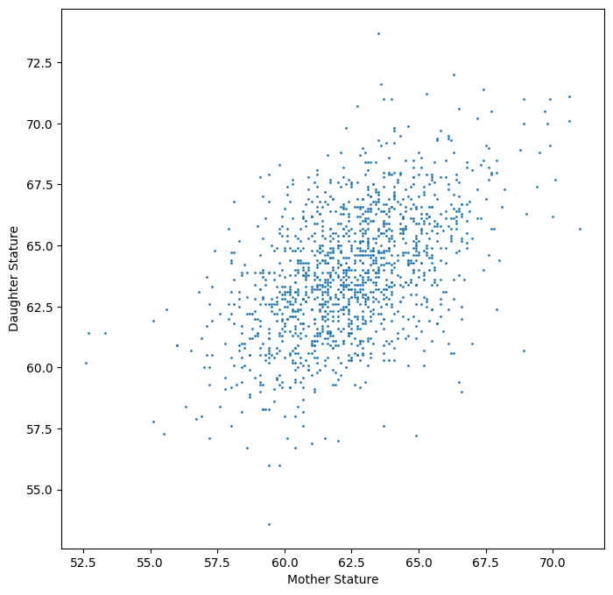
- separated points either well separated from others on v and h, leverage (h)outliers(v)
- What daughter’s heigh should we expect given a 65 inches tall mother?
- Daughter Height=β0​+β1​(Mother Height)

What line is a good line

We want the line's predictions to be as close as possible to the actual observations.
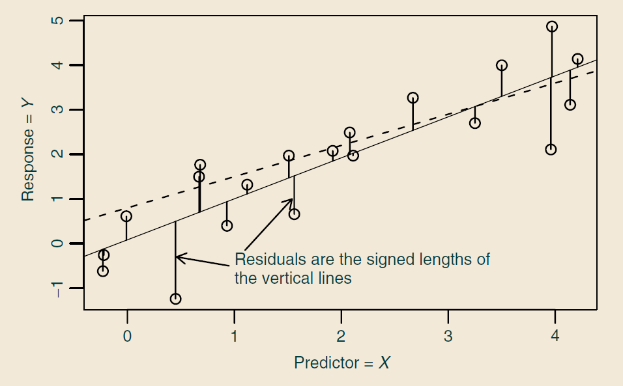
For this mother, the line might predict a daughter height of 64 inches, but the actual daughter is 66 inches. The difference between the actual value and the prediction is called residual. Every point has its own residual. If we simply added all the errors together, the positive and negative errors would cancel each other out. To avoid that, we square the errors." The best-fit line is the line that makes the total squared error as small as possible."
$$\sum_{i=1}^{n}{(}y_{i}-{\hat{y}}_{i})^{2}$$
Don't worry about the notation. The idea is simple: measure how far every point is from the line, square those distances, add them up, and choose the line that makes that total as small as possible.
$$Daughter=30+0.54mother$$

Slope (0.54)
"The number 0.54 is the most important part of the equation. It tells us how much the daughter's expected height changes when the mother's height increases by one inch. For every additional inch in a mother's height, the daughter's expected height increases by approximately 0.54 inches on average. Comparing two mothers who differ by 10 inches in height, we would expect their daughters to differ by about 5.4 inches on average.
Intercept
No. Nobody has a height of 0 inches. The intercept is simply where the line crosses the vertical axis. It helps position the line correctly, but it may not have a meaningful real-world interpretation.
Only interpret the intercept if $X=0$is realistic and meaningful in the context of the problem. Monthly electric bill = $20 + $0.15 × (kWh used)

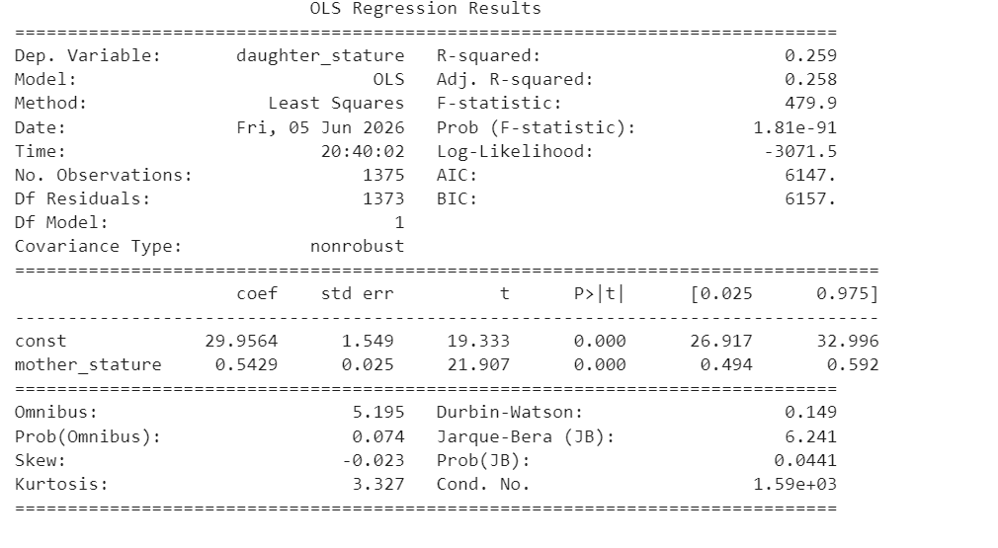
- For every additional 1 inch in mother’s height, the daughter’s predicted height increases by about 0.54 inches on average. So if mother A is 10 inches taller than Mother B, the model tells usher daughter would be 5 inches taller on average.
- The p-value shows strong evidence that mother height and daughter height are positively related
- Confidence interval doesn’t include 0 corroborating the significance of mother height impact on daughter height
- The $R^{2}$value is 0.259. This means mother height explains about 25.9% of the variation in daughter height. That is meaningful, but it is not everything. About 74.1% of the variation is still not explained by mother height alone. Other factors matter, such as father height, genetics more broadly, nutrition, environment, and random biological variation.
- The F-statistic, also tells the overall model is statistically useful compared with a model with no predictor

A practical example Auto_mpg
- about 82.4% of the variation in mpg is explained by these predictors together. The overall model is statistically significant because the F-test p-value is extremely small.
- Model year: Holding the other variables fixed, each one-year newer model is associated with about 0.78 higher mpg on average. This is one of the strongest and most significant predictors.
- Weight: For every additional 100 pounds, mpg decreases by -0.67. So, a car that is 100 pounds heavier is predicted to have about 0.67 lower mpg, on average.
- (1) USA : USA is the reference group. European cars are predicted to have about 2.63 higher mpg than comparable USA cars. Japanese cars are predicted to have about 2.85 higher mpg than comparable USA cars.

“Which variables should we keep so the model is useful, interpretable, and not unnecessarily complicated?”
Three principlas:
- Start with domain logic
- weight, model_year, origin, horsepower, displacement, cylinders, acceleration. But some are overlapping. For example, heavier cars often have larger displacement, more cylinders, and more horsepower. So not all of them may be needed together.
- Build more and make comparison using adjusted R2, AIC, Simpler model is preferred

For this dataset, a reasonable model would keep weight, model year, and origin. These variables are statistically significant, easy to interpret, and strongly related to mpg.

Classification
So far, we've looked at regression. Regression answers questions where the outcome is a number
Comparison:
Regression | Classification
What will the house sell for? | Will the customer buy or not?
What will the cholesterol level be? | Does the patient have diabetes?
What will the MPG be? | Is this car fuel-efficient or not?
 | Customer churn or stay
 | Malignant or benign
 | cat dog cow

Classification predicts which group.

Methods
- Logistic regression
- Decision Tree
- K nearest Neighbor
- SVM
- Neural Networks
- etc

Logistic regression
$$\log\left(\frac{p}{1-p}\right)=b_{0}+b_{1}X_{1}$$
- Probability: Probability(customer buys) = 0.80
- Odds: Compare success to failure The odds are 4 to 1 in favor of buying.
- Logit:
Let’s say b1 = 0.5, A one-unit increase in x increases the log-odds by 0.5. The odds increase by about exp(0.5)=65%

Eg. Suppose we model whether a customer buys a product.
$$log(\frac{p}{1-p}​)=-2+0.5(Years as Customer)$$
For each additional year a person remains a customer, the odds of purchasing increase by about 65%.

Abalone
- The overall likelihood-ratio p-value is 0.000, so the predictors together are statistically useful for distinguishing old versus not old abalones.
- The pseudo-$R^{2}$ is 0.3627. For logistic regression, this is not interpreted exactly like ordinary $R^{2}$, but it suggests the model has meaningful explanatory power.
- Since the reference category is likely female, infant abalones are less likely to be old than female abalones with the same measurements.
- Male abalones are not significantly different from the reference group after controlling for the physical measurements.
- Length=-4.7517, Holding other variables fixed, greater length is associated with lower odds of being old. This may seem counterintuitive, but the size variables are highly correlated, so individual signs should be interpreted cautiously.
- Diameter =5.81 Greater diameter is associated with higher odds of being old, holding other variables fixed.
- Higher shucked weight is associated with lower odds of being old and whole_weight and Shell weight are associated with much higher odds of being old.

