METR4202 Team 13 Algorithm Theory and System Application
State Machine Frontier Search Coverage and ArUco

metr4202_2026_team13
Theory and source-level application guide for project members

1 System Purpose and Architecture
This package uses SLAM and Nav2 as the mapping and motion layers. The custom code controls mission phases, generates frontier goals, plans visual coverage, and builds the ArUco map. The system explores first, finalizes marker observations second, and runs coverage on a frozen map.
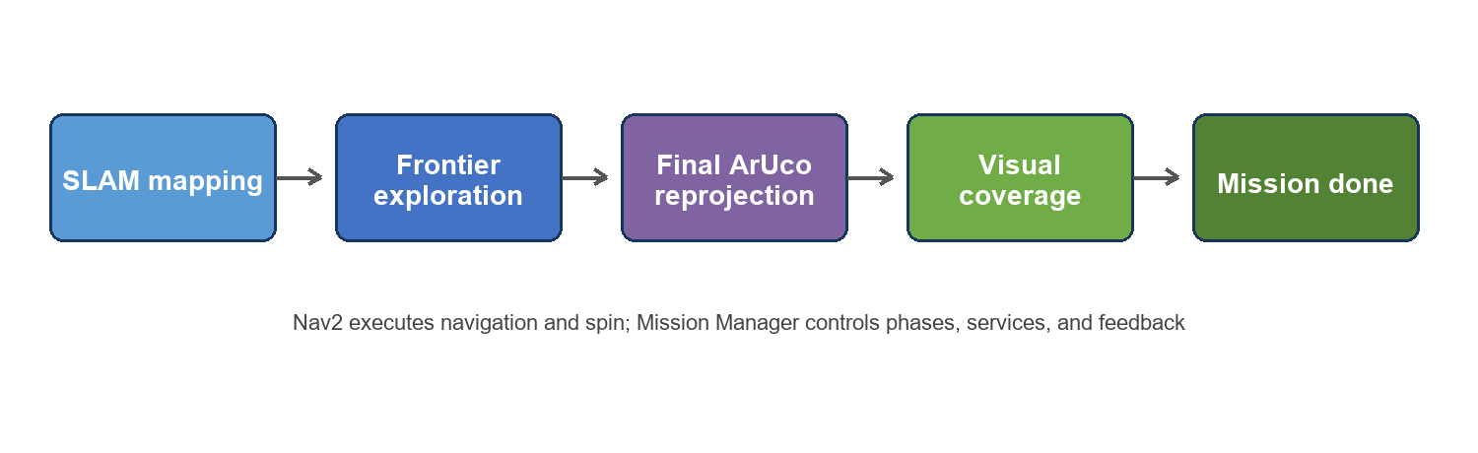
Figure 1 End to end mission flow
Module | Theoretical role | Implementation
State machine | Controls discrete mission phases and events | mission_manager.py
Frontier search | Uses known unknown boundaries to drive exploration | exploration.py
Coverage | Selects viewpoints for boundary targets | coverage.py and coverage_geometry.py
ArUco | Detects markers and fuses global positions | aruco_detection.py and aruco_localization.py

Algorithm nodes produce tasks, Mission Manager controls order, and Nav2 executes motion. This separation allows decisions, phase transitions, and robot motion to be tested independently.

2 State Machine Theory and Application

2 1 Theory
A finite state machine represents a mission with a limited set of phases. Events or conditions trigger transitions, and each state permits only phase-appropriate behaviour. It prevents concurrent exploration and coverage, duplicate action submission, and startup before dependencies are ready.
- A state represents mission phase rather than the robot's continuous physical pose.
- Transitions come from service responses, Nav2 action results, and readiness checks.
- Task IDs and pending flags reject stale callbacks and duplicate requests.
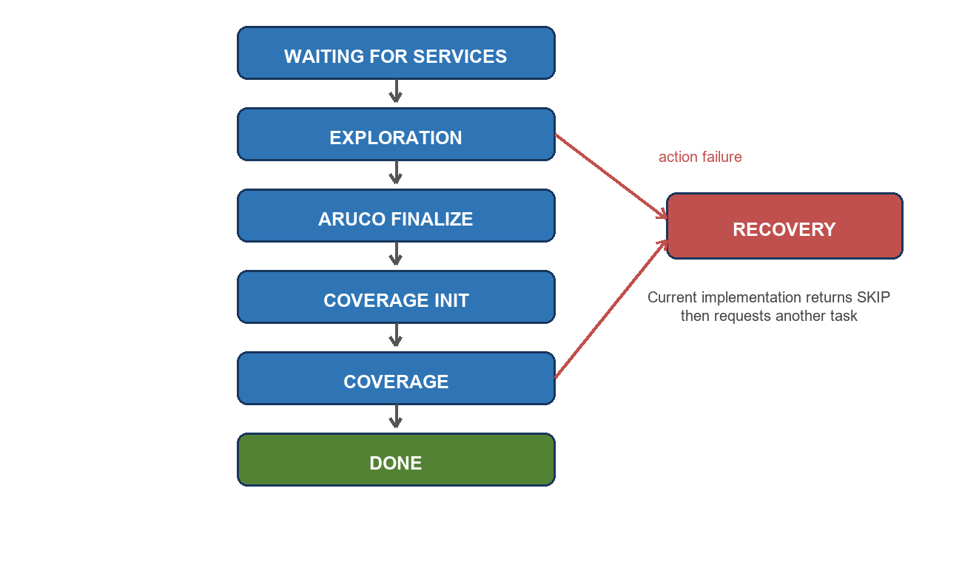
Figure 2 Mission Manager state machine

2 2 Application in this package
- WAITING FOR SERVICES waits for custom services and the Nav2 lifecycle.
- EXPLORATION requests frontier goals and submits NAVIGATE actions.
- ARUCO FINALIZE reprojects historical observations using the final map to odom relation.
- COVERAGE INIT freezes the map and builds the coverage model.
- COVERAGE performs navigation and spin transactions until no task remains.
- RECOVERY receives failure context; the current implementation returns SKIP.
The state machine interface allows future retry, escape, and abort policies, but active recovery is not yet implemented.

3 Frontier Search Theory and Application

3 1 Theory
An occupancy grid classifies space as free, occupied, or unknown. A frontier is a known free cell adjacent to unknown space. Moving near a frontier exposes new space to the sensors, so frontiers provide exploration goals. A useful goal must also be safe and connected to the robot.
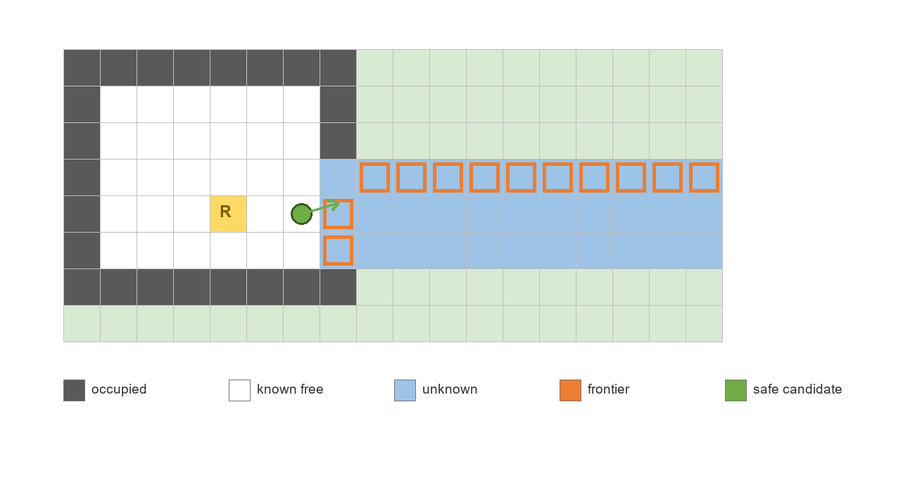
Figure 3 Frontier cells and a safe candidate

3 2 Application in this package
- Read the continuously updated map and obtain the robot pose through TF.
- Find free cells adjacent to unknown cells and form 8-connected frontier clusters.
- Reject small clusters and search from each frontier into safely cleared free space.
- Keep candidates in the robot's reachable component and reject goals that are too close, unsafe, or recently ineffective.
- Select the nearest valid candidate, orient it toward the frontier, and return NAVIGATE.
- After navigation, measure known-cell growth and temporarily suppress goals with insufficient gain.
- Finish exploration when no valid candidate remains.
Decision | Current implementation
Frontier | Known free cell adjacent to unknown space
Safety | Candidate keeps configured obstacle clearance
Reachability | Candidate is in the robot's safe connected component
Effectiveness | Arrival produces enough additional known cells

Selection is currently distance-led. Declared information-gain weight, distance weight, and bootstrap spin angle do not enter the active score, so the implementation is not a full global utility optimizer.

4 Coverage Theory and Application

4 1 Theory
Coverage here means visual coverage of environmental boundaries, not floor cleaning. A target is coverable only when camera range is valid, viewing direction satisfies the surface incidence limit, line of sight is clear, and the robot can safely reach the viewpoint.
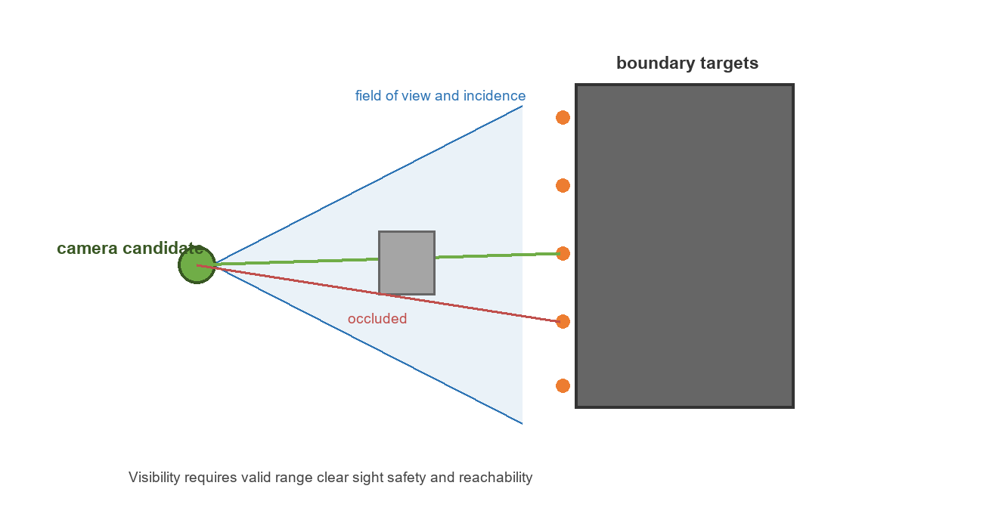
Figure 4 Coverage visibility conditions

4 2 Application in this package
- Copy the final OccupancyGrid at initialization and freeze it.
- Classify free, occupied, and unknown cells; unknown space blocks both travel and sight.
- Inflate obstacles using robot radius, radial camera offset, and safety clearance.
- Extract free occupied boundaries and discretize them into targets with surface normals.
- Generate coarse-to-fine candidate positions in reachable safe space and precompute visibility.
- Rank candidates by newly covered targets divided by travel distance plus fixed visit cost.
- Issue NAVIGATE first and a 360-degree SPIN after success; commit coverage only after the spin.
Constraint | Implementation
Range | Camera to target range is within configured limits
Angle | Viewing direction satisfies maximum incidence angle
Occlusion | A supercover ray crosses neither obstacles nor unknown space
Safety and reachability | Candidate is outside inflated obstacles and in the reachable component

Targets visible from no candidate are initially uncoverable. When navigation failure removes a candidate, the model re-evaluates runtime-uncoverable targets.

5 ArUco Theory and Application

5 1 Detection and Pose Theory
An ArUco marker is a square binary pattern with a unique ID. The detector finds four image corners and decodes the ID. With camera intrinsics, distortion, and physical marker size, PnP estimates the marker's 3D position in the camera frame.
Single-frame estimates are affected by range, corner noise, and viewing angle. The implementation estimates measurement variance from range and reprojection error so poorer observations receive less fusion weight.
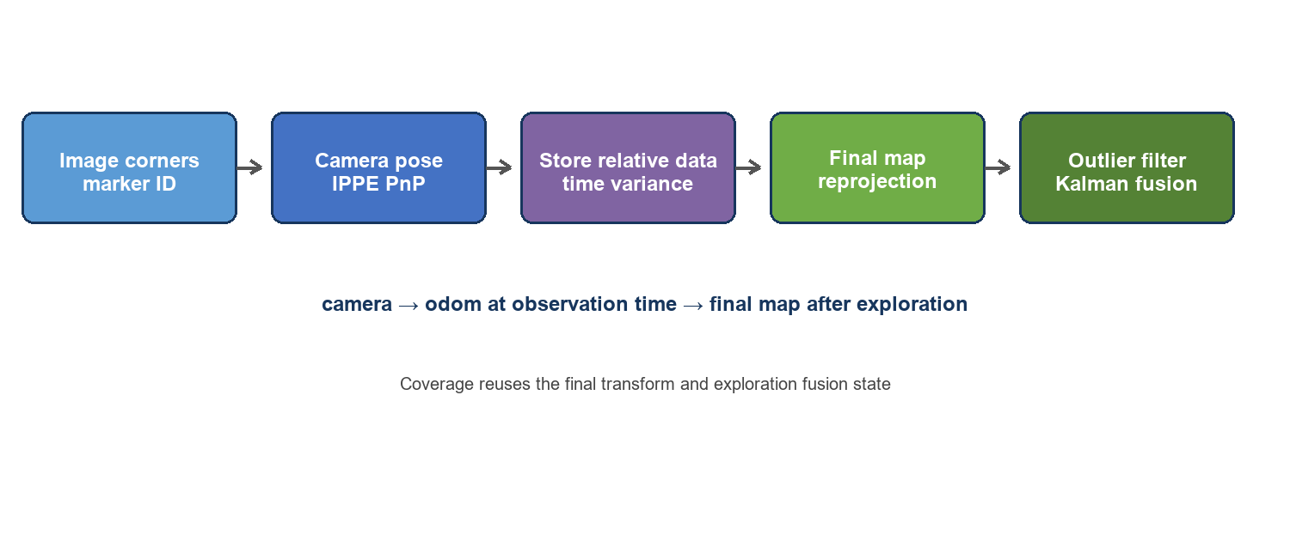
Figure 5 ArUco relative observations and final reprojection

5 2 Application in this package
- Detection publishes marker ID, four corners, image timestamp, and camera frame.
- Localization uses square IPPE PnP and rejects non-positive depth, excessive range, or excessive reprojection error.
- During exploration it stores ID, camera-frame position, timestamp, matching odom to camera translation and rotation, and variance.
- At exploration completion it freezes the latest map to odom relation and reprojects all historical observations.
- Per-ID median, MAD, and a noise floor remove batch outliers.
- Accepted observations enter an independent statistical Kalman fusion state for each marker in timestamp order.
- Coverage reuses the final transform and existing fusion state without automatic reset.
Stored quantity | Purpose
marker ID | Separates each marker database and filter state
Camera-frame 3D position | Retains original relative geometry
Image timestamp | Finds observation-time TF and preserves order
odom to camera pose | Anchors history in the continuous odometry frame
Measurement variance | Controls outlier tests and fusion weight

SLAM can change map to odom during exploration. Saving only the current map coordinate preserves obsolete map error. Relative observations allow every historical measurement to be recomputed with the same final map relation.

6 System Coordination and Boundaries
The state machine decides when algorithms run, frontier search selects exploration goals, ArUco retains observations and corrects them at the phase boundary, and Coverage generates visual tasks on the final map. Nav2 executes navigation and spin and returns results to the state machine and Coverage model.
Phase | Main input | Processing | Output
Exploration | Live map and TF | Frontier clustering and candidate selection | NAVIGATE
ArUco finalization | Relative observations and final transform | Reproject filter fuse | Marker map
Coverage initialization | Final map and robot pose | Targets candidates visibility | Frozen model
Coverage execution | Model and Nav2 result | Greedy selection navigate spin | Coverage grid

6 1 Current Boundaries
- The system requires a correct TF tree, camera calibration, physical marker size, and synchronized timestamps.
- Coverage uses theoretical visibility on a 2D map and does not directly confirm appearance in an image.
- Frontier selection uses the nearest effective candidate rather than full global utility optimization.
- Recovery is currently skip-only.
- ArUco accuracy depends on camera parameters, extrinsics, final SLAM consistency, and viewpoint diversity.
The four parts connect through custom services and MotionTask. Goal scoring, recovery policy, or the observation model can be replaced without rewriting the full mission chain.

