**CS398-Deep Learning**

**Homework 3**

**Lingyi Xu (lingyix2)**

1. **Description of Implementation**

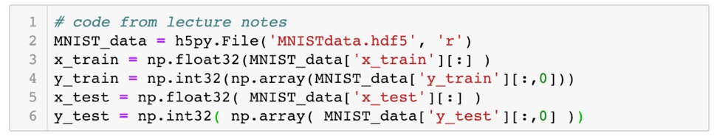First, I load the MNIST data from the dataset.

Then I build my mini-batch CNN model.

I define the nonlinearities σ(z) (relu) function I will use:

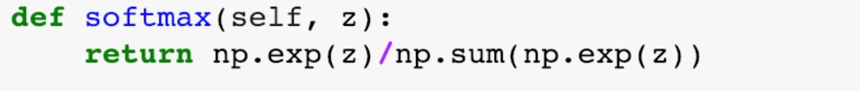The softmax function I will use:

The convolution layer:

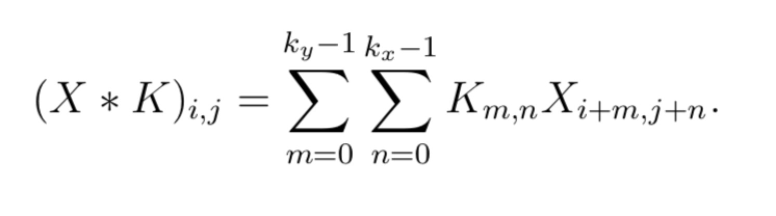

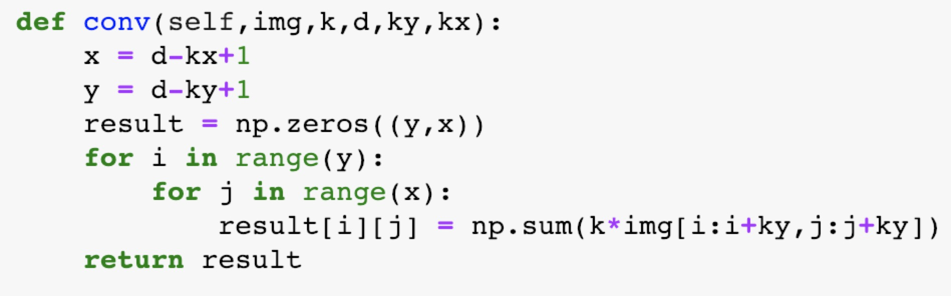

My one-layer CNN model looks like this:

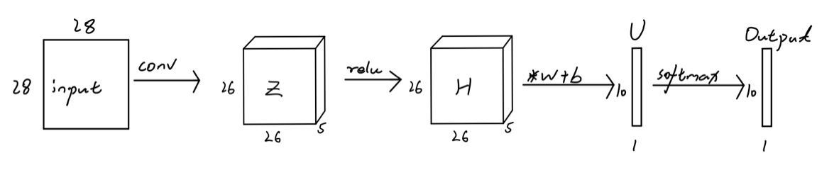

Accordingly, I defined the forward propagation step.

For the backward propagation step, according to the lecture note:

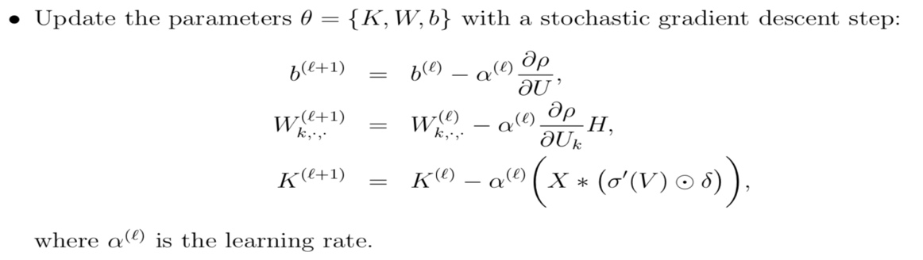For the forward and backward propagation, see “HW3.ipynb”.

For this particular dataset, I use the following parameters:

Iteration = 1000

Batch size = 150

Number of channel = 5

Learning rate = 0.01/（0.01*itr+1）

**2. Final Test Accuracy:**

97.05%

