**CS398-Deep Learning**

**Homework 4**

**Lingyi Xu (lingyix2)**

1. **Description of Implementation**

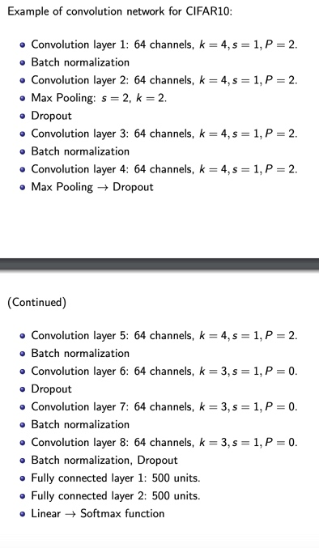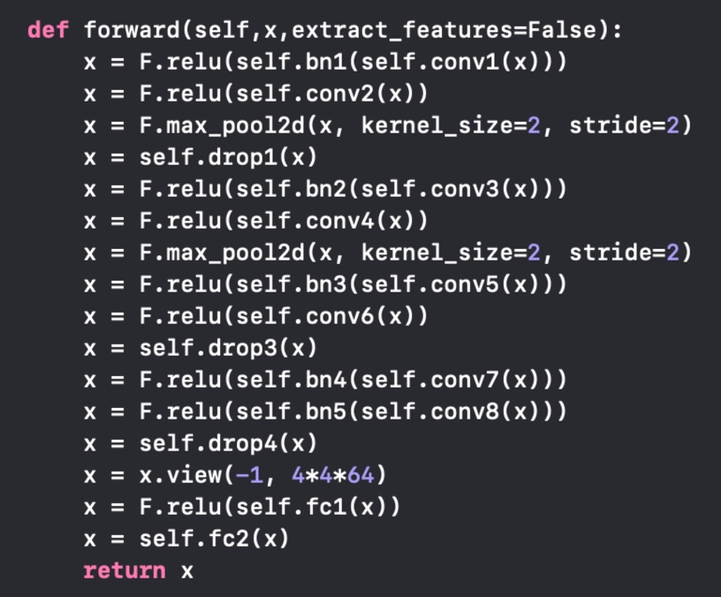First, I implement the deep convolutional neural network following the architecture of lecture 6 slides.

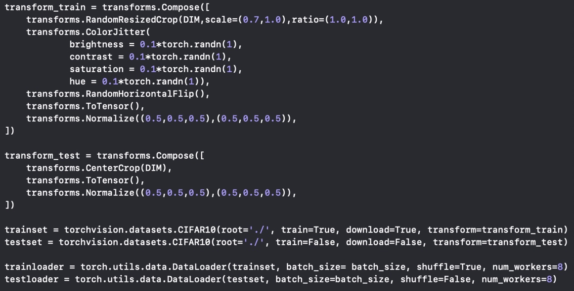Then I load and prepare the training data and test data of CIFAR10. When loading data, I used Transforms to normalize and enlarge the dataset to help training. For Transforms, I used random flip, random resize and random color jitter.

Train the model with GPU acceleration. For this particular dataset, I use the following parameters:

Iteration = 30, Batch size = 120, Learning rate = 0.001/（0.1*itr+1）

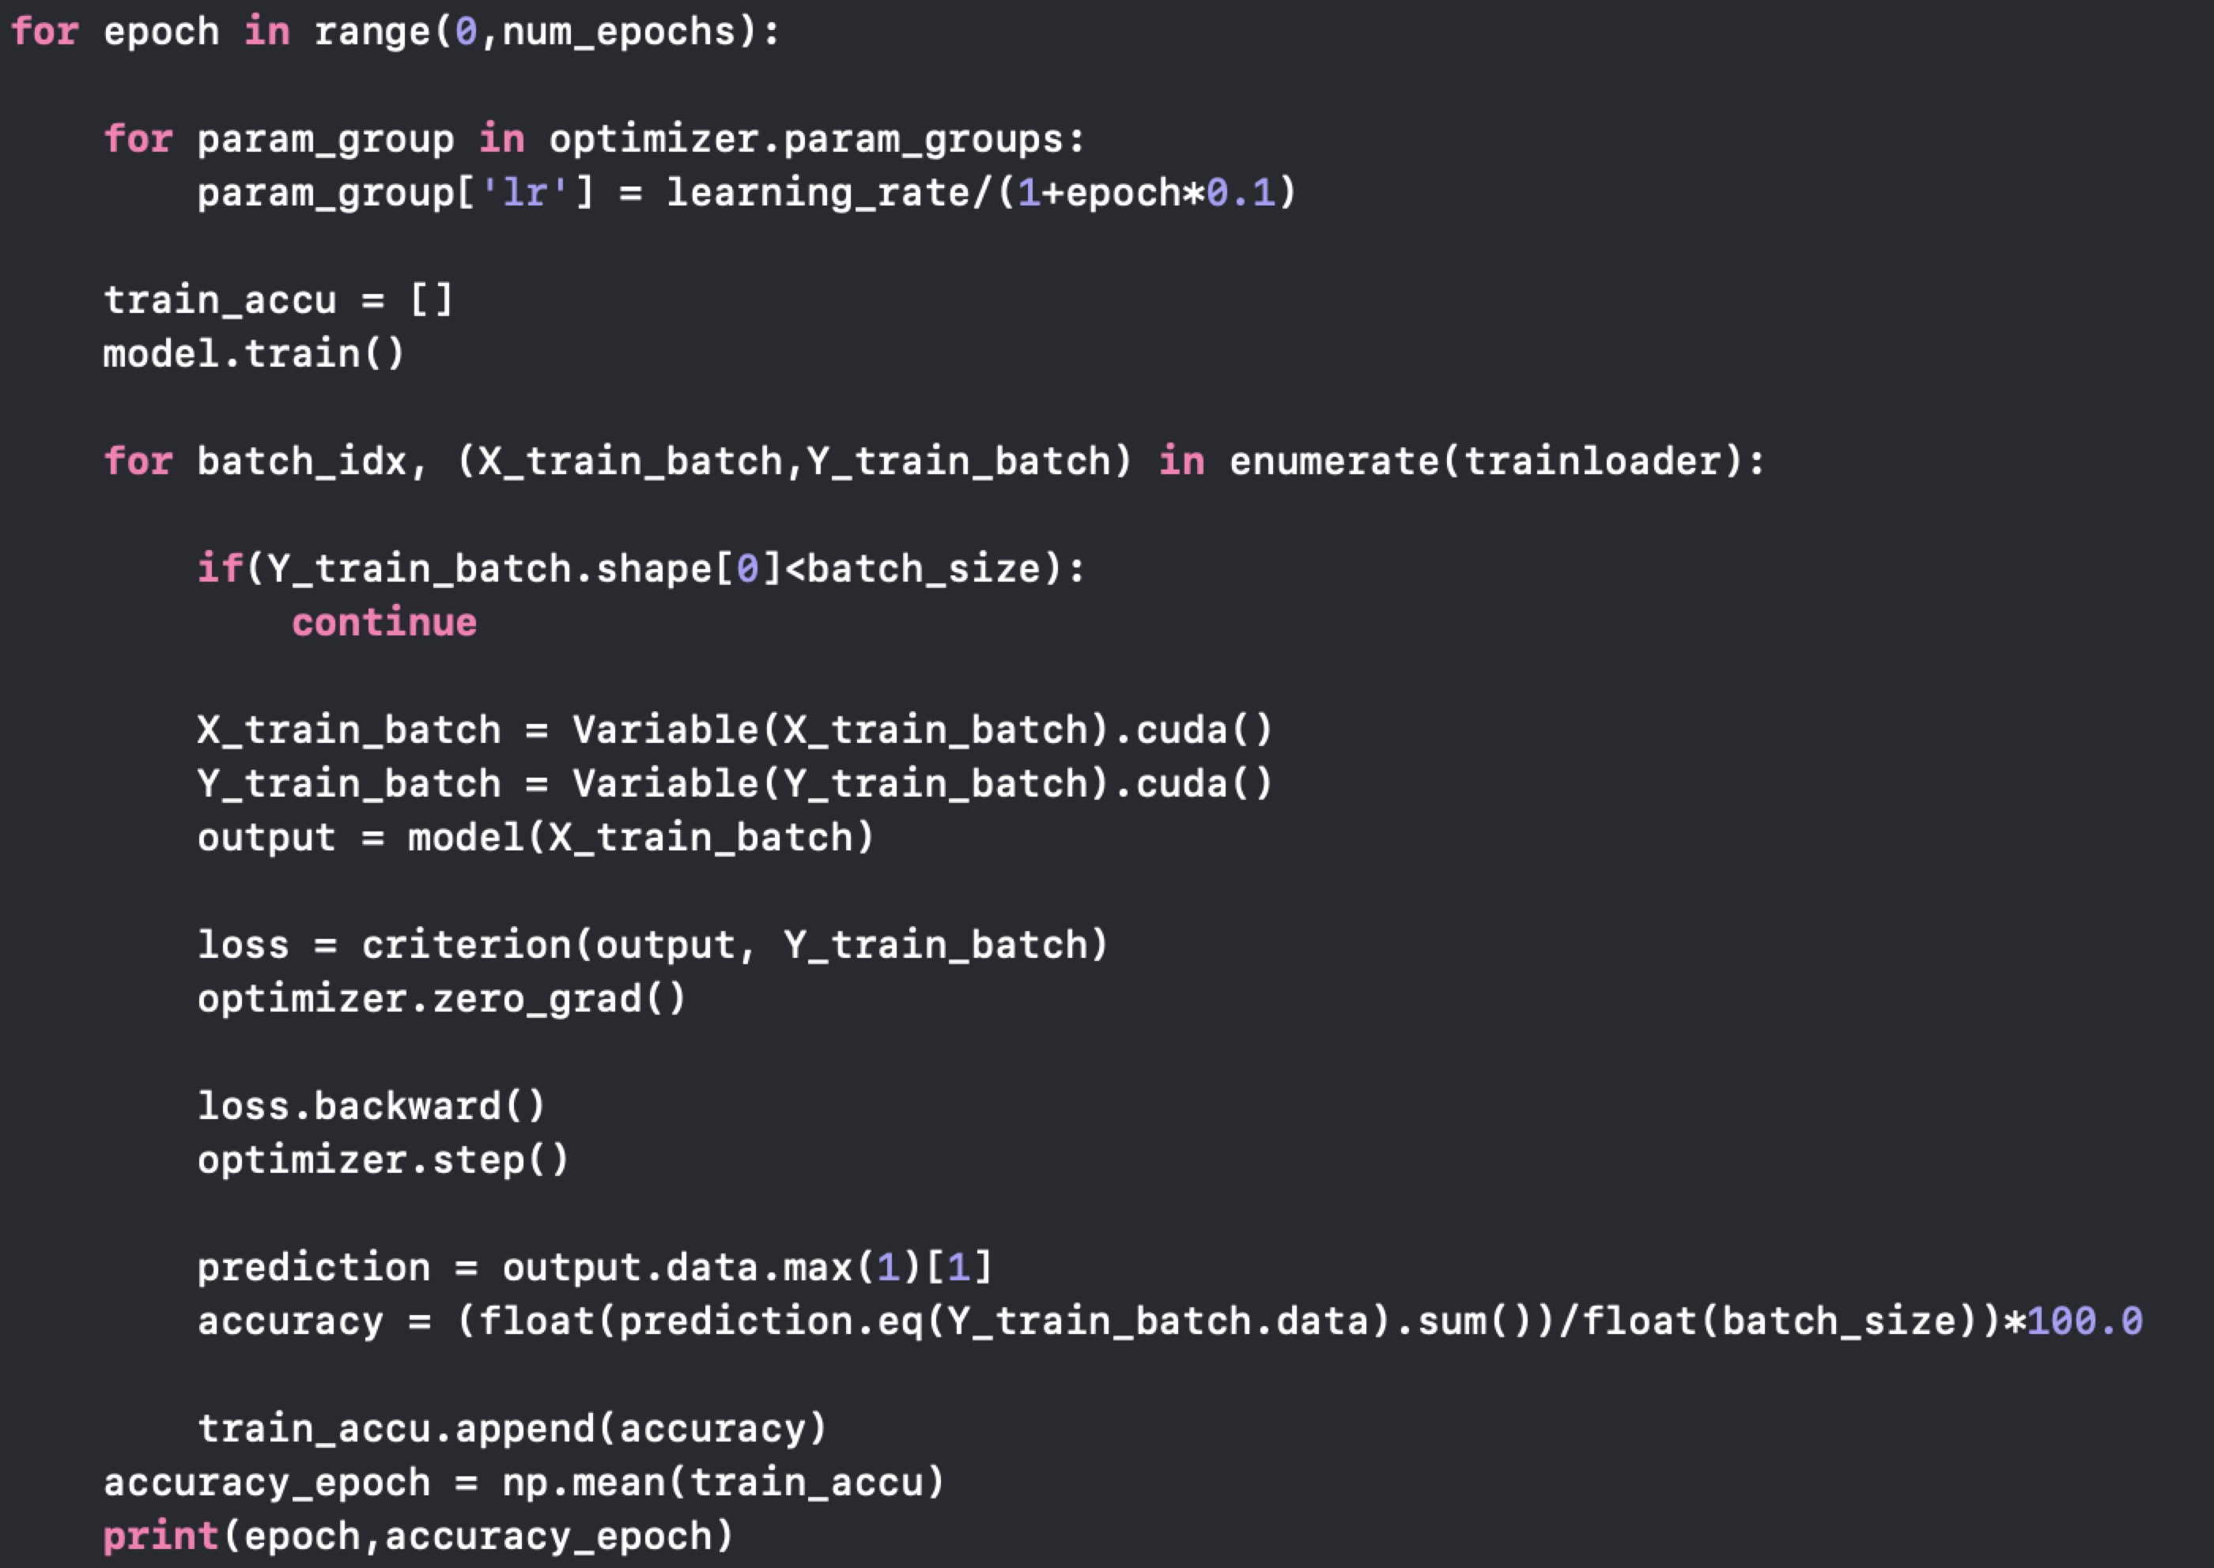

In the end, apply Monte Carlo methods, heuristic test methods, and normal test methods:

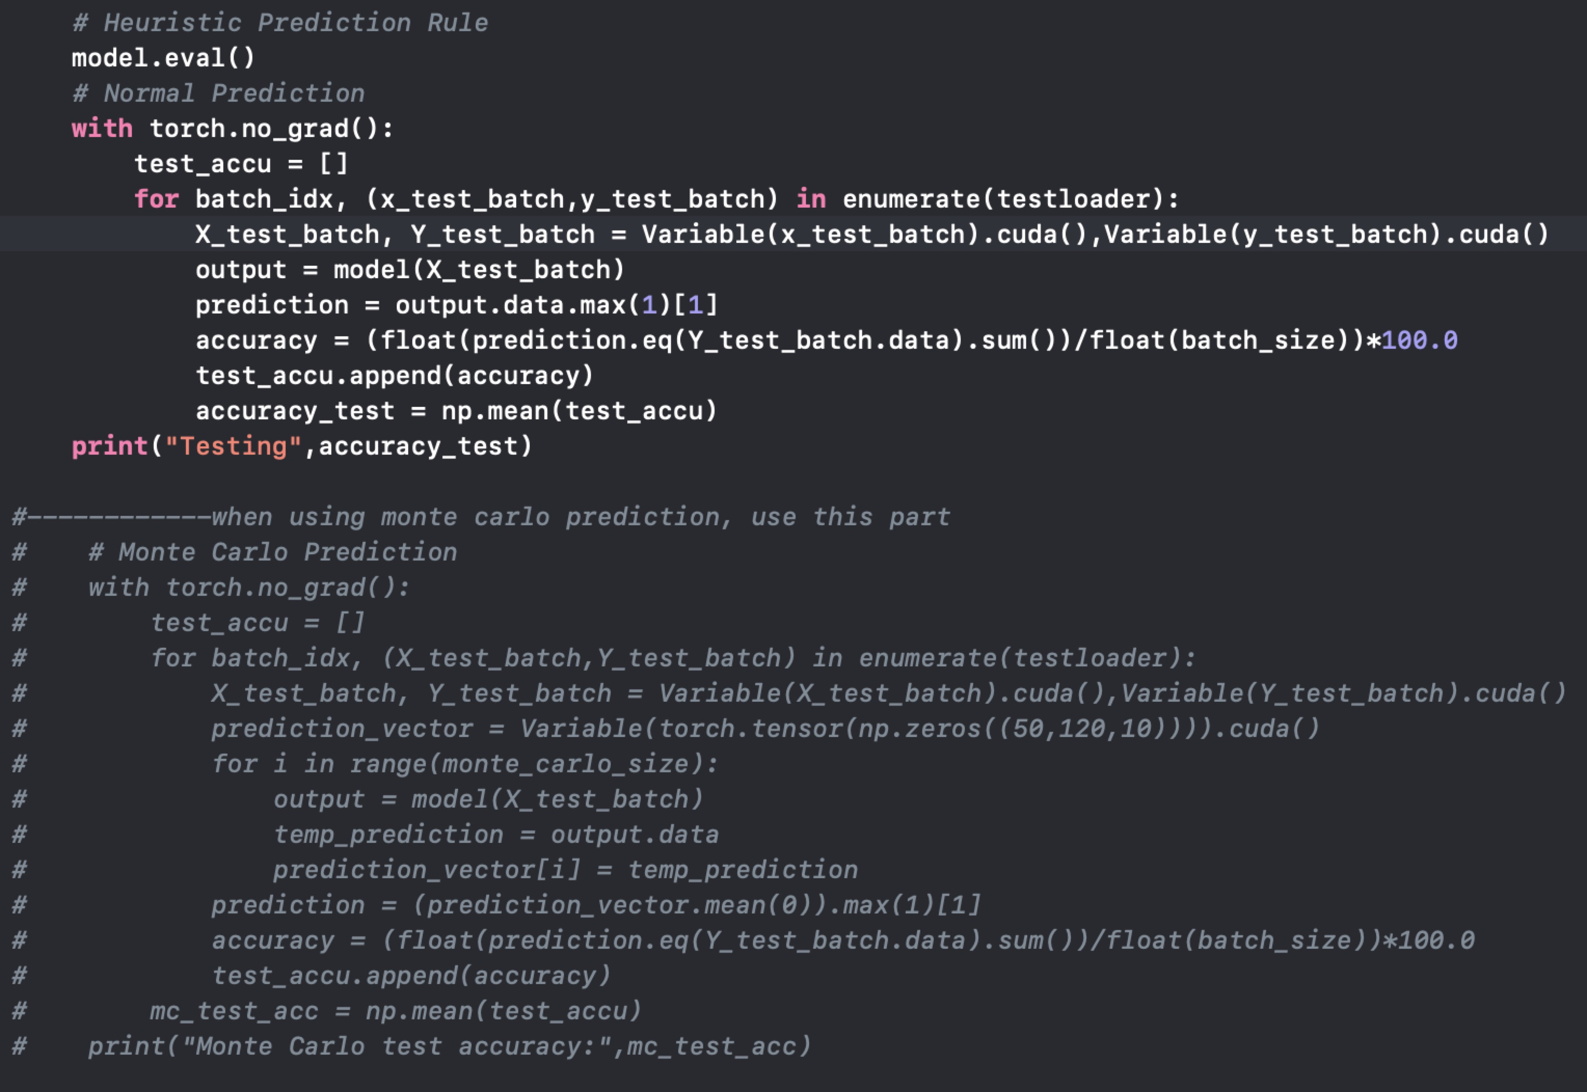

1. **Final Test Accuracy:**

Normal: 83.9369%

Monte Carlo Method: 84.9326%

Heuristic Method: 84.0257%

1. **Structure of CNN (from lecture slides):**

