**CS398-Deep Learning**

**Homework 5**

**Lingyi Xu (lingyix2)**

1. **Description of Implementation**

**Part1:**

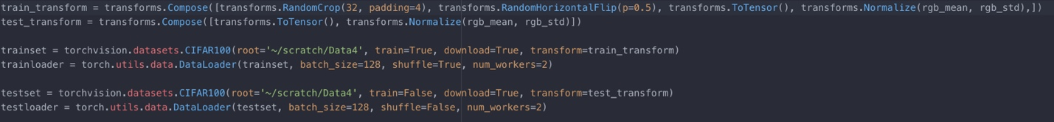First, I load and prepare the training data and test data of CIFAR100. When loading data, I used Transforms to normalize and enlarge the dataset to help training.

Then, I define the basic convolutional block for resNet

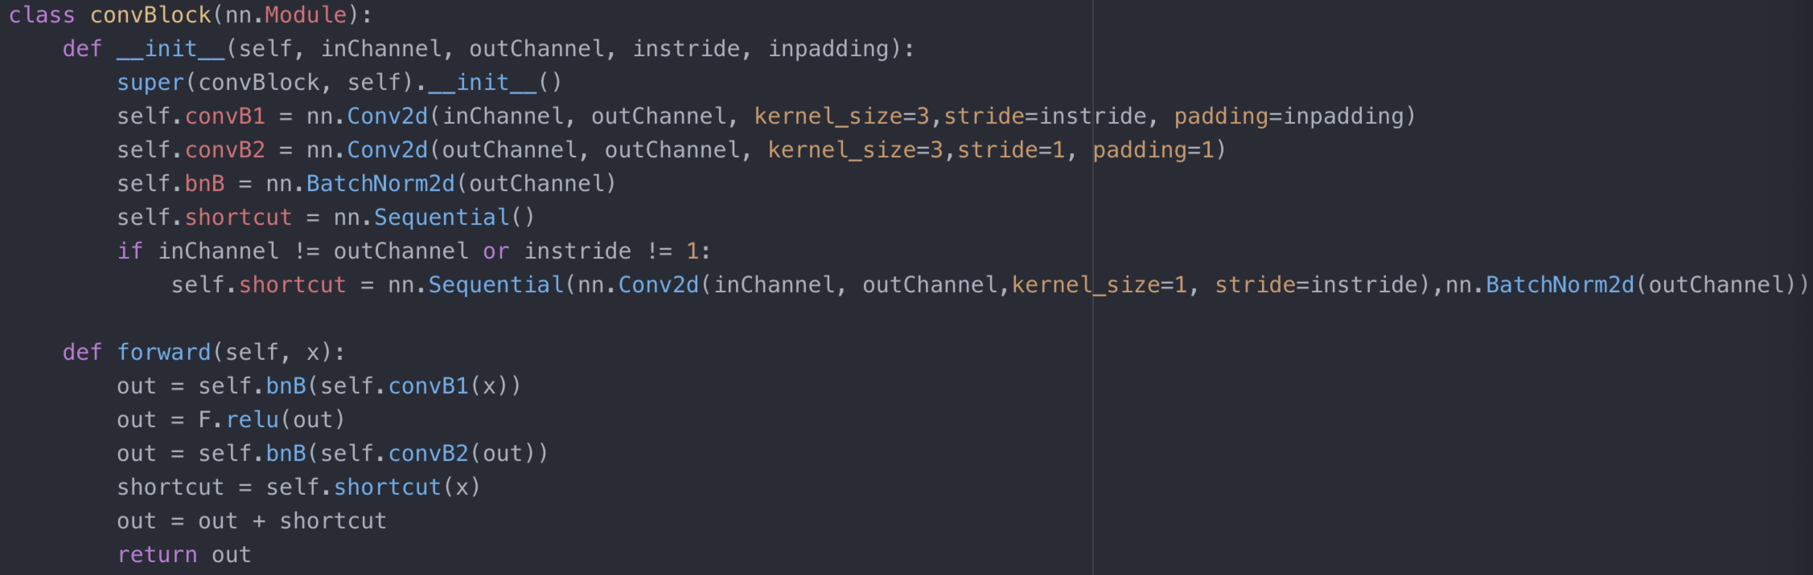

Then, I define and build the resNet network.

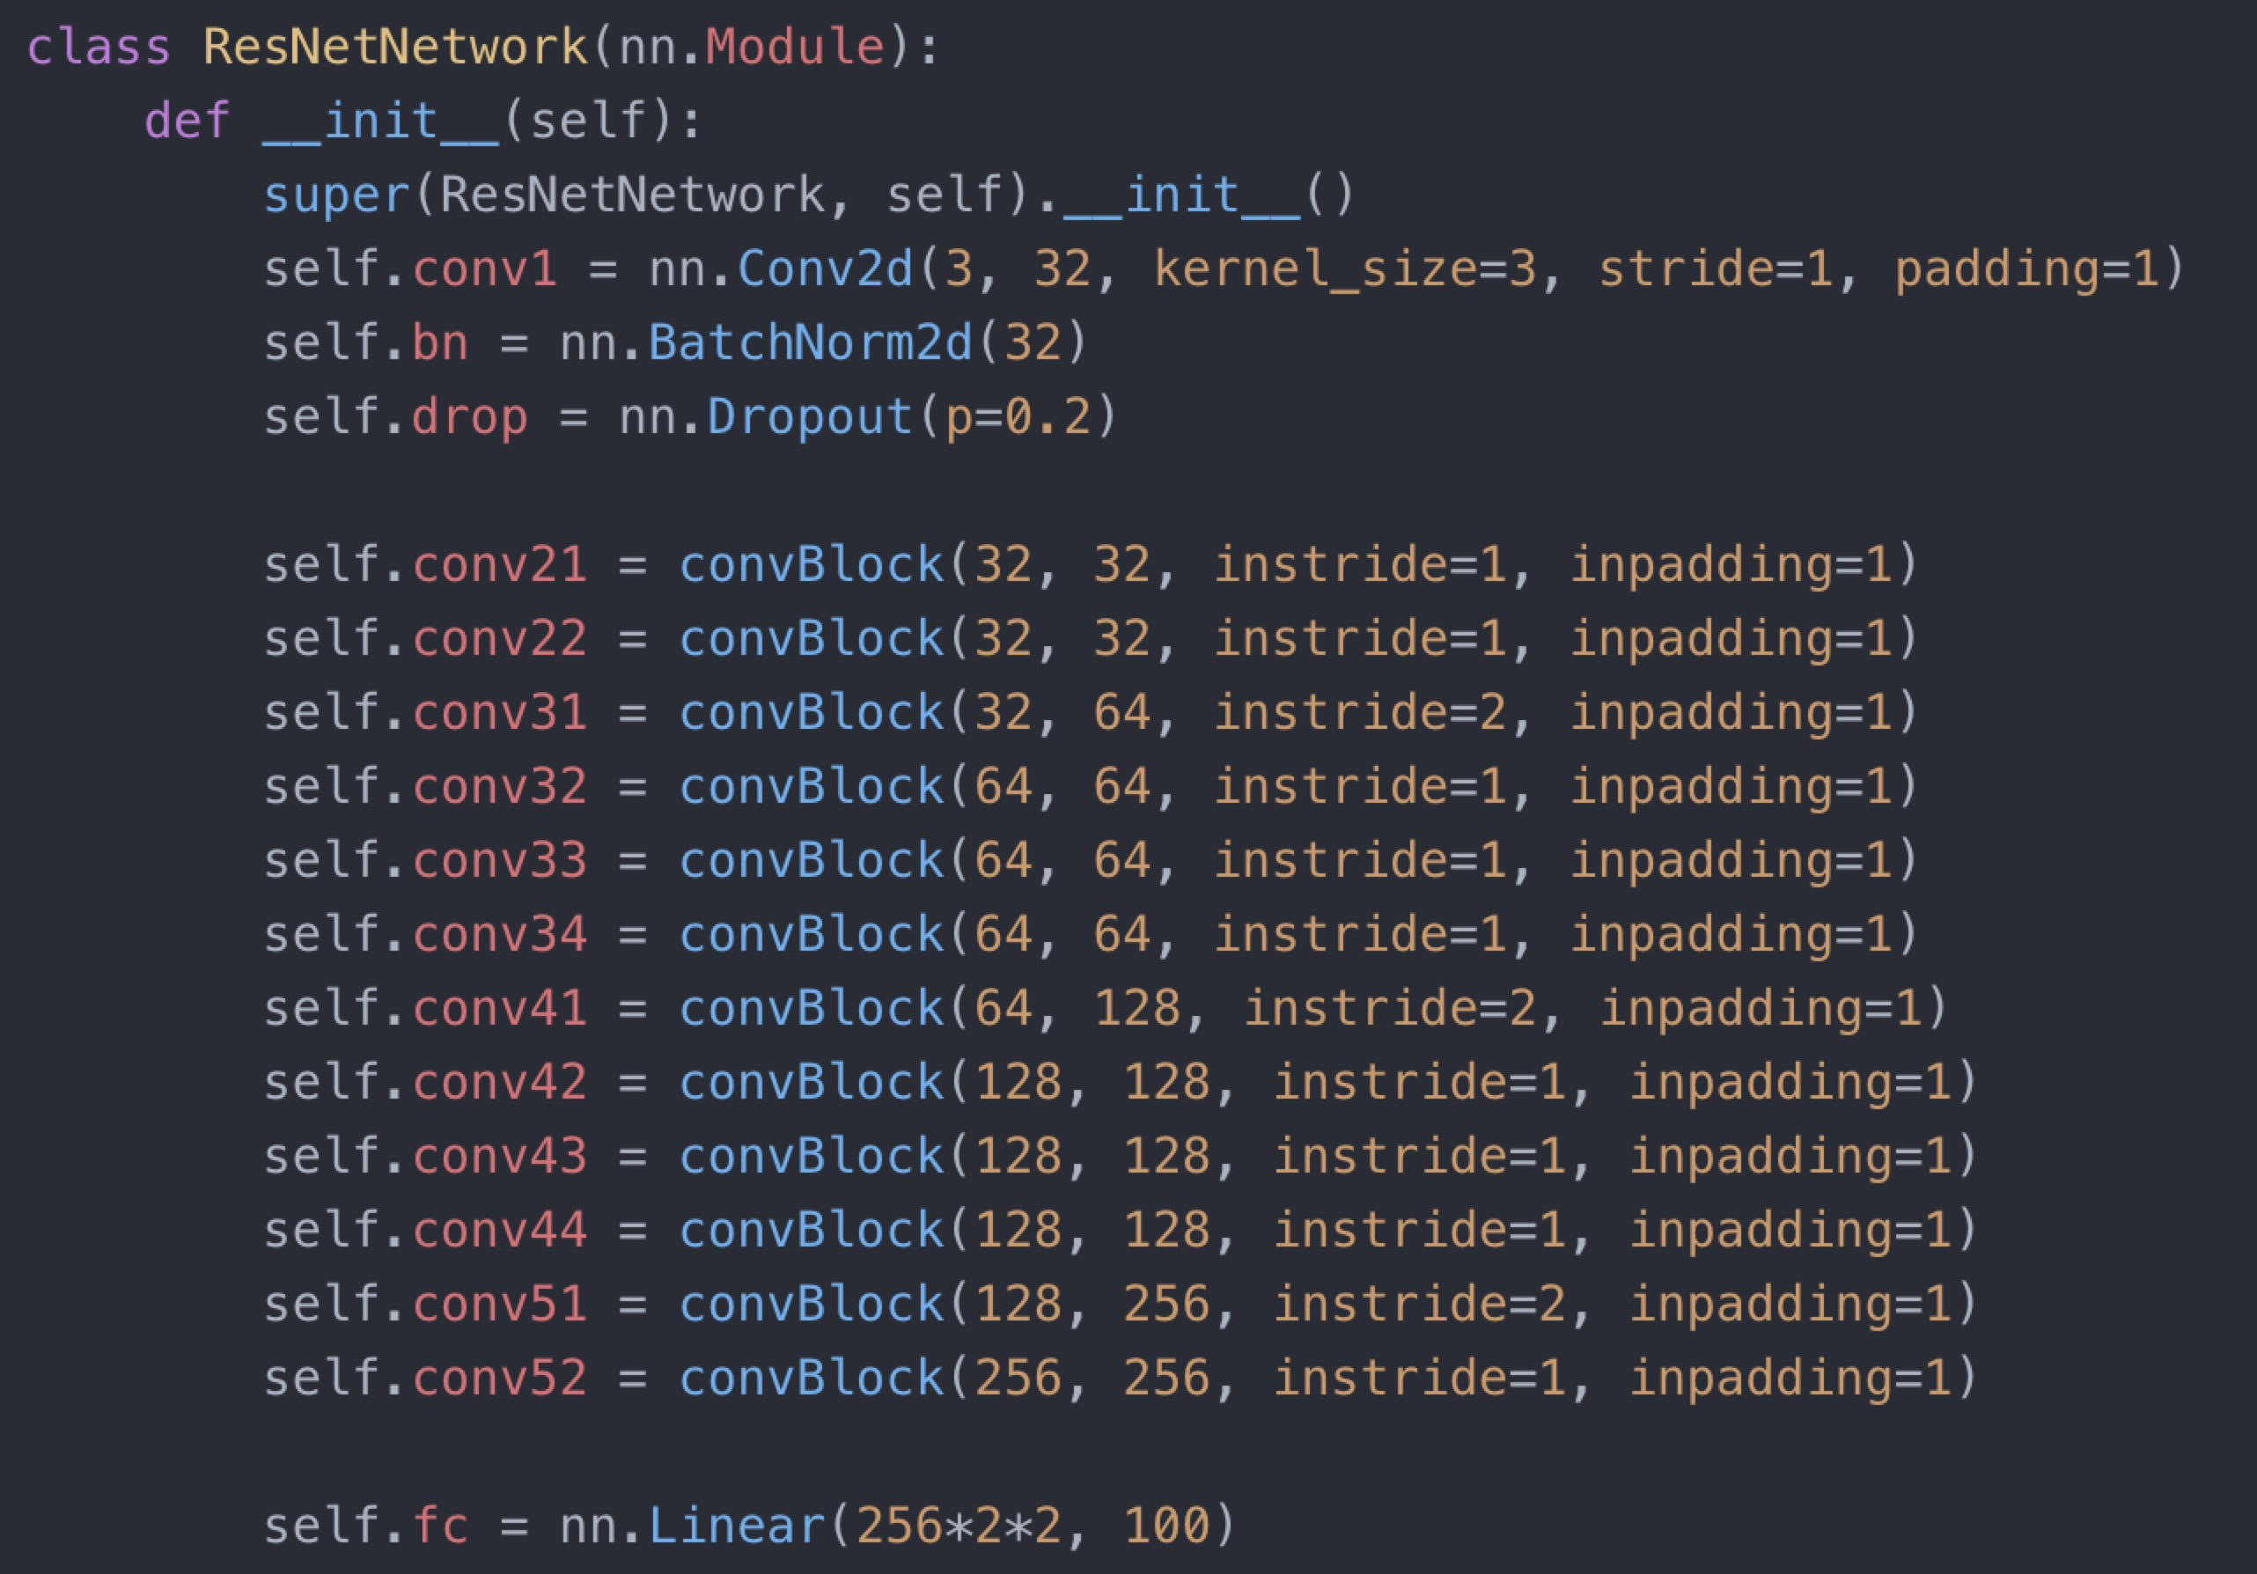

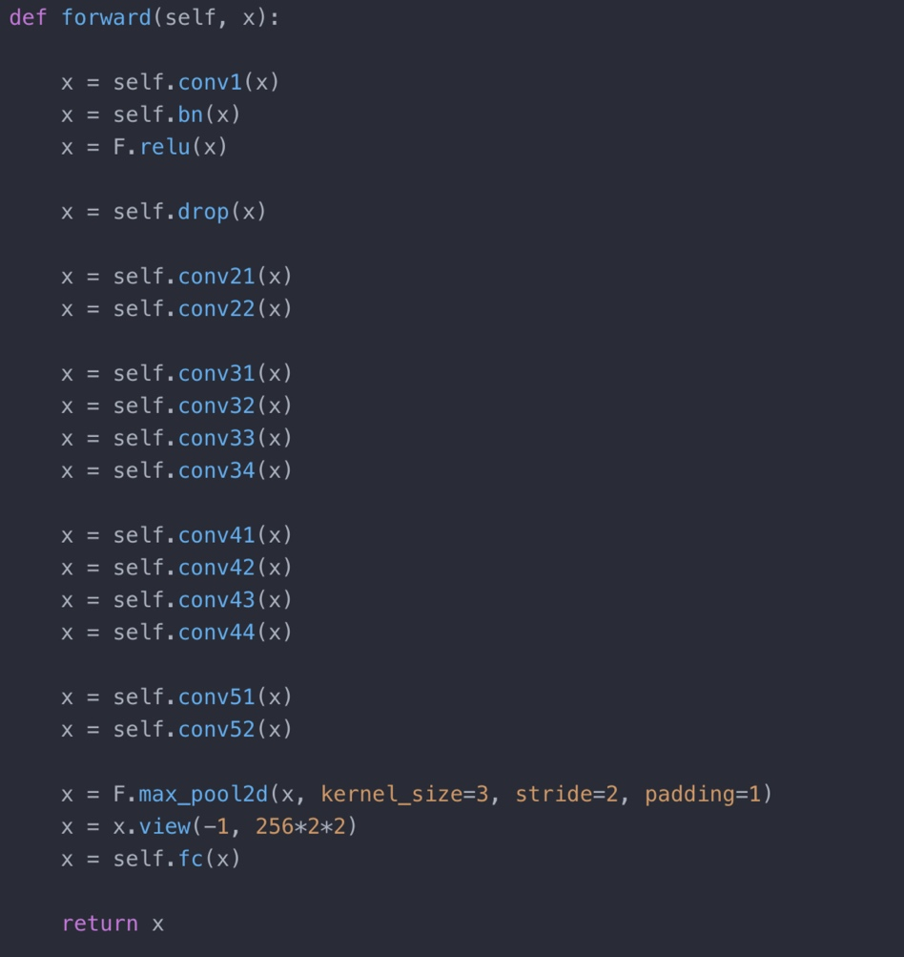

Train the model with GPU acceleration. For this particular dataset, I use the following parameters:

Iterations: 40

Learning rate = 0.001*0.9^num_iterations

And trained the model on the dataset

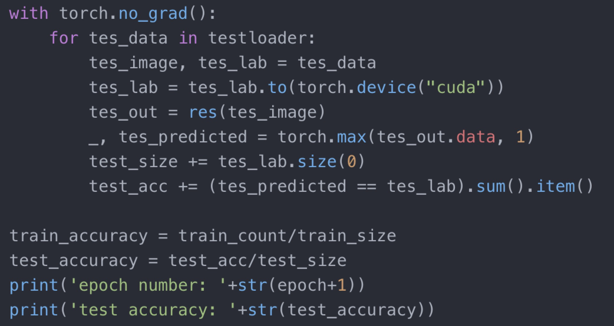

**Part2:**

The implementation of part 2 is mostly same as part 1. The only difference is that we need to load the pretrained model:

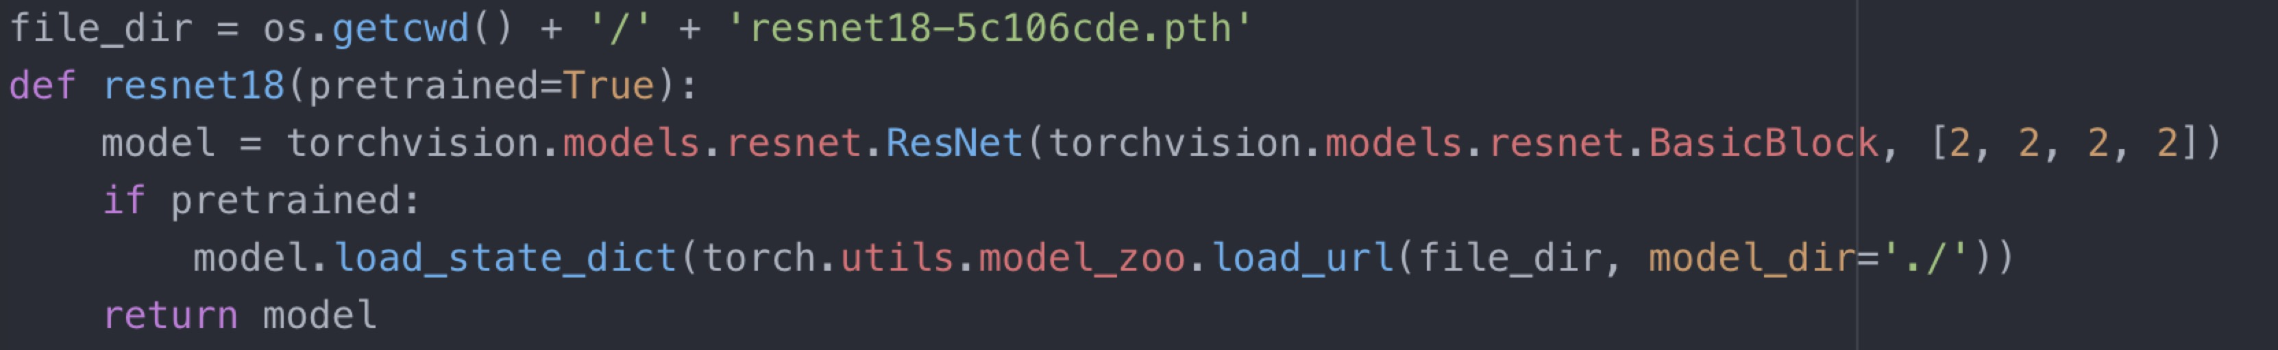

1. **Final Test Accuracy:**

Part1: 0.6073

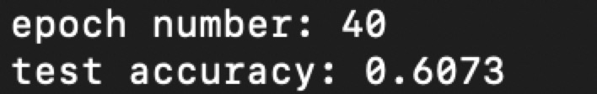

Part2: 0.7245

