Graphic Result

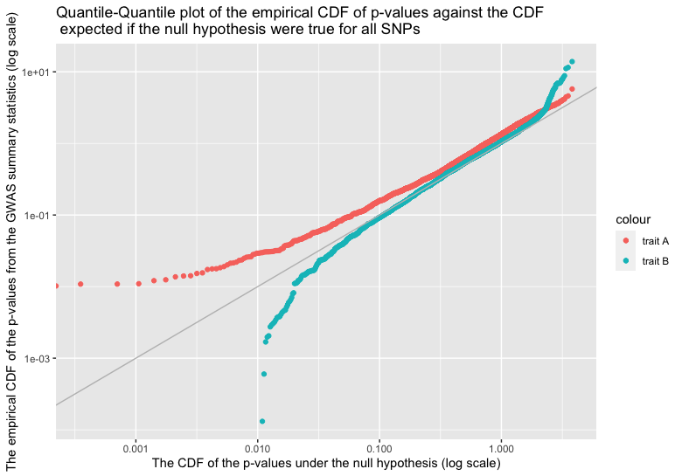

Discussion  
1 Interpretation of the 45 degree line

It is a reference line for normal distribution. It examines the distribution of p-value if they has come from a normal distribution function. Since we are plotting p-values to evaluate many tests simultaneously, if the SNPs were null, then the distribution of their p-values to be distributed uniformly on the unit interval (U (0, 1)), and the qqplot would closely approach the 45 degree line.

Qualitatively, the deviation of a data trend from the 45 degree line in the graph signifies how far the distribution of the p-value against the null-hypothesis is from being normally distributed.

2 Interpretation of the Q–Q plot

Because Q–Q plot is a probability plot, and the probability at each p-value must be at least 0, therefore, the qqplot must be monotonically increasing, if not strictly increasing.

a) The trend of trait A QQ plot: The pattern of points seems to indicate that the distribution is skewed or perhaps light-tailed. It first increases slowly from less than 0.001 then constantly increases until 1. It suggests that all SNPs are not likely to be 0, and we may reject null hypothesis for each SNP in the GWAS results at 0.001 confidence level, means that we estimate the SNP to be non-null.

b) The trend of trait B QQ plot: It first increases fastly from 0.01 then slowly increases until 1. It suggests that all SNPs are not likely to be 0, and we may reject null hypothesis for each SNP in the GWAS results at 0.01 confidence level, means that we estimate the SNP to be non-null.