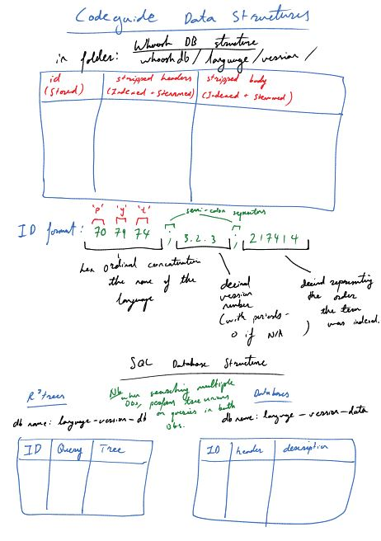

Basically build a Whoosh database and a SQL database in parallel

Whoosh needs to be stored as a different file for each version of python + 1 extra file for the misc python modules. Name the files something related to the version of the python being indexed (external modules always return version = 0)

Whoosh needs 3 fields:

* identifier**(TEXT field type) (Stored = True)**
* stripped header (with arguments and all punctuation removed), **(TEXT field type) (analyzer=StemmingAnalyzer()) (field_boost = 10.0)**
* stripped body (with all punctuation / html tags removed) **(TEXT field type) (Analyzer = StemmingAnalyzer())**

Name the SQL tables something in relation to version in the same way as above.

SQL also needs 3 fields:

* identifier <- functions in Whoosh and SQL must have identical id’s
* fully formed header <- including all tags/formatting
* fully formed body <- same deal