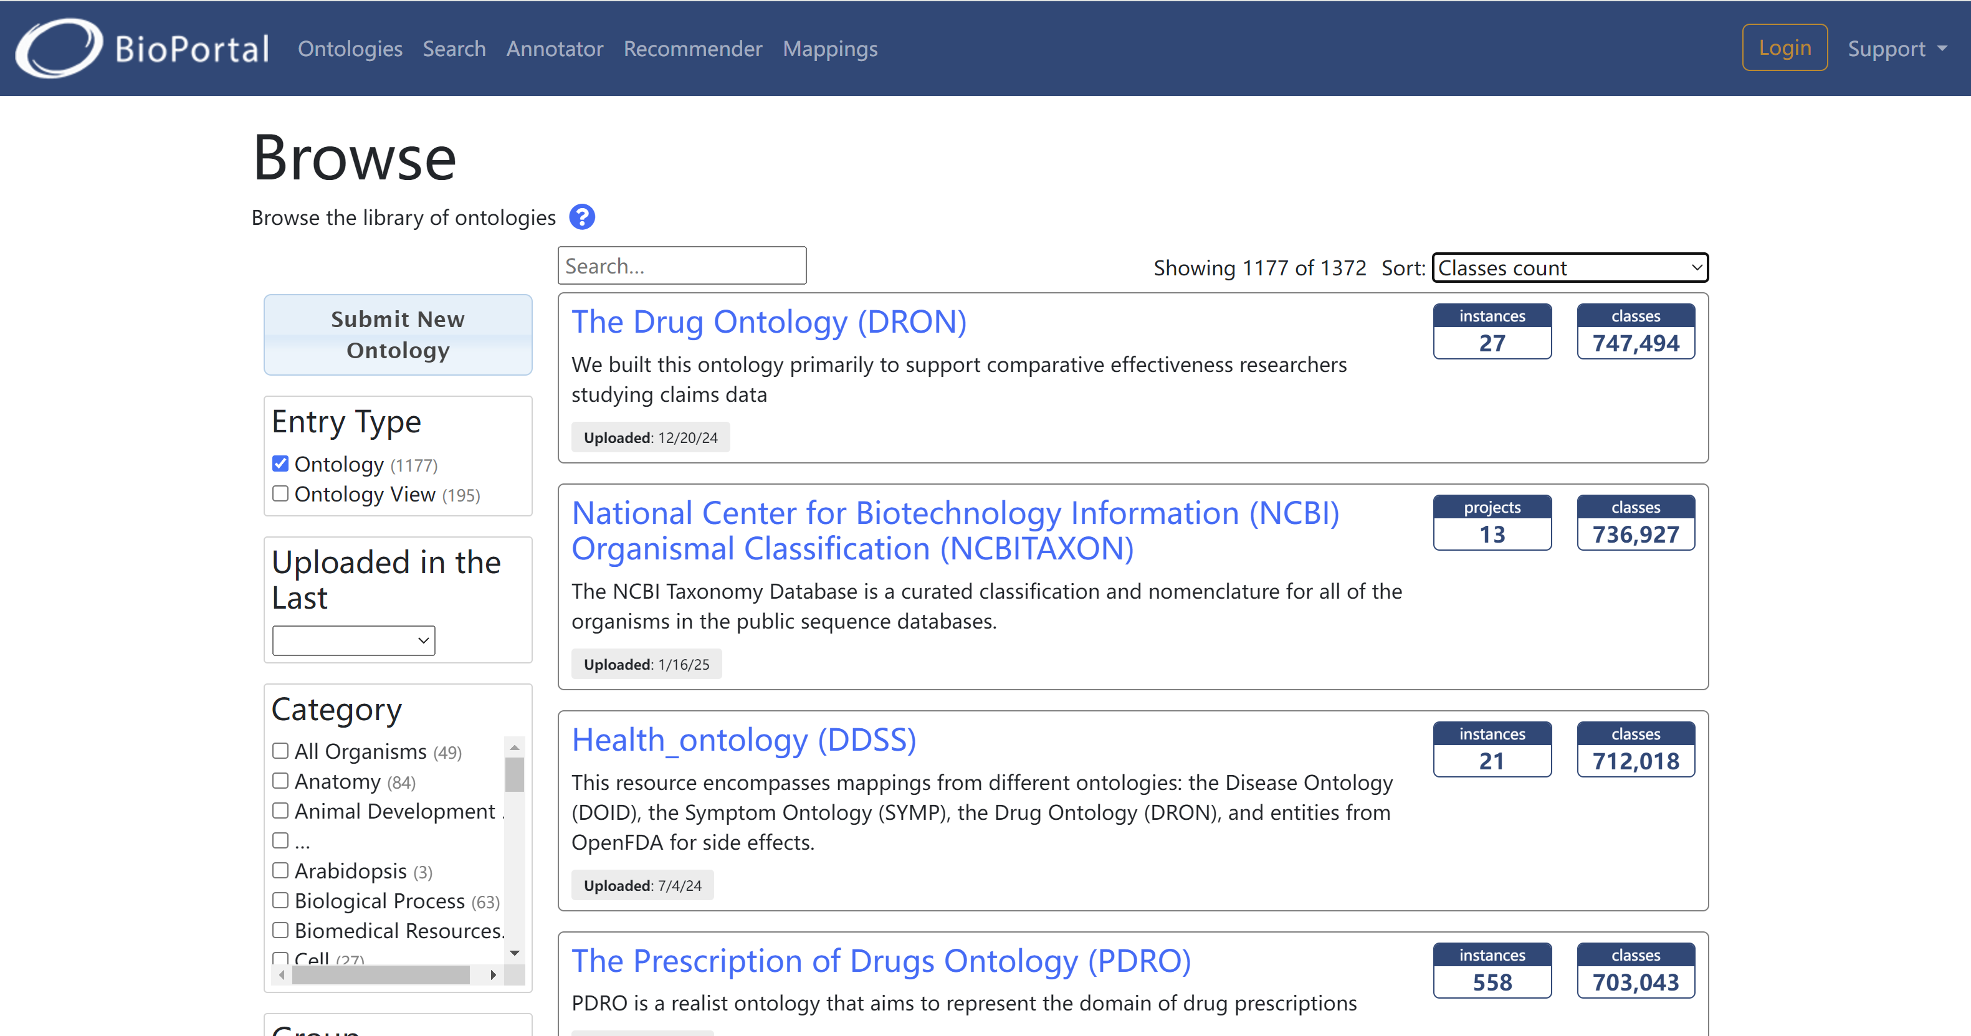

The top 5 ontologies in the NCBO ranked by Ontology classes are:
- The Drug Ontology (DRON)
DRON is aimed to support comparative effectiveness researchers studying claims data. They need to be able to query U.S. National Drug Codes (NDCs) by ingredient, mechanism of action (beta-adrenergic blockade), physiological effect (diuresis), and therapeutic intent (anti-hypertensive). This ontology contains a total of 747,494 classes and 127 properties.
- National Center for Biotechnology Information (NCBI) Organismal Classification (NCBITAXON)
The NCBI Taxonomy Database is a curated classification and nomenclature for all of the organisms in the public sequence databases. This ontology contains a total of 736,927 classes and 4 properties.
- Health_ontology (DDSS)
This resource encompasses mappings from different ontologies: the Disease Ontology (DOID), the Symptom Ontology (SYMP), the Drug Ontology (DRON), and entities from OpenFDA for side effects. This ontology contains a total of 712,018 classes and 69,113 properties.
- The Prescription of Drugs Ontology (PDRO)
PDRO is a realist ontology that aims to represent the domain of drug prescriptions. PDRO’s central focus is the structure of a drug prescription, which is represented as a mereology of informational entities. Current use cases are (1) refining this structure (e.g., adding closure axioms, cardinality, datatype bindings, etc) for prospectively standardizing local electronic prescriptions and (2) annotating prescription data of differing EHRs for detecting inappropriate prescriptions using a central semantic framework. This ontology contains a total of 703,043 classes and 391 properties.
- Gazetteer (GAZ)
GAZ is a large, ontologically-oriented resource listing place names which can be treated as instances of environments. This ontology contains a total of 668,838 classes and 15 properties.

