Student ID: 20162431
Student name: Nguyễn Lê Ngọc Linh
Class: ICT-02

Report Homework 1

1. Formulate the training problem:
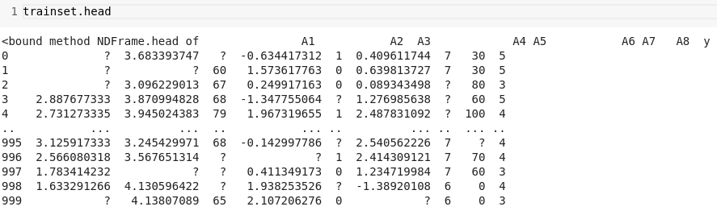
- As we can see in the dataset, each row has 9 columns, and the last column is label. We can conclude that this is classification problem.

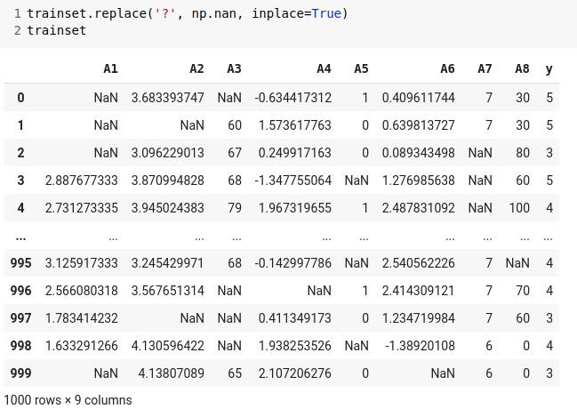

- We can see that the dataset contain many ‘?’ symbol. So we will convert it into np.nan

2. Dealing with missing value:

- After that, we need to convert non numerical into numerical data by using pd.to_numeric function with “coerce” argument. It will turn non-numeric one into NaN.
- And then we use SimpleImputer to replace NaN bby mean value of column.

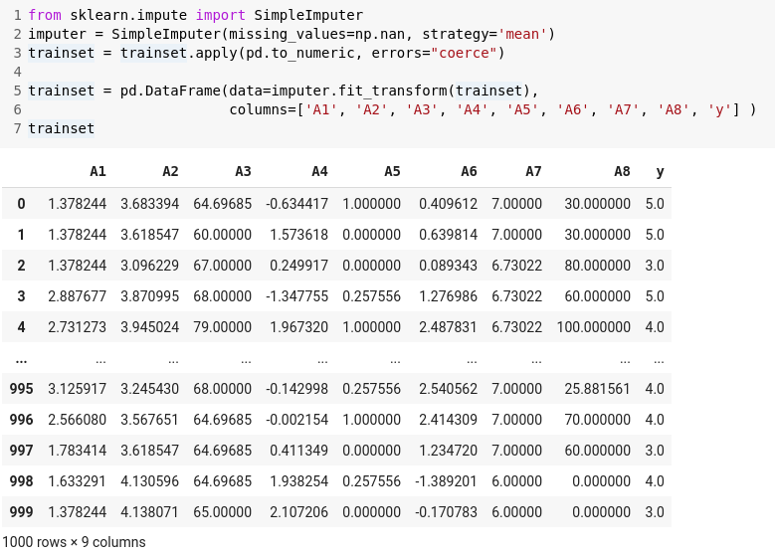

3. Model training and evaluation:
- First, we divide data set into training and testing set.

- Then we will use GridSearchCV to find the optimal value for n-neighbors.

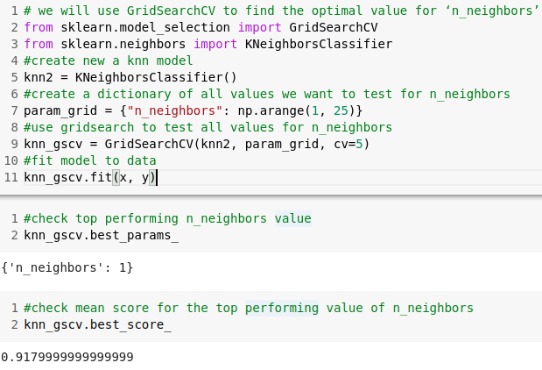
→ best n neighbors is just 1.

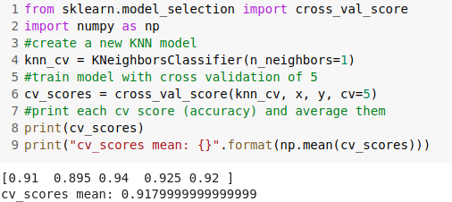
- And then we will use cross validation to evaluation our model.

- At last, we will have result for testing set.
