Algorithm Description
This is an algorithm of optimizing a neural network (NN) with Augmented Lagrange Multiplier method (ALMNN) in case of a lack of training samples. A perfect sample set is very important to improve the NN’s generalization ability. However, it is usually difficult to acquire sufficient training samples for many systems, and as a result, the training samples will be shortage. Therefore, in this case, the NN’s generalization ability is very poor. Fortunately, prior knowledge (such as the symmetry, the ranking list, the boundary and the monotonicity) is very useful for improving the NN’s performance, for example, it can effectively improve the NN’s generalization ability by constructing the constraint conditions for the NN’s training samples, the NN’s weights and the NN’s structures. ALMNN is an algorithm of optimizing a neural network by constructing the constraint conditions for the NN’s weights. The detail of this algorithm is show Reference [1].([1] Haijun Lin, Lucai Wang, Jingrong Yu, Zhaosheng, Teng, and Houde Dai, “Nonlinear Error Compensation for Load Cells Based on Optimal Neural Network with Augmented Lagrange Multiplier”, IEEE Transactions on Instrumentation and Measurement, vol.64, no.11, pp.2850-2862, Nov., 2015.)
(1) Algorithm of ALMNN
Assuming that the system is monotonic(which is the prior knowledge), the performance index of training the NN is E, a batching training method (N training samples) is used, and then E is expressed as follows:
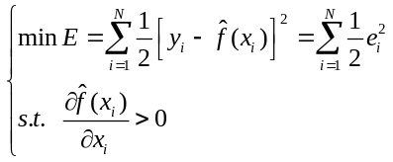, (1)
In Equation (1), the activation functions in the hidden layer take the sigmoid function, the activation functions in the output layer take linear function, and 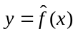 is the NN’s output.
As a special case, if it is a one-input-one-output system, is a 1-M-1 neural network (i.e., an one-input-M-hidden-neurons-one-output neural network), therefore, is given by
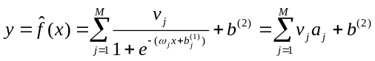, (2)
where 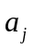 is the output of the j-th neuron of the hidden layer, and can be expressed as:
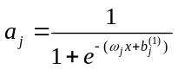. (3)
In Equations (2) and(3), ω=(ω₁, ω₂,…, ω_{M})^{T} is the matrix of weights connecting the nodes in the input layer with the neurons of the hidden layer, b⁽¹⁾=(b₁⁽¹⁾, b₂⁽¹⁾, …, b_{M}⁽¹⁾)^{T} is the biases vector of the neurons of the hidden layer, V=(v₁, v₂,…, v_{M})^{T} is the vector of weights connecting the neurons of the hidden layer with the ones of the output layer, b⁽²⁾ is the bias of the neuron of the output layer, M is the number of hidden neurons.
In Equation (1), the constraint condition is rewritten by
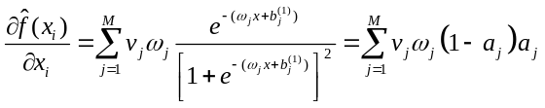. (4)
Because 0<a_{j}<1, the constraint condition is simplified as:
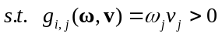. (5)
Thus, Equation (1) is modified as
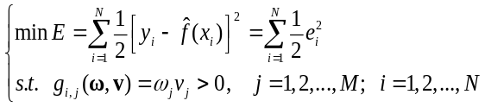. (6)
We apply the augmented Lagrange multiplier method to solving the equation (6), and construct the augmented performance index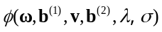, i.e.,
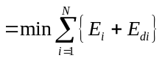, (7)
where λ is the multiplier, σ is the penalty factor, 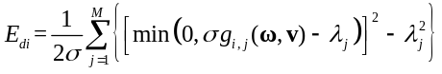, and 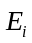=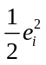.
By using the Back-Propagation learning rule (BP) and the Gradient Training method, and assuming that the learning rate is lr, the parameters V, b ⁽²⁾, W, and b ⁽¹⁾ are regulated by
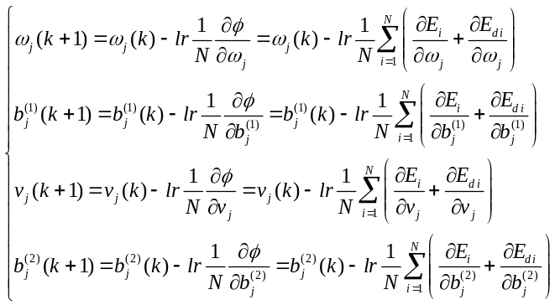 (8)
where,
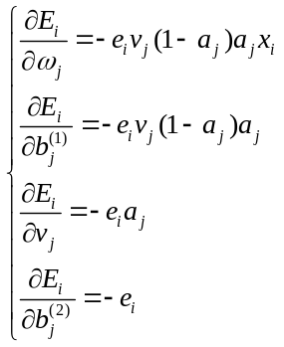. (9)
If 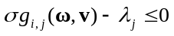, 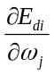, 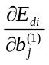,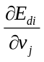, and 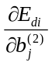 is respectively rewritten as
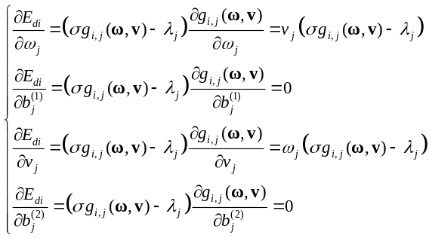. (10)
If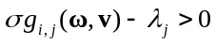, , ,, and is respectively given by
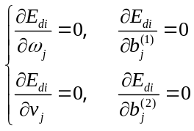. (11)
Equations (9), (10) and (11) are substituted into (8), then
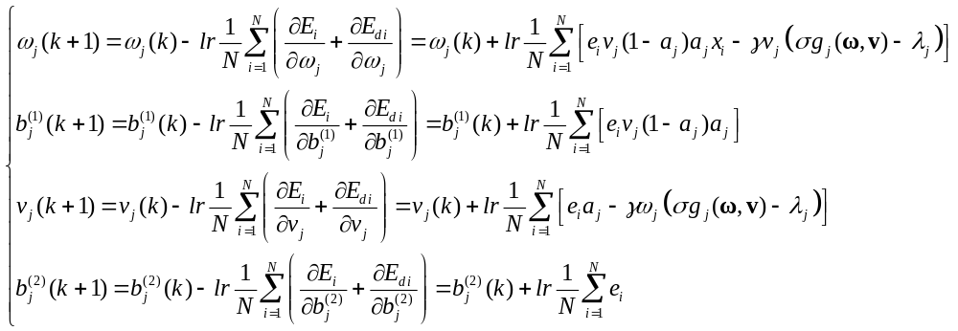, (12)
Where,
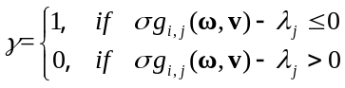. (13)
According to the augmented Lagrange multiplier method, the iterative function of the multiplier λ_{j} in (12) is given by
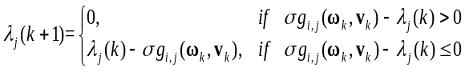. (14)
The stopping iteration criterion of ALMNN β is given by
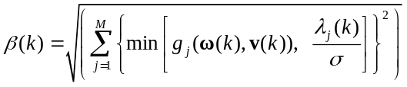. (15)
(2) The major steps of ALMNN are summarized as follows:
Step 1) Initialize some parameters of ALMNN. They are including the NN’s parameters (ω, b⁽¹⁾, v, b⁽²⁾), the penalty factor σ (σ(0)≥0), the multiplier λ (λ(0)≥0), the stopping iteration criterion of ALMNN β, the error tolerance for stopping iteration criterion ε (0≤ε≤1), the learning rate for training NN lr (0<lr≤1), the internal iteration number Train_num (i.e., the iteration number for training the NN, Train_num(0)=0), the maximum internal iteration number maxepochs, the target of NN’s mean square error Err_MSE (0≤Err_MSE≤1), the updating factor of the stopping iteration criterion θ (0<θ≤1), the updating factor of the penalty factor η( η>1), the external iteration number k (i.e., the number of updating the penalty factor, k=1), and the maximum external iteration number maxk.
Step 2) Train the NN. Solve the augmented performance index described in (7) by using the k-1th parameters parameters ω(k-1), b⁽¹⁾(k-1), v(k-1), b⁽²⁾(k-1) and the algorithms described in (12) and (13). If the mean square error of training NN is less than Err_MSE or Train_num is more than maxepochs, stops training the NN.
Step 3) Check the stopping iteration criterion of ALMNN. If β(k)≤ε or k≥maxk, stop the ALMNN and output the NN’s optimal parameters ω(k), b⁽¹⁾(k), v(k), b⁽²⁾(k); otherwise, go to the next step.
Step 4) Renew the penalty factor σ. If β(k)<ηβ(k-1), σ(k+1)=σ(k); else σ(k+1)= θσ(k).
Step 5) Update the multiplier λ by (14).
Step 6) Let k=k+1 and go to the Step 2).
In Step 3), β(k) is described as Equation (15).

