Scaling Law Discovery (SLD): a new testbed for scientific discovery in AI
[Website] https://linhaowei1.github.io/scaling_law_discovery/
[Paper] https://arxiv.org/abs/2507.21184
[HuggingFace] https://huggingface.co/collections/pkuHaowei/scaling-law-discovery
Scaling laws have quietly become one of the most “scientific” tools in modern AI: we run a small number of experiments at small scale, fit a simple mathematical relationship, and use it to make decisions at large scale, where experiments are expensive and slow.
In this post, we introduce our new work on Scaling Law Discovery (SLD): a benchmark + agentic framework for automating the process of discovering scaling laws from experimental data. The high-level goal is simple:
Can AI agents discover the scaling laws that govern AI systems more efficiently and more accurately than humans?

What is a scaling law?
A scaling law is an empirical relationship that predicts a model’s performance (loss, perplexity, accuracy, etc.) as a function of “scale variables” like:
- model size (N)
- dataset size (D)
- compute / FLOPs (C)
- hyperparameters like learning rate and batch size
- architecture knobs (e.g., number of experts in MoE)
The canonical example is the “Chinchilla-style” pretraining form [1], where loss is modeled as a power-law function of model size and data size:$$L =θ_{0} +θ_{1}/N^{θ_{2}} +θ_{3}/D^{θ_{4}} .$$
Why do scaling laws matter? Because their predictive capability helps with real decisions: compute-optimal planning [1], choosing which model to fine-tune [2], and picking hyperparameters that would otherwise require huge sweeps [3].

A real example: when the “standard” scaling law fails
Two years ago (Year 2023), we ran into scaling laws the way many people do: not as a theory exercise, but because we needed an answer under real resource constraints. We were working on LLM selection for SFT [2]: given a set of pretrained LLMs and only a small subset of downstream data, how do we pick which model will perform best after full fine-tuning?

The problem: fine-tuning has two phases
In low-data fine-tuning, we observed a consistent phase transition pattern—what we called a pre-power phase followed by a power phase—and existing “Chinchilla-style” power-law forms simply couldn’t capture it well.
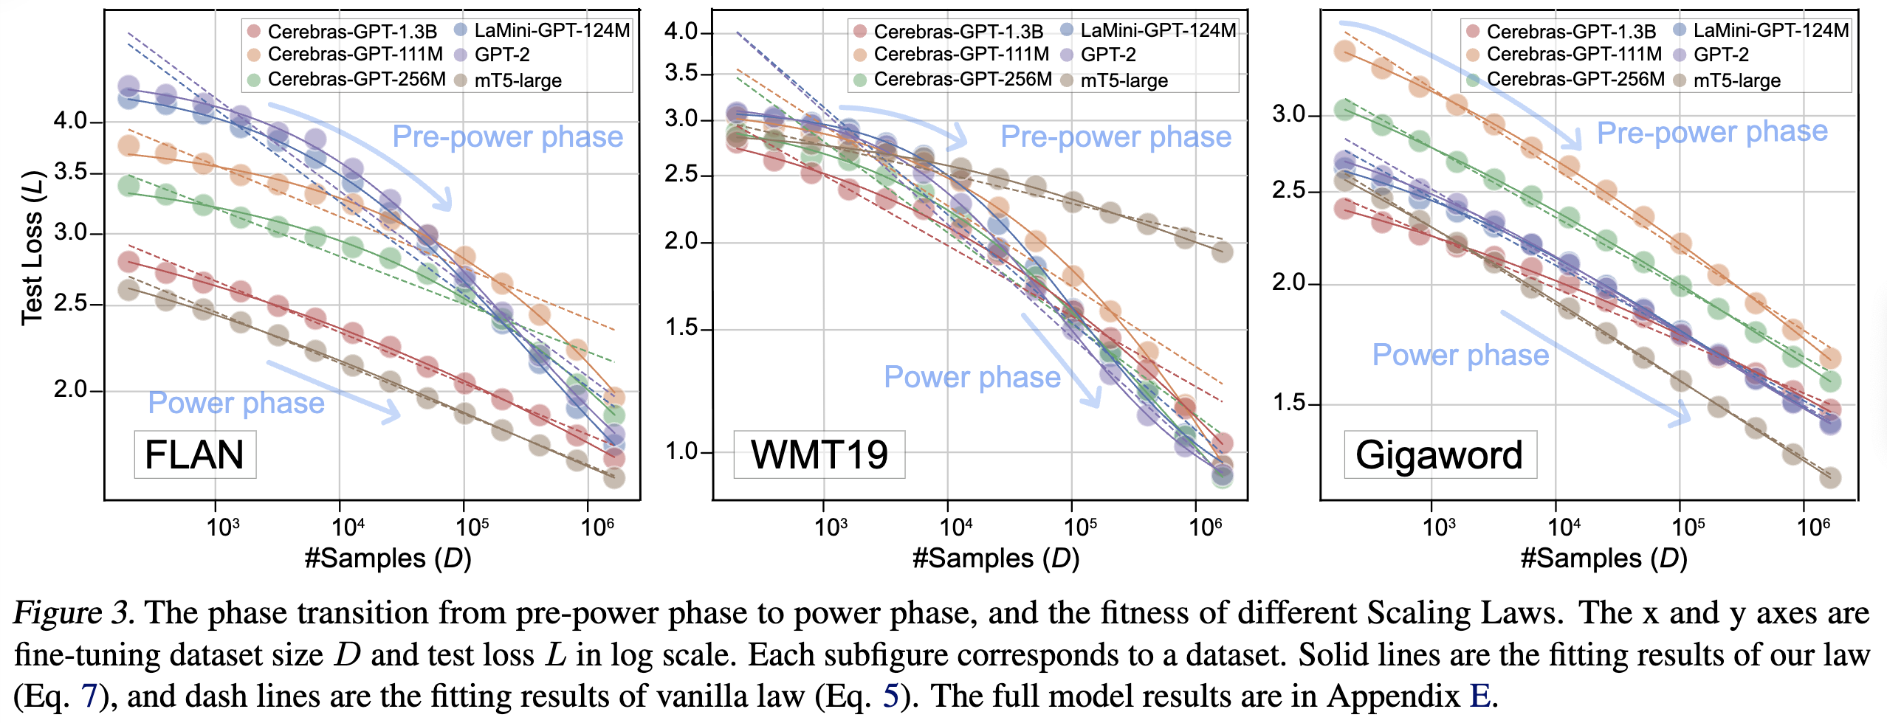
In fact, the paper gives a clean reason: under the classic law (Eq. 5 in that work), the log-log slope has a monotonicity property that contradicts the observed two-phase behavior.

The fix: “Rectified Scaling Law” with a pre-learned data size
The key idea was to explicitly represent how much downstream-relevant knowledge the model already has before fine-tuning. We introduced a pre-learned data size ($D_{l}$) and proposed the rectified law:
$$\hat{L}\left(D\right)=\frac{B}{D_{l}+ D^{β}} + E.$$
This single extra concept (“pre-learned data size”) makes the law both more interpretable and mathematically able to express the two-phase pattern in one formula.
Empirically, it fit much better: the paper [2] reports an average RMSD of 0.007 for the rectified law vs 0.036 for the vanilla law (same number of fitted parameters), indicating the rectified form captures the intrinsic behavior more accurately.

Turning the law into a practical algorithm
Once we had a usable law, we built an efficient selection algorithm that fine-tunes on a sequence of size-decreasing subsets, detects the transition pattern, and extrapolates full-data performance. Crucially, it achieves near-optimal selection while using hundreds of times less compute than full fine-tuning across candidates.
This project taught us something important: the scaling law itself was the bottleneck. We spent a lot of human effort on hypothesis → fit → failure → redesign loops.
Which leads to the question that motivated our new work:

Scaling laws are everywhere now—so why is discovery still manual?
In 2026 and beyond, scaling laws have expanded well beyond classical pretraining:
- supervised fine-tuning laws
- vocabulary-size laws
- MoE laws
- domain-mixture laws
- parallelism laws
- learning-rate & batch-size laws
- even adversarial extrapolation settings like U-shaped/double-descent patterns
The SLD paper [4] summarizes this clearly: the scope has expanded rapidly, but discoveries are still manual and case-specific, requiring repeated cycles of hypothesis generation (design the symbolic law expression) and experimentation (fit the law to observed datapoints).
So we asked: can we formalize scaling law discovery as a task that coding agents can solve?

Introducing Scaling Law Discovery (SLD)
Our work frames scaling law discovery as: given observed experimental trials, output
- a symbolic formula (the law form), and
- an optimizer that robustly fits coefficients on seen data, so the resulting parameterized law extrapolates well.
More precisely, the input is a dataset of trials $\{(x_{i}, j_{i}, y_{i})\},$ where:
- ($x_{i}$) are feature variables (e.g., (model size N, dataset size D, lr, bsz))
- ($y_{i}$) is the target metric (e.g., loss)
- ($j_{i}$) is a control index (a setting like “which model” or “which corpus”), where all settings share the same law form but have different fitted coefficients.
That “shared form, different coefficients” detail sounds small, but it’s exactly what makes real scaling-law work different from many synthetic symbolic regression tasks.

SLDBench: a benchmark built from 5,000+ real experiments
To evaluate this problem rigorously, we curated SLDBench, a scaling law discovery testbed built from over 5,000 LLM training experiments collected from existing scaling-law literature.
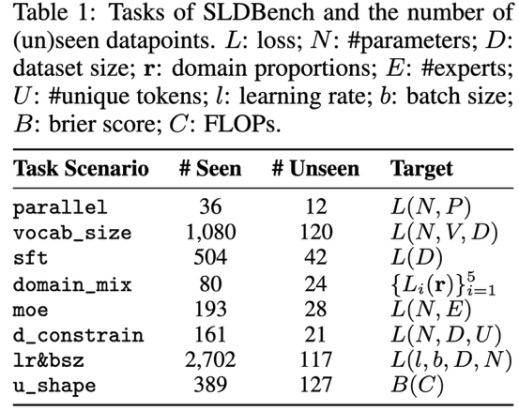
SLDBench includes tasks spanning a wide range of scaling scenarios. Table 1 in the paper lists (currently) eight tasks, including:
- parallelism scaling
- vocabulary scaling
- SFT scaling
- domain mixture scaling
- MoE scaling
- data-constrained scaling
- learning rate & batch size scaling
- U-shaped (non-monotonic) scaling

Why SLDBench is a “scientific discovery” benchmark
SLDBench is designed to be open-ended in a way that’s closer to real research than typical benchmarks while maintaining focused simplicity:
- The agent gets the experimental results; it does not need to run training.
- The score is continuous and objective: extrapolation on held-out “large-scale” settings.
- There is no learned reward model, and the “true best law” is unknown even to human experts.
- The evaluation environment is a sandbox terminal: agents output a law.py, and we compute metrics (NMSE, NMAE, R^2) on an extrapolation test split.
This makes SLDBench a natural yardstick for “can agents do long-horizon, research-like iteration?”

SLDAgent: co-evolving a law and its optimizer
A key lesson from our own experience (and from watching others do this) is:
Discovering a scaling law is not just “find a formula.” It’s “find a formula and a fitting procedure that actually works.”
So our agent, SLDAgent, evolves two coupled components:
- Expression: the law form ($f_{θ}\left(x\right)$)
- Optimization: a robust routine that fits $(\hat{θ} = argmin_{θ} L(y,f_{θ}(x))$)
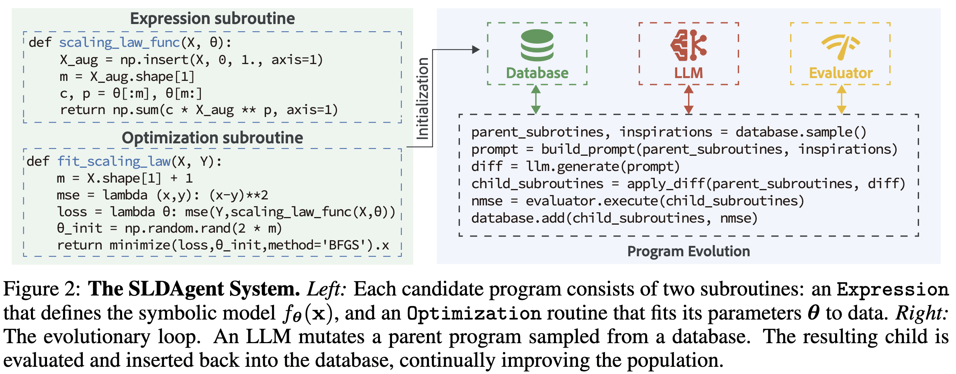
It starts from a baseline (often power-law + BFGS), then iteratively proposes code modifications, executes them, and keeps the best variants while maintaining diversity via a multi-island + MAP-Elites style evolutionary database.
(Implementation note: the system is built on the OpenEvolve framework [5]. )
This “co-optimization” framing matches the real research loop: hypothesize → fit → evaluate → refine.

What we found: agents can beat our past human discoveries
Across SLDBench, SLDAgent achieves state-of-the-art performance and “superhuman” results relative to human baselines and existing agent systems.
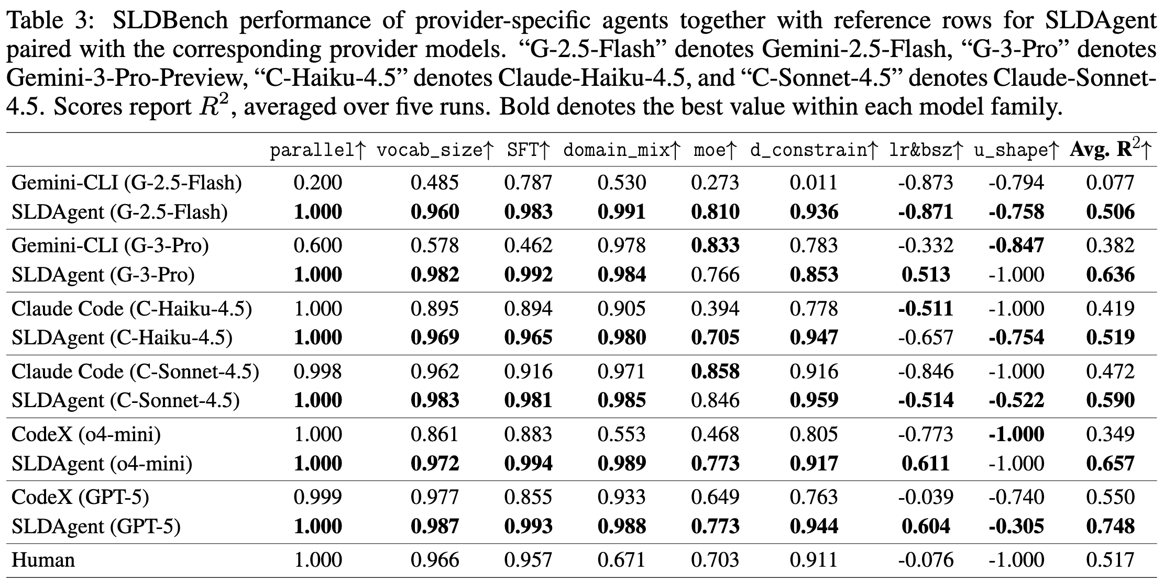
But the more interesting part is how it wins:

1) Better laws are often more “principled,” not just more complex
For example, in the SFT task, SLDAgent discovers a saturated power-law parameterization where the “effective data size” appears as a dimensionless ratio (${\left(\frac{D}{θ_{3}}\right)}^{θ_{1}}$), making ($θ_{3}$) retain the natural unit of dataset size and improving interpretability and downstream usability.

2) The optimizer matters as much as the formula
Many “pretty” formulas become useless if they’re numerically brittle, hard to fit, or fail under extrapolation. SLDAgent explicitly searches over fitting strategy changes (multi-start, stability tricks, etc.) as part of the same evolutionary loop. Check our website for comprehensive cases.

Application: hyperparameter optimization for pretraining (lr & batch size)
One of the most practical use cases is: “I’m pretraining a model, and I need good lr + batch size choices for my scale.”
The paper points out a limitation of a common approach: prior work may run thousands of experiments but only keep a tiny set of “best points” to fit a scaling law for optimal hyperparameters. For instance, the original StepLaw [6] ran ~3,000 experiments but used only 17 optimal points to fit (lr^*) and (bsz^*).
In contrast, SLDAgent discovers a law for the final loss surface (L(N, D, lr, bsz)), then derives optimal hyperparameters by setting partial derivatives ($∂ L/∂ lr$) and $(∂ L/∂ bsz$) to zero, yielding a closed-form solution as a function of (N) and (D).
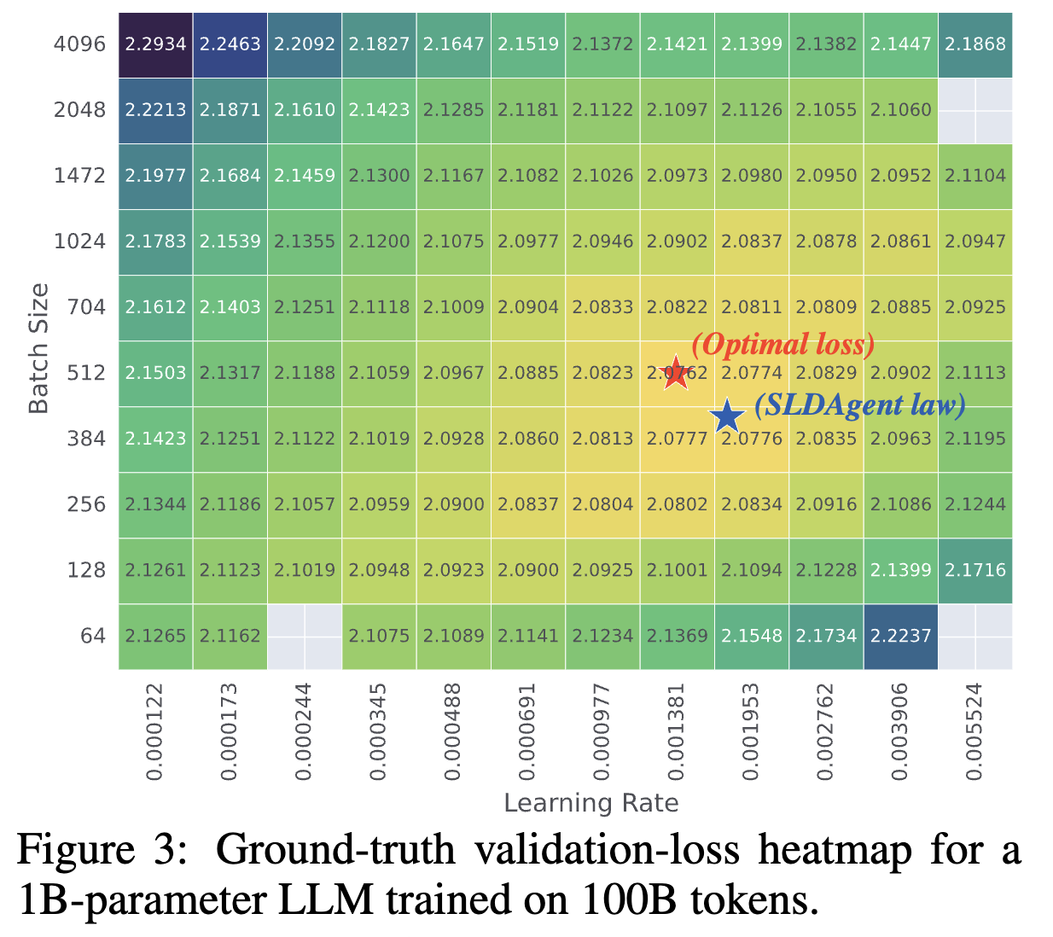
That’s exactly the kind of “turn experiments into a usable law” pipeline that scaling laws were meant for.

Why we think SLD is a strong “AI-for-science” benchmark (for AI science)
Most “AI4Science” benchmarks focus on physics, chemistry, or biology. SLD is slightly different: it’s a benchmark where the “science” is AI itself. SLDBench was built to demand symbolic reasoning, multi-context generalization, robust extrapolation, and long-horizon execution in a constrained environment…and to do so with a clear, unbiased objective function.
We also find it useful as a diagnostic for general-purpose coding agents: as those agents get better at scientific-style iteration, the gap to task-specific systems like SLDAgent should shrink.
SLDBench is our first attempt to make “AI for AI research” programmable, benchmarkable, and eventually automatable.

References
[1] Jordan Hoffmann, Sebastian Borgeaud, Arthur Mensch, Elena Buchatskaya, Trevor Cai, Eliza Rutherford, Diego de Las Casas, Lisa Anne Hendricks, Johannes Welbl, Aidan Clark, Tom Hennigan, Eric Noland, Katie Millican, George van den Driessche, Bogdan Damoc, Aurelia Guy, Simon Osindero, Karen Simonyan, Erich Elsen, Jack W. Rae, Oriol Vinyals, and Laurent Sifre. “Training Compute-Optimal Large Language Models.” arXiv preprint arXiv:2203.15556. (arXiv)
[2] Haowei Lin, Baizhou Huang, Haotian Ye, Qinyu Chen, Zihao Wang, Sujian Li, Jianzhu Ma, Xiaojun Wan, James Zou, and Yitao Liang. “Selecting Large Language Model to Fine-tune via Rectified Scaling Law.” arXiv preprint arXiv:2402.02314. (arXiv)
[3] Jared Kaplan, Sam McCandlish, Tom Henighan, Tom B. Brown, Benjamin Chess, Rewon Child, Scott Gray, Alec Radford, Jeffrey Wu, and Dario Amodei. “Scaling Laws for Neural Language Models.” arXiv preprint arXiv:2001.08361. (arXiv)
[4] Haowei Lin, Haotian Ye, Wenzheng Feng, Quzhe Huang, Yujun Li, Hubert Lim, Zhengrui Li, Xiangyu Wang, Jianzhu Ma, James Zou, and Yitao Liang. “Can Language Models Discover Scaling Laws?” arXiv preprint arXiv:2507.21184. (arXiv)
[5] Asankhaya Sharma. “OpenEvolve: an open-source evolutionary coding agent.” Software (GitHub), 2025. (GitHub)
[6] Houyi Li, Wenzhen Zheng, Qiufeng Wang, Hanshan Zhang, Zili Wang, Shijie Xuyang, YuanTao Fan, Zhenyu Ding, Haoying Wang, Ning Ding, Shuigeng Zhou, Xiangyu Zhang, and Daxin Jiang. “Predictable Scale: Part I, Step Law – Optimal Hyperparameter Scaling Law in Large Language Model Pre-training.” arXiv preprint arXiv:2503.04715. (arXiv)

