Part 1

Listen to the conversations. Then choose the word or phrase that correctly completes each sentence.

**Example:** The woman prefers to be called **( Mrs. / Miss / [Ms.] )** Graham.

**1.** It is **( impolite / taboo / customary )** to use first names at this office.

**2.** Ayako registered for the conference **( before / after / when )** it was announced.

**3.** In Sophia’s culture, it’s **( bad table manners / taboo / impolite )** to eat beef.

**4.** The man would like to be called by his **( first name / title and last name / nickname )**.

**5.** They are talking about **( table manners / greetings / punctuality )**.

**6.** First, Ms. Pilman **( taught a class / became a doctor / went to her doctor )**.

**7.** In Patricia’s culture, it’s considered **( offensive / good etiquette / customary )** for a student to use a teacher’s first name.

Part 2

Complete each sentence with a word from the box. Not all the words will be used.

|  |
| --- |
| **customary etiquette impolite table manners ~~small talk~~ cultural literacy** |

**Example:** It’s appropriate to make ____small talk______ when you first meet a person.

**8.** I think      **cultural literacy**        is important for people who move to another country.

**9.** When I was a child, it was considered bad      customary      to put your elbows on the table.

**10**. Eating with your mouth open is         impolite        in our culture.

**11.** Different cultures have different rules about        etiquette    , or what is considered polite.

Part 3

Complete each sentence with the correct tag question.

**Example:** She was in Thailand last semester, _____wasn’t she_____?

**12.** You’re going to New Zealand,                        aren’t you                         ?

**13.** I’m not enrolled in the class yet,                        am I                         ?

**14.** Dr. Holland prefers to be called Michael,                   doesn’t he                              ?

**15.**  You and I will always be friends,                             won’t you and I                  ?

**16.** They have contacted the director of the program,               haven’t they                                  ?

**17.** Your parents didn’t grow up in Madrid,                  did your parents                               ?

**18.** I’m right about when the paper is due,               aren’t I                                  ?

**19.** You’d never be that rude,                        would you                         ?

**20.** It’s taken a long time to finish all this work,                   isn’t it                              ?

Part 4

Read each sentence. Then put the events in the correct order.

**Example:** I’d already made plans with Patrick when you told me about the party.

_1_ I made plans with Patrick. _ 2_ You told me about the party.

**21.** By the time she left Spain, she’d learned Spanish pretty well.

     1      She left Spain.      2      She learned Spanish pretty well.

**22.** He’d already heard the news when his boss told him about the promotion.

     1      He heard the news.      2      His boss told him about the promotion.

**23.** When we arrived at the office, the meeting had started.

   2        We arrived at the office.     1       The meeting started.

Part 5

Look at some of Laura’s life events. Complete each sentence. Use the past perfect of the provided verb and already or yet. Use contractions when possible.

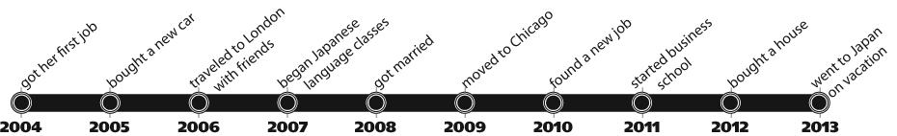

**Example:** By 2009, Laura had gotten married, but she _____hadn’t yet found_____ a new job.

**(find)**

**24.** Laura          hadn’t yet bought                                   a house when she bought a new car.

**(buy)**

**25.** By the time she went to Japan, Laura      had already began         Japanese language classes.

**(begin)**

**26.** When Laura got married, she        had already moved         to Chicago.

**(move)**

**27.** By 2012, Laura         hadn’t yet started         business school.

**(start)**

Part 6

Read the article. Then choose True or False for each sentence.

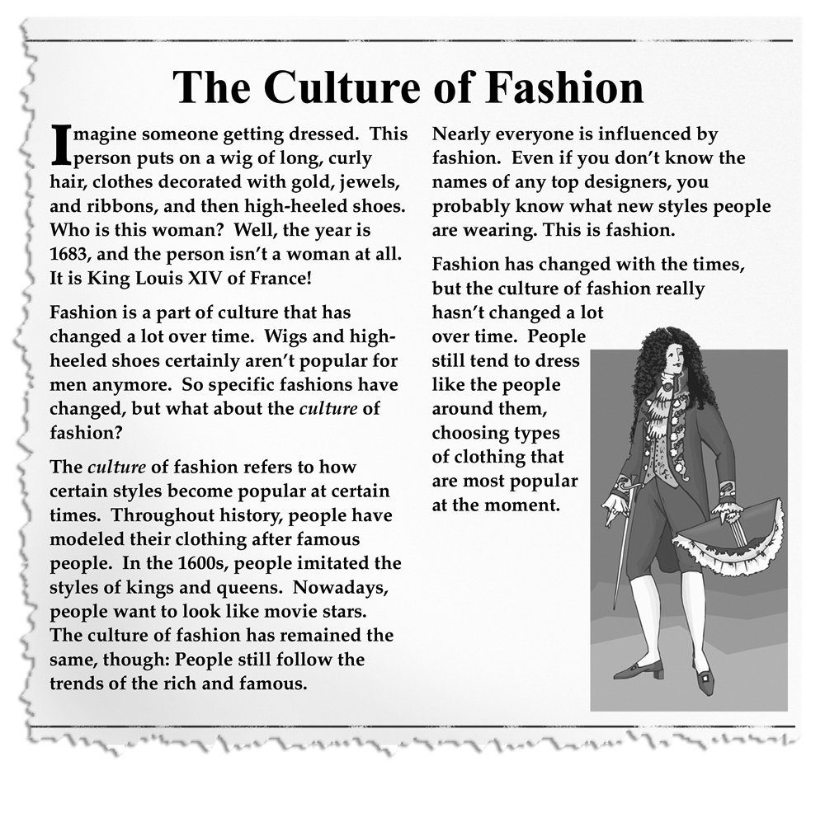

**True False**

**Example:** Fashion changes with time. ( ✓) ( )

**28.** Long ago in France, men dressed similarly to women today. ( ) ( ✓)

**29.** The culture of fashion has changed a lot over time. ( ) ( ✓)

**30.** You can know about fashion without knowing designers’ names. ( ✓) ( )