Programmer's name: Linh Cao

Email address: linhcao@csu.fullerton.edu

Course: CPSC 223j

Assignment number: 1

Due date: Sept 14, 2015

Title: Sphere Computations

Purpose: Find the area and the volume of any sphere

Screen shots:

Start up screen

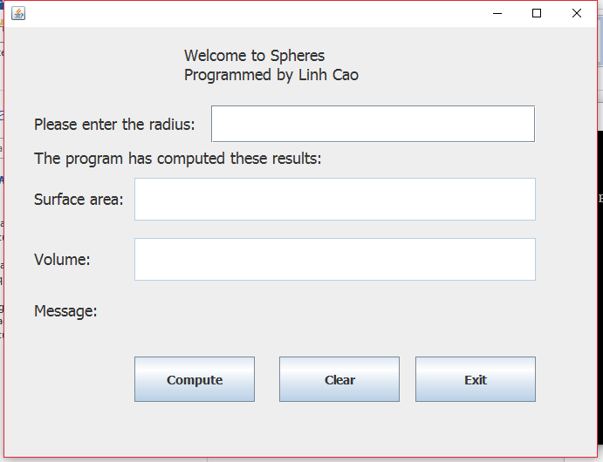

Radius = 2.0

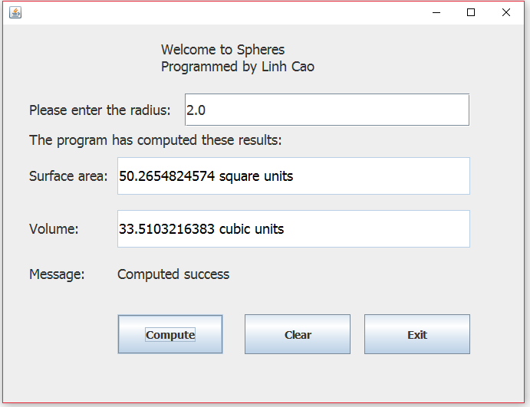

Radius = 3.5

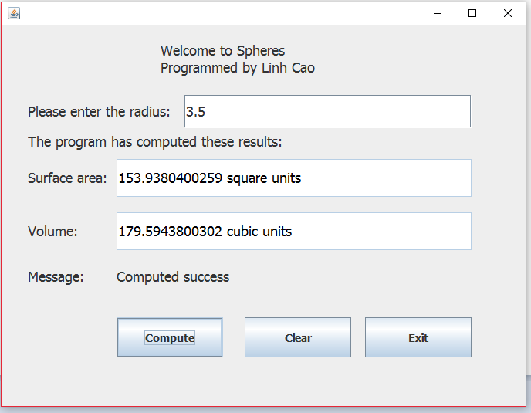

Radius = 6.0

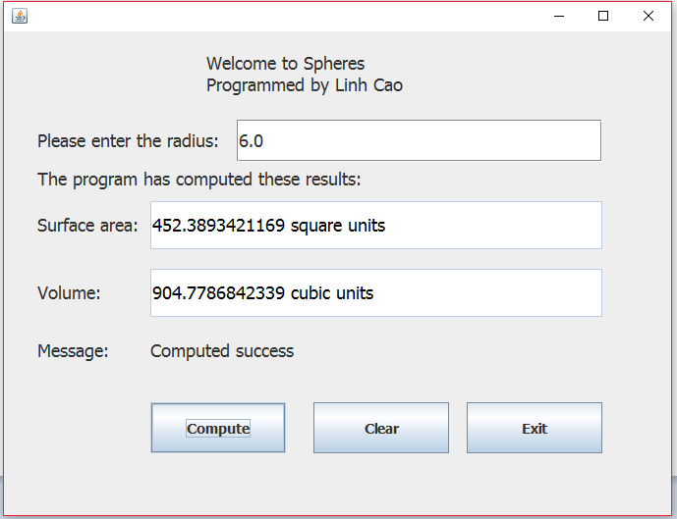

Click on clear

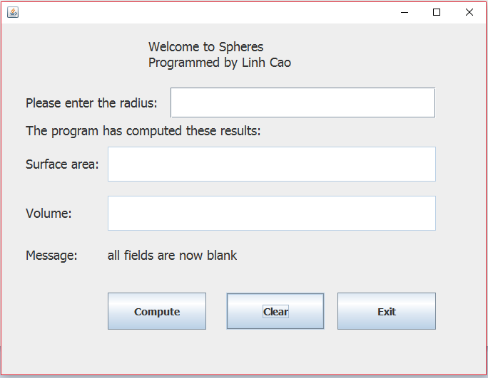

Radius = 25.75

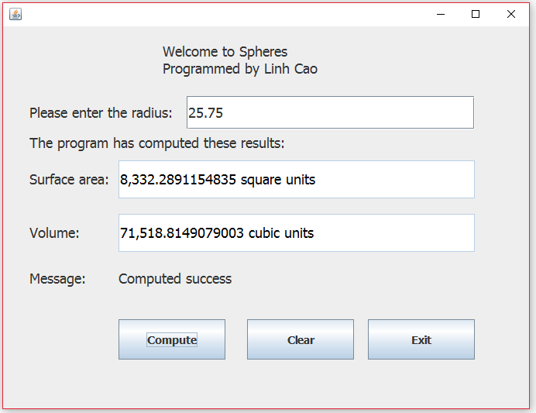

Input a ‘W’

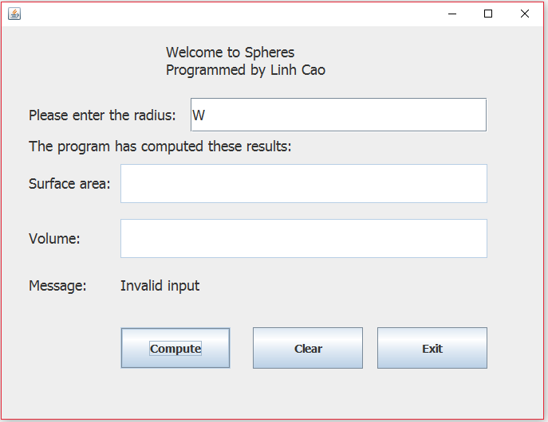

Radius = 104.0000000003

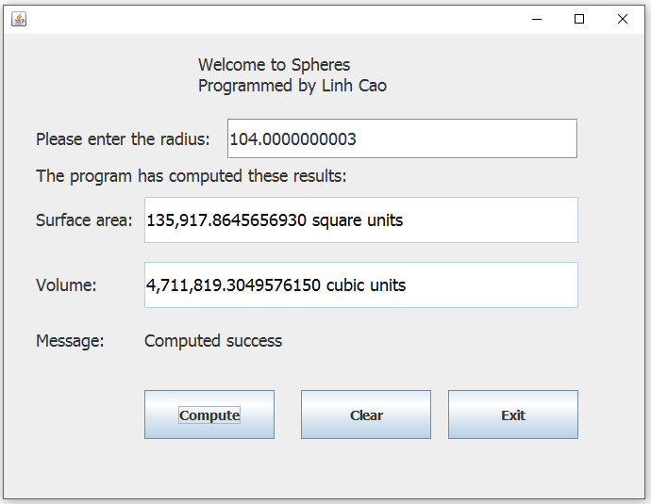

No input received

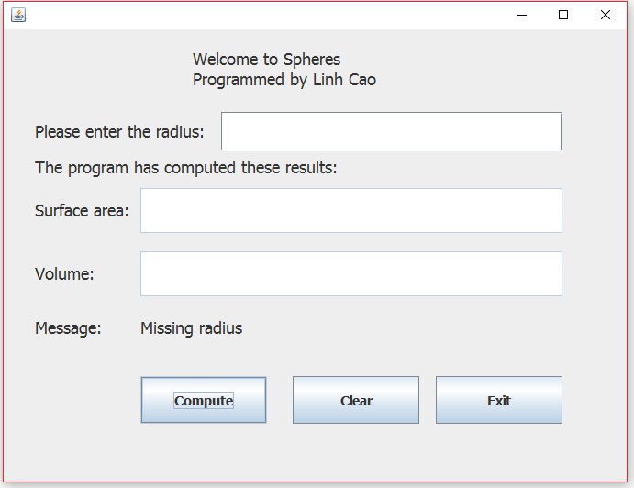

Radius = 0.25

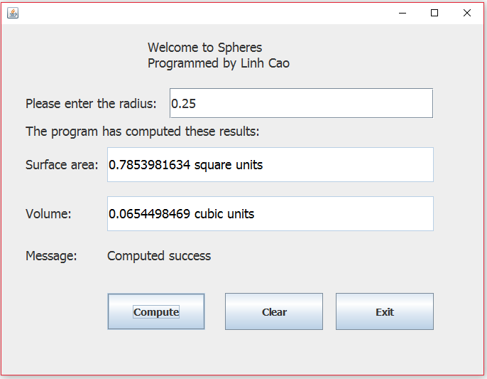

Radius = 0.00006

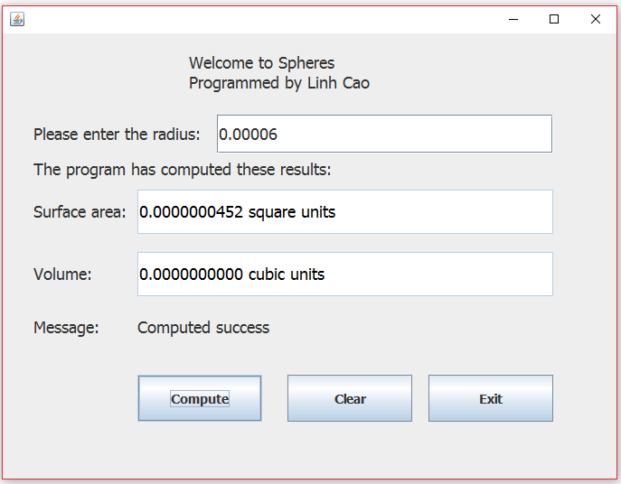

Radius = 0.0000000038

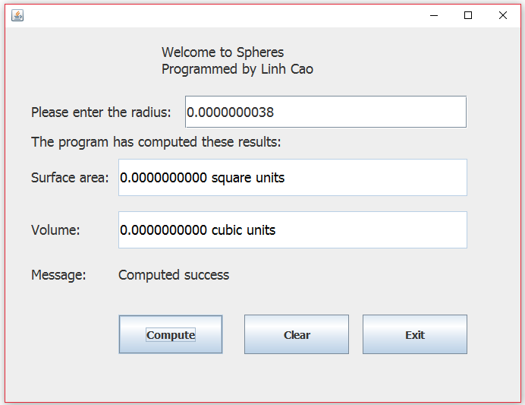

Click on close button

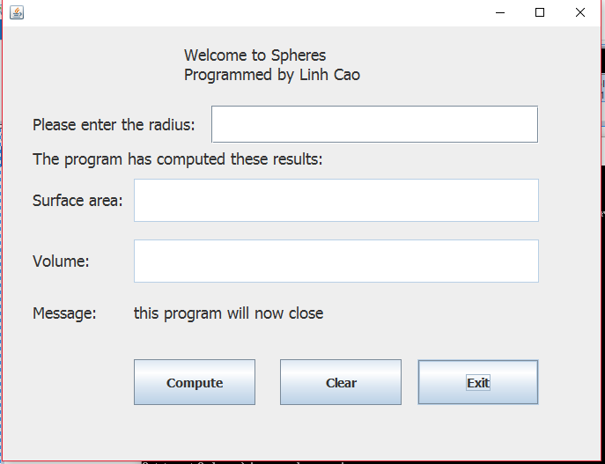

A listing showing information about the files in this Java project

