**KL46Z**

Component in KL46Z

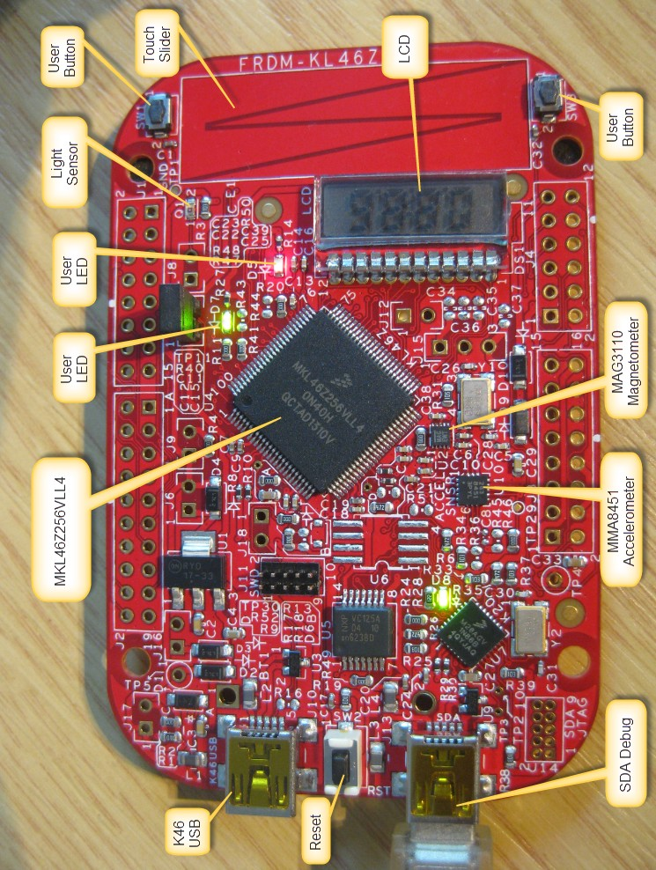

Bước 1: Access [FRDM-KL46Z_SCH.pdf](C:/Users/linhh/Desktop/StudyUET/Embedded/Documents/FRDM-KL46Z_SCH.pdf)

Bước 2: Ctrl + F tìm MAG3110

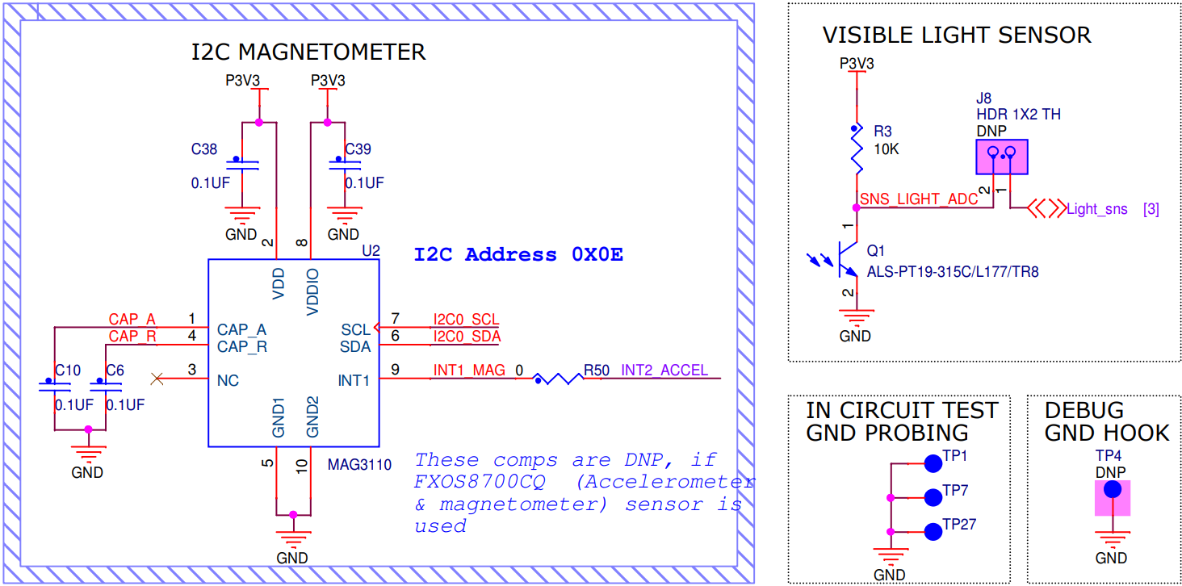

Bước 3: Tài liệu cảm biến [SparkFun Triple Axis Magnetometer Breakout - MAG3110 - SEN-12670 - SparkFun Electronics](https://www.sparkfun.com/products/retired/12670)