6/2/2014
Advanced Internet & Web Services
Final Project installation guide
Class: 3C-16
Students: Nguyễn Ngọc Linh
Bùi Quang Thành
Đinh Thị Trà Mi
Bùi Ngọc Trung

Contents
I. General 2
II. Server Config 2
III. Client Config 3

- General

- Exact project file
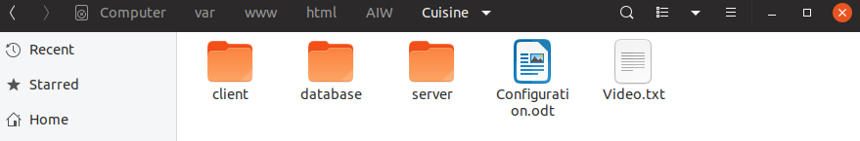

- Server Config

- create and import database
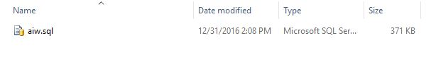
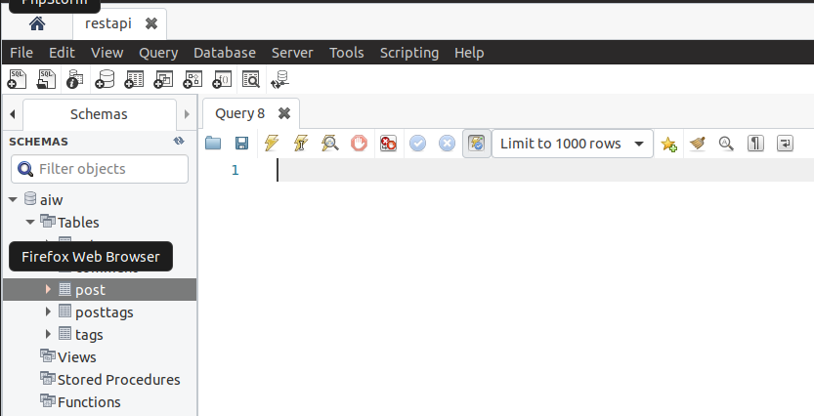

- Coppy file in server folder to your website that will run server
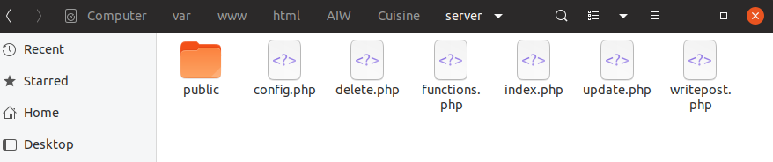
- Open config.php and edit with your server information
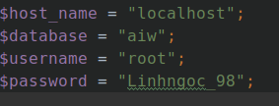

- If you don’t use password, you can change:
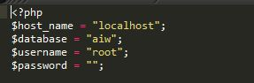
- Client Config

- coppy file in client folder to your website

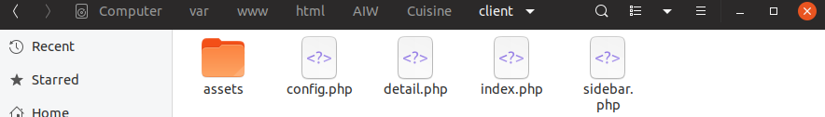
- open config.php and edit link to your server (default value is online server ,can use it if dont want install server).

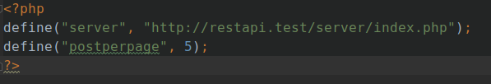
- run your client and enjoy!
