Max pooling

|  |  |  |  |
| --- | --- | --- | --- |
| 12 | 11 | 8 | 6 |
| 122 | 0 | 21 | 32 |
| 33 | 165 | 125 | 84 |
| 105 | 48 | 11 | 210 |

|  |  |
| --- | --- |
| 122 | 32 |
| 165 | 210 |

Average pooling

|  |  |
| --- | --- |
| 36.25 | 16.75 |
| 87.75 | 107.5 |

...

...

Cat

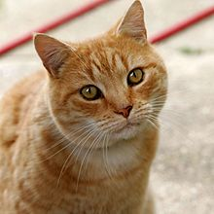

Dog

Pig

Sheep

...

Input image

Convolutional

Pooling

Fully connected + Dropout

Output classes