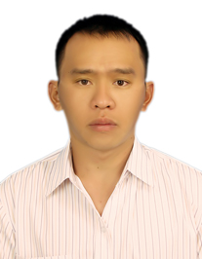
Van-Linh Le has received his B.S. degree in Information Technology from Dalat University, Vietnam in 2011 and his M.S. degree in Computer Science (Software Engineer) from Univ. of Bordeaux, France in 2016. He is currently a Ph.D. student in Computer Science at Image and Sound Team, LaBRI Laboratory - Univ. of Bordeaux. His interests are in computer vision, image processing, pattern recognition, deep learning, neural network.

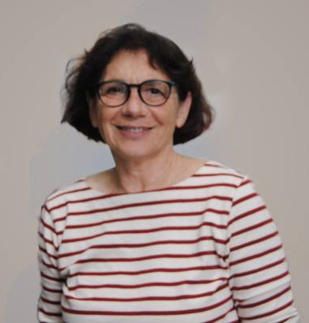
Marie Beurton-Aimar received her Ph.D in Sciences Biological and Medical from Univ. of Bordeaux 2 in 2000. She obtained Habilitation from Univ. of Bordeaux in 2014. Currently, she is a Assistant Professor in Biology and Computer Science at University of Bordeaux. She works at Image and Sound Team, LaBRI Laboratory – Univ. of Bordeaux. Her research interests are in image processing, pattern recognition, metabolic network, heritage image analysis, archeology image, deep learning, neural network.


Akka Zemmari has received his Ph.D. degree from the University of Bordeaux, France, in 2000. He is an associate professor in computer science since 2001 at University of Bordeaux, France. His research interests include distributed algorithms and systems, graphs, randomized algorithms, machine learning and security. He is head of Distributed algorithms team at the University of Bordeaux. He participated to national research projects, European research projects, and Europe-India projects. He wrote about 70 research papers published in international journals and conference proceedings and he is involved in program committees and organization committees of international conferences.

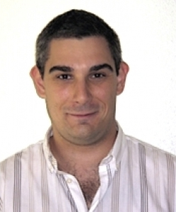
Nicolas Parisey received his M.S. in Bio-Informatics (2003) and his Ph.D. in systems biology (2007) from the Univ. of Bordeaux (France) and his Habilitation in systems ecology (2017) from the Univ. of Rennes (France). Since 2009, he has been a member of the French National Institute of Agricultural Research (INRA) and his currently leader of a team dedicated to theoretical epidemiology (INRA team Demecology). His research interests include spatio-temporal modeling of epidemics processes, the importance of pest cognition in epidemics, image processing for plant health issues, including deep learning applications, and optimal design of experiments.

